Software Requirements Specification Document

Team number | 10
Project Title | Supply Chain Management System with Autonomous Robots
Document | Software Requirements Specification Document
Creation date | 14 September 2014
Created By | Abhineet Jain, Tanmay Sahay and Kashish Punjani
Client | Hemanth Satyanarayana, Imaginate, CIE, IIIT-H

Brief problem statement
To create a friendly user interface for controlling and managing robots involved in a supply chain system for varied users.
The robot control is to be managed using ROS. This has to be linked to a Django web server and a MySQL database.
The latter part of the project involves providing intelligence to the robots with algorithms like path planning, etc (in ROS).

System requirements
Languages – Python, JavaScript, HTML, CSS
Web Framework(s) – Django
Robot Operating System – ROS Hydro
Technologies – Gazebo
Libraries – jQuery, jQuery UI
1. The web server interface should provide a login interface for the user (landing page), no registration would be required, the administrator controls all registrations.
2. The login page redirects the user to a home page where a navigation bar will present him with whatever he is permitted to carry out which will be different for different users.
2.1. Administrator: Has the permissions to perform CRUD on User database, Robot database and viewing of robot status, commanding the robots and controlling the robot.
2.2. Manager: Has the permissions to view robot status, command the robots, and control the robots. Also, he can override any command, or instruction given by an employee.
2.3. Employee: Has the permissions to view robot status, command the robots, and control the robots.
3. A status page should display the current positions of the robots on a map (of the location where robots are being used). The map is located on the center of the Status page.
4. Selecting a robot (either by clicking on a robot on the map or selecting from a dropdown list), should display the status log of the robot including its previous jobs, current job and position co-ordinates along with the user who entered the command (or controlled/is controlling), below the map on the Status page.
5. The View Live Feed page provides the user with a dropdown list to select a robot and select the type of feed they desire to view namely, Live Feed or Depth Feed. The feed is from the camera installed in the robot selected by the user.
5. The Command page provides the user with a dropdown list to select a robot, and an input box to enter its destination in terms of say, isle number (as in a warehouse environment).
6. The system checks if the entered isle number is valid, and passes the command on to the ROS server to be executed by the robot selected by the user.
7. If valid, the system makes sure that the robot reaches the required destination following a path-planning algorithm. If a robot is not available (id est, it is currently doing a job), it is not available for any other job.
8. The page also displays a success message once the robot reaches the destination.
9. The Control page of the web server, presents the user with robot selection dropdown list and navigation controls to control the direction of the robot manually, which will override the path-planning algorithm.
10. Navigation controls include up, down, left, right – these should be sent to the ROS server for execution by the selected robot.
11. An FAQ page that has answers to basic questions pertaining to how to use the web application.
12. The User Interface has to be web responsive. Should work on desktops, tablets, mobiles, et al.
13. The user can logout of the system by clicking on a logout button. This redirects him to the landing page.

Users profile
Server Administrators – The person who's managing the server and will have the write permissions to make changes to the server for improved efficiency. He'll also be responsible for maintenance of the server. Said person must be comfortable with Django web framework.
Manager – This person can move and monitor robots. He/she can move the robot on his/her own using controls. And, can also override any instruction to any robot given by a warehouse employee. Said person must be comfortable with web portals.
Employees – This person can move and monitor robots. He/she can move the robot on his/her own using controls. Said person must be comfortable with web portals.

Feature requirements (described using use cases)

No. | User Case Name | Description | Release
 | Login | User logs into the system to access what he's permitted to. | R1
 | View Robot Status | User can view the status log of a selected robot. | R1
 | CRUD on Robots | Administrator can execute CRUD operations on the robots database. | R1
4. | CRUD on Users | Administrator can execute CRUD operations on the users database. | R1
5. | Command Robot | User can command a selected robot by giving it a destination. | R2
6. | Control Robot | User can control a selected robot by using direction inputs (keys or buttons). | R2
7. | View Robot Position | User can view the position of robot on a map with its coordinates. | R1
8. | Access Robot Log | Django server sends robot ID to the ROS server where the ROS server sends the log for the corresponding robot ID. | R1
9. | Send User Commands | Django server sends the commands given by the User to the ROS. | R2
10. | Logout | User leaves the web application. | R1
 | View Feed | User can view the feed from a selected robot's camera. | R1
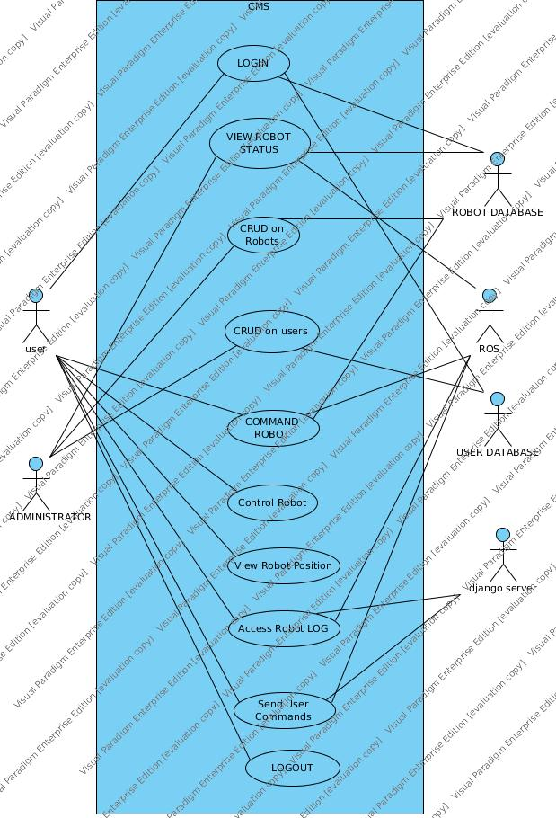
Use case diagram

Use case description

Use Case Number: | UC-01
Use Case Name: | Login
Overview: | User logs into the system to access what he's permitted to.
Actors: | User, Database system
Pre condition: | User knows the userID and password for logging in.
Flow: | Main (success) Flow:  - User inputs userID and password in the required fields.  - The inputs are sent to the User database for validation.  - On successful matching, the user is redirected to his/her home page.
Alternate Flows:
3a. On unsuccessful matching, the user stays at the login page with an error that communicates that the userID or password was incorrect.
Post Condition: | The logged-in user receives only permitted applications to work on.

Use Case Number: | UC-02
Use Case Name: | View Robot Status
Overview: | User can view the status log of a selected robot.
Actors: | User, Robot Database, ROS
Pre condition: | User has permissions to view the status log.
Flow: | Main (success) Flow:  - User selects the robot, he desires to view status of.  - Django server sends the corresponding robotID to ROS.  - ROS returns the status log of the desired robot in a file.  - Django server reads the file and the content is thus displayed.
Alternate Flows:
4a. If the data could not be returned due to technical errors, print error message.
Post Condition: | Status log refers to the selected robot.

Use Case Number: | UC-03
Use Case Name: | CRUD on robots.
Overview: | Administrator can execute CRUD operations on the robots database.
Actors: | Administrator, Robot Database
Pre condition: | The user is logged in as Administrator.
Flow: | Main (success) Flow:  - The administrator selects CRUD on robots option.  - Gets four options, New, Show, Edit, Delete.  - The database is updated and saved.
Alternate Flows:
2a. User selects New
2a1. A form for the database is displayed.
2a2. Admin enters the required details and submits.
2b. User selects Show
2b1. User is displayed the list of all entries in the database.
2b2. Clicks on 'Show' for a record and can view the details.
2c. User selects Edit
2c1. A form for the database is displayed.
2c2. Admin enters details he wants to update and submits.
2d. User selects Delete
2d1. User is displayed the list of all entries in the database.
2d2. Admin clicks on 'Delete' for a record.
2d3. System asks for confirmation.
Post Condition: | The updated data exists in the database.

Use Case Number: | UC-04
Use Case Name: | CRUD on users.
Overview: | Administrator can execute CRUD operations on the users database.
Actors: | Administrator, User Database
Pre condition: | The user is logged in as Administrator.
Flow: | Main (success) Flow:  - The administrator selects CRUD on users option.  - Gets four options, New, Show, Edit, Delete.  - The database is updated and saved.
Alternate Flows:
2a. User selects New
2a1. A form for the database is displayed.
2a2. Admin enters the required details and submits.
2b. User selects Show
2b1. User is displayed the list of all entries in the database.
2b2. Clicks on 'Show' for a record and can view the details.
2c. User selects Edit
2c1. A form for the database is displayed.
2c2. Admin enters details he wants to update and submits.
2d. User selects Delete
2d1. User is displayed the list of all entries in the database.
2d2. Admin clicks on 'Delete' for a record.
2d3. System asks for confirmation.
Post Condition: | The updated data exists in the database.

Use Case Number: | UC-05
Use Case Name: | Command Robot
Overview: | User can command a selected robot by giving it a destination.
Actors: | User, Robot Database, ROS
Pre condition: | User has the permissions to command the robot.
Flow: | Main (success) Flow:  - The user selects the desired robot and its destination.  - Django sends the robotID and the path to be followed using Cartesian coordinates, output by the path-planning algorithm to ROS.  - ROS moves the desired robot to the desired coordinates.
 | Alternate Flows:
Post Condition: | Robot reaches the destination.

Use Case Number: | UC-06
Use Case Name: | Control Robot
Overview: | User can control a selected robot by using direction inputs (keys or buttons).
Actors: | User (Admin, Manager, Employee)
Pre condition: | Valid user must be logged in. A robot must be available for the required job.
Flow: | Main (success) Flow:  1. User gains access to available robot.  2. User uses direction keys/buttons to control robot movement.  3. Robot successfully delivers payload at destination.
Alternate Flows:
2a. If user is not admin and the admin gains control of robot to override commands, the admin becomes the main controller (actor).
Post Condition: | Robot is available after job completion.

Use Case Number: | UC-07
Use Case Name: | View Robot Position
Overview: | User can view the position of robot on a map with its coordinates.
Actors: | User (Admin, Manager, Employee)
Pre condition: | Valid user must be logged in.
Flow: | Main (success) Flow:  1. User chooses status page.  2. User chooses a robot on the map on the aforementioned page.  3. Position of the robot is shown on the screen.
Alternate Flows:
3a. If position is not retrieved, show an error message.
Post Condition: | The robot continues to exist and the page stays the same.

Use Case Number: | UC-08
Use Case Name: | Access Robot Log
Overview: | Django server sends robot ID to the ROS server where the ROS server sends the log for the corresponding robot ID.
Actors: | Django Server, ROS server, User (Admin, Manager, Employee)
Pre condition: | Valid user is logged in. ROS and Django servers are functional.
Flow: | Main (success) Flow:  1. User chooses status tab/page.  2. User chooses a robot on the map of the aforementioned page by clicking on it or selecting it by a dropdown list.  3. Status log of robot is shown on screen.
Alternate Flows:
3a. If log is not retrieved, show an error message
Post Condition: | The robot still exists and the page stays the same.

Use Case Number: | UC-09
Use Case Name: | Send User Commands
Overview: | Django server sends the commands given by the User to the ROS for ROS to process and command robots.
Actors: | Django Server, ROS Server, User(Admin, Manager, Employee)
Pre condition: | Valid user is logged in and both servers are functional.
Flow: | Main (success) Flow:  1. User chooses control page.  2. User selects a robot that is available to perform a job.  3. User controls the robot by direction keys/buttons.  4. Django server sends the commands input by the user to the ROS server which in turn controls the robots.
Alternate Flows:
3a. Same as 2a of UC-06.
Post Condition: | Robot continues to exist and moves to new valid position.

Use Case Number: | UC-10
Use Case Name: | Logout
Overview: | User leaves the web application.
Actors: | User (Admin, Manager, Employee)
Pre condition: | User is logged into web application
Flow: | Main (success) Flow:  1. User clicks logout button.  2. User is logged out of web application.
 | Alternate Flows:
Post Condition: | User is on the initial landing page of the web application.

Use Case Number: | UC-11
Use Case Name: | View Feed
Overview: | User can view the feed from robot's camera
Actors: | User (Admin, Manager, Employee), ROS Server, Django Server
Pre condition: | User is logged into web application and has the permission to view the feed
Flow: | Main (success) Flow:  1. User selects the robot from dropdown menu.  2. User selects the type of feed he desires to view.
Alternate Flows:
2.1. If user selects Live Feed: The page displays the live feed from the camera installed in the robot selected by the user.
2.2. If user selects Depth Feed: The page displays the depth feed from the camera installed in the robot selected by the user.
Post Condition: | The page displays the selected feed continuously, unless the robot or type of field is changed.

