Product Design
Team | 10, Abhineet Jain, Tanmay Sahay, Abhinav Shukla, Kashish Punjani

Architectural Model

Django Server | Component state  - Information related to all users.  Component behavior  - Acts as a conduit for data that pertains to the operations.
ROS Server | Component state  - Information related to all the robots like their position, velocity, job assigned, etc.  Component behavior  - Acts as a master control center for all the robots
Admin Interface | Component state  - Information pertaining to all the users (i.e., employees) and robots at the location where the robots are in use.  Component behavior  - CRUD operations on robots and users
Employee Interface | Component state  - Acts as a renderer for the information pertaining to the robots that are in use  Component behavior  - Viewing the status and getting relevant information pertaining to robots and also controlling/commanding the robots

SEQUENCE DIAGRAM(S)
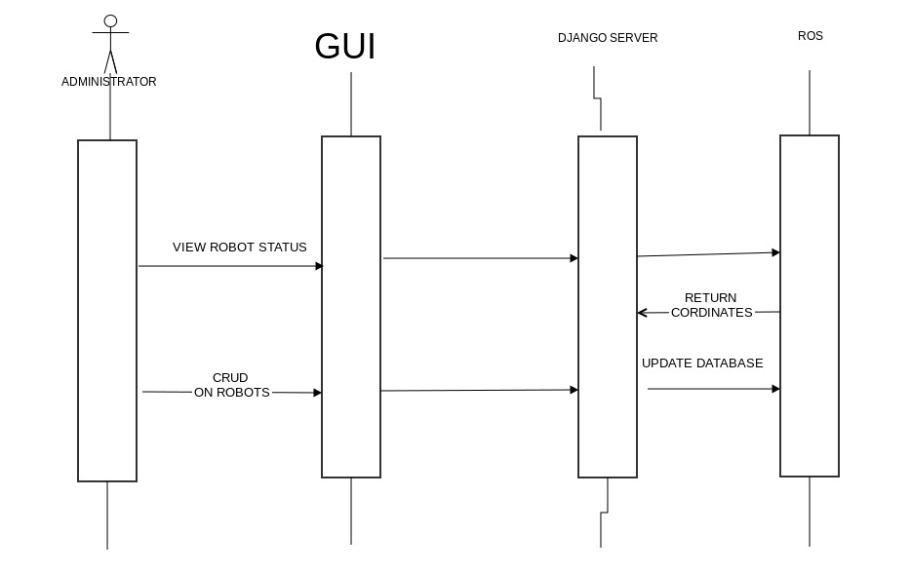

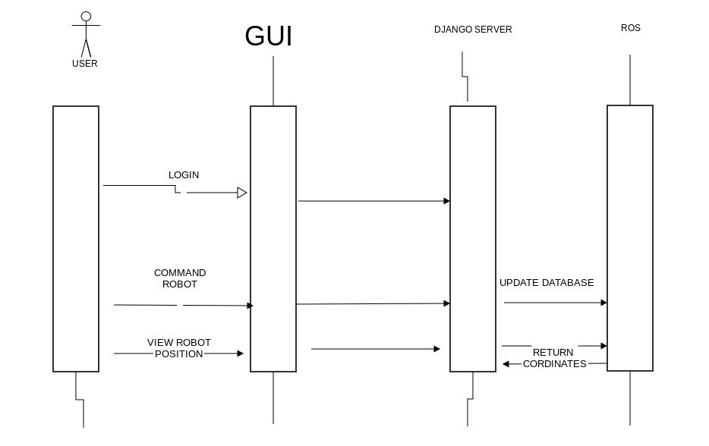

CLASS DIAGRAM

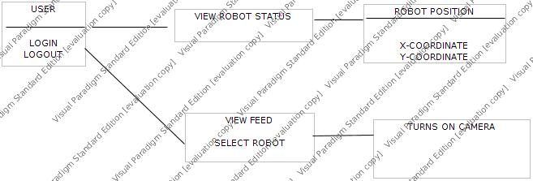

Design Rationale

The problem initially faced by the team was that everybody was new to the technology being used. So measures were taken to break down work for different members of the team so as to give a more productive output where everyone could work on a different module of the final product from the initial stages of development.
- Initially, we had planned two separate servers running for ROS and Django individually, which functioned fine as standalone units, but did not fulfill the purpose of the project because there was no way to facilitate transfer data from one server to another in real-time which was the essence of the product.
- In an attempt to overcome the above stated issue, we tried to parse odometric robot data using ROS libraries and code on the ROS server side, but this led to similar problems as above because this could not be easily incorporated with the front-end and there were difficulties in communicating the other way, i.e., from the front-end to the ROS server via the Django server.
- We thought of using Gazebo, an inbuilt 3D simulator built within ROS Hydro as a visualization tool but decided against it because there was no way to directly redirect its display to the front-end.
- Ultimately, we agreed that the best way to proceed with development was to use the 'rospy' library which provides ROS APIs in Python which can be easily embedded in Django controllers which serves the purpose of two-way communication between the two servers and the front-end in real-time.

