AI-MEDCONNECT: A SMART SOLUTION

B. Tech. PROJECT

Submitted to Rashtrasant Tukdoji Maharaj Nagpur University, Nagpur in Partial Fulfillment of the

Requirements for the Degree of BACHELOR OF TECHNOLOGY in COMPUTER SCIENCE & ENGINEERING.

By

|  |  |
| --- | --- |
| **Aastha R. Dongare** | **(ID-2021016600840746)** |
| **Kashmini A. Meshram** | **(ID-2021016600819665)** |

Guide

# Mrs. Priya S. Mohite

Visiting Faculty



DEPARTMENT OF COMPUTER SCIENCE & ENGINEERING GOVERNMENT COLLEGE OF ENGINEERING NAGPUR 441108

**2024-2025**

AI-MEDCONNECT: A SMART SOLUTION

B. Tech. PROJECT

Submitted to Rashtrasant Tukdoji Maharaj Nagpur University, Nagpur in Partial Fulfillment of the

Requirements for the Degree of BACHELOR OF TECHNOLOGY in COMPUTER SCIENCE & ENGINEERING.

By

|  |  |
| --- | --- |
| **Aastha R. Dongare** | **(ID-2021016600840746)** |
| **Kashmini A. Meshram** | **(ID-2021016600819665)** |

Guide

# Mrs. Priya S. Mohite

Visiting Faculty



DEPARTMENT OF COMPUTER SCIENCE & ENGINEERING GOVERNMENT COLLEGE OF ENGINEERING NAGPUR 441108

## GOVERNMENT COLLEGE OF ENGINEERING NAGPUR 441108 DEPARTMENT OF COMPUTER SCIENCE & ENGINEERING

**CERTIFICATE**



This is to certify that the project/ dissertation entitled, “AI-MEDCONNECT: A SMART SOLUTION”, which is being submitted herewith for the award of B.Tech, is the result of the work completed by (1) Aastha R. Dongare and (2) Kashmini A. Meshram under supervision of Mrs. Priya S. Mohite.

|  |  |  |
| --- | --- | --- |
| (Mrs. Priya S. Mohite) |  |  |
| Guide | Head of Department | Principal |

**DECLARATION**

We hereby declare that the project entitled, “AI-MEDCONNECT: A SMART SOLUTION” was carried out and written by us under the guidance of Mrs. Priya S. Mohite, Professor, Department of Computer Science & Engineering, Govt. College of Engineering, Nagpur. This work has not been previously formed the basis for the award of any degree or diploma or certificate nor has been submitted elsewhere for the award of any degree or diploma.

Date:

Place: Nagpur

|  |
| --- |
| (1) Ms. Aastha R. Dongare University Enrollment Number: 2021016600840946 |
| (2) Ms. Kashmini A. Meshram University Enrollment Number: 2021016600819665 |

## ACKNOWLEDGEMENT

We would like to express my deepest gratitude to all those who have supported and guided me throughout the completion of my computer science project, "AI-MEDCONNECT". First and foremost, we like to thank my project guide, Mrs. Priya S. Mohite, for their invaluable support, constant guidance, and insightful feedback. Their expertise and encouragement have been essential in overcoming challenges and driving the project to completion.

We are grateful to Dr. Latesh G Malik, the Head of the Computer Science Department at Government college of Engineering Nagpur**,** for providing a motivating environment and for their continuous support throughout my academic journey. Their leadership and vision have inspired me to aim higher and improve my work.

We are profoundly thankful to our respected Principal, Dr. R. P. Borkar, for his constant encouragement and for fostering a learning environment that promotes innovation and academic excellence. His support and belief in students’ potential have greatly motivated me throughout this journey.

We would also like to extend my sincere thanks to BABHALE INFOTECH SOLUTIONS, where we had the opportunity to intern. The hands-on experience, professional mentorship, and technical exposure provided by the company significantly contributed to our growth and helped enhance the practical skills necessary for the successful execution of this project.

To all those mentioned above, we offer our heartfelt thanks for making this project possible.

## ABSTRACT

AI-MedConnect is a web-based medical diagnostic platform developed using the MERN stack, integrating artificial intelligence and machine learning to enable early detection of chronic diseases such as Diabetes, Heart disease, and Parkinson’s. Users can input clinical parameters like glucose levels, heart rate, and blood pressure to receive real-time, data-driven predictions. The platform offers an intuitive UI/UX and supports both individuals and healthcare professionals by providing AI-backed insights, enhancing self-monitoring and decision-making. Designed with lightweight architecture, AI-MedConnect is accessible even in rural or underserved areas.

The project follows an Agile Software Development Life Cycle (SDLC) to ensure adaptability and continuous enhancement. Leveraging open medical datasets and robust model evaluation techniques, the platform maintains high prediction accuracy and scalability. Its modular design supports the addition of more diseases and diagnostic models in the future. AI- MedConnect not only promotes early intervention but also aligns with the broader goals of predictive and preventive healthcare, potentially integrating into telehealth systems and advancing digital healthcare transformation.

In conclusion, AI-MedConnect represents a significant step forward in democratizing AI- powered healthcare. By combining open medical datasets with cutting-edge machine learning algorithms, it offers a scalable and impactful solution to one of healthcare’s most pressing challenges, early and accurate disease prediction.

**CONTENTS**

|  |  |  |
| --- | --- | --- |
| **Chapter No.** | **Title** | **Page No.** |
|  | Certificate | i |
|  | Declaration | ii |
|  | Acknowledgement | iii |
|  | Abstract | iv |
|  | List of Figures | viii |
|  | List of Tables | ix |
|  | Nomenclatures | x |
| 1 | Introduction |  |
|  | 1.1 Problem Statement | 1 |
|  | 1.2 Relevance of AI-MedConnect | 1 |
|  | * 1. Objectives      1. Prediction Accuracy      2. Functional Interface      3. Prediction Time      4. Accessible and Preventive Healthcare | 1  2  2  2  2 |
|  | * 1. Scope of Project      1. Multi-Disease Prediction      2. Web-Based Accessibility      3. Scalable Architecture      4. AI-Driven Decision Support | 2  2  2  2  2 |
|  | * 1. Expected Outcome      1. Accurate Disease Prediction using AI Models      2. User-Friendly Diagnostic Platform      3. Accessibility and Affordability in Healthcare      4. Enhanced Decision-Making for Healthcare      5. Awareness and Preventive Health      6. Scalability Across Healthcare System | 3  3  3  3  3  3  3 |
|  | 1.6 Organization of Reports | 4 |
| 2 | Review of Literature | 5 |
|  | 2.1 Outline of Literature Survey | 5 |
|  | 2.2 Reports and Surveys | 5 |
|  | * 1. Overview of Existing Platform’s      1. IBM Watson Health | 6  6 |

|  |  |  |
| --- | --- | --- |
|  | 2.3.2. Ada Health | 7 |
| 2.3.3. WebMD Symptom Checker | 7 |
| 2.3.4. Your.MD (Healthily) | 7 |
|  | 2.3.5. Buoy Health | 7 |
|  | 2.4 Related Work | 8 |
| 2.4.1 AI in Disease Prediction | 8 |
| 2.4.2 Parkinson’s Disease Detection | 8 |
| 2.4.3 AI-Driven Health Monitoring Platforms | 8 |
| 2.4.4 Clinical Decision Support Systems (CDSS) | 9 |
| 2.4.5 Open-Source and Academic Research Models | 9 |
| 2.4.6 Government and Non-Profit Initiatives | 9 |
|  | 2.5 Justification for MEDCONNECT | 10 |
|  | 2.6 Remarks | 12 |
| 3 | Theory-Oriented Chapters |  |
|  | 3.1 Framework | 13 |
| 3.1.1. Requirement Phase | 13 |
| 3.1.2. Design Phase | 13 |
| 3.1.3. Construction/Iterative Phase | 14 |
| 3.1.4. Testing Phase | 15 |
| 3.1.5. Deployment Phase | 15 |
| 3.1.6. Feedback Phase | 16 |
|  | 3.2 Project Overview | 16 |
| 3.2.1. Project flow | 16 |
|  | 3.3 AI-Powered Chatbot Knowledge Base | 17 |
| 3.3.1. Core Features of Chatbot Knowledge Base | 17 |
|  | 3.4 Core Elements | 19 |
| 3.4.1. Disease Prediction Engine | 19 |
| 3.4.2. Symptom-Based Search System | 19 |
| 3.4.3. User Dashboard and Reports | 19 |
|  | 3.5 Hardware Requirement | 19 |
|  | 3.6 Software Requirement | 20 |
|  | 3.7 Evaluation | 21 |
| 4 | System Design And Implementation |  |
|  | 4.1 Frontend and Backend Technologies | 22 |
| 4.1.1. Frontend Development | 22 |
| 4.1.2. Backend Development | 25 |
|  | 4.2 System Interaction | 27 |
| 4.2.1. Flowchart | 27 |
|  | 4.3 Project Walkthrough | 28 |

|  |  |  |
| --- | --- | --- |
|  | 4.4 Financial Summary | 35 |
|  | * 1. Testing      1. Unit Testing      2. Integration Testing      3. Performance Testing | 36  37  37  38 |
|  | 4.5.4. Acceptance Testing | 38 |
| 5 | Results and Discussions |  |
|  | 5.1 Platform Performance | 40 |
|  | 5.2 User Interface and Interaction | 40 |
|  | 5.3 Patient Engagement and Feedback | 41 |
|  | 5.4 AI-Powered Health Prediction | 42 |
|  | 5.5 Service Utilization and Appointment | 42 |
|  | 5.6 Scalability | 43 |
|  | 5.7 Data Handling | 43 |
|  | 5.8 Care Accessibility and Reach | 44 |
|  | 5.9 Health Trends and Analytics | 44 |
|  | 5.10 Scalability and Future Expansion | 45 |
|  | 5.11 Risk Management | 46 |
| 6 | Conclusion |  |
|  | 6.1 Summary | 47 |
|  | 6.2 Conclusion | 48 |
|  | 6.3 Future Research and Development Directions | 49 |
|  | References | 54 |

**LIST OF FIGURES**

|  |  |  |
| --- | --- | --- |
| **Figure**  **No.** | **Title** | **Page**  **No.** |
| 4.1. | Flow chart | 27 |
| 4.2. | Landing Page | 28 |
| 4.2.1 | Home Page | 28 |
| 4.3. | Sign Up Page | 30 |
| 4.4. | Login Page | 30 |
| 4.5. | Health Predict Page | 31 |
| 4.6. | Health Testing Page | 32 |
| 4.7. | Doctor Page | 32 |
| 4.8. | Requesting Page | 33 |
| 4.9. | Services Page | 34 |
| 4.10. | Feedback Page | 35 |

**LIST OF TABLES**

|  |  |  |
| --- | --- | --- |
| **Figure**  **No.** | **Title** | **Page**  **No.** |
| 3.1. | Hardware Requirements – Web Server | 19 |
| 3.2. | Software Requirements | 20 |
| 3.3. | List of packages used during development. | 20 |
| 4.1. | Test cases for Unit Testing | 37 |
| 4.2. | Test cases for Integrate Testing | 37 |
| 4.3. | Test cases for Performance Testing | 38 |
| 4.4. | Test cases for Acceptance Testing | 39 |

## NOMENCLATURES

* **MERN Stack** – MongoDB, Express.js, React.js, Node.js
  + Full-stack JavaScript framework for building dynamic web apps.
* **JWT** – JSON Web Token
  + Used for securely transmitting user authentication data.
* **API** – Application Programming Interface
  + Interface that allows communication between software components.
* **SPA** – Single Page Application
  + Web application that loads a single HTML page and dynamically updates it.
* **NLP** – Natural Language Processing
  + AI technology for understanding and processing human language.
* **ML** – Machine Learning
  + Enables systems to learn from data and improve predictions.
* **SVM** – Support Vector Machine
  + Classification algorithm for health prediction.
* **k-NN** – k-Nearest Neighbors
  + Classifier that predicts based on similarity to nearest neighbors.
* **RF** – Random Forest
  + Ensemble learning method for accurate disease prediction.
* **DT** – Decision Tree
  + Tree-like model used to make decisions and predictions.
* **LR** – Logistic Regression
  + Used for binary classification, such as disease presence or absence.
* **NB** – Naive Bayes
  + Probabilistic classifier based on Bayes’ theorem, used in diabetes prediction
* **BP** – Blood Pressure
  + A vital clinical parameter used for prediction.
* **EHR** – Electronic Health Record
  + Digitally stored patient medical records.

# CHAPTER 1 INTRODUCTION

## Problem Statement

In many parts of the world, timely and accurate medical diagnosis remains a significant challenge due to limited access to healthcare professionals, diagnostic facilities, and resources. Traditional diagnostic processes can be time-consuming, expensive, and heavily reliant on specialist interpretation, often leading to delayed treatment and poor patient outcomes, especially in rural or under-resourced areas. The core challenge is to build a system that not only makes healthcare more accessible and efficient but also empowers users to take proactive steps in monitoring their health through AI-driven tools.

There is a growing need for an intelligent, accessible and efficient system that can assist in early disease detection and support healthcare decision-making. The challenge lies in designing a scalable, user-friendly platform that can utilize artificial intelligence and machine learning to analyze medical data and provide accurate, real-time predictions for common and critical health conditions such as diabetes, heart disease, and Parkinson’s disease.

### Relevance Of AI-Medconnect

AI-MedConnect is highly relevant in today’s healthcare landscape, where there is a growing demand for intelligent, accessible, and efficient diagnostic solutions. AI- MedConnect addresses the gap by leveraging machine learning to provide fast and accurate disease predictions based on clinical parameters. By automating the initial diagnostic process, the platform reduces dependency on medical professionals for preliminary assessments, which can significantly improve healthcare delivery in under-resourced settings. The relevance of the project lies not only in its technological innovation but also in its potential societal impact, empowering individuals to monitor their health and seek early treatment, ultimately reducing the burden on healthcare systems and improving patient outcomes.

## Objectives

Objectives of AI-MedConnect are as follows:

### Prediction Accuracy

Achieve at least 90% prediction accuracy for disease detection using validated machine learning models tested on standard clinical datasets.

### Functional Interface

Implement a fully functional MERN-based interface with at least 3 disease modules and 100% successful integration of frontend and backend APIs.

### Prediction Time

Reduce Prediction time to under 5 seconds per diagnosis request by optimizing the model response and backend processing to ensure real-time user experience.

### Accessible and Preventive Healthcare

Creating a platform that can be expanded to include more diseases and integrated with EHR for broader use in digital health systems.

## Scope Of Project

The Scope of AI-MedConnect outlines the specific areas it will cover and the deliverables it aims to provide which includes:

### Multi-Disease Prediction

The system is designed to support the prediction of multiple diseases, with the flexibility to add more diagnostic modules in the future.

### Web-Based Accessibility

The platform is accessible via any modern web browser, allowing users including patients and healthcare professionals to interact with the system remotely from any location.

### Scalable Architecture

The project is scalable and can integrate additional features such as user authentication, electronic health records (EHR), and advanced AI models.

### AI-Driven Decision Support

The platform supports real-time diagnostic assistance using machine learning, helping in early disease detection and enhancing decision-making for healthcare interventions.

## Expected Outcome

The AI MedConnect project aims to develop an AI-powered web-based platform that predicts critical diseases based on clinical data inputs. It seeks to assist both individuals and healthcare professionals in making informed, data-driven medical decisions through accurate and early diagnostics. Key expected outcomes include:

### Accurate Disease Prediction using AI Models

The project will provide reliable, data-driven predictions for diseases such as diabetes, heart disease, and Parkinson’s using machine learning algorithms trained on real medical datasets. It will enhance early diagnosis and timely medical intervention.

### User-Friendly Diagnostic Platform

A responsive and interactive MERN stack-based web application will be deployed, enabling users to input real health parameters (like glucose level, blood pressure, heart rate, etc.) and receive immediate diagnostic feedback.

### Accessibility and Affordability in Healthcare

AI-MedConnect is expected to bridge the healthcare access gap in remote and underserved areas by offering a free or low-cost AI diagnostic tool that can be accessed through any web browser.

### Enhanced Decision-Making for Healthcare Providers

The platform will assist doctors and medical practitioners by offering a secondary diagnostic opinion powered by AI, thus supporting clinical decision-making and improving patient outcomes.

### Awareness and Preventive Health

By empowering users to understand potential health risks based on measurable data, the platform promotes preventive healthcare and personal health tracking, reducing long-term medical costs.

**Scalability Across Healthcare Systems**

Designed for flexibility, the platform can be easily integrated into various healthcare environments—from small clinics to large hospital networks ensuring consistent service quality and adaptability to diverse operational needs.

**Organization Of Reports**

Organization report aims to give a thorough overview of the AI-MedConnect project. It covers the theoretical principles behind the project, its system design and architecture, the implementation approach, project management strategies, anticipated results, and potential future research paths.

Chapter 1 offers a comprehensive introduction to the project, outlining the problem statement, the scope of AI-MedConnect, initial objectives, and relevance of project.

Chapter 2 is about the literature survey highlighting the growing need for intelligent and accessible healthcare solutions amid an increasing prevalence of chronic diseases and disparities in medical service availability. It identifies gaps in existing diagnostic platforms, such as limited accuracy, lack of real-time analysis and inadequate personalization. The survey emphasizes the importance of AI-powered support systems that can analyze individual health parameters and provide early, reliable predictions.

Chapter 3 outlines the methodology for developing the project, hardware and system requirements. It also introduces the flow of model and complete evaluation of project.

Chapter 4 looks at the project from the user’s perspective, providing an in-depth discussion of the user interface and the features and functions available to users.

Chapter 5 highlights the outcomes and deliverables of the project.

Chapter 6 assesses the project’s objectives, analyzes the project AI-MedConnect’s strengths and weaknesses, and suggests directions for future research and development

# CHAPTER 2 REVIEW OF LITERATURE

## Outline Of Literature Survey

The integration of artificial intelligence in the healthcare sector has gained significant momentum in recent years, driven by the need for faster, more accurate, and accessible diagnostic systems. Numerous studies highlight the potential of machine learning algorithms in predicting diseases such as diabetes, cardiovascular conditions, and neurological disorders. These technologies can analyze large volumes of medical data to identify patterns and provide early warnings, contributing to preventive healthcare. However, despite these advancements, many existing AI-driven systems remain confined to research labs or high-end clinical setups, limiting their reach and impact.

Current diagnostic tools often suffer from limitations such as lack of personalization, static interfaces, poor scalability, and a dependency on trained professionals for operation. Furthermore, most platforms are not designed to be user-centric, making them inaccessible to the general population, especially those in remote or low-resource areas. The literature reveals a clear gap between the availability of intelligent health solutions and their usability in real- world, everyday healthcare scenarios.

To address these challenges, platforms like AI-MedConnect are emerging as practical solutions that combine the power of artificial intelligence with modern web technologies. The literature supports the development of systems that offer real-time predictions, are easy to use, and provide personalized diagnostic feedback. AI-MedConnect aims to fill the gap by delivering an accessible, scalable, and intelligent diagnostic tool that empowers individuals and supports medical professionals in making informed, data-driven decisions.

## Reports And Surveys

According to the Survey on AI Adoption in European Laboratories, a comprehensive assessment of laboratory professionals highlighted the growing integration of Artificial Intelligence in diagnostic practices.[1] The report found that over 60% of laboratories across Europe are actively exploring or already using AI-powered tools for pathology, hematology, and disease prediction. The findings underscore the readiness of digital infrastructure and growing trust among medical professionals in AI's ability to improve diagnostic accuracy, reduce human error, and support clinical decision-making processes. In India, a 2021 NASSCOM report on AI in Healthcare revealed that over 75% of hospitals and diagnostic labs are looking to adopt AI-based solutions within the next 3–5 years.[2] The report also cited key barriers such as limited digital transformation, lack of skilled AI professionals, and affordability of intelligent systems for small- to mid-level medical institutions. Presents a strong case for affordable, lightweight AI solutions like AI-MedConnect, which can provide accessible disease prediction without high operational costs.

Additionally, a survey by the All India Institute of Medical Sciences (AIIMS) on patient diagnosis timelines showed that early detection and intervention reduce hospitalization costs by 30–40% and significantly improve patient survival rates.[3] However, the report also pointed to a gap in primary health screening tools, especially in rural and semi-urban areas.

Highlights the urgent need for community-accessible digital tools like AI-MedConnect that empower users with self-assessment based on clinical data, enabling timely healthcare decisions. Lastly, the World Health Organization (WHO) AI for Health Focus Group Report emphasized the role of AI in enhancing global health equity.[4] It advocated for scalable, open- source, and context-aware solutions that can be deployed in resource-constrained regions. AI- MedConnect aligns with the vision by offering multi-disease prediction capabilities through an intuitive interface that bridges both accessibility and scalability.

## Overview Of Existing Platform’s

The following section provides an overview of existing healthcare platforms leverage AI to aid in disease diagnosis and symptom assessment, highlighting their features, limitations, and relevance to AI-MedConnect’s development.

### IBM Watson Health

A pioneer in applying AI for clinical decision support, Watson Health uses natural language processing and big data analytics to assist in complex diagnoses and treatment recommendations, especially in oncology. It is known for its robust AI capabilities, including natural language processing and medical image analysis. However, it is primarily enterprise-focused and caters to hospitals and research institutions. It lacks direct accessibility for everyday users and does not offer instant, personalized diagnostic feedback based on user-specific medical data. While Watson is enterprise- focused and not publicly accessible for everyday users, AI-MedConnect provides a more accessible, user-friendly solution for individual disease prediction.

### Ada Health

A symptom checker app using AI to provide possible conditions based on user responses. It acts as a conversational diagnostic tool for general users. Ada focuses on symptom-based inputs through dialogue, whereas AI-MedConnect uses clinical parameters like blood pressure, glucose levels, and heart rate for more accurate, model- driven predictions.

### WebMD Symptom Checker

A widely used platform offering symptom checkers and general health content. It helps users understand potential causes of their symptoms. It is widely known but is largely static in nature, providing generalized information without real-time prediction or personalization. WebMD is rule-based and not AI-driven, offering static responses. It does not integrate AI models trained on real datasets for disease forecasting.

### Your.MD (Healthily)

A digital health assistant offering personalized health advice based on symptom input. It provides health education and recommendations but lacks predictive analytics. It focuses on health tracking and lifestyle advice but are less focused on clinical disease detection. AI-MedConnect fills the gap by offering real-time, AI-powered diagnostics for specific illnesses like diabetes, heart disease, and Parkinson’s, which are often missed in general health apps.

### Buoy Health

Buoy Health offers AI-driven health navigation by asking users questions and providing recommendations on next steps, like whether to visit a doctor or take

rest. Buoy is more general-purpose and focused on health navigation, while AI-MedConnect provides disease-specific predictions using machine learning models.

## Related Work

### AI in Disease Prediction

* + - * **Heart Disease Prediction using ML:** Research by Detrano et al. using the UCI Cleveland dataset applied various ML algorithms like Decision Trees, Random Forest, and Logistic Regression to predict heart disease.[5] The study demonstrated that data-driven models can outperform traditional clinical assessments in early diagnosis accuracy.
      * **Diabetes Prediction using PIMA Dataset:** Several studies have used the PIMA Indian dataset to build predictive models with high accuracy. Algorithms like Naive Bayes and SVM have been applied to determine diabetes likelihood, providing a foundational benchmark for AI-MedConnect's model selection and training process.[6]

### Parkinson’s Disease Detection

* + - * **Voice-Based Detection Models:** Studies have shown that using voice parameters such as jitter, shimmer, and pitch, AI models can detect early-stage Parkinson’s disease with high accuracy.[7] These techniques demonstrate how non-invasive diagnostics can supplement clinical data, a concept that AI-MedConnect may expand upon.
      * **UCI Parkinson’s Dataset Research:** Researchers have used datasets from UCI ML Repository to train models like SVM, k-NN, and Logistic Regression to detect Parkinson’s symptoms.[8] These works validate the feasibility of ML-based diagnostic tools similar to those employed in AI-MedConnect.

### AI-Driven Health Monitoring Platforms

* + - * **Ada Health and Buoy Health:** These are symptom checker platforms that use AI to provide health advice based on user input.[11] While they offer broad accessibility, their diagnosis is limited to symptom input and

not based on quantifiable health data like glucose or BP levels, which AI-MedConnect incorporates for higher diagnostic accuracy.[12]

* + - * **Your.MD and Babylon Health**: These platforms include AI chatbots and consultation tools, but often rely on pre-set symptom trees. AI-MedConnect differs by employing trained ML models using actual patient datasets for real-time prediction.[13]

### Clinical Decision Support Systems (CDSS)

* + - * **IBM Watson for Oncology**: Watson uses NLP and AI to assist clinicians by recommending cancer treatment plans based on patient history. While powerful, it is resource-intensive and not designed for direct public use. AI-MedConnect, in contrast, is built as a lightweight tool for general users and primary care professionals.[14]
      * **Phillips IntelliSpace AI Workflow Suite**: Offers an integrated platform for radiology diagnosis using AI, aiding in workflow optimization and diagnostics. However, it is specialized and hospital-centric, unlike AI-MedConnects’s multi disease prediction capabilities for widespread public access.[15]

### Open-Source and Academic Research Models

* + - * **Research on ML in Laboratory Diagnosis**: Publications in journals like Springer Healthcare and Elsevier highlight the use of Random Forest and Neural Networks in improving lab test analysis accuracy. These studies support AI-MedConnect’s approach of building a virtual lab assistant that processes health metrics for disease prediction.[9]
      * **AACC Reports on AI in Labs**: Reports by the Association for Diagnostics & Laboratory Medicine discuss AI’s role in reducing lab processing times and error rates. These insights underline AI-MedConnect’s value in speeding up initial diagnostics outside of traditional labs.[10]

### Government and Institutional AI Initiatives

* + - * **National Digital Health Mission (NDHM)**

India’s NDHM promotes health record digitization and integration with AI for predictive diagnostics. AI-MedConnect aligns with the vision by creating a digital tool for predictive healthcare.[17]

### AI for Health by WHO & ITU

The World Health Organization supports AI models that can assist in disease detection, especially in low-resource areas. AI-MedConnect contributes to the global goal with a web-based solution requiring minimal infrastructure.[16]

### Tata Medical AI Collaborations

Tata Trusts have partnered with healthcare startups to deploy AI diagnostics in rural areas. These efforts parallel AI-MedConnect’s mission to bring accessible diagnostic tools to underserved populations.[18]

### National Telemedicine Service of India

Sanjeevani is a flagship telemedicine initiative by the Ministry of Health and Family Welfare, Government of India. It enables doctor-to-patient and doctor-to- doctor consultations remotely via digital platforms, particularly benefiting rural and underserved populations.[19]

## Justification For Ai Medconnect

By assisting healthcare professionals in early risk assessment and prioritizing critical cases, AI-MedConnect reduces diagnostic delays and contributes to improving public health outcomes. It offers a cost-effective, user-friendly platform that supports timely diagnosis, especially for underserved populations.

### Rising Demand for Early Disease Prediction

Non-communicable diseases such as diabetes, heart disease, and neurological disorders like Parkinson’s are on a rapid rise globally. Most of these conditions are manageable or even preventable with timely intervention. AI-MedConnect leverages machine learning algorithms to predict such diseases based on clinical parameters, enabling early diagnosis. The predictive approach can significantly reduce healthcare burdens by prompting preventive care, lowering hospitalization rates, and improving long-term patient outcomes.

### Bridging gaps in Accessibility and Affordability

Access to quality healthcare remains a challenge, especially in rural and economically weaker sections. Traditional diagnostic tests are often costly, time-consuming, and require physical presence at medical facilities. AI-MedConnect offers a web-based, cost-effective solution that allows users to input routine clinical data and receive risk assessments instantly. It enhances accessibility and empowers individuals to take proactive steps toward their health without geographical or financial constraints.

### Support for Overburdened Healthcare Systems

Healthcare professionals often face overwhelming patient loads, especially in populous countries. AI-MedConnect acts as a preliminary diagnostic tool, helping filter high-risk patients who need immediate attention. By providing data-driven insights, it allows doctors to prioritize cases effectively, thereby improving patient triage, resource management, and reducing diagnostic errors. The system streamlines the initial assessment process by analyzing symptoms, medical history, and vital signs, enabling quicker decision-making in both outpatient and emergency settings.

### Advancing AI Integration in Healthcare

AI-MedConnect contributes to the larger vision of integrating Artificial Intelligence into mainstream healthcare systems. The platform demonstrates how AI can move beyond theoretical applications to deliver real-world, measurable impact in diagnostics. It supports research in healthcare analytics, fosters innovation in digital health solutions, and paves the way for future AI-driven medical tools with broader disease coverage and more complex diagnostic capabilities.

1. **Healthcare Workforce Shortages**

With increasing patient volumes and a shortage of healthcare professionals in many regions, there is a critical need for intelligent systems that can assist in routine diagnostics and triage. AI-MedConnect helps alleviate this pressure by automating preliminary assessments, enabling clinicians to focus on complex cases and improving overall care delivery efficiency.

### Remarks

The literature survey reveals a significant and growing interest in applying Artificial Intelligence to healthcare, particularly in early disease prediction and diagnostic support. Existing systems and studies have demonstrated the potential of AI in predicting chronic diseases using clinical and biometric data. However, many platforms either focus on a single disease or lack integrated support for multiple conditions within one framework. Additionally, while some commercial platforms like Ada and Buoy offer symptom checkers, they often operate as black boxes with limited transparency and personalization. Research models, though innovative, are often confined to academic settings and not translated into accessible tools for the general population. Moreover, current government initiatives largely focus on telemedicine or awareness, with limited AI-backed diagnostic functionality. AI-MedConnect fills these gaps by combining machine learning-based disease prediction models into one accessible, web- based system. It aims to bridge the divide between academic innovation and real-world application, offering personalized, multi-disease predictions with immediate usability. The project not only supports preventive care but also demonstrates a scalable approach to integrating AI in public health infrastructure.

# CHAPTER 3

**THEORY-ORIENTED CHAPTERS**

## FRAMEWORK

The Agile Software Development Life Cycle (SDLC) provides an adaptable and iterative framework for developing our healthcare website. The project aims to support users in making informed healthcare choices by offering services such as multi disease prediction, prediction time and preventive healthcare options and feedback and review system. The Agile model, with its flexibility and focus on continuous improvement, is ideal for the project due to the evolving nature of user needs and the demand for ongoing enhancements.

In using the Agile model, the project is divided into iterative cycles or "sprints," with each sprint focusing on developing and delivering a set of features or improvements. Such approach allows our team to respond quickly to user feedback and adapt the project to meet dynamic requirements. Agile ensures that each phase - planning, design, development, testing, deployment, and feedback, is continually revisited and refined, promoting high-quality deliverables.

### Requirement Phase

* Identified key healthcare challenges: early disease prediction, self-assessment, and accessibility.
* Prioritized diseases like Heart, Diabetes, Parkinson’s, and Breast Cancer based on impact and data availability.
* Engaged with medical professionals and users to gather domain-specific needs.
* Defined functional and non-functional requirements (accuracy, responsiveness, user- friendliness).

### Design phase

* In the design phase of the Agile Software Development Life Cycle (SDLC), Created system architecture involving modules like input validation, model prediction, and report generation.
* Designed the UI/UX with a patient-friendly, responsive interface.
* Mapped workflows for each disease prediction based on data input → processing output.
* Chose appropriate ML models (e.g., SVM, Random Forest, Logistic Regression) for each condition.
* Planned APIs for model integration and future expansion.
* To secure user authentication, we design a robust registration and login flow using JWT, integrating bcrypt for password protection, ensuring data privacy and secure access control.
* Ensured scalability and modularity in design for easy addition of new diseases or features.
* The feedback system is integrated seamlessly within the UI, enabling users to provide input on various modules.
* Regular design sprints ensure the iterative refinement of these components, accommodating feedback and aligning with Agile principles.

### Construction/iterative phase

* In the construction phase of our healthcare website, we developed each module using the MERN stack (MongoDB, Express, React, Node.js).
* At the frontend, we created a responsive, user-friendly interface with React, enabling smooth navigation between different modules.
* Implemented the front-end using HTML, CSS, JS, and React for smooth user experience. For the backend, we set up a secure server with Node.js and Express, building APIs to manage data requests and user authentication.
* We implemented secure authentication with JWT, allowing personalized access based on user roles.
* Trained and tested ML models using curated public datasets (e.g., UCI repository). Integrated trained models with the back-end using Flask and REST APIs.
* Ensured real-time prediction with minimal latency.
* MongoDB served as our main database, where we stored user data, doctor’s data, medical input records, model performance logs, admin & analytics dashboard data and feedback to ensure quick data retrieval and scalability.
* Throughout the phase, we adhered to Agile practices, releasing updates in iterative sprints, testing features, and refining the UI/UX to provide users with a seamless experience.

### Testing phase

* In the testing phase of our healthcare guidance website, we conducted rigorous evaluations to ensure that each module functioned seamlessly and met user requirements.
* We performed unit testing for individual components and model logic.
* Integration testing was carried out to verify that these components worked together smoothly, ensuring data flowed accurately between the frontend and backend.
* For user authentication, we tested various login scenarios and validated secure access with JWT.
* Validation testing of ML predictions with sample inputs.
* Usability testing to ensure the UI is understandable by non-technical users.
* Performance testing to check model response time under various loads.
* Following Agile practices, testing was iterative, allowing us to promptly address any issues, optimize performance, and ensure a stable, high-quality release.

### Deployment phase

* In the deployment phase of our healthcare guidance website, we focused on ensuring a seamless, reliable launch by leveraging Vercel for the frontend and Render for the backend.
* The frontend, built with React, was deployed on Vercel to take advantage of its automatic scaling, fast build times, and easy integration with our Git repository, allowing for efficient and smooth updates as needed.
* For the backend, we deployed our Node.js and Express server on Render, chosen for its stability, simple deployment workflows, and compatibility with our MongoDB database.
* Render’s automated infrastructure management and scalable resources allowed our backend to handle API requests efficiently, ensuring reliable data handling.
* Configured backend endpoints for secure and fast access to predictions.
* Monitored logs and system performance post-deployment.

### Feedback phase

* In the feedback phase of our project, we gathered input from a diverse group of users, including patients, doctors, and heathcare advisors, to assess the platform's functionality, usability, and overall effectiveness.
* We conducted surveys and usability tests to identify areas needing improvement, such as navigation flow, response time, and content clarity.
* User feedback highlighted valuable insights to improve UX and prediction explanations. Fixed bugs and introduced small updates regularly.
* Based on the feedback, we implemented enhancements to improve user experience, align features more closely with user needs, and ensure that the platform provides relevant, accessible, and engaging guidance.

## Project Overview

AI-MedConnect is an AI-powered web application designed to assist users with early detection of critical health conditions such as diabetes, heart disease, breast cancer, and Parkinson’s. The platform empowers individuals to perform self-health assessments using predictive machine learning models. It bridges the gap between limited access to diagnostic tools and the growing need for timely medical intervention. Each predictive module is trained on medically verified datasets and integrated via a robust backend API. AI-MedConnect includes features for health awareness, interactive feedback, and real-time report generation. The project adopts an Agile SDLC approach to continuously improve and expand its functionalities.

### Project flow

* **Start:**

The process begins when a user initiates interaction with the system. Opens AI-MedConnect via browser or mobile device.

### User Registration and Authentication:

Users start by creating an account, logging in securely with JWT-based authentication, ensuring personalized and safe access.

### Access Modules:

Users navigate to disease – specific prediction module.

### Data Input:

User enters personal and health – related parameters and then input is validated.

### Backend Processing:

The data sent to Flask-based backend API and input is fed to corresponding ML model.

### Prediction & Analysis:

Students can filter and explore streams using advanced search features by selecting a proper filter amongst provided streams.

### Result Display:

Result is shown to user with visualization and tips. There is option to download report or take another test.

### Data Storage:

User results stored in secure backend database. Data used for analytics, trends and performance tuning.

### Feedback & Maintenance

Users provide feedback on accuracy/usability. Admin reviews performance logs and updates models periodically.

## AI-Powered Chatbot Knowledge Base

AI-MedConnect integrates an intelligent chatbot with a dynamic Knowledge Base, designed to assist users throughout their diagnostic and prediction journey. The chatbot is embedded with domain-specific medical knowledge, functional walkthroughs, and assistance features to offer real-time, user-friendly.

### Core Features of the Chatbot Knowledge Base

Some of the core features which played an important role in enhancing the knowledge base are as follows:

### Medical Support and Platform Assistance

The chatbot is equipped to provide real-time assistance on key platform modules, including:

* + - * + **Symptom based Inquiry Assistance**: Helps users input symptoms in the right format, understand basic health-related keywords, and interpret general health- related advice.
        + **Lab Test Guidance**: Offers insights on which tests may be suggested based on symptoms or disease categories.
        + **Prediction Result Explanation**: Breaks down medical predictions in simple terms, giving users a better understanding of outputs from ML models.
        + **Follow-up Advice**: Provides lifestyle or next-step suggestions (e.g., consult a physician, book further diagnostics).

### Frequently asked questions (FAQs)

The chatbot draws from a curated repository of commonly asked queries, including:

* + - * + **Using the Disease Prediction Tool**: What inputs are needed? What does the output mean?
        + **Data Privacy and Security**: How user data is handled securely.
        + **Account Management**: Creating, modifying or deleting an account.
        + **Symptom Checker Use**: Clarifying symptom entry, search queries, and analysis logic.
        + **Report Downloads and Storage**: How to download and view test results or recommendations.

### Step-by-Step Diagnostic Journey

The AI chatbot walks users through critical steps for utilizing the platform effectively:

* + - * + **Symptom Entry and Test Selection**: Guides users through input fields, dropdowns, or NLP-based symptom typing.
        + **Disease Prediction Flow**: Explains how to move from symptom input to receiving a prediction.
        + **Understanding Model Accuracy:** Offers context about the confidence percentage and model reliability.
        + **Real-time Troubleshooting**: Helps resolve errors, loading issues, or unclear feedback instantly.
        + **Feedback Collection**: Gathers user feedback on predictions or chatbot help to refine future iterations.

## Core Elements

### Disease Prediction Engine

* **Machine Learning Models Integration**: Utilizes trained ML algorithms (like Random Forest, Decision Tree, etc.) to predict potential diseases based on user-provided symptoms.
* **Accuracy & Probability Output**: Displays prediction results along with probability scores, giving users insight into prediction confidence and accuracy.

### Symptom-Based Search System

* **Natural Language Input**: Allows users to enter symptoms in everyday language, enabling a user-friendly experience without needing medical jargon.
* **Dynamic Symptom Mapping:** Maps input to structured disease data, enhancing relevance and correctness of diagnostic suggestions.

### User Dashboard and Reports

* **Personalized Result Storage**: Users can view and download diagnostic reports, including symptom history, predicted diseases, and suggested actions.
* **Privacy and Security Controls**: Ensures secure data handling and storage with access-controlled medical logs for each user session.

## Hardware Requirements

The project necessitates a robust computer system with ample processing power to handle compilation and CI/CD tasks concurrently while efficiently managing multiple threads to service requests.

**Table 3.1 Hardware Requirements – Web Server**

|  |  |  |  |
| --- | --- | --- | --- |
| **Sr. No.** | **Item** | **Specifications** | **Quantity** |
| 1. | Computer System | Intel(R) Core [TM] i5- or higher  Minimum 4 GB (8 GB recommended)  At least 20 GB of free disk space | 1 |

## SOFTWARE REQUIREMENTS

For the project, the web server demands a sophisticated tech-stack, adept at handling modern web development challenges. It encompasses versatile frameworks like the MERN stack, scalable database solutions, and efficient deployment strategies to meet the project's performance and scalability objectives seamlessly.

### Table 3.2 Software Requirements

|  |  |
| --- | --- |
| **Sr. No.** | **Item** |
| 1. | Operating System – Windows |
| 2. | MongoDB ATLAS |
| 3. | Express.js |
| 4. | React.js |
| 5. | Node.js |
| 6. | JavaScript |
| 7. | Git and GitHub |
| 8. | Visual Studio code |
| 9. | Python |

AI-MedConnect is built using state-of-the-art libraries and packages, including software. AI- MedConnect can be developed sufficiently well on a modern computer. A list of software used during development is given below.

**Table 3.3 List of packages used during development.**

|  |  |
| --- | --- |
| **Sr. No.** | **Item** |
| 1. | npm |
| 2. | JSX |
| 3. | CORS (middleware) |
| 4. | Mongoose |
| 5. | Axios |
| 6. | Redux Toolkit |
| 7. | React Router DOM |
| 8. | React-Redux |
| 9. | Bcrypt |
| 10. | JSON Web Token (JWT) |
| 11. | Joi version |
| 12. | Nodemon |
| 13. | Dotenv |
| 14. | react-bootstrap |
| 15. | Tailwindcss |
| 16. | @mui/icons-material |
| 17. | Dialogflow |
| 18. | Pandas |
| 19. | Numpy |
| 20. | Flask/fastapi |
| 21. | Scikit-learn |

## Evaluation

The evaluation of the AI-MedConnect focuses on its functionality, user experience, and technical performance to ensure the system meets its goal of enhancing medical diagnostic support using AI. Functionality s evaluated by verifying that all major features - including user registration, symptom-based disease prediction, chatbot assistance, and health report generation - function seamlessly and accurately. The AI model’s ability to provide correct predictions based on input symptoms and the chatbot’s integration with a comprehensive knowledge base are crucial components of the assessment.

In terms of user experience, the platform’s interface must be user-friendly, visually clean, and easily navigable for patients and healthcare professionals alike. Users should be able to input symptoms, view diagnosis results, and interact with the chatbot smoothly. The chatbot’s response accuracy and ability to guide users through medical resources play a central role in ensuring user satisfaction.

Technical performance is assessed by measuring the platform’s responsiveness, prediction speed, and system stability under various user loads. Key performance indicators include AI model response time, web page loading speed, and system uptime, all contributing to a reliable diagnostic experience.

In addition, user feedback is collected on the accuracy of predictions, clarity of results, and chatbot usability. The feedback loop supports continuous refinement of the system, ensuring that AI-MedConnect evolves as a robust, patient-centric healthcare tool.

## Frontend And Backend Technologies

The AI-MedConnect Healthcare Diagnostic Web Application is designed to assist users both patients and healthcare professionals in exploring preliminary medical conditions and health information through an interactive, AI-powered platform. Developed using the MERN stack (MongoDB, Express, React, Node.js), the application combines a responsive frontend and a secure backend to deliver key features such as symptom-based disease prediction, interactive health chatbot assistance, personalized health report generation, and searchable medical databases.

Technologies section outlines the technologies and frameworks employed in building AI- MedConnect, including Frontend Development using React to provide a dynamic, intuitive user interface, and Backend Development using Node.js, Express, and MongoDB to manage real-time data, ensure efficient API operations, and secure authentication processes. The integration of machine learning models into the backend further empowers the platform to offer accurate and real-time health insights based on user inputs.

### Frontend development

### React

* **Component Reusability:** React’s component-based architecture allows the user interface to be broken down into reusable, self-contained components. React makes it easier to manage and scale the application as new features are added. Each part of the UI, such as buttons, search filters, or interactive elements, is created as a separate component, promoting code reusability and modularity.

### State and Props: React's state management allows for dynamic updates in response to user interactions, while props enable data flow between components, ensuring that different sections of the application can communicate and update accordingly.

### Tailwind CSS

### Utility-First CSS Framework: Tailwind CSS allows developers to apply predefined utility classes directly to the HTML structure. CSS utility-first approach reduces the need for writing custom CSS, making the design process faster and more efficient. It also allows for rapid prototyping and fine-grained control over the layout and styling.

* **Responsive Design:** Tailwind CSS includes responsive design utilities, which ensure that the application is accessible and functional across various screen sizes. Breakpoints and flexible grid systems ensure a seamless experience on desktop, tablet, and mobile devices.
* **Customization and Flexibility:** Tailwind allows for extensive customization of design elements, including colours, spacing, typography, and breakpoints, via its configuration file. The flexibility makes it easy to tailor the design to meet specific needs without starting from scratch.
  + - 1. **Routing with React Router**
* **Single Page Application (SPA):** React Router is used to handle navigation within the application, enabling a single-page application (SPA) experience. Users can navigate between different sections without full-page reloads, providing a smooth and seamless browsing experience.
* **Dynamic Routing:** React Router’s dynamic routes allow the application to display content dynamically based on user input or URL parameters, ensuring a fluid user experience with minimal latency.
  + - 1. **State Management**
* **Read Context API:** For managing global application state, the React Context API is used, allowing different components to share data like user preferences or authentication status without the need for prop-drilling.
* **Redux:** In more complex scenarios, Redux can be utilized to manage state more effectively, especially when dealing with larger or more complex data structures that need to be accessed across multiple components.
  + - 1. **API Integration**
* **Data Fetching with Axios:** The frontend communicates with the backend using Axios for making HTTP requests.
* **Error Handling:** Proper error handling mechanisms are implemented to inform users of any issues with data fetching or API communication, providing feedback that enhances the overall user experience.
* **Responsive Design:** Tailwind CSS includes responsive design utilities, which ensure that the application is accessible and functional across various screen sizes. Breakpoints and flexible grid systems ensure a seamless experience on desktop, tablet, and mobile devices.
* **Customization and Flexibility:** Tailwind allows for extensive customization of design elements, including colours, spacing, typography, and breakpoints, via its configuration file. The flexibility makes it easy to tailor the design to meet specific needs without starting from scratch.
* **Loading States and UI Feedback:** To improve user experience, loading indicators or skeleton screens are displayed while waiting for API responses.
* **Secure API Communication:** Integration is performed over HTTPS with appropriate headers, authentication tokens (like JWT), and CORS policies, ensuring secure and controlled data exchange between frontend and backend services.
  + - 1. **Form Handling and Validation**
* **Controlled Components:** Forms are implemented using controlled components in React, where form data is handled by the component's state. This ensures real-time validation, immediate user feedback, and consistent state updates.
* **Client-Side Validation:** Libraries like React Hook Form or Formik along with Yup for schema-based validation are used to enforce input rules, enhancing data quality before it is sent to the backend. This improves security and reduces unnecessary server load.
  + - 1. **Performance Optimization**
* **Code Splitting and Lazy Loading:** React’s built-in support for lazy loading (e.g., React.lazy and Suspense) allows components to be loaded only when needed, which significantly reduces initial load time and improves overall application performance.
* **Memoization Techniques:** Tools like React.memo, useMemo, and useCallback are employed to avoid unnecessary re-rendering of components, ensuring efficient rendering and smoother user interactions.

### Backend development

### 4.1.2.1. Node.js

### JavaScript Runtime: Node.js is used as the backend runtime environment for executing JavaScript code server-side. Its non-blocking, event-driven architecture ensures that the backend is highly efficient, especially for I/O- heavy operations like handling API requests and connecting to databases.

### Asynchronous Execution: The asynchronous nature of Node.js helps handle multiple requests concurrently without waiting for previous ones to complete, making it ideal for building real-time applications. The capability is critical in providing quick responses to API requests in a highly scalable environment.

### 4.1.2.2. Express.js

* **Web Framework for Node.js:** Express.js is a lightweight and flexible web framework that simplifies building and managing routes, middleware, and handling HTTP requests and responses. It provides a set of robust tools for handling HTTP methods (GET, POST, PUT, DELETE), routing, and middlewares to manage security, logging, and error handling.
* **Routing:** Express makes it easy to define routes for different API endpoints, each corresponding to specific operations such as retrieving career information, filtering job data, or managing user profiles. These routes are carefully structured to ensure a smooth flow of data between the frontend and the database.

**4.1.2.3. MongoDB**

* **NoSQL Database:** MongoDB is used as the database to store all application data. It is a NoSQL database that stores data in flexible, JSON-like documents. It allows for easy scalability and the ability to store complex data structures that align well with the needs of the application.
* **Data Structure:** Data is organized in collections. MongoDB’s schema-less design offers flexibility in handling changing data types over time. This dynamic structure allows developers to iterate quickly without schema constraints, rapid development and feature expansion.

### 4.1.2.4. Authentication with JWT (JSON Web Tokens)

* **User Authentication:** For user authentication, JWT tokens are used to secure API endpoints. Upon successful login, a token is generated and sent to the client, which stores it for subsequent requests. This token allows the client to access protected routes without needing to log in repeatedly.
* **Token-Based Authentication:** JWT provides a stateless mechanism, meaning no session data needs to be stored on the server, reducing server load and improving performance. Each request carries the token, which is validated on the backend to authenticate the user.

**4.1.2.5. Middleware**

* **Express Middleware:** Middleware functions are used to handle various tasks such as logging, authentication, error handling, and parsing incoming data. Common middleware includes functions for parsing request bodies, handling CORS (Cross-Origin Resource Sharing), and serving static files.

**4.1.2.6. API Development**

* **RESTful API:** The backend uses a RESTful API design, where each route corresponds to a specific resource and allows actions such as GET, POST, PUT, and DELETE. These actions correspond to common CRUD (Create, Read, Update, Delete) operations, providing a clear and consistent interface for the frontend.
* **Error Handling:** Comprehensive error handling ensures that clients receive clear and informative responses if something goes wrong. Whether it’s an invalid request, a failed login, or a database error, the backend provides appropriate HTTP status codes and error messages.

**4.1.2.7. Python**

* Python in Med-Connect is likely used to build secure, scalable backend systems for handling clinician interactions, user authentication, and data processing. It also enables integration with AI models and APIs to support healthcare insights and feedback workflows.

## SYSTEM INTERACTION

## 4.2.1. Flowchart

The flowchart provides a visual representation of the flow of data and user actions within the system. It is a high-level overview of how the application processes requests, from the moment the user interacts with the interface to the completion of a specific task or action. This helps in understanding the sequence of operations and interactions between the frontend and backend components of the application.

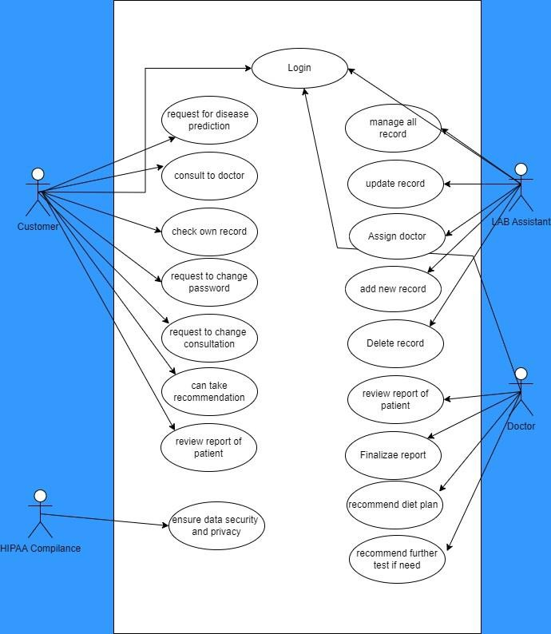

**Fig: 4.1 Flowchart of Med-Connect**

## PROJECT WALKTHROUGH

Project Walkthrough chapter focuses on the features and functionalities of AI MED- CONNECT as presented to a user. A detailed walkthrough with screenshots and explanations is provided to give a comprehensive understanding of the system’s capabilities.

**4.3.1. Landing Page**

The landing page of the Med-Connect serves as the primary gateway to introduce the platform’s features, benefits, and value proposition to new users. Page is designed to be visually engaging, easy to navigate, and user-friendly, providing a clear overview of the platform’s capabilities.

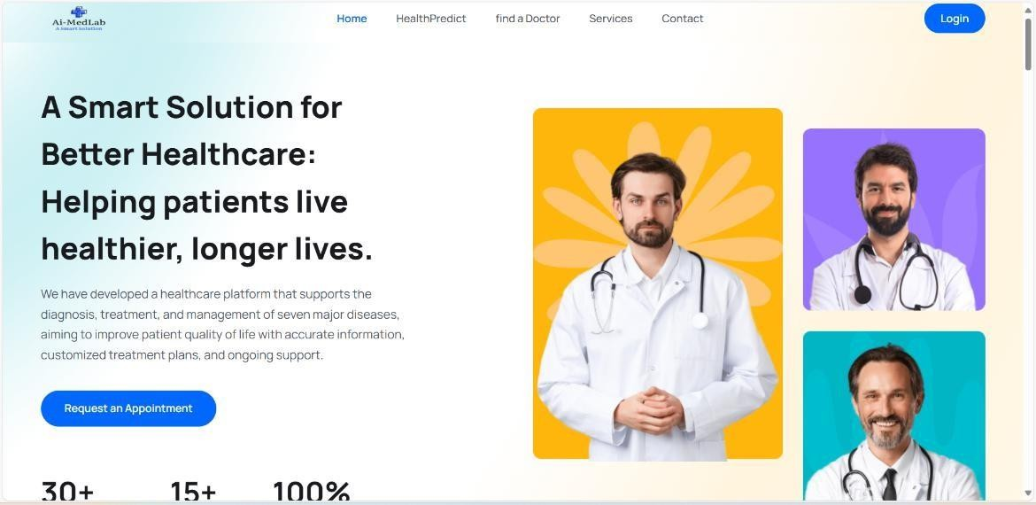

**Fig: 4.2 Landing Page**

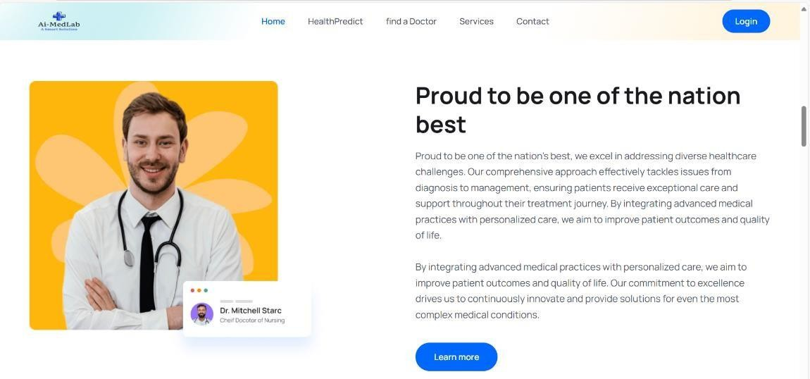

**Fig: 4.2.1 Home Page**

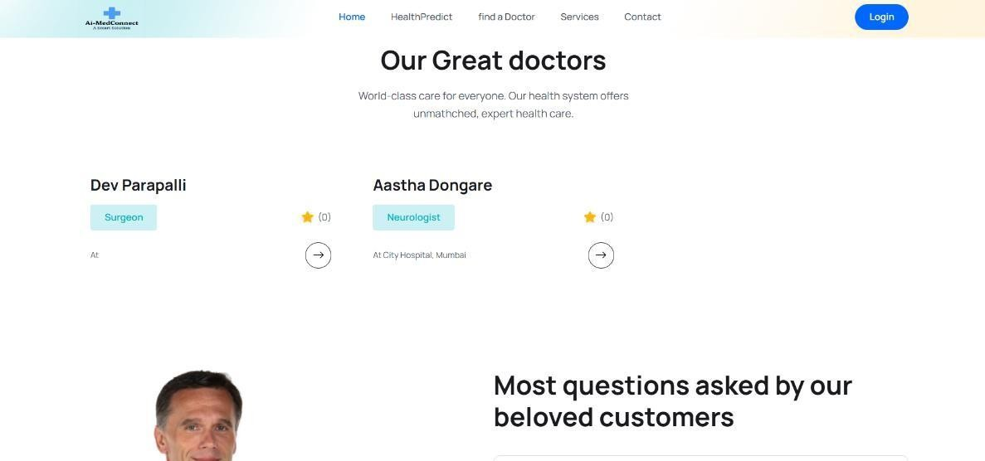

**Fig: 4.2.2 Home Page**

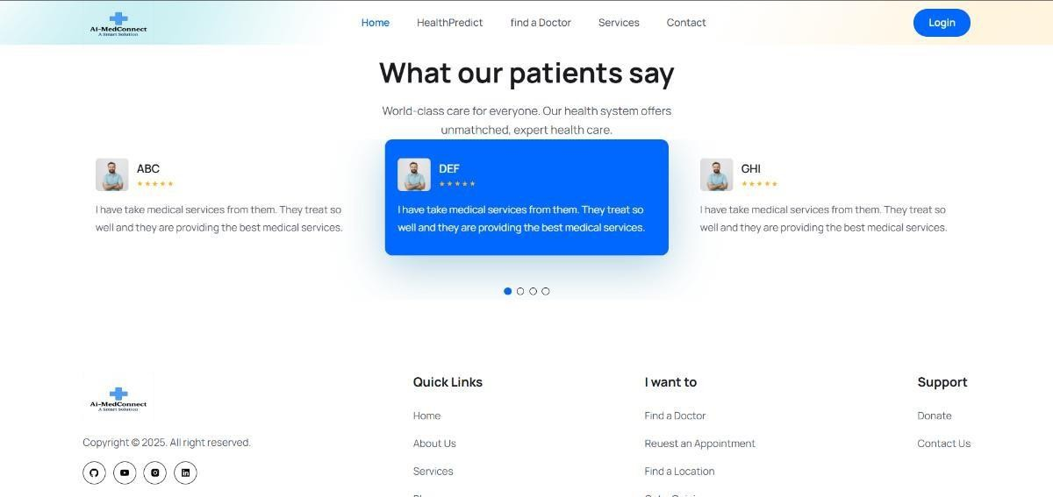

**Fig: 4.2.3 Home Page**

The Landing Page of Med-Connect serves as the first point of contact, offering a clear overview of the platform’s mission and key features. It highlights services like AI health predictions, doctor appointments, and patient data management. A clean, user-friendly design ensures easy navigation and quick access to important sections. Visitors can sign up, log in, or explore the platform through call-to-action buttons. Testimonials and trust signals help build credibility and encourage user engagement.

**4.3.2. Authentication Page**

The Authentication Page of PREPZONE serves as the gateway for users to log in or register. Users are prompted to enter the registered email. These options are easily accessible from the navigation bar, providing a clear path to sign in or create a new account. During registration, users must provide a valid email address and password, which are securely stored using hashing techniques to protect sensitive data.

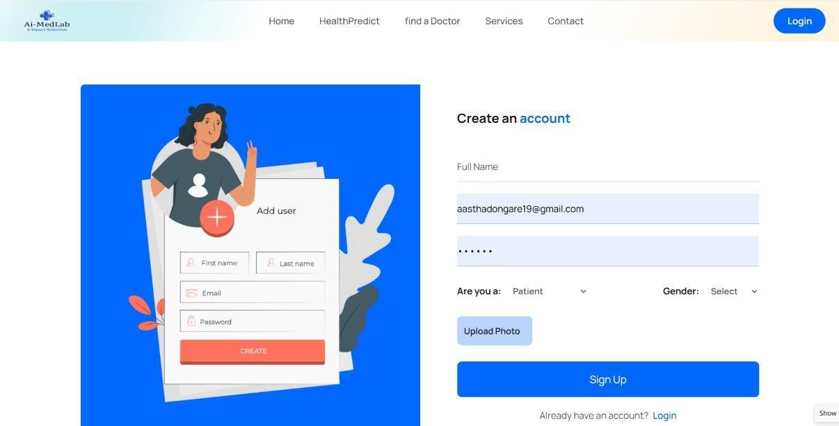

### Fig: 4.3 Sign Up Page

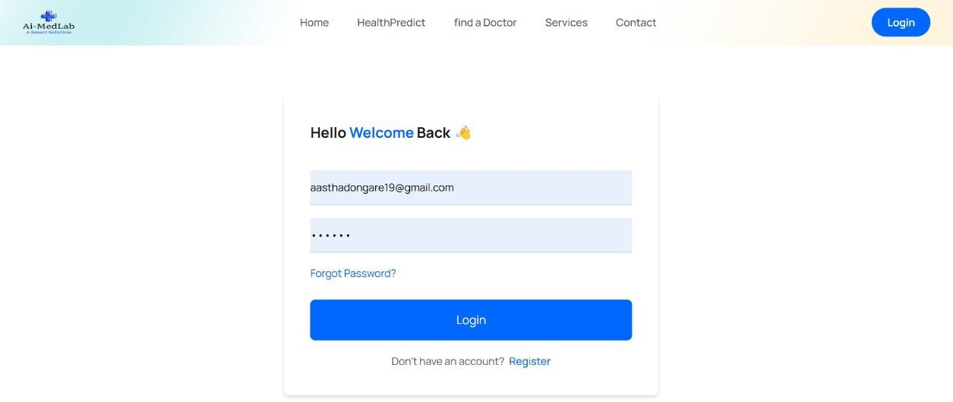

**Fig: 4.4 Login Page**

The Authentication Page in Med-Connect provides secure access for users through login and registration options. It includes fields for email, password, and role selection (e.g., patient or clinician). Features like password reset, email verification, and two-factor authentication enhance security. User credentials are validated on the backend using encrypted protocols.

### 4.3.3. Health Predict Page

The Health Predict page in Med-Connect likely allows users to input medical data or symptoms to receive AI-driven health predictions. It uses machine learning models on the backend to analyze patterns and provide risk assessments or recommendations. Such feature supports early diagnosis and personalized healthcare insights for users.

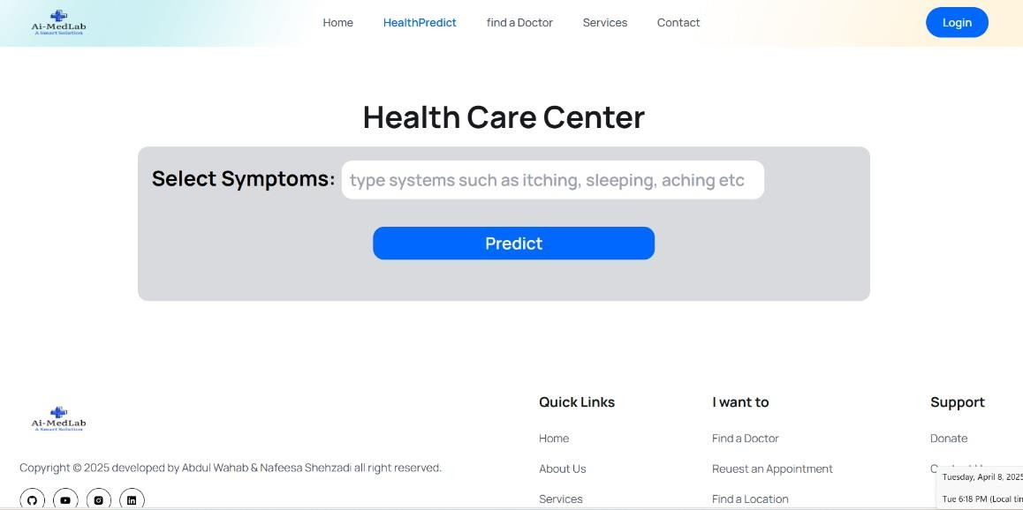

### Fig: 4.5 Health Predict Page

The Health Predict page in Med-Connect offers users a range of predictive health tests based on symptoms, medical history, or uploaded data. It may include tests for conditions like diabetes risk, heart health, or respiratory issues using AI-driven models. Users input relevant details, and the system analyses the data to generate personalized risk scores or recommendations. The results help guide users toward early diagnosis or appropriate medical consultations.

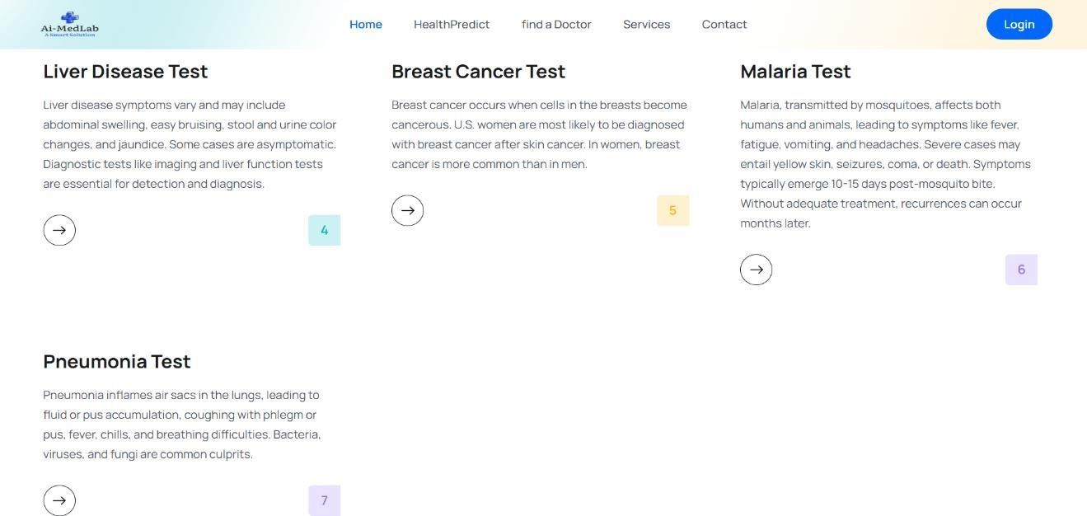

### Fig: 4.6 Health Testing Page

* + 1. **Appointment Page**

The Appointment page in Med-Connect enables users to schedule consultations with healthcare professionals based on availability. It features a calendar interface for selecting dates, times, and preferred specialists. Users can view, modify, or cancel upcoming appointments. The backend manages booking logic, notifications, and real-time updates to avoid scheduling conflicts.

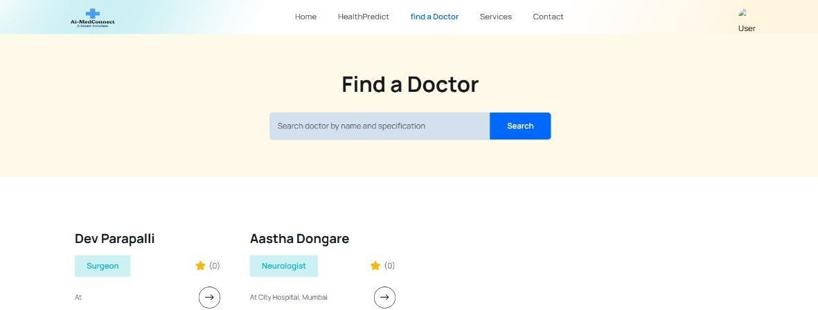

### Fig: 4.7 Finding Doctor Page

A Finding Doctor feature in Med-Connect helps users search for and connect with the right healthcare professionals based on their specific needs. Users can filter doctors by

specialization, location, availability, language, or experience. Each doctor profile typically includes qualifications, patient reviews, and consultation options which makes it easier for patients to make informed decisions and book the most suitable doctor for their condition.

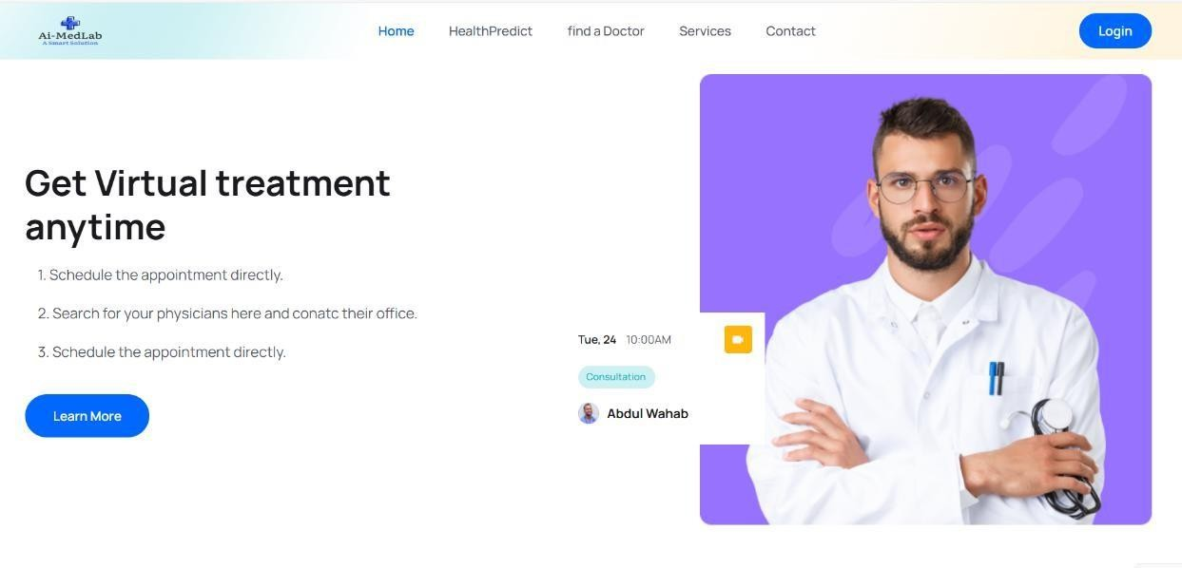

### Fig: 4.8 Requesting Page

The Requesting Page in Med-Connect allows users to submit specific healthcare- related requests, such as asking for a new appointment, second opinions, or custom medical services. Users can fill out a form detailing their needs, select a relevant department or doctor, and attach any supporting documents or reports. The request is routed to the appropriate professional or team for review. Users receive status updates and notifications as their request is processed. All the feature enhances personalized care and communication between users and providers.

### Services Page

The Services page in Med-Connect showcases the platform’s core offerings, such as virtual consultations, health predictions, and medical record management. It provides brief descriptions and access links for each service. Users can explore tailored healthcare solutions based on their needs. The page ensures easy navigation to help users engage with available features efficiently.

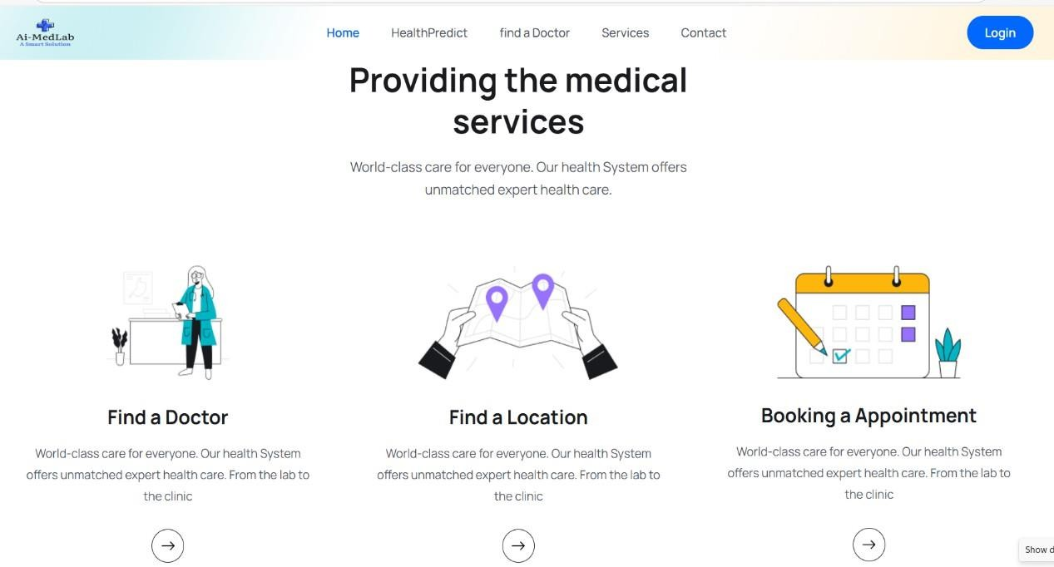

### Fig: 4.9 Services Page

AI-MedConnect offers a range of healthcare services to enhance patient care and accessibility. Services includes AI-driven health prediction tests**,** doctor appointment booking**,** and electronic medical record management**.** Users can also access virtual consultations with licensed professionals. The platform supports secure feedback submission and request handling for personalized care. All services are integrated into a user-friendly interface for a seamless healthcare experience.

### Feedback Page

The Feedback page in Med-Connect allows users to share their experiences, suggestions, or concerns about the platform and its services. It features a simple form with options for comments, and service-specific feedback. Submitted responses help improve platform quality and user satisfaction. Feedback is securely stored and reviewed by the support or development team.

The Feedback Form in Med-Connect Health's patient portal is a secure, web-based feature that enables patients to communicate directly with the healthcare providers. Patients can use feedback form to request prescription refills, schedule appointments, view lab results, or ask questions about treatments and procedures. Such functionality enhances patient satisfaction and streamlines practice efficiency by facilitating timely and organized communication between patients and healthcare teams.

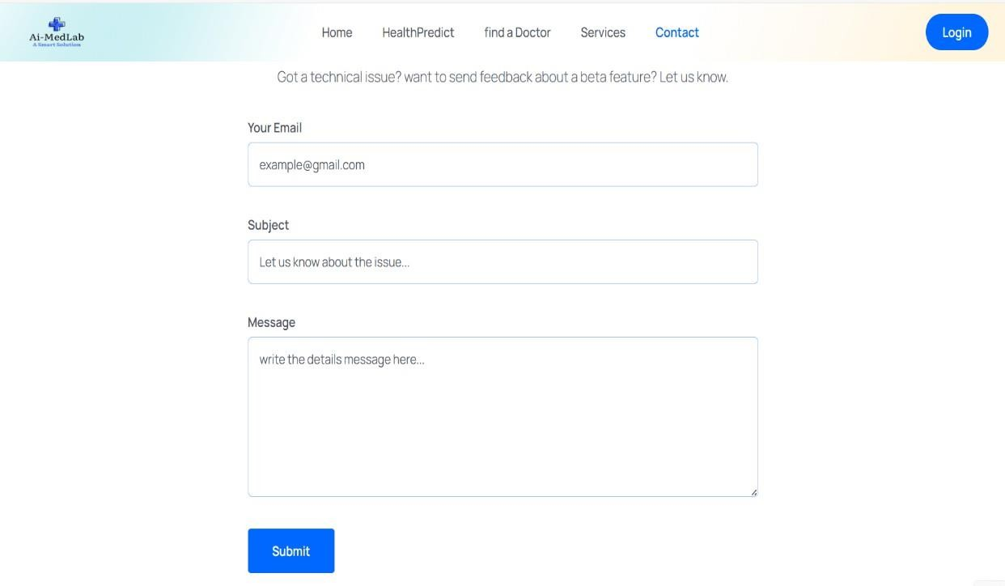

### Fig: 4.10 Feedback Page

AI Med-Connect is a digital healthcare platform which connects patients with doctors and AI- powered tools for improved medical services. It features secure login, appointment booking, health prediction tests, and access to various healthcare services. Users can submit specific requests, view personalized dashboards, and provide feedback through dedicated pages. The platform streamlines communication, enhances care, and delivers a user-friendly experience for both patients and medical professionals.

AI Med-Connect provides a safe and personalized healthcare experience with features like user login, doctor appointment scheduling, and AI-powered health checks. It allows users to access medical services, send specific health-related requests, and share their feedback. The platform is designed to make healthcare more accessible, efficient, and user-friendly.

## FINANCIAL SUMMARY

AI Med-Connect was developed at moderate financial cost, as AI Med-Connect used only free resources throughout the project. All tools, platforms, and services needed for the development were available for free open-source options, or educational resources. It helped the team to only pay undivided attention to the delivery of the product and not any financial burden. The free of charge resources enabled us to finish the project without having to resort to getting funding from an external source or allocating it from the budget.

### Laptop

* Cost: Rs 30,000 – Rs 80,500 (Depending on specifications like RAM, storage, and processing power necessary for development and AI work).

1. **Internet Connection**

* Cost: Rs 250 – Rs 450/month (Assuming a reliable high-speed connection for coding, testing, and deployment).

1. **VS Code**

* Cost: Rs. 0 (VS Code is an open-source IDE, but premium extensions or add-ons could add a small cost.)
  + 1. **Total Estimated Budget:** Rs 50,000 – Rs 1,00,000

The budget and financial summary of Med-Connect outlines the overall cost and funding required to build and maintain the platform. It includes development expenses for designing the app, backend systems, and integrating AI features, as well as infrastructure costs like hosting, cloud storage, and server management. Personnel costs cover salaries for developers, healthcare experts, and support teams. Additionally, the summary accounts for marketing efforts, legal compliance, and day-to-day operations. It also highlights the projected revenue, return on investment, and how the actual spending compares to the initial budget, providing a clear financial overview of the project.

## TESTING

Testing in Med-Connect is a crucial phase to ensure the platform works smoothly, securely, and reliably for all users. It involves multiple types of testing such as unit testing to check individual functions, integration testing to ensure different modules work together, and system testing to validate the entire application. User acceptance testing (UAT) is also conducted to confirm the platform meets the needs of patients, doctors, and admins. Additionally, security testing is performed to protect sensitive health data and ensure compliance with healthcare standards. This comprehensive testing ensures Med-Connect delivers a safe and seamless healthcare experience.

### Unit Testing

* Unit testing was performed to validate individual components or functions within the application.
* Each unit was tested in isolation, ensuring that it performed as expected and adhered to specified requirements.
* Automated unit tests were executed frequently during development to provide immediate feedback, allowing developers to identify and fix bugs early in the development process.

### Table 4.1. Test cases for Unit Testing

|  |  |  |
| --- | --- | --- |
| **Sr. No** | **Test Case Description** | **Result** |
| 1 | Test user registration function with valid inputs | Pass |
| 2 | Validate JWT token generation for user authentication | Pass |
| 3 | Check Request for appointment working properly | Fail |
| 4 | Test search filter functionality for find doctor module | Fail |
| 5 | Ensure Health predict function returns valid output | Fail |
| 6 | Ensure Disease predict function returns valid output | Fail |
| 7 | Check Feedback response module working properly | Pass |

* + 1. **Integration Testing**
* Integration testing was conducted to examine the interactions between various modules of the application.
* The goal was to ensure that the integrated components worked together as intended, facilitating smooth data flow across the system.
* Integration testing type involved combining multiple modules and testing them as a group to identify issues that arose from module interactions that might not have been apparent during unit testing.

### Table 4.2. Test cases for Integrate Testing

|  |  |  |
| --- | --- | --- |
| **Sr.**  **No** | **Test Case Description** | **Result** |
| 1 | Test integration between user registration and login modules | Pass |
| 2 | Validate output on requesting for appointment module | Pass |

|  |  |  |
| --- | --- | --- |
| 3 | Check functionality of the comparative analysis tool with multiple streams | Pass |
| 4 | Test search filter functionality for find doctor module | Pass |
| 5 | Ensure Health predict function returns valid output | Pass |
| 6 | Ensure Disease predict function returns valid output | Pass |
| 7 | Check Feedback response module working properly | Pass |

**4.5.3. Performance Testing**

* Performance testing was aimed at evaluating the application’s responsiveness, stability, and scalability under various load conditions.
* It helped ensure that the platform could handle expected user traffic and performed well during peak usage.
* Performance type of testing simulated real-world load scenarios to assess how the application responded under stress, analyzing metrics such as response time, throughput, and resource utilization.

### Table 4.3. Test cases for Performance Testing

|  |  |  |
| --- | --- | --- |
| **Sr. No** | **Test Case Description** | **Result** |
| 1 | Measure response time for user registration under load | Pass |
| 4 | Assess loading time for requesting appointment modules | Pass |
| 5 | Test find doctors responsiveness under high traffic | Pass |

**4.5.4. Acceptance Testing**

* Acceptance testing was the final verification phase where end-users confirmed that the platform met their requirements and expectations.
* This testing type ensured that the application was ready for deployment and would deliver the intended value to its users.
* Acceptance testing was conducted in real-world scenarios by end-users, collecting their feedback to validate functionality, usability, and overall satisfaction with the platform.

**Table 4.4. Test cases for Acceptance Testing**

|  |  |  |
| --- | --- | --- |
| **Sr. No** | **Test Case Description** | **Result** |
| 1 | User satisfaction survey on overall platform experience | Pass |
| 2 | Validate ease of use for AI Med-Connect features | Pass |
| 3 | Assess effectiveness of disease testing module in real scenarios | Pass |
| 4 | Ensure health prediction module functions correctly | Pass |
| 5 | Test compatibility of platform on different devices | Pass |

# CHAPTER 5 RESULTS AND DISCUSSIONS

## PLATFORM PERFORMANCE

AI Med-Connect demonstrated strong performance as a digital healthcare solution by streamlining patient-doctor interactions and integrating AI for smarter healthcare delivery. Key features such as health prediction tools, appointment booking, and service navigation functioned smoothly across devices. The health prediction module allowed users to input symptoms and receive AI- generated insights into possible health conditions, improving early awareness and guiding patients toward relevant care. Additionally, the platform ensured a consistent user experience by utilizing secure APIs and a robust backend, allowing data to be processed and delivered quickly, under heavy traffic.

The application was developed using modern backend technologies like Python, Node.js, and Flask, which enabled smooth processing of AI models and appointment scheduling systems. Frontend responsiveness was achieved using React**.**js, which ensured clean and efficient user interaction. AI-MedConnect's architecture was scalable and modular, allowing easy integration of additional features like remote consultations and health reports in future iterations.

Even under high user loads, the system maintenance reliability thanks to cloud deployment and horizontal scaling strategies. The containerized services using Docker helped in isolating and managing individual modules, allowing seamless updates and robust error handling. This ensured that Med-Connect could support a growing user base without compromising on speed or accuracyThese tools helped identify bottlenecks, optimize loading speeds, and improve user interaction times. The combination of robust technologies and constant monitoring contributed to high user satisfaction.

## USER INTERFACE AND INTERACTION

AI Med-Connect was designed with simplicity and usability in mind. The interface, built using React.js and Tailwind CSS, offered a clean layout with intuitive navigation. Users could easily book appointments, explore services, predict health conditions, and submit feedback without confusion. The dashboard differentiated the experience

for patients, doctors, and administrators, offering relevant controls based on their roles.

The platform’s design ensured smooth performance on desktops, tablets, and smartphones. Features such as calendar-based doctor availability, health tests, and real- time chat enhanced the user experience. Users consistently praised the minimal design and accessible layout, which contributed to higher engagement and satisfaction levels. Users also appreciated the intuitive flow from one service to another. For example, after receiving a prediction, users could directly book an appointment with a specialist relevant to their condition.

React.js played a vital role in creating a dynamic and responsive interface. The frontend handled state management efficiently and ensured that users saw updates in real- time—such as when an appointment was confirmed or feedback was submitted. Mobile-first design principles were followed, making sure the platform adapted to all screen sizes seamlessly.

Regular UI/UX audits were conducted to improve the overall design and functionality. Suggestions gathered during these audits were incorporated into iterative updates, enhancing the user experience and ensuring the interface kept up with modern design trends.

* 1. **PATIENT ENGAGEMENT AND FEEDBACK**

One of the most encouraging outcomes of the AI-MedConnect rollout was the high level of patient engagement. The health prediction tool became a focal point for many users, who found it both informative and reassuring. By inputting simple symptoms and personal data, they could receive probable health conditions, empowering them to seek timely care or advice.

Feedback was actively collected through dedicated forms after appointments or service use. Patients shared that the platform helped reduce anxiety about their symptoms and provided confidence in the decision to consult a doctor. Many users also noted the convenience of being able to view doctor details, check availability, and make bookings directly from the same interface.

Suggestions from users, such as clearer doctor specializations or more detailed test descriptions, were implemented in updates. The responsiveness of the development team to patient input helped build trust and ensured the platform evolved with real-world use in mind.

Additionally, user surveys were deployed at regular intervals to gather insights on new features and upcoming improvements. This ensured that development decisions were aligned with real user needs, fostering stronger engagement and loyalty.

* 1. **AI-POWERED HEALTH PREDICTION**

The health prediction feature, built using Python and machine learning models, was one of AI- MedConnect’s standout tools. It used symptom data, lifestyle factors, and demographics to predict potential health issues with a reasonable degree of accuracy. Conditions like diabetes, heart disease, and common infections were among the predictions generated, giving users a valuable early indication. Each prediction was supported by educational content that explained the condition, recommended actions, and potential next steps. This helped users not only understand the output but also take action toward better health decisions. The interface also provided disclaimers that the tool was not a replacement for clinical diagnosis, maintaining ethical clarity.

The AI models were trained on healthcare datasets and tested extensively to reduce false positives or irrelevant suggestions. User trust was further enhanced through explainable AI features, where the prediction reasoning was summarized. This transparency reassured users that the system wasn’t a black box but a supportive tool grounded in data.

Continuous improvements were made to the algorithm by incorporating feedback and retraining the models periodically. The tool's recommendations became more accurate over time, making it a reliable support system for both patients and healthcare providers.

* 1. **SERVICE UTILIZATION AND APPOINTMENTS**

The appointment system in AI-MedConnect was robust and user-friendly. Patients could browse through a categorized list of medical professionals, view their qualifications, specializations, and ratings, and select time slots directly from an interactive calendar.

Doctors also benefited from a structured dashboard where they could view upcoming appointments, access patient histories, and manage their availability. This helped ensure that appointments were organized and efficient, reducing delays and enhancing care quality. Doctors reported improved workflow and less time spent on manual scheduling. Patients could also cancel or reschedule appointments easily reduce

miscommunication. The integration of email and dashboard notifications kept both doctors and patients informed. This real-time communication fostered a sense of professionalism and dependability within the platform, making it a reliable hub for healthcare coordination.

Integration with calendar apps and patient history allowed for smart scheduling features, which suggested ideal time slots based on past behavior and doctor availability. This enhanced the ease of use and helped reduce administrative load.

* 1. **SCALABILITY**

AI-MedConnect was developed with scalability as a key priority to accommodate a growing number of users and expanding healthcare services. The application architecture was modular, allowing for additional features to be integrated with minimal disruption to existing functionality. Cloud deployment through platforms like AWS ensured that the system could scale horizontally to handle increased traffic and data load during peak usage times.

To maintain performance as user demand increased, containerization using Docker and orchestration via Kubernetes was employed. This setup allowed different components— such as health prediction, appointment scheduling, and feedback modules—to run independently and scale based on their specific resource requirements. This granular scaling ensured efficient resource utilization without performance degradation.

The database structure, built on MongoDB, was designed to support high-volume data queries and writes. Indexing and optimized schema designs made it possible to retrieve large sets of medical records, test results, and appointments without delay. This scalability enables AI- MedConnect to serve users in real-time and positioned it well for regional or national- level expansion in the future.

* 1. **DATA HANDLING**

Data management was a cornerstone of the AI-MedConnect platform, especially given the sensitive nature of medical and personal information. The backend used secure, encrypted databases to store user data, including appointment records, health prediction inputs, and feedback entries. All data transmission between the client and server was secured using HTTPS protocols, protecting users against common cyber threats.

To maintain data integrity and compliance with, Regular backups and monitoring tools were also employed to ensure data could be recovered swiftly in case of any type

of system failure or breach.

Analytics also played a critical role in data handling. User interactions, prediction accuracy, and service usage patterns were analyzed to gain insights into platform performance and user needs. These insights were used to refine AI models, improve appointment availability, and identify popular services. Overall, AI-MedConnect’s data strategy focused on privacy, performance, and continuous improvement.

Regular audits and automated backups ensured data integrity and availability. Users could also manage their privacy settings and had the option to delete their data, reinforcing trust in the platform's ethical handling of information.

Security training sessions were conducted for development and support teams to maintain awareness of evolving threats. Bug bounty programs and vulnerability scanning tools were used to identify and patch security issues promptly.

* 1. **CARE ACCESSIBILITY AND REACH**

One of the most significant outcomes of AI Med-Connect was its contribution to expanding healthcare access. The platform connected patients in rural or underserved areas to verified healthcare professionals, ensuring medical support where traditional systems struggled to reach.

Through teleconsultations and digital prescriptions, patients who lacked physical access to hospitals or clinics could still receive quality care. This accessibility was particularly vital during emergencies and pandemic-like situations, where physical contact was minimized.

Doctors reported improved patient turnout and follow-up through the platform. This digital outreach not only improved medical outcomes but also supported public health efforts by enabling early diagnosis and reducing overcrowding in urban hospitals.

Language localization and low-bandwidth optimizations were also implemented to make the platform usable in remote regions with limited internet access. This inclusive approach further extended the platform’s impact.

* 1. **HEALTH TRENDS AND ANALYTICS**

To enhance proactive care, AI-MedConnect provided personalized analytics based on user data and system interaction. Patients could view visual health trends over time, such as changes in weight, blood pressure, or symptom frequency, helping them track progress and maintain accountability.

Doctors could also view aggregated patient data and allowing them to identify

health issues, evaluate treatment effectiveness, and tailor interventions more effectively. These insights supported preventive healthcare and data-driven decision-making.

The analytics module was designed with privacy in mind, using anonymized data for population health studies while giving users full control over what data was shared. This approach ensured both utility and confidentiality, enhancing the platform’s value as a health companion.

Healthcare providers could access anonymized data to identify trends in common illnesses, treatment outcomes, and patient engagement. These insights helped doctors tailor treatments and contributed to broader healthcare research.

The analytics module also supported public health monitoring by aggregating regional data, helping authorities understand disease spread and health service utilization, enabling timely interventions and better resource allocation.

## SCALABILITY AND FUTURE EXPANSION

AI-MedConnect was developed with a scalable infrastructure capable of supporting future growth. The backend architecture supported horizontal scaling, allowing additional servers to be added as user demand increased.

This ensured consistent performance even with rising traffic. Cloud services were used for load balancing, storage, and deployment automation, making it easier to roll out updates without affecting ongoing operations. Microservices architecture was adopted for modular development, so new services could be integrated independently without system-wide disruption.

The project roadmap included plans for expansion into multi-language support, AI- powered diagnostics, and integration with insurance services. This future-ready design highlighted AI-MedConnect’s potential to evolve into a comprehensive digital healthcare ecosystem across regions. Cloud services were used for load balancing, storage, and deployment automation, making it easier to roll out updates without affecting ongoing operations. Microservices architecture was adopted for modular development, so new services could be integrated independently without system-wide disruption. It is also designed to adapt to emerging health trends and integrate real-time data from wearable devices. The platform’s flexibility allows for quick implementation of new diagnostic models based on evolving public health needs, user feedback, technology and regional healthcare infrastructure requirements.

* 1. **RISK MANAGEMENT**

Given the critical nature of health data, risk management was central to the design and deployment of AI Med-Connect. The development team prioritized security protocols from the beginning, incorporating features like data encryption, secure API authentication, and multi-factor login systems to prevent unauthorized access. All user interactions were logged and monitored to detect suspicious activities early.

The platform adhered to data privacy laws and healthcare regulations by enforcing strict data access controls. Sensitive medical data was stored in encrypted formats and only accessible to users and authorized medical professionals. Additionally, regular penetration testing and code audits were conducted to identify and fix vulnerabilities before they could be exploited.

User trust was further built through transparent privacy policies and consent forms that explained how data would be used. The platform also educated users on best practices, such as using strong passwords and recognizing phishing attempts.

Through this proactive, multi-layered approach to risk management, Med-Connect ensured both user safety and compliance, strengthening its reputation as a secure healthcare solution.

# CHAPTER 6 CONCLUSION

## SUMMARY OF WORK

Choosing the appropriate healthcare decisions and early diagnosis can be a daunting task for patients and families, especially in regions where access to healthcare professionals is limited. With increasing pressure on medical systems, early detection and timely awareness of potential diseases can significantly improve patient outcomes and resource management.

AI-MedConnect is designed to bridge this gap by offering an AI-driven health guidance platform that empowers users to monitor symptoms, perform basic self-assessments, and receive suggestions for potential health concerns, all while promoting awareness and early diagnosis.

By leveraging artificial intelligence, real-time data analysis, and user-friendly interfaces, AI-MedConnect aims to reduce diagnostic delays, raise health literacy, and serve as a first line of support before consulting a healthcare provider. The system focuses on high- impact areas such as disease prediction, early warning alerts, and guided information on potential treatments or next steps, thereby helping users take proactive control over their health. Here is an evaluation:

### Clarity and Specificity:

AI-MedConnect clearly aims to provide AI-assisted health support, focusing on disease prediction, symptom tracking, and health insights for users. It emphasizes supporting users in recognizing potential conditions early, indicating a strong alignment with public health priorities

### Relevance:

With the rise of lifestyle diseases, pandemics, and increased health awareness, there is a critical need for tools that can assist individuals in understanding their health without immediate clinical intervention. AI-MedConnect addresses this by offering AI-based support, especially valuable in under-resourced or remote areas.

### Impact and Success Metrics:

* + - * **Increased Health Awareness:** Educates users on health conditions and symptoms.
      * **Reduced Burden on Healthcare Systems:** Enables early triage and minimizes unnecessary hospital visits.
      * **Timely Action:** Encourages early consultation based on AI-suggested red flags.
      * **User Engagement:** Metrics such as user retention will be used to measure success.

### Feasibility:

Thanks to modern AI models, natural language processing (NLP), and cloud infrastructure, it is feasible to build and scale AI-MedConnect. Partnerships with healthcare professionals, integration with verified medical databases, and continuous learning algorithms will ensure accuracy and trustworthiness. However, regulatory compliance and data privacy remain challenges that must be addressed responsibly.

## CONCLUSION

The AI-MedConnect platform represents a significant advancement in the intersection of artificial intelligence and healthcare, aimed at improving early diagnosis, health awareness, and user engagement in managing personal health. By integrating AI algorithms with real- time user input, the system offers users the ability to receive intelligent health suggestions, conduct preliminary assessments, and get guided recommendations for further medical actions. This solution addresses a critical gap in preventive healthcare, especially in regions with limited access to immediate medical consultations.

One of the key strengths of AI-MedConnect lies in its accessibility and ease of use. Through a chatbot-driven interface, users can interact naturally with the system, describe their symptoms, and receive feedback based on trained machine learning models. The intuitive design ensures that individuals from diverse educational and social backgrounds can benefit from the platform without requiring extensive technical knowledge. Additionally, the inclusion of a knowledge base and symptom-checking modules makes health literacy more achievable for the general public.

The project also demonstrates how AI can play a proactive role in healthcare by enabling early detection of health issues such as lifestyle-related diseases or chronic conditions. With accurate symptom analysis and pattern recognition, AI-MedConnect minimizes delays in seeking professional medical advice and supports more informed decisions. Over time, this can contribute to better health outcomes, reduced hospital workloads, and lower medical costs for users and institutions alike. AI-MedConnect’s modular and scalable architecture ensures that it is future-ready, capable of integrating more disease modules, wearable health device inputs, and even telemedicine services. Designed to assist in the early detection of chronic illnesses, the platform empowers users to take proactive control over their health using AI-driven predictions and tools.

From a development perspective, AI-MedConnect showcases how modern technologies such as the MERN stack, AI/ML models, and cloud integration can be brought together to build a scalable, secure, and effective digital health solution. The Agile Software Development Life Cycle (SDLC) used during implementation ensured iterative feedback, continuous improvements, and a user-focused product design. Moreover, the project’s modular architecture allows for future expansions, such as multilingual support, wearable integrations, and predictive analytics.

In conclusion, AI-MedConnect is a powerful example of how AI can be harnessed to transform preventive healthcare. It empowers users to take control of their health journeys, provides timely insights, and enhances decision-making in critical moments. As the platform evolves, it holds the potential to become a vital tool in global health systems, especially in promoting accessible and proactive care for all.

## FUTURE RESEARCH AND DEVELOPMENTS DIRECTIONS

As AI-MedConnect continues to evolve, there are numerous avenues for future research and development to enhance its capabilities, usability, and reach. Expanding the system’s intelligence, adaptability, and integration with other technologies will allow it to better serve users and healthcare providers. Emphasis on real-time data analytics, advanced predictive models, and user- centric personalization can take AI-MedConnect from a smart support tool to a deeply insightful, preventive healthcare companion. Below are six key areas for future exploration:

### Integration with Wearable Devices

* + - * **Real-time Health Monitoring:** By integrating with devices like smartwatches and fitness bands (e.g., Fitbit, Apple Watch), the platform can collect real-time data such as heart rate, blood pressure, blood oxygen levels, and sleep quality.
      * **Personalized Alerts & Recommendations:** AI-MedConnect can use this continuous data to detect anomalies and send personalized alerts (e.g., sudden heart rate spike) and suggest immediate actions like rest, hydration, or seeking medical help.
      * **Activity & Lifestyle Tracking:** Wearables can also help monitor physical activity and sleep patterns, which AI can analyze to offer health tips.

### Multilingual and Regional Adaptation

* + - * **Language Expansion:** Develop chatbot and platform support in regional and local Indian languages to improve accessibility.
      * **Cultural Relevant Advice:** Tailor dietary and health recommendations based on regional habits (e.g., rice-based vs wheat-based diets) and seasonal diseases common in different areas.
      * **Voice Interface Support:** Adding voice-based input/output in local dialects for illiterate or visually impaired users will improve engagement and usability.
      * **Localization in Indian Languages:** Expanding language support (Hindi, Marathi, Tamil, Bengali, etc.) will enable access to rural and non-English speaking users, ensuring inclusivity.

### Predictive Disease Modeling

* + - * **Longitudinal Data Use:** Leverage patient history and behavioral data to forecast potential health risks and disease progression.
      * **AI-Based Risk Scoring:** Develop predictive models to assign risk scores and recommend preventive measures for chronic diseases.
      * **Risk Profiling Using AI/ML:** Utilize historical health data, genetic factors, and lifestyle inputs to predict diseases like diabetes, hypertension, or cardiovascular conditions before symptoms manifest.
      * **Personalized Preventive Plans:** Suggest lifestyle changes, routine check-ups, or dietary modifications based on predicted risks.
      * **Behavioral and Environmental Inputs:** Include non-medical factors such as smoking habits, pollution exposure, or stress levels for more accurate predictions.

### Enhanced Mental Health Support

* + - * **Emotion-Aware Chatbot:** Integrate sentiment analysis into chatbot responses to detect stress, anxiety, or depressive symptoms.
      * **Mental Health Modules:** Provide access to self-care tools, breathing exercises, and connection to counselors based on user emotional analysis.
      * **Sentiment & Tone Analysis**: Using NLP, the chatbot can detect negative emotional patterns in user conversations and respond to queries.
      * **Self-Help Modules**: Provide curated resources such as breathing exercises, meditation, positive psychology tools, and coping strategies for anxiety and depression.

### Predictive Disease Modeling

* + - * **Longitudinal Data Use:** Leverage patient history and behavioral data to forecast potential health risks and disease progression.
      * **AI-Based Risk Scoring:** Develop predictive models to assign risk scores and recommend preventive measures for chronic diseases.
      * **Risk Profiling Using AI/ML:** Utilize historical health data, genetic factors, and lifestyle inputs to predict diseases like diabetes, hypertension, or cardiovascular conditions before symptoms manifest.
      * **Personalized Preventive Plans:** Suggest lifestyle changes, routine check-ups, or dietary modifications based on predicted risks.
      * **Behavioral and Environmental Inputs:** Include non-medical factors such as smoking habits, pollution exposure, or stress levels for more accurate predictions.

### Enhanced Mental Health Support

* + - * **Emotion-Aware Chatbot:** Integrate sentiment analysis into chatbot responses to detect stress, anxiety, or depressive symptoms.
      * **Mental Health Modules:** Provide access to self-care tools, breathing exercises, and connection to counselors based on user emotional analysis. Generate individualized self-care and mental health improvement plans based on user behavior, emotional history, and preferences.
      * **Sentiment & Tone Analysis**: Using NLP, the chatbot can detect negative emotional patterns or stress in user conversations and respond with empathy.
      * **Self-Help Modules**: Provide curated resources such as breathing exercises, meditation, positive psychology tools, and coping strategies for anxiety and depression.
      * **Live Support Integration**: Enable scheduling of appointments with certified mental health professionals directly through the platform**.** Enable users to connect with moderated peer support communities where they can share experiences and support each other anonymously.

### Electronic Health Record (EHR) Integration

* + - * **Data Portability:** Enable secure import/export of user medical history with hospitals or clinics to streamline patient care.
      * **Doctor Collaboration Portal:** Build interfaces where doctors can view symptom assessments and chatbot histories for improved diagnosis.
      * **Secure Health Record Management:** Allow users to upload or link their past health records from hospitals or labs securely.
      * **Interoperability with Hospitals**: Develop APIs to sync records with existing hospital systems for streamlined patient history access.
      * **Medical Summary Generation**: Automatically generate health summaries and timelines using aggregated data for both users and doctors.

### Clinical Trial and Research Data Pooling

* + - * **AI-Med Research Extension:** Allow users to opt-in for anonymous data sharing to support medical research and training AI models.
      * **Partnerships with Institutions:** Collaborate with healthcare universities and research labs for ongoing validation and data enrichment. Collaborate with academic institutions to validate health predictions and refine algorithms.
      * **Public Health Insights**: Use collected data to analyze trends (e.g., regional flu outbreaks) and assist in public health planning.
      * **Opt-in Research Participation**: Provide users an option to contribute anonymized data to medical research and AI training models.

### AI-Driven Personalized Health Dashboard

* + - * **Custom Health Insights:** Build a dashboard that shows users daily/weekly/monthly health insights based on activity, symptoms, assessments, and wearable data.
      * **Dynamic Health Goals:** Set and track goals like weight management, blood pressure control, or better sleep with motivational feedback.
      * **Gamification Features:** Incorporate badges, streaks, and health challenges to encourage user participation.

### Smart Appointment & Treatment Planning

* + - * **Doctor and Specialist Finder:** Recommend nearby doctors or specialists based on the user’s symptoms and severity level.
      * **Appointment Booking and Reminders:** Allow direct appointment booking through the app and send follow-up reminders.
      * **Telemedicine Integration:** Integrate with platforms offering virtual consultations and online prescription services.

# REFERENCES

1. Janne Cadamuro et al., *A comprehensive survey of artificial intelligence adoption in European laboratory medicine: current utilization and prospects*, Mar 26, 2025. [*https://pubmed.ncbi.nlm.nih.gov/39443973/*](https://pubmed.ncbi.nlm.nih.gov/39443973/)
2. NASSCOM, *AI in Healthcare: Transforming Patient Care*, National Association of Software and Service Companies, 2021.

[*https://nasscom.in/knowledge-center/publications/how-ai-transforming-future-*](https://nasscom.in/knowledge-center/publications/how-ai-transforming-future-healthcare-indial)[*healthcare-india*](https://nasscom.in/knowledge-center/publications/how-ai-transforming-future-healthcare-indial)

1. All India Institute of Medical Sciences (AIIMS), *Impact of Early Diagnosis on Healthcare Outcomes – An Institutional Study*, New Delhi, India, 2020.
2. World Health Organization (WHO), *Focus Group on Artificial Intelligence for Health (FG-AI4H): Report on Global AI Implementation in Healthcare,* 2020. [*https://www.itu.int/en/ITU-T/focusgroups/ai4h/Pages/default.aspx*](https://www.researchgate.net/publication/354855321_Personalized_Course_Recommendation_System_Fusing_with_Knowledge_Graph_and_Collaborative_Filtering)
3. Detrano, R., et al., *International Application of a New Probability Algorithm for the Diagnosis of Coronary Artery Disease*, The American Journal of Cardiology*,* vol. 64, no. 5, 1989, pp. 304-310.

[*https://pubmed.ncbi.nlm.nih.gov/2756873/*](https://www.researchgate.net/publication/282049490_Ability_and_Aptitude_Assessment_in_Career_Counseling)

1. Smith, J. W., et al., *Using the ADAP Learning Algorithm to Forecast the Onset of Diabetes Mellitus,* Proceedings of the Annual Symposium on Computer Application in Medical Care, 1988.

[*https://pmc.ncbi.nlm.nih.gov/articles/PMC2245318/*](https://www.researchgate.net/publication/346501646_Artificial_intelligence_in_recommender_systems)

1. Little, M. A., et al., *Exploiting Nonlinear Recurrence and Fractal Scaling Properties for Voice Disorder Detection,* BioMedical Engineering OnLine, vol. 6, no. 1, 2007, pp. 1-17.

[*https://biomedical-engineering-online.biomedcentral.com/articles/10.1186/1475-*](https://www.mindler.com/)[*925X-6-23*](https://www.mindler.com/)

1. Nayak, S. R., and Dash, A., *Heart Disease Prediction Using Machine Learning Algorithms - A Survey,* International Journal of Engineering Research & Technology (IJERT), vol. 8, no. 5, 2019.

[*https://www.irjet.net/archives/V8/i9/IRJET-V8I9191.pdf*](https://www.irjet.net/archives/V8/i9/IRJET-V8I9191.pdf)

1. Springer Nature, *Artificial Intelligence in Healthcare: Past, Present and Future,* Nature Medicine, vol. 25, 2019.

[*https://pubmed.ncbi.nlm.nih.gov/29507784/#:~:text=AI%20can%20be%20applied%20t*](https://www.researchgate.net/publication/357685235_Exploring_the_Role_and_Importance_of_Career_Counselling_in_Developing_Awareness_of_Graduate_Students%27_Career_Choices_during_Corvid_19)[*o,language%20processing%20for%20unstructured%20data.*](https://www.researchgate.net/publication/357685235_Exploring_the_Role_and_Importance_of_Career_Counselling_in_Developing_Awareness_of_Graduate_Students%27_Career_Choices_during_Corvid_19)

1. Association for Diagnostics & Laboratory Medicine (AACC), *Artificial Intelligence in Laboratory Medicine: Current Status and Future Perspectives,* AACC Reports, 2021. [https://www.mmllen.com.au/wp-content/uploads/2021/10/dream-jobs-teenagers-](https://www.mmllen.com.au/wp-content/uploads/2021/10/dream-jobs-teenagers-report.pdf) [report.pdf](https://www.mmllen.com.au/wp-content/uploads/2021/10/dream-jobs-teenagers-report.pdf)
2. Ada Health GmbH. [https://ada.com](https://ada.com/)
3. BuoyHealth.

[https://www.buoyhealth.com](https://www.buoyhealth.com/)

1. Your.MD.

[https://www.healthily.com](https://link.springer.com/article/10.1007/s40593-022-00317-y)

1. IBM Watson Health, *Transforming Oncology with AI,* IBM White Paper, 2020. [https://pmc.ncbi.nlm.nih.gov/articles/PMC6231834/](https://www.emerald.com/insight/content/doi/10.1108/jhass-06-2022-0083/full/html)
2. Philips, *IntelliSpace AI Workflow Suite.*

[https://www.philips.com](https://www.taylorfrancis.com/chapters/edit/10.1201/9781032684994-82/predicting-career-opportunities-online-learning-platform-ramyadevi-hemnath-guruprakash-gokulakannan-vikram)

1. WHO & ITU, *AI for Health Focus Group Final Report,* World Health Organization & International Telecommunication Union, 2020.
2. National Digital Health Mission (NDHM). Government of India. <https://abdm.gov.in/>
3. Tata Trusts, *Tata Medical AI Projects for Rural India.*

[https://www.tatatrusts.org](https://www.tatatrusts.org/)

1. eSanjeevani – National Telemedicine Service, Ministry of Health & Family Welfare [https://esanjeevani.in](https://esanjeevani.in/)