DBMS-LAB ASSIGNMENT 7

NAME: KASHA SINGH

REG. NO.: 19BCS051

1. Write two stored Procedures relevant to your database.

QUERY:

USE T3_Travel;

CREATE PROCEDURE Names_starting_with_M

AS

SELECT * FROM T3_CustomerDetails WHERE first_name LIKE 'M%'

GO

EXEC Names_starting_with_M;

DATABASE OUTPUT:

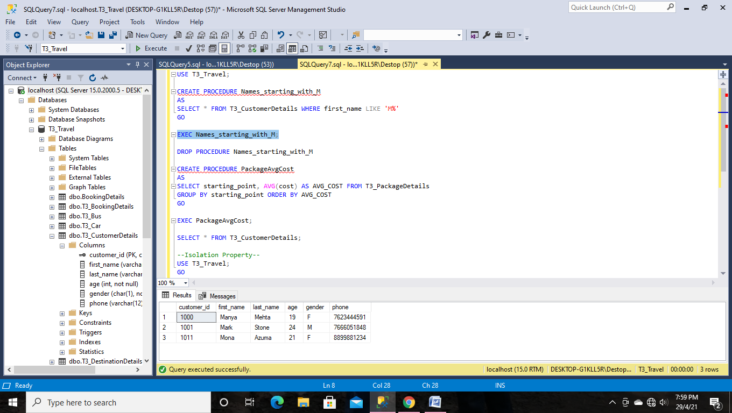

CREATE PROCEDURE PackageAvgCost

AS

SELECT starting_point, AVG(cost) AS AVG_COST FROM T3_PackageDetails

GROUP BY starting_point ORDER BY AVG_COST

GO

EXEC PackageAvgCost;

DATABASE OUTPUT:

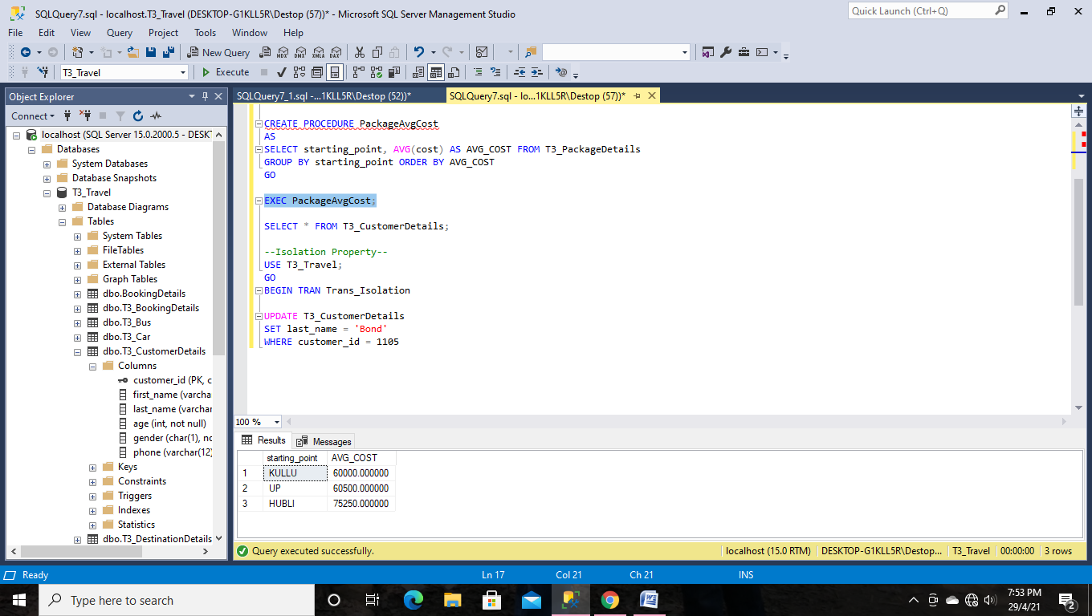

2. Write a transaction to illustrate atomicity (related to your database)

QUERY:

--Atomicity--

BEGIN TRAN Transaction_Update

UPDATE T3_CustomerDetails SET age = 24 WHERE customer_id = 1001

UPDATE T3_BookingDetails SET payment_amount = 80000 where booking_id = 111111

COMMIT

DATABASE OUTPUT:

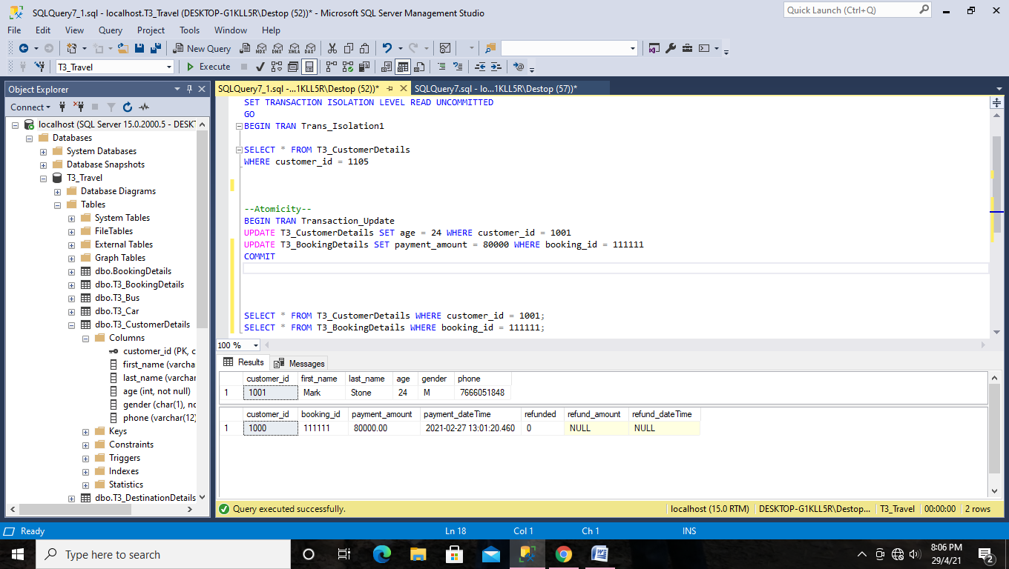

As the transaction is atomic, both of the updates on the two separate tables will commit together, or they will rollback together.

3. Write a transaction to illustrate isolation level. It can be on commit or uncommit read (related to your database)

Window 1:

--Isolation Property--

USE T3_Travel;

GO

BEGIN TRAN Trans_Isolation

UPDATE T3_CustomerDetails

SET last_name = 'Bond'

WHERE customer_id = 1105

Window 2:

USE T3_Travel;

GO

SET TRANSACTION ISOLATION LEVEL READ UNCOMMITTED

GO

BEGIN TRAN Trans_Isolation1

SELECT * FROM T3_CustomerDetails

WHERE customer_id = 1105

DATABASE OUTPUT:

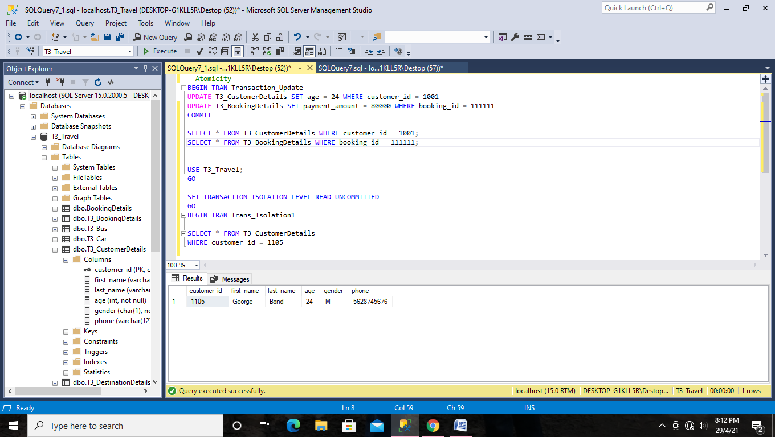

When we set the isolation level to read uncommitted, we will be able to see the last_name set to ‘Bond’, called Dirty Read.