**Kashaf Armaghan Chaudhary**

**49972**

**Lab 02**

**Insert:**

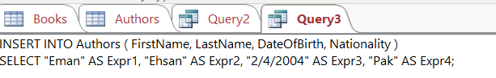

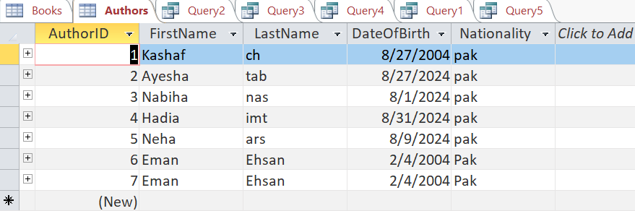

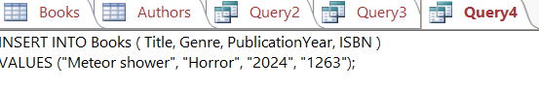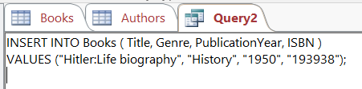

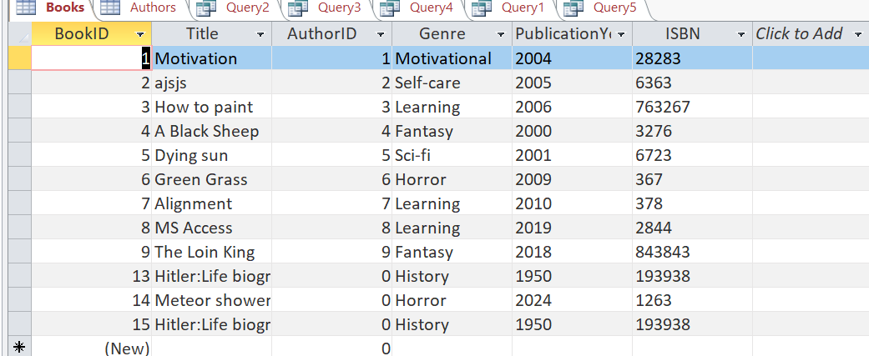

**Delete:**

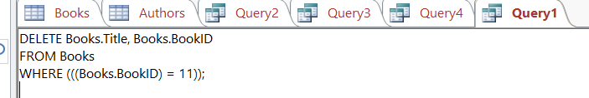

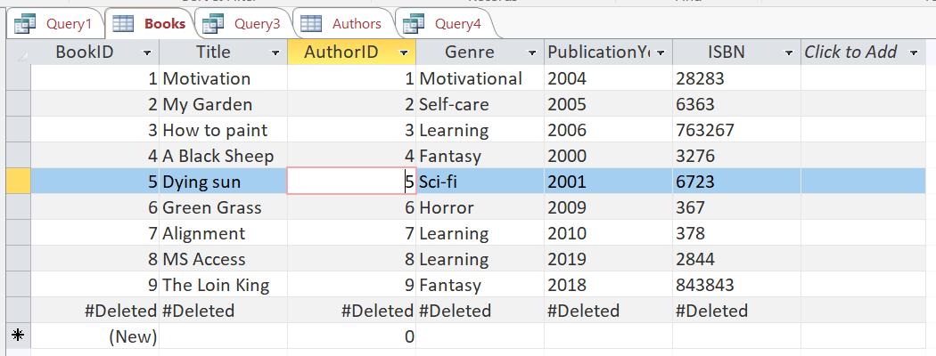

**Update:**

