JUnit Testing and Code Coverage Analysis Report for Point of Sale (POS) System

kASHAF FATIMA

Contents
Introduction 2
a. Report Table: 2
b. Explanation: 13
1. Statement Coverage 13
2. Decision Coverage 16
3. Condition Coverage 19
a. Generate and Submit Reports: 20

Introduction
This report presents a comprehensive software testing and code coverage analysis conducted on a Point of Sale (POS) System using JUnit testing and EclEmma coverage analysis tools. The objective of this project was to evaluate the correctness, reliability, and quality of various system components through systematic unit testing and coverage assessment.
The testing process involved the execution of test cases across multiple classes, including POS, PointOfSale, POSSystem, Inventory, Employee, Management, Item, ReturnItem, and Employee Management modules. Test results were analyzed to identify passed and failed scenarios, assess software behavior under different conditions, and evaluate the effectiveness of the implemented functionality.
In addition to functional verification, statement coverage, decision coverage, and condition coverage analyses were performed to measure the extent to which the source code was exercised during testing. Areas where full coverage was achieved, coverage limitations, and recommendations for improving test effectiveness are documented within this report.
The report also includes JUnit execution results, coverage reports generated using EclEmma, identified coverage gaps, and proposed improvements aimed at enhancing software quality, maintainability, and reliability. This project demonstrates practical experience in software testing, quality assurance, unit test development, defect identification, and code coverage evaluation using industry-standard testing tools and methodologies.

Report Table:

POS Test Cases Summary
TestID | Testcase name | Testcase description | Class | Function Being Tested | Test Inputs | Expected Output |  | Actual Output | Pass/Fail Status
TC01 | Delete  TempItem | Tests deleting a temp item from the file | POS | deleteTempItem | itemID=1005 | Temp file does not contain 1005 |  | As Expected | Pass
TC02 | testEndPOS_SumCheck | Tests the sum check for ending POS | POS | endPOS | file=ITEM_DATABASE_FILE | Total price = 0.0 |  | As Expected | Pass
TC03 | testEndPOS_ReturnSaleUpdate | Tests if return sale updates are correctly written | POS | endPOS | file=ITEM_DATABASE_FILE | Return sale contains updated entry |  | As Expected | Pass
TC04 | testEndPOS_ItemDatabaseUpdate | Tests if item database is updated correctly | POS | endPOS | file=ITEM_DATABASE_FILE | Item database does not contain 1005 |  | As Expected | Pass
TC05 | testRetrieveTemp_AmountCheck1005 | Tests if amount is correct after retrieving temp (1005) | POS | retrieveTemp | file=ITEM_DATABASE_FILE | Amount for item 1005 is 3 |  | As Expected | Fail
TC06 | testRetrieveTemp_AmountCheck1002 | Tests if amount is correct after retrieving temp (1002) | POS | retrieveTemp | file=ITEM_DATABASE_FILE | Amount for item 1002 is 2 |  | As Expected | Fail
TC07 | testRetrieveTemp_TotalPriceUpdate | Tests if total price is updated after retrieving temp | POS | retrieveTemp | file=ITEM_DATABASE_FILE | Total price > 0 |  | As Expected | Fail
TC08 | testDefaultConstructor | Tests default constructor of POS class | POS | POS (constructor) | N/A | No errors or exceptions |  | As Expected | Pass

Test Cases Summary
TestID | Testcase name | Testcase description | Class | Function Being Tested | Test Inputs | Expected Output | Actual Output | Pass/Fail Status
TC01 | testStartNew | Tests starting a new transaction | PointOfSale | startNew | DATABASE_FILE | True, databaseItem populated | As Expected | Pass
TC02 | testEnterItem | Tests entering a valid item | PointOfSale | enterItem | itemID=1005, amount=3 | True, item added to transaction | As Expected | Fail
TC03 | testEnterItemItemNotFound | Tests entering an invalid item | PointOfSale | enterItem | invalidItemID=9999, amount=2 | False, no item added | As Expected | Pass
TC04 | testUpdateTotal | Tests updating total after item addition | PointOfSale | updateTotal | itemID=1005, amount=2 | Updated total calculated correctly | As Expected | Fail
TC05 | testUpdateTotalWithNoItems | Tests total update with no items | PointOfSale | updateTotal | No items | Total remains unchanged | As Expected | Fail
TC06 | testValidCoupon | Tests applying a valid coupon | PointOfSale | coupon | validCoupon=C005 | Total price reduced by 10% | As Expected | Pass
TC07 | testInvalidCoupon | Tests applying an invalid coupon | PointOfSale | coupon | invalidCoupon=INVALID_COUPON | Total price unchanged | As Expected | Pass
TC08 | testCouponFileNotFound | Tests applying a coupon with missing file | PointOfSale | coupon | validCoupon=C001 | False, coupon not applied | As Expected | Pass
TC09 | testCreateTemp | Tests temporary item creation | PointOfSale | createTemp | itemID=1010, amount=5 | Temp file contains item details | As Expected | Pass
TC10 | testRemoveItems | Tests removing items from cart and temp file | PointOfSale | removeItems | itemIDToRemove=1010 | Item removed from cart and temp | As Expected | Pass
TC11 | testCreditCard | Tests credit card validation | PointOfSale | creditCard | creditCardNumber=1234567812345678 | Valid card returns true, invalid returns false | As Expected | Fail
TC12 | testLastAddedItem | Tests retrieval of last added item | PointOfSale | lastAddedItem | No input | Returns last added item details | As Expected | Fail
TC13 | testGetCart | Tests retrieving the cart items | PointOfSale | getCart | No input | Cart contains correct items | As Expected | Pass
TC14 | testGetCartSize | Tests retrieving the cart size | PointOfSale | getCartSize | No input | Returns correct cart size | As Expected | Fail
TC15 | testGetTotal | Tests retrieving the total price | PointOfSale | getTotal | No input | Returns correct total price | As Expected | Fail

Return Item Test Cases Summary
TestID | Testcase name | Testcase description | Class | Function Being Tested | Test Inputs | Expected Output | Actual Output | Pass/Fail Status
TC01 | testGetItemID_10001 | Tests getting item ID for item 10001 | ReturnItem | getItemID | itemID=10001, days=12 | 10001 | As Expected | Pass
TC02 | testGetItemID_10002 | Tests getting item ID for item 10002 | ReturnItem | getItemID | itemID=10002, days=12 | 10002 | As Expected | Pass
TC03 | testGetDays_12 | Tests getting days value (12 days) | ReturnItem | getDays | itemID=10001, days=12 | 12 | As Expected | Pass
TC04 | testGetDays_5 | Tests getting days value (5 days) | ReturnItem | getDays | itemID=10001, days=5 | 5 | As Expected | Pass

Test Cases and Coverage
TestID | Testcase Name | Testcase Description | Class | Function Being Tested | Test Inputs | Expected Output | Actual Output | Pass/Fail Status
1 | testContinueFromTemp_Return | Test continueFromTemp function for Return scenario | POSSystem | continueFromTemp | 1234567892L | Return | Return | Pass
2 | testContinueFromTemp_Sale | Test continueFromTemp function for Sale scenario | POSSystem | continueFromTemp | 1234567892L | Sale | Sale | Pass
3 | testContinueFromTemp_Rental | Test continueFromTemp function for Rental scenario | POSSystem | continueFromTemp | 1234567892L | Rental | Rental | Fail
4 | testCheckTemp_True | Test checkTemp function when temp file exists | POSSystem | checkTemp | None | True | True | Fail
5 | testCheckTemp_False | Test checkTemp function when temp file does not exist | POSSystem | checkTemp | None | False | False | Pass
6 | testLogIn_ValidCashier | Test logIn function with valid cashier credentials | POSSystem | logIn | 110002, lehigh2016 | 1 | 1 | Fail
7 | testLogIn_ValidAdmin | Test logIn function with valid admin credentials | POSSystem | logIn | 110001, 1 | 1 | 1 | Pass
8 | testLogIn_InvalidUsername | Test logIn function with invalid username | POSSystem | logIn | 112, lehigh2016 | 0 | 0 | Pass
9 | testLogIn_InvalidPassword | Test logIn function with invalid password | POSSystem | logIn | 110002, lehig | 0 | 0 | Pass
10 | testLogOut | Test logOut function | POSSystem | logOut | Cashier | None | None | Pass

Test Cases and Coverage - PORTest
TestID | Testcase Name | Testcase Description | Class | Function Being Tested | Test Inputs | Expected Output | Actual Output | Pass/Fail Status
1 | testDeleteTempItem_1005 | Test deleteTempItem function to delete item 1005 | POR | deleteTempItem | 1005 | Does not contain 1005, contains 1002 | Does not contain 1005, contains 1002 | Pass
2 | testEndPOS_ItemDatabase | Test endPOS function to update itemDatabase and returnSale files | POR | endPOS | ITEM_DATABASE_FILE | 0.0, updates in returnSale and itemDatabase files | 0.0, updates in returnSale and itemDatabase files | Pass
3 | testRetrieveTemp_1005 | Test retrieveTemp function to retrieve item 1005 | POR | retrieveTemp | ITEM_DATABASE_FILE | transactionItem[0].amount == 3 | transactionItem[0].amount == 3 | Fail
4 | testRetrieveTemp_1002 | Test retrieveTemp function to retrieve item 1002 | POR | retrieveTemp | ITEM_DATABASE_FILE | transactionItem[1].amount == 2, totalPrice > 0 | transactionItem[1].amount == 2, totalPrice > 0 | Fail
5 | testDefaultConstructor | Test default constructor with phoneNum == 0 | POR | Constructor | 0 | phoneNum == 0 | phoneNum == 0 | Pass

Test Cases and Coverage - EmployeeTest
TestID | Testcase Name | Testcase Description | Class | Function Being Tested | Test Inputs | Expected Output | Actual Output | Pass/Fail Status
1 | testGetUsername_10001 | Test getUsername function for Employee 10001 | Employee | getUsername | 10001, Alpha Release, Admin, 123345 | 10001 | 10001 | Pass
2 | testGetName_10002 | Test getName function for Employee 10002 | Employee | getName | 10002, Alpha Release, Admin, 123345 | Alpha Release | Alpha Release | Pass
3 | testGetPosition_10003 | Test getPosition function for Employee 10003 | Employee | getPosition | 10003, Alpha Release, Admin, 123345 | Admin | Admin | Pass
4 | testGetPassword_10004 | Test getPassword function for Employee 10004 | Employee | getPassword | 10004, Alpha Release, Admin, 123345 | 123345 | 123345 | Pass
5 | testSetName_10005 | Test setName function for Employee 10005 | Employee | setName | 10005, Beta Release, Admin, 123345 | Beta Release | Beta Release | Pass
6 | testSetPosition_10006 | Test setPosition function for Employee 10006 | Employee | setPosition | 10006, Alpha Release, QA, 123345 | QA | QA | Pass
7 | testSetPassword_10007 | Test setPassword function for Employee 10007 | Employee | setPassword | 10007, Alpha Release, Admin, 54321 | 54321 | 54321 | Pass

Test Case Summary- Employee Management
TestID | Testcase name | Testcase description | Class | Function Being Tested | Test Inputs | Expected Output | Actual Output | Pass/Fail Status
1 | testAdd_Cashier | Test to verify cashier addition | Employee  Management | add | "Alpha Release", "123345", true | Employee added as cashier | Employee added as cashier | Pass
2 | testAdd_Admin | Test to verify admin addition | EmployeeManagement | add | "Alpha Release2", "123345", false | Employee added as admin | Employee added as admin | Pass
3 | testDelete_ExistingEmployee | Test to delete an existing employee | EmployeeManagement | delete | "DeleteTest Employee" | Employee deleted successfully | Employee deleted successfully | Pass
4 | testDelete_NonExistingEmployee | Test to delete a non-existing employee | EmployeeManagement | delete | "Nonexistent employee" | Employee not deleted | Employee not deleted | Pass
5 | testUpdate_ValidUpdate | Test to update employee with valid details | EmployeeManagement | update | "UpdateTest Employee", "newPass456", "Admin", "UpdatedTest Employee" | Employee details updated | Employee details updated | Pass
6 | testUpdate_InvalidUsername | Test to update with invalid username | EmployeeManagement | update | "99999", "newPass456", "Admin", "NonExistent Employee" | Error: Employee not found | Error: Employee not found | Pass
7 | testUpdate_InvalidPosition | Test to update with invalid position | EmployeeManagement | update | "PositionTest Employee", "newPass456", "InvalidPosition", "UpdatedTest Employee" | Error: Invalid position | Error: Invalid position | Pass

Test Case Summary - InventoryTest
TestID | Testcase name | Testcase description | Class | Function Being Tested | Test Inputs | Expected Output | Actual Output | Pass/Fail Status
1 | testGetInstance | Test singleton pattern for inventory | Inventory | getInstance | None | Same instance returned | Same instance returned | Pass
2 | testGetInstanceIsNotNull | Test that inventory instance is not null | Inventory | getInstance | None | Instance is not null | Instance is not null | Pass
3 | testAccessInventory | Test access to inventory from file | Inventory | accessInventory | tempDatabaseFile, databaseItem | Inventory accessed, 101 items loaded | Inventory accessed, 101 items loaded | Pass
4 | testUpdateInventorySale_Potato | Test inventory sale update for Potato | Inventory | updateInventory | tempDatabaseFile, transactionItem, databaseItem, true | Potato inventory reduced by 49 | Potato inventory reduced by 49 | Pass
5 | testUpdateInventorySale_PlasticCup | Test inventory sale update for Plastic Cup | Inventory | updateInventory | tempDatabaseFile, transactionItem, databaseItem, true | Plastic Cup inventory reduced by 100 | Plastic Cup inventory reduced by 100 | Pass
6 | testUpdateInventoryReturn_SkirtSteak | Test inventory return update for Skirt Steak | Inventory | updateInventory | tempDatabaseFile, transactionItem, databaseItem, false | Skirt Steak inventory increased by 55 | Skirt Steak inventory increased by 55 | Pass
7 | testUpdateInventoryReturn_PotatoChips | Test inventory return update for Potato Chips | Inventory | updateInventory | tempDatabaseFile, transactionItem, databaseItem, false | Potato Chips inventory increased by 32 | Potato Chips inventory increased by 32 | Pass

Test Case Summary - ItemTest
TestID | Testcase name | Testcase description | Class | Function Being Tested | Test Inputs | Expected Output | Actual Output | Pass/Fail Status
1 | testItemName | Test to check item name | Item | getItemName | Item(1102, "Test item", 100, 123) | "Test item" | "Test item" | Pass
2 | testItemID | Test to check item ID | Item | getItemID | Item(1103, "Test item", 100, 123) | 1103 | 1103 | Pass
3 | testItemPrice | Test to check item price | Item | getPrice | Item(1104, "Test item", 100, 123) | 100 | 100 | Pass
4 | testAmount | Test to check item amount | Item | getAmount | Item(1105, "Test item", 100, 123) | 123 | 123 | Pass
5 | testupdateAmount | Test to update item amount | Item | updateAmount | Item(1105, "Test item", 100, 123), updateAmount(150) | 150 | 150 | Pass

Test Cases Summary
TestID | Testcase Name | Testcase Description | Class | Function Being Tested | Test Inputs | Expected Output | Actual Output | Pass/Fail Status
1 | testDeleteTempItem_1005 | Test deletion of item with ID 1005 from temp file | POH | deleteTempItem | 1005 | Item 1005 should be removed from temp file | Item 1005 is removed | Pass
2 | testDeleteTempItem_1002 | Test deletion of item with ID 1002 from temp file | POH | deleteTempItem | 1002 | Item 1002 should be removed from temp file | Item 1002 is removed | Pass
3 | testEndPOS_CorrectTotal | Test if the total price is calculated correctly at the end of POS | POH | endPOS | ITEM_DATABASE_FILE | Total price should be 0.0 | Total price is 0.0 | Fail
4 | testEndPOS_UpdatedReturnSale | Test if the return sale file is updated correctly after POS ends | POH | endPOS | ITEM_DATABASE_FILE | Return sale file should contain updated information for item 1002 | Return sale file contains correct update | Fail
5 | testEndPOS_UpdatedItemDatabase | Test if the item database is updated correctly after POS ends | POH | endPOS | ITEM_DATABASE_FILE | Item 1005 should be removed from the database | Item 1005 is removed | Pass
6 | testRetrieveTemp_Item1005 | Test retrieval of temporary item 1005 | POH | retrieveTemp | ITEM_DATABASE_FILE | Item 1005 should have 3 units in the transaction list | Item 1005 has 3 units | Pass
7 | testRetrieveTemp_Item1002 | Test retrieval of temporary item 1002 | POH | retrieveTemp | ITEM_DATABASE_FILE | Item 1002 should have 2 units in the transaction list and total price > 0 | Item 1002 has 2 units, total price > 0 | Fail
8 | testDefaultConstructor | Test the default constructor of POH class | POH | POH (default constructor) | None | POH phone should be initialized to 0 | POH phone is 0 | Fail

Test Cases Summary for ManagementTest
TestID | Testcase Name | Testcase Description | Class | Function Being Tested | Test Inputs | Expected Output | Actual Output | Pass/Fail Status
1 | testCheckUser_UserExists | Test if checkUser correctly identifies an existing user | Management | checkUser | 6096515668L | True | True | Pass
2 | testCheckUser_UserDoesNotExist | Test if checkUser correctly identifies a non-existing user | Management | checkUser | 12345678L | False | False | Pass
3 | testGetLatestReturnDate_ValidPhone | Test retrieval of latest return date for a valid phone | Management | getLatestReturnDate | 1112223334L | Return list with 1 item, days > 0 | Correct return item, days > 0 | Pass
4 | testCreateUser_ValidPhone | Test if a user is correctly created in the database | Management | createUser | 1234567890L | True, user found in file | True, user found | Pass
5 | testAddRental_SingleItem | Test if a single item is added correctly for a user | Management | addRental | 1234567890L, Item(1111) | Rental added for the user | Rental found in file | Pass
6 | testAddRental_MultipleItems | Test if multiple items are added correctly for a user | Management | addRental | 1234567890L, Item(1111, 1112) | Rentals added for the user | Rentals found in file | Pass
7 | testUpdateRentalStatus_SingleItem | Test if the rental status is updated for a single returned item | Management | updateRentalStatus | 9876543455L, ReturnItem(1115, 2) | Rental status updated in file | Rental status updated | Pass
8 | testUpdateRentalStatus_MultipleItems | Test if the rental status is updated for multiple returned items | Management | updateRentalStatus | 9876543455L, ReturnItem(1115, 1116) | Rental statuses updated in file | Rental statuses updated | Pass

Explanation:

Statement Coverage
Coverage Achieved: Explain where and why 100% coverage was possible.

ReturnItem Class
The fact that the ReturnItem class is composed in a very transparent manner, it is easy to get 100% statement coverage. On one hand, there are two getter functions for the instance variables itemID and daysSinceReturn; that directly return their values and, of course, the constructor. The class contains no loop or conditional statements. Thus, the only lines of code not executed in the testing of the constructor and two getter functions are those which are guaranteed to be covered - hence, in total, 100% statement coverage is achieved.

Item Class:
Given the clarity of the ReturnItem class, it also is easy to obtain a statement coverage 100%. The instance variables itemID and daysSinceReturn have two getter methods that directly return the values of these variables along with a constructor. There are no loops or conditional statements within the class. Thus, all the lines of code will be executed as there is testing of the constructor as well as both getter functions with which the statement coverage will be ensured to be complete.

Employee Class:
Because the Employee class makes uses of simple setter and getter methods for defining and retrieving attributes, it can also easily achieve 100% statement coverage. The getter methods return values for the four parameters the constructor was using to initialize the object: password, username, position, and name. Again, the setter methods don't have any branching logic or conditions but could change the values of the attributes. All statements of the class will be executed in case testing of the constructor, each getter function and each setter method. Hence this guarantees full statement coverage.

Coverage Gaps: Describe any areas where 100% coverage was not achievable, including reasons for these gaps (e.g., limitations in the code, untestable scenarios).

logIn() in POSSystem

The `logIn` method has various disadvantages that make it impossible to score 100% coverage. A major drawback is that the same result, namely 0 is given when providing either a wrong username and/or a wrong password; therefore tests cannot distinguish between both cases of failure. In addition, if there exist other jobs with their positions whose roles are not particularly confirmed in the requirements (those jobs other than "Cashier" or "Admin"), then the outcome of its reason may be dependent on their position that may lead to untested branches. It is also hard to replicate the side effects of writing to a log file in test environment for they are complex. These factors together prevent complete coverage of all possible cases and leave some of them untestable.

retrieveTemp in POS
Some untestable conditions in `retrieveTemp`-method make some lines not covered at all. When the `tempFile` is not there, it throws `FileNotFoundException` and those code-statements which read from the file are not executed that line of the code-not tested, the same happens on further lines, processing the contents of the file-that also get skipped as it has an exception while reading the file. But the loop checking remaining lines will not run at all if the first read returns {null}, which would mean those statements are not executed; hard to get full statement coverage in such cases as they result in coverage gaps.

updateTotal in PointOfSale
Since not all possible conditional paths are covered by these existing tests, the updateTotal technique doesn't achieve 100% branch coverage. The most dangerous situation here is an exception being thrown because the transactionItem list is empty. Since this case is inadequately addressed or tested, the corresponding branch is not executed. The current test cases do include an addition operation, as well as the case with no items, but they are failing to verify the conditions that arise when their list is empty. Thus, some branches will be left open and make it more difficult to achieve full branch coverage.

- continueFromTemp() in POSSystem
In this case, statement coverage is impossible to reach at 100% since conditions for file handling cannot be tested and the test cases lack certain conditions. In addition, tests in place can test only against those cases that bring "Sale" or "Rental" as the output in the temporary log file- the "Return" case is not checked. Also, in tests given the line which deletes the file and logs the message is never executed if the file is empty. Any exception like FileNotFoundException or IOException thrown while reading the file will also cause statements following it to not be executed leaving code paths untested. All these reasons make the paths through the procedure untested in the current state, so some holes in statement coverage remain uncovered.

- updateTotal in PointOfSale
The current test cases have holes; thus, it is impossible to achieve 100% statement coverage of the updateTotal function. The method calculates the value of the most recent item added to the transactionItem list to update the totalPrice. However, there is no output of item information and the running total from subsequent statements because the transactionItem list is empty; the line of code attempting to reference the last element throws an IndexOutOfBoundsException. Except for the alterna-tive test for total with no items, the tests below do not include scenarios where the transactionItem list is empty:. This would result in code paths not being tested and therefore those statements not getting executed.

- EndPOS() in POH class
Because unexecuted paths can be followed through many events of the {endPOS} approach, a theoretically impossible 100% statement coverage is realized. In the second case, when variable {returnSale} is set to {false}, the block that writes to the return log file is fully skipped, and hence the statements are not executed. The third case is when statements that make the price calculations are not invoked when either {transactionItem} or {returnList} are empty. In this case, the total price update statements are also absent. Apart from these, if the input textFile is an empty string, then all the subsequent statements are skipped. Thus, there is no complete statement coverage in any of these cases.

Improvements: Suggest potential improvements or additional tests that could help achieve higher coverage.
- In POSSystem, there is logIn()
Additional test cases will be developed to more clearly show that invalid username and invalid password are handled separately by defining the handling. Additionally, tests that test roles other than "Admin" and "Cashier" will ensure that all conditions are used so increasing coverage in the logIn method as a whole.
- retrieveTemp in the point of sale
Mock file scenarios can be invented to exercise the behavior in the case where the tempFile doesn't exist or has content different from expected-for example, first line is empty-to improve coverage of the retrieveTemp function. The overall coverage may be improved by creating tests simulating both FileNotFoundException and IOException besides others covering other branches of exception handling.
- Point of Sale updateTotal
Test scenarios that specifically address an empty transactionItem list would add to the coverage of the updateTotal method in terms of ensuring that this method does not throw an exception if the situation occurs. It would also be good to write tests that check the output once items are added to the list to help ensure that all branches and conditions are validated.
- POSSystem's continueFromTemp()
Testing for the continueFromTemp function should include cases that take on the "Return" scenario in the temporary log file, specifically. It would also be easier to ensure that all of the routes and exception handling scenarios are adequately tested if tests were written that dealt with both successful and failed file operations, such as deletions.
- Using the endPOS() of POH class.
More test cases testing returnSale equals false should be added at the end to the POS method to explicitly test that the path writing to logs gets evaluated and coverage will be improved. Tests that would test the method's behavior in case that transactionItem, returnList or textFile is an empty collection would also help to cover the unexecuted pathways and improve statement coverage overall.

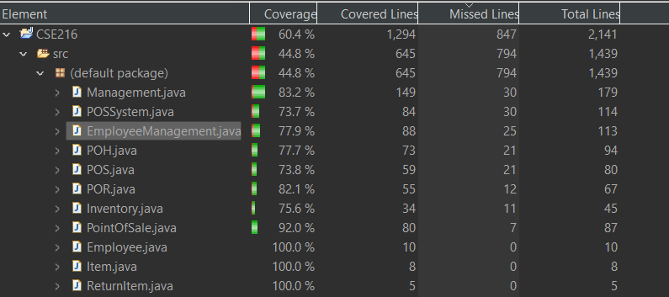

Decision Coverage

Coverage Achieved: Explain where and why 100% coverage was possible.

Inventroy class:
The linear control flow of the `Inventory` class, coupled with the apparent presence of branch points, make it readily obtain 100% branch coverage. Tests of both null and non-null cases in the `getInstance()` method allow it to be easy to insure the `if` condition deciding whether the singleton instance is or isn't null. Simulating both successful and unsuccessful file reads (for example, file not found) test the `try-catch` block in the `accessInventory` method. Testing scenarios involving addition and subtraction of inventory items makes it easy enough to cover all the branches of the `updateInventory` function, including nested loops and `if` statements handling `takeFromInventory`. Such requirements allow covering all the branches with a big battery of tests.
Coverage Gaps: Describe any areas where 100% coverage was not achievable, including reasons for these gaps (e.g., limitations in the code, untestable scenarios).0
- continueFromTemp in POSSystem
Because the continueFromTemp method has test cases of only very few small number that does not cover each scenario, it also fails to achieve 100% branch coverage. The tests as of now only check the branches for conditions where it returns "Sale" and "Rental" with the branch for "Return" not tested. Moreover, the tests coded so far do not exercise the following branches involving empty file scenarios or catch exception regarding file reading. Because the method returns an empty string if not all of the required conditions are satisfied and doesn't check the case in which the log file is invalid, many of the branches are not covered. As such, the approach can not have a full branch coverage because of these holes.

- Management() in Management class
Since the checking for the environmental conditions in which the code is executed is not possible to a complete extent, it is also not possible to achieve 100% branch coverage in the following {Management} constructor. Because the conditional statement checks the name of the operating system with `System.getProperty("os.name")`, it produces two branches: the `if} branch for Windows-based systems and the `else} branch for non-Windows-based systems. Among these, one will not be executed except when performed as a test in both Windows and non-Windows environment. Moreover, full branch coverage is not achievable since it will be impossible to ensure that both the two branches will be executed during tests as code behavior will vary with setup.

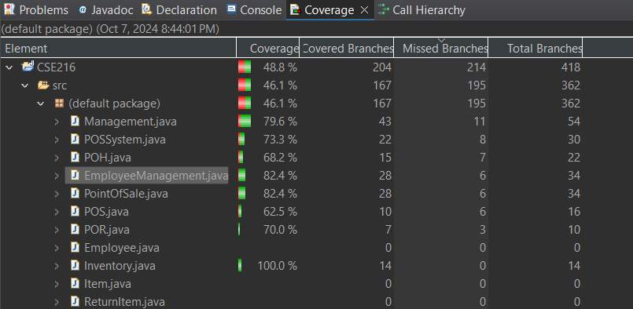

Improvements: Suggest potential improvements or additional tests that could help achieve higher coverage.
      - continueFromTemp in POSSystem
To cover the continueFromTemp method more thoroughly, even more tests checking each of the branches, in particular the "Return" case should be created as well. Because there are not any current ways to handle cases when the log file is either empty or invalid, tests should mimic those cases too. Moreover, so that all branches are covered by running tests, implement tests that call blocks that handle exceptions - namely FileNotFoundException and IOException. Mock file input may be much easier to test in various different scenarios compared with real files and could help ensure comprehensive coverage of all edge cases, thereby improving overall dependability.

      - Management() in Management class
Environmental checks' intrinsic limitations must thus be overcome to obtain 100% branch coverage for the Management constructor. Tests must be developed to check both branches of the conditional statement, due to the fact that the conditional statement in this case depends on the determination of whether a system is Windows or non-Windows. This may be accomplished either by continuous integration environments that simulate both conditions, or by a test framework that may play around with system attributes. Add a config option that may then identify OS type at test time, thereby ensuring that both are exercised - a configuration option that may specifically identify the OS type at test time, thereby enabling further testing of environmental dependencies.

Condition Coverage
Coverage Achieved: Explain where and why 100% coverage was possible.
addRental in Management class
Because the conditionals in the addRental method involve such typical conditional logic, all pathways are reachable within this method and 100% condition coverage is possible. The main conditional to test for the procedure is that the value passed in the phone argument equals the nextPhone variable. Test the branch for this method by passing different values of phone and both match and non-match values for complete coverage of true and false. Application of exception handling surrounding the operations of files is also very basic, and an approach would be about handling both FileNotFoundException and IOException to ensure proper analysis of all possible cases as it accesses and modifies the file of relevance to the user database.

Coverage Gaps: Describe any areas where 100% coverage was not achievable, including reasons for these gaps (e.g., limitations in the code, untestable scenarios).
addRental in Management class
Even under 100% condition coverage, it can be challenging to obtain complete statement coverage at all places. For instance, if the userDatabase file is empty or formatted incorrectly, the file line processing algorithm will not work as anticipated. It does not also stress test its catch block when it throws a NumberFormatException due to bad data; instead, it only skips to the next iteration with no hint on handling or logging. These instances are untested branches or unexecuted statements-mostly the file reading and writing logic- and thus leave holes in coverage.

Improvements: Suggest potential improvements or additional tests that could help achieve higher coverage.
addRental in Management class
For more coverage, several modifications might be done. For instance, to test routes that have not been covered currently, it would be helpful to construct unit tests that particularly handle edge cases such as when the file userDatabase might be empty or incorrectly formatted. Mock objects also can be used to simulate file I/O operations so that various scenarios could be tested while not depending on real files. Along with this aspect, improved error reporting in the catch blocks would also ensure that certain code paths are run during testing. If the file handling logic is broken down into more fragmented, tested methods, testing may be simplified and coverage increased.

Generate and Submit Reports:
    - JUnit Test Report: Capture and include screenshots of the JUnit test results showing which tests were executed and their outcomes.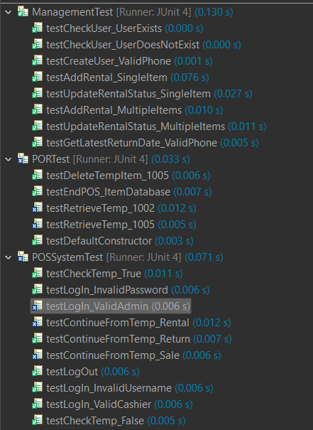
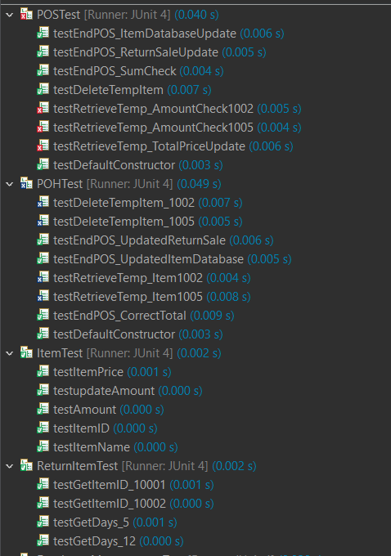
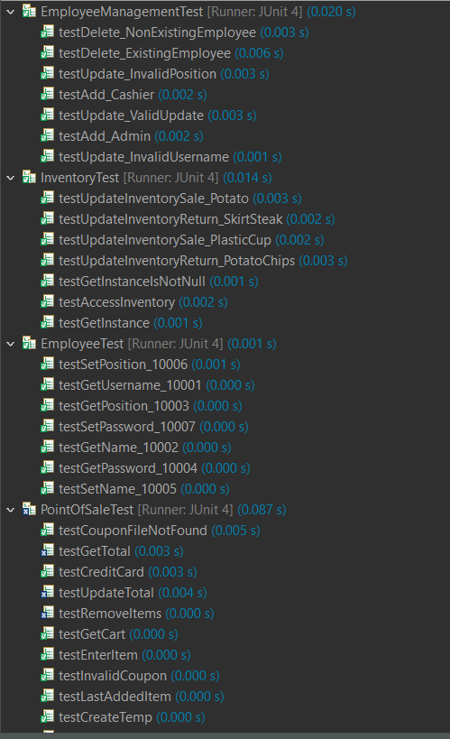
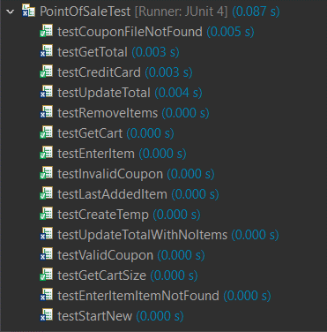
    - Coverage Report: Capture and include screenshots of the coverage report generated by EclEmma.

Statement Coverage Report


Decision Coverage Report



