APOLLO-M: AI FRAMEWORK FOR FORECASTING INSTABILITY IN DIGITAL COMMUNITIES

Kashaf Fatima
Rizwan Saleem
Aaqib Mehmood

A project report submitted in partial fulfilment of the
requirements for the award of the degree of
Bachelor of Science in Computer Science (BSCS)

Computer Science Department
Bahria University, Karachi Campus

2026

DECLARATION
We hereby declare that this project report is based on our original work except for citations and quotations which have been duly acknowledged. We also declare that it has not been previously and concurrently submitted for any other degree or award at Bahria University or any other institution.

Signature : _________________________
Name : Kashaf Fatima
Reg No. : 84381
Signature : _________________________
Name : Rizwan Saleem
Reg No. : _________________________
Signature : _________________________
Name : Aaqib Mehmood
Reg No. : _________________________
Date : _________________________

APPROVAL FOR SUBMISSION
We certify that this project report entitled “APOLLO-M: AI FRAMEWORK FOR FORECASTING INSTABILITY IN DIGITAL COMMUNITIES” was prepared by KASHAF FATIMA, RIZWAN SALEEM and AAQIB MEHMOOD, and has met the required standard for submission in partial fulfilment of the requirements for the award of the degree of Bachelor of Science in Computer Science at Bahria University, Karachi Campus.

Approved by,
Signature : _________________________
Supervisor : Mr. Saghir Ahmed
Date : _________________________

The copyright of this report belongs to Bahria University according to the Intellectual Property Policy of Bahria University. Due acknowledgement shall always be made of the use of any material contained in, or derived from, this report.

© 2026 Bahria University. All rights reserved.

ACKNOWLEDGEMENTS
We would like to thank everyone who contributed to the successful completion of this project. In particular, we wish to express our sincere gratitude to our supervisor, Mr. Saghir Ahmed, for his invaluable advice, guidance and patience throughout the development of APOLLO-M, and for consistently pushing us to justify our results rather than merely present them.
We also thank the Computer Science Department at Bahria University, Karachi Campus, for providing the environment and resources that made this work possible, and the maintainers of the open datasets and open-source libraries on which this project depends — without the Davidson toxicity corpus, the SNAP Reddit hyperlink network and the PyTorch ecosystem, a project of this scope would not have been achievable within a single academic year.
Finally, we thank our families and friends for their encouragement and support throughout this work.

APOLLO-M: AI FRAMEWORK FOR FORECASTING INSTABILITY IN DIGITAL COMMUNITIES

ABSTRACT
Online communities can deteriorate. Hostility rises, moderators are overwhelmed, constructive members leave, and a space that functioned collapses into conflict. Existing moderation tools are almost entirely reactive: they classify an individual comment after it has been posted, and they describe the present state of a community rather than its direction of travel. By the time a dashboard reports that a community is unhealthy, the damage that made it unhealthy has already occurred.
APOLLO-M is a multi-layer framework that treats community instability as a forecasting problem rather than a classification problem. A micro layer scores individual comments for toxicity using a transformer classifier. A meso layer aggregates those scores, together with author churn and graph-derived polarisation and echo-chamber measures, into a Community Health Index and a trend-aware instability score. An unsupervised layer clusters communities by behavioural profile without labels. A macro layer applies a Temporal Fusion Transformer to produce a five-day toxicity forecast with p10/p50/p90 confidence bands per community. Results are persisted to PostgreSQL, served through an authenticated REST API, and presented in a dashboard with Prometheus and Grafana monitoring. A language model is used only to explain findings in natural language; every number is produced by a deterministic model or a measurable classifier.
Because no public dataset labels which online communities genuinely destabilised and when, the framework is validated against a declared simulation with recorded ground truth: sixty communities are generated over one hundred and twenty days from real Reddit community structure and a real labelled toxicity corpus, and fifteen are given a deliberately rising toxicity trend that the pipeline never sees. The forecaster identifies a rising trend in 15 of 15 planted communities, with a slope ROC-AUC of 0.7319. Ranking communities by the trend-aware instability score achieves an ROC-AUC of 1.0, against 0.5748 for the Community Health Index and 0.6489 for raw toxicity alone. That ordering is itself a finding: an index built from present-tense health cannot rank communities by how quickly they are changing, which is what forecasting instability requires. The toxicity classifier, evaluated on a held-out split of real labelled data, achieves 90.1% accuracy and a macro F1 of 0.702.

TABLE OF CONTENTS
DECLARATION ii
APPROVAL FOR SUBMISSION iii
ACKNOWLEDGEMENTS v
ABSTRACT vi
TABLE OF CONTENTS vii
LIST OF TABLES ix
LIST OF FIGURES x
LIST OF SYMBOLS / ABBREVIATIONS xi

CHAPTER
1 INTRODUCTION 1
1.1 Background 1
1.2 Problem Statement 3
1.3 Aims and Objectives 4
1.4 Scope of Project 5
2 LITERATURE REVIEW 6
2.1 Background 6
2.2 Related Work 7
2.2.1 Toxicity and Abusive Language Detection 7
2.2.2 Community-Level Health and Conflict 8
2.2.3 Graph Representations of Communities 9
2.2.4 Temporal Forecasting of Social Signals 9
2.2.5 Misinformation Detection 10
2.3 Research Gap and Summary 11
2.4 Comparison with Existing Studies 14
2.5 Chapter Summary 15
3 DESIGN AND METHODOLOGY 16
3.1 Proposed Methodology (Framework / Architecture) 16
3.2 Process Model 18
3.3 Modules Discussion 19
3.3.1 Micro Layer 19
3.3.2 Meso Layer 20
3.3.3 Unsupervised Layer 21
3.3.4 Macro Layer 21
3.3.5 Act, Serve and Observe 22
3.4 Project Diagrams 23
3.4.1 Database Design (ERD) 23
3.4.2 Sequence Diagram 24
3.4.3 Context Diagram 25
3.4.4 Use Case Diagram 26
3.5 Datasets and Data Provenance 27
3.6 Evaluation Methodology and Results 28
3.7 Chapter Summary 30
REFERENCES 31

LIST OF TABLES
TABLE TITLE PAGE
Table 2.1: Research Summary 11
Table 2.2: Comparison with Existing Studies 14
Table 3.1: Datasets Used and Their Role 27
Table 3.2: Detection Performance Against Planted Ground Truth 28
Table 3.3: Forecasting Performance Against Planted Ground Truth 29

LIST OF FIGURES
FIGURE TITLE PAGE
Figure 3.1: APOLLO-M System Architecture 17
Figure 3.2: Process Model 18
Figure 3.3: System Block Diagram 19
Figure 3.4: Database Design (ERD) 23
Figure 3.5: Sequence Diagram 24
Figure 3.6: Context Diagram 25
Figure 3.7: Use Case Diagram 26
Figure 3.8: Request Processing Flow 28
Figure 3.9: Integration with CEREBRO 30

LIST OF SYMBOLS / ABBREVIATIONS
API Application Programming Interface
AUC Area Under the Receiver Operating Characteristic Curve
BERT Bidirectional Encoder Representations from Transformers
CHI Community Health Index
DBSCAN Density-Based Spatial Clustering of Applications with Noise
ERD Entity Relationship Diagram
F1 Harmonic mean of precision and recall
GNN Graph Neural Network
JWT JSON Web Token
LLM Large Language Model
MAE Mean Absolute Error
NLP Natural Language Processing
p10 / p50 / p90 10th, 50th and 90th percentile forecast quantiles
PCA Principal Component Analysis
RAG Retrieval-Augmented Generation
REST Representational State Transfer
RoBERTa Robustly Optimised BERT Pretraining Approach
ROC Receiver Operating Characteristic
SNAP Stanford Network Analysis Project
TFT Temporal Fusion Transformer
TF-IDF Term Frequency – Inverse Document Frequency

CHAPTER 1

INTRODUCTION

1.1 Background
Online communities are now a primary venue for public discussion, technical collaboration, journalism and political organisation. They are also fragile. A space that functions for years can deteriorate within weeks: hostility rises, established members disengage, moderators are overwhelmed by volume, and the community either fragments or is closed. The pattern is familiar enough that platforms have named it, yet the tools available to moderators remain almost entirely reactive.
The question that motivates this project has an unusual origin. Between 1968 and 1973 the ethologist John B. Calhoun ran a series of experiments, the last and best known of which is Universe 25, in which a mouse population was given unlimited food, water and protection from predators, but a fixed amount of space. The population grew, then collapsed. What Calhoun documented was not starvation but a breakdown of social behaviour: withdrawal, aggression, the abandonment of normal social roles. He called the result a behavioural sink [11]. The experiment is contested as a model of human society, and this project does not claim otherwise. What is striking for our purposes is a methodological absence: the collapse was observed and described in detail after the fact, but there was no measurement that signalled it in advance. Nobody could have said, at month nine, that month sixteen was coming.
Digital communities present the same problem with one crucial advantage: they are continuously and completely instrumented. Every message, every participant and every interaction is recorded with a timestamp. If a community is deteriorating, the evidence exists in that record before the outcome is visible. The difficulty is that existing systems do not look for it. Toxicity classifiers judge a single comment after it has been posted. Health dashboards report what a community looks like today. Both describe a state; neither describes a direction.
APOLLO-M is built on the position that community instability should be treated as a forecasting problem rather than a classification problem. The system scores individual comments, aggregates them into community-level measures, learns how those measures move over time, and projects them five days forward with explicit uncertainty. The intended output is not a verdict on a comment but a warning about a community, issued early enough that intervention is still possible.

1.2 Problem Statement
Moderation tooling operates at the wrong unit of analysis and at the wrong point in time. It is applied per comment, after publication, and reports present state rather than trajectory. Consequently a community whose hostility is rising sharply but from a low base attracts no attention, while a community that is stably contentious generates continuous alerts that require no action. Moderators receive volume rather than priority.
There is a second, subtler problem. Composite health indices are usually constructed from present-tense measurements such as toxicity rate, polarisation and churn. An index of this form measures how unhealthy a community is, which is not the same quantity as how quickly it is changing. This project shows empirically that the distinction matters: ranking communities by such an index performs worse than ranking them by a single one of its own inputs (Section 3.6).
APOLLO-M therefore addresses the need for a system that operates at community level, models change over time rather than state, quantifies its own uncertainty, and produces a prioritised, actionable signal instead of an undifferentiated stream of flags.

1.3 Aims and Objectives
The objectives of this project are as follows:
1. To score individual community messages for toxicity using a transformer-based classifier, and to evaluate that classifier on held-out labelled data.
2. To aggregate per-message scores, together with author churn and graph-derived polarisation and echo-chamber measures, into an interpretable community-level Community Health Index and a trend-aware instability score.
3. To discover behavioural groupings among communities without supervision, so that communities may be compared against structurally similar peers.
4. To forecast each community's toxicity five days ahead using a Temporal Fusion Transformer, producing p10, p50 and p90 quantiles rather than a point estimate, so that the confidence of each forecast is explicit.
5. To convert forecasts into graded alerts and recommended moderation actions, and to serve them through an authenticated API, an interactive dashboard and a monitoring stack.
6. To validate the framework against recorded ground truth and report the result quantitatively, including where components underperform.

1.4 Scope of Project
The scope of the current phase is defined as follows:
1. Analysis operates on English-language text. Multilingual toxicity detection is outside the present scope.
2. Community-level analysis covers the sixty largest communities in the working corpus, selected by message volume; the selection criterion is stated so that it can be reproduced and criticised.
3. The forecasting horizon is five days, with a fourteen-day lookback window.
4. Live platform ingestion is implemented as a module and is pending credential approval; the present evaluation uses a declared simulation with recorded ground truth, described in Section 3.5.
5. The language model is confined to generating natural-language explanations of results already computed. It does not classify, score or decide.

CHAPTER 2

LITERATURE REVIEW

2.1 Background
Research relevant to this project falls into five strands. The first is the automatic detection of toxic, abusive and hateful language, which supplies the per-message signal on which everything else is built. The second concerns community-level health and conflict, and asks what happens to a community as a whole rather than to an individual message. The third represents platforms as graphs, capturing relationships between communities rather than only their contents. The fourth is temporal forecasting, which supplies the machinery for projecting a signal forward with quantified uncertainty. The fifth is misinformation detection, contributing a second and distinct mode of community harm. Each strand is well developed individually; the gap this project addresses lies in their combination.

2.2 Related Work

2.2.1 Toxicity and Abusive Language Detection
Davidson et al. [1] distinguished hate speech from merely offensive language and released a labelled corpus of approximately 25,000 annotated messages that remains a standard benchmark; their central finding, that lexical methods systematically confuse offensive language with hate speech, motivated later transformer-based work. Wulczyn et al. [12] scaled annotation to over a hundred thousand Wikipedia discussion comments, demonstrating that crowd labels can approximate expert judgement at scale, and Founta et al. [13] characterised abusive behaviour on Twitter across multiple overlapping categories. With the arrival of pretrained language models [3][4], classification accuracy improved substantially; the Detoxify family of models [2], used in this project, fine-tunes BERT on the Jigsaw toxicity corpora and provides calibrated per-message toxicity probabilities.
The limitation common to this strand is one of unit and timing. These systems classify a message, in isolation, after it has been published. They provide no aggregate view of a community and make no statement about the future.

2.2.2 Community-Level Health and Conflict
Chandrasekharan et al. [9] examined the 2015 ban of several hate-focused Reddit communities and measured the effect on the hate speech produced by their former members, providing rare quantitative evidence on the effect of a community-level intervention. Kumar et al. [5] studied conflict between communities directly, analysing hyperlinks between subreddits and the mobilisation effects that follow. Cinelli et al. [10] compared echo-chamber formation across four platforms and showed that the effect varies with platform architecture rather than being a universal property of social media. Garimella et al. [16] proposed graph-based measures for quantifying controversy within discussion networks.
This strand establishes that community-level measurement is both meaningful and tractable. It is, however, predominantly retrospective: the analyses characterise what happened, and none produces a forward-looking estimate with quantified uncertainty.

2.2.3 Graph Representations of Communities
The SNAP Reddit hyperlink network released with Kumar et al. [5] models communities as nodes and inter-community references as sentiment-weighted directed edges, and is used in this project to derive per-community polarisation and echo-chamber measures. Hamilton et al. [6] introduced GraphSAGE, an inductive framework that generates embeddings for previously unseen nodes by sampling and aggregating neighbourhood features. That property matters here: new communities appear continuously, and a transductive method would require retraining for each one.

2.2.4 Temporal Forecasting of Social Signals
The attention mechanism [8] underpins most current sequence models. Lim et al. [7] introduced the Temporal Fusion Transformer, which combines recurrent processing of local dynamics with interpretable attention over longer horizons, supports static covariates alongside time-varying inputs, and, decisively for this project, is trained with a quantile loss so that it produces prediction intervals rather than point estimates. For a moderation system this distinction is not cosmetic: a forecast of rising toxicity with wide uncertainty warrants a different response from the same forecast with narrow uncertainty, and a point estimate cannot express the difference.

2.2.5 Misinformation Detection
Shu et al. [14] surveyed misinformation detection on social media and characterised the problem as one of combining content, social context and propagation signals. Zannettou et al. [15] mapped the wider ecosystem of false information and its actors. Retrieval-augmented generation [21] offers a route to verdicts grounded in retrieved evidence rather than in a model's parameters, which is the approach taken by CEREBRO, the companion system described in Section 3.8.

2.3 Research Gap and Summary
Taken together, the reviewed work supplies every component this project requires, but no reviewed system combines them. Toxicity classifiers operate per message and after the fact. Community-level studies operate retrospectively and produce no forecast. Graph methods characterise structure without projecting it forward. Forecasting architectures are mature but have not been applied to community instability with quantified uncertainty. The gap APOLLO-M addresses is therefore integrative: an end-to-end framework moving from per-message scoring, through community-level aggregation and unsupervised structure discovery, to a probabilistic five-day forecast and a prioritised alert, with each stage measurable in isolation.
A second and narrower gap emerged during development and is, to our knowledge, not addressed in the reviewed literature: composite community health indices are constructed from present-tense measurements, and are therefore poorly suited to ranking communities by rate of change. Section 3.6 quantifies this effect and presents a trend-aware alternative.
Table 2.1: Research Summary
Paper Title | Year | Author | Limitation / Research Gap | Algorithms / Methodology | Result
Automated Hate Speech Detection and the Problem of Offensive Language | 2017 | Davidson, Warmsley, Macy, Weber | Per-message classification only; no community-level aggregation and no temporal component. | Crowd-sourced annotation of about 25,000 tweets into hate speech, offensive language and neither; logistic regression over n-gram and lexical features. | Established that lexical methods conflate offensive language with hate speech. The released corpus is the labelled toxicity data used in this project.
Ex Machina: Personal Attacks Seen at Scale | 2017 | Wulczyn, Thain, Dixon | Produces per-comment attack scores; no notion of community trajectory. | Crowd annotation of over 100,000 Wikipedia talk-page comments; linear and MLP classifiers over character and word n-grams. | Demonstrated that crowd labels approximate expert judgement at scale, enabling large toxicity corpora.
Detoxify: Toxic Comment Classification | 2020 | Hanu and the Unitary team | Message-level probabilities only; no aggregation, forecasting or community context. | BERT-family transformers fine-tuned on the Jigsaw toxicity corpora and released as pretrained models. | Calibrated per-message toxicity probabilities. unitary/toxic-bert is the micro-layer scorer in this project.
Community Interaction and Conflict on the Web | 2018 | Kumar, Hamilton, Leskovec, Jurafsky | Retrospective analysis of conflict that has already occurred; no predictive model of community health. | Directed hyperlink network of 36,000 subreddits with sentiment-weighted edges; LSTM over user, community and text features to predict mobilisation. | Showed that inter-community conflict is driven by a small number of communities. Supplies the SNAP graph used here for polarisation and echo-chamber measures.
You Cannot Stay Here: The Efficacy of the 2015 Reddit Ban Examined Through Hate Speech | 2017 | Chandrasekharan et al. | Evaluates an intervention after the fact; offers no early-warning signal that would allow earlier action. | Causal analysis of hate-speech usage by affected users before and after the ban, with matched controls. | Community-level intervention measurably reduced hate speech by affected users, establishing that community-scale action is effective.
The Echo Chamber Effect on Social Media | 2021 | Cinelli et al. | Descriptive and cross-sectional; no temporal forecast of a community trajectory. | Comparative analysis of feed algorithms and interaction networks across Facebook, Twitter, Reddit and Gab. | Echo-chamber strength varies with platform architecture, motivating echo-chamber measures as a per-community feature.
Inductive Representation Learning on Large Graphs (GraphSAGE) | 2017 | Hamilton, Ying, Leskovec | General-purpose graph learning; not applied to community health or instability. | Inductive node embeddings produced by sampling and aggregating neighbourhood features, generalising to unseen nodes. | Enables embeddings for communities absent at training time. Adopted as the Phase 2 structural component of the meso layer.
Temporal Fusion Transformers for Interpretable Multi-horizon Time Series Forecasting | 2021 | Lim, Arik, Loeff, Pfister | Demonstrated on retail, traffic and electricity data; not applied to social or community signals. | Attention-based architecture with variable selection, static covariate encoders and a quantile loss for multi-horizon forecasting. | Interpretable multi-horizon forecasts with prediction intervals. Forms the macro layer of this project.
Fake News Detection on Social Media: A Data Mining Perspective | 2017 | Shu, Sliva, Wang, Tang, Liu | Detects individual false items; does not model the effect of misinformation on community stability. | Survey and taxonomy of content-based, social-context and propagation-based detection methods. | Framed misinformation detection as a multi-signal problem, informing the planned misinformation-pressure covariate.

2.4 Comparison with Existing Studies
Table 2.2 compares APOLLO-M with representative systems from the reviewed literature along the dimensions that distinguish it.
Table 2.2: Comparison with Existing Studies
System | Unit of analysis | Temporal | Uncertainty | Graph features | Deployed
Davidson et al. [1] | Message | No | No | No | No
Detoxify [2] | Message | No | No | No | Model release
Kumar et al. [5] | Community pair | Retrospective | No | Yes | No
Chandrasekharan et al. [9] | Community | Retrospective | No | No | No
Cinelli et al. [10] | Platform | Cross-sectional | No | Yes | No
APOLLO-M (this work) | Community | 5-day forecast | p10 / p50 / p90 | Yes | API + dashboard

2.5 Chapter Summary
The reviewed literature provides mature solutions to each sub-problem this project depends upon: transformer-based toxicity classification, community-level measurement, graph representations of inter-community relationships, and interpretable probabilistic forecasting. What it does not provide is their integration into a system that issues an early, prioritised and uncertainty-aware warning about a community rather than a verdict about a message. That integration, together with the empirical finding that present-tense health indices are ill-suited to ranking communities by rate of change, constitutes the contribution of this work.

CHAPTER 3

DESIGN AND METHODOLOGY
This chapter describes what has been built, how it is organised, and what it measures. The framework is implemented end to end and deployed; Section 3.6 reports its measured performance and Section 3.9 sets out the work scheduled for the next phase.

3.1 Proposed Methodology (Framework / Architecture)
APOLLO-M is organised as a layered pipeline. Each layer consumes the output of the layer beneath it, produces an artefact that can be inspected and measured on its own, and is independent of the layers above. The design follows one governing principle: every number the system reports is produced by a deterministic computation or a measurable model, and a language model is used only to describe those numbers in natural language. No score, alert or forecast originates from a language model.
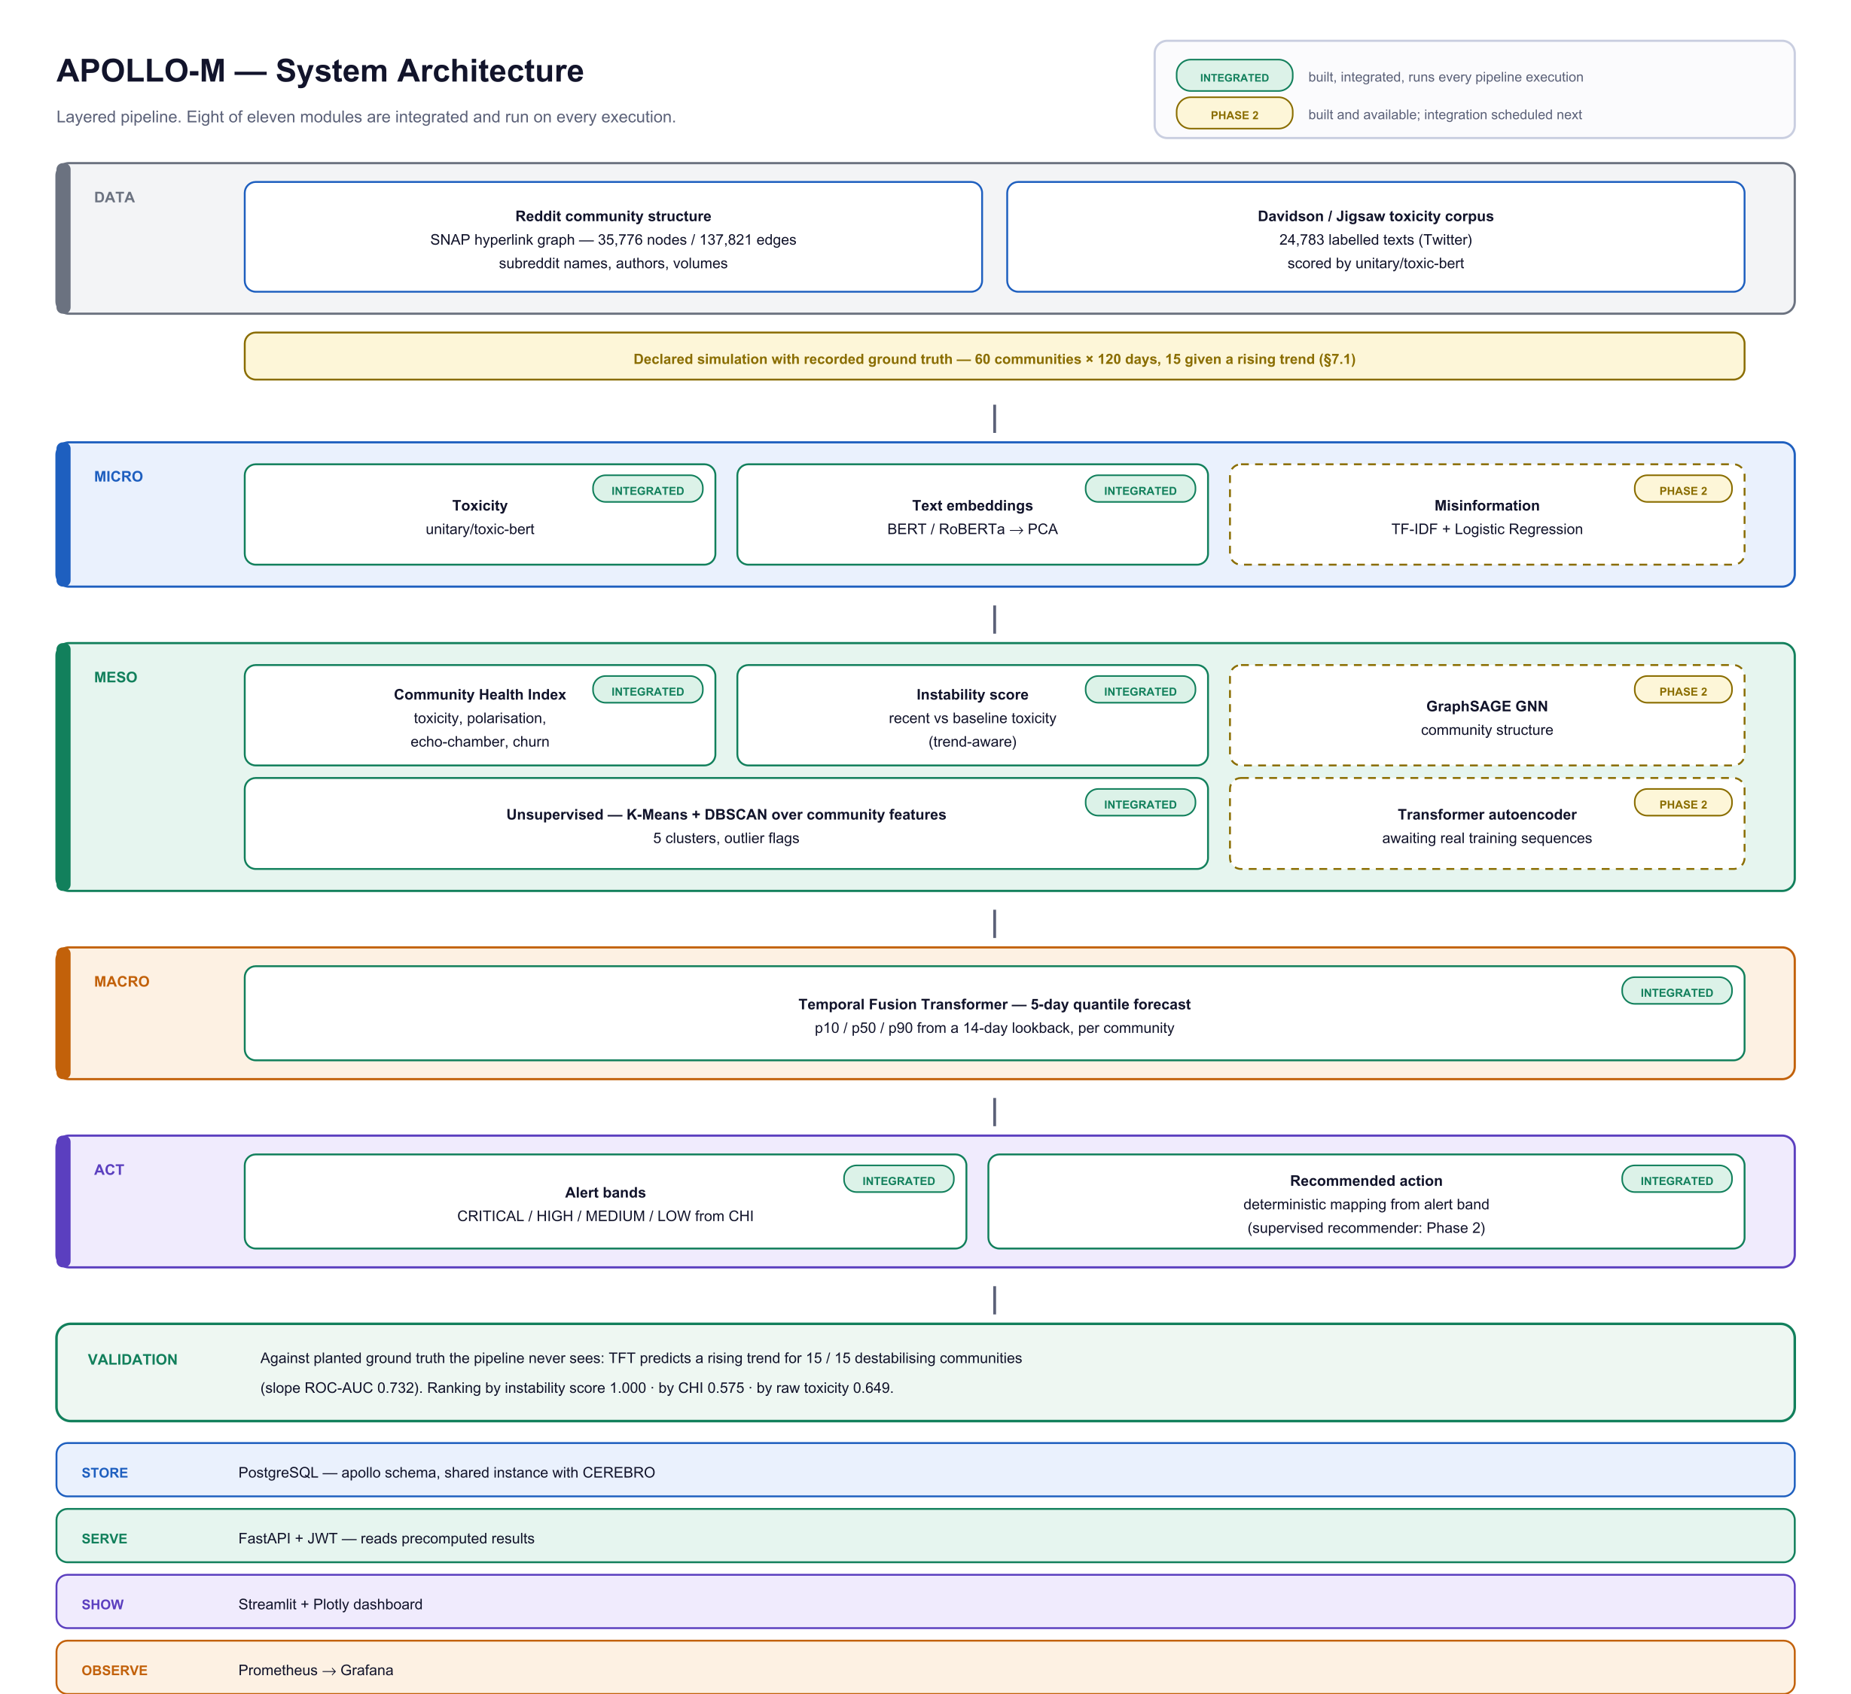
Figure 3.1: APOLLO-M system architecture. Modules marked INTEGRATED are built and execute on every pipeline run; those marked PHASE 2 are implemented and available, with integration scheduled for the next phase.
The DATA layer supplies real Reddit community structure from the SNAP hyperlink network together with a labelled toxicity corpus. The MICRO layer scores every message. The MESO layer aggregates those scores into community-level measures and discovers behavioural groupings. The MACRO layer forecasts. The ACT layer converts forecasts into graded alerts and recommended actions. Results are then stored, served and observed.

3.2 Process Model
Development followed an incremental and iterative model rather than a sequential one. Each layer was built, measured against data, and only then integrated with the layer above. This choice was deliberate: a layered analytical pipeline accumulates error silently, and a defect introduced early is expressed as a plausible but wrong number later. Measuring each layer before depending on it localises faults to the layer that produced them.
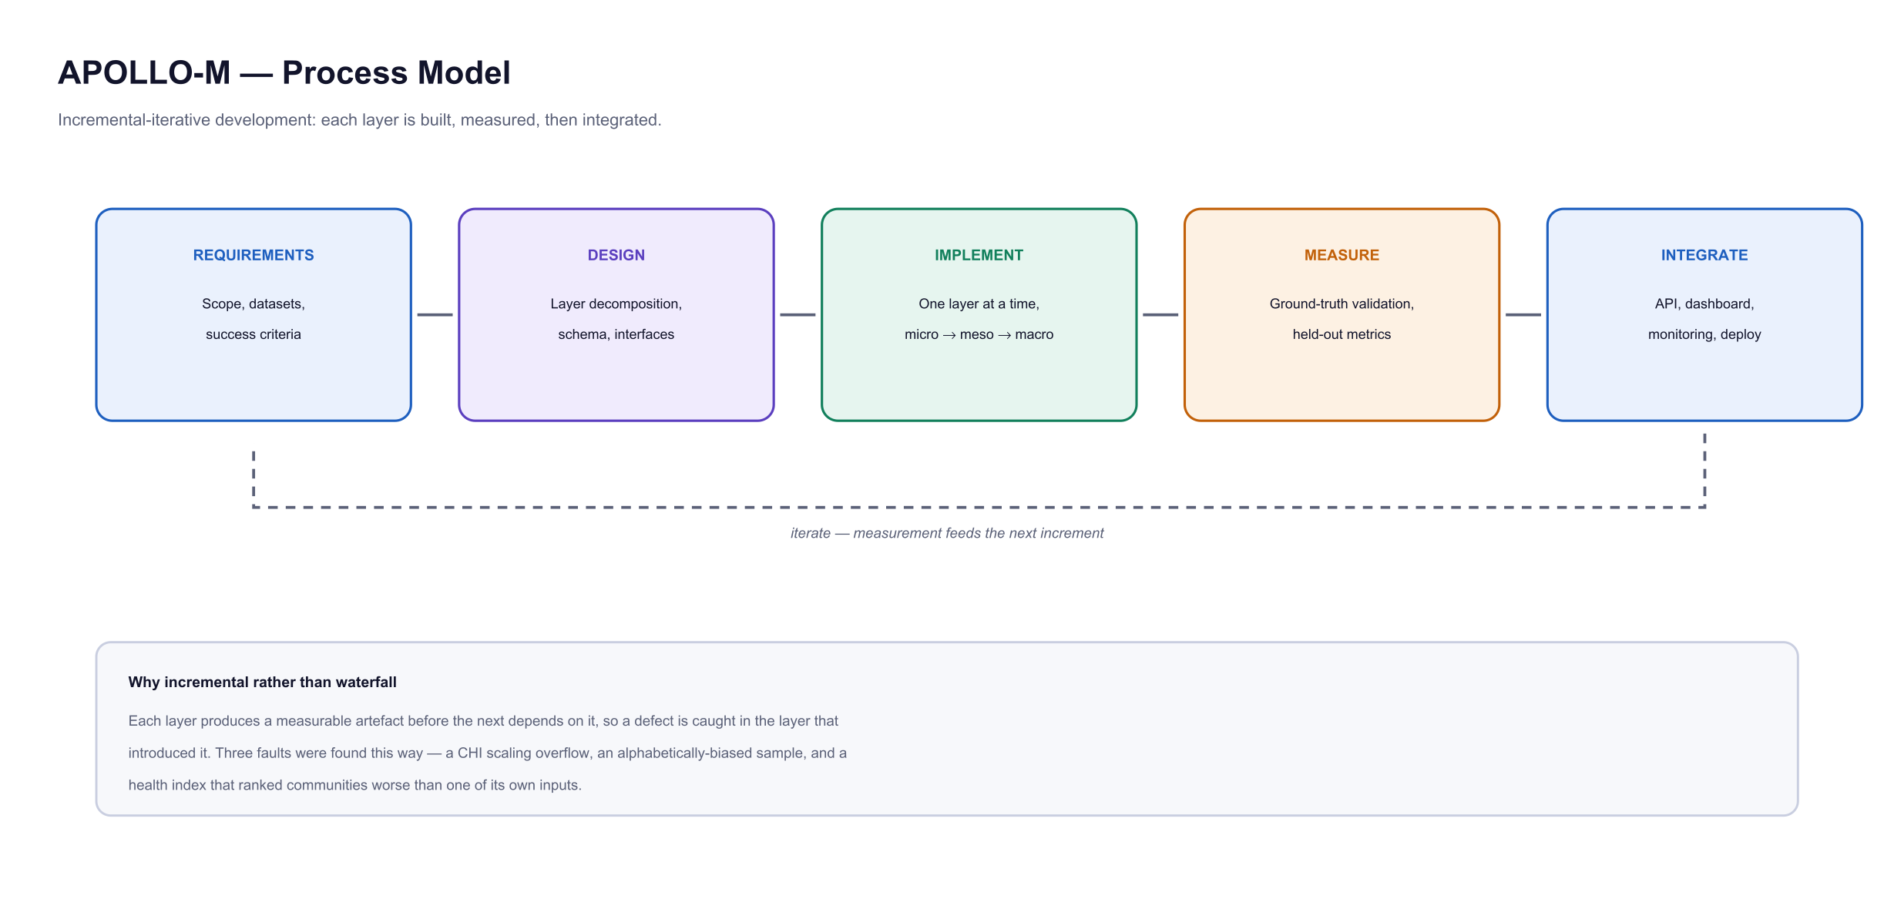
Figure 3.2: Process model. Measurement precedes integration at every increment, and its results feed the following increment.
The approach was validated in practice. Three defects were identified by measuring intermediate outputs rather than by inspecting code: a scaling error that drove the Community Health Index to zero for every community; a sampling defect in which the corpus loader read a fixed prefix of a file sorted by community name, so that analysis covered only communities beginning with a single letter; and the finding, described in Section 3.6, that the health index ranked communities less accurately than one of its own inputs. None of these would have been visible from the code alone.

3.3 Modules Discussion
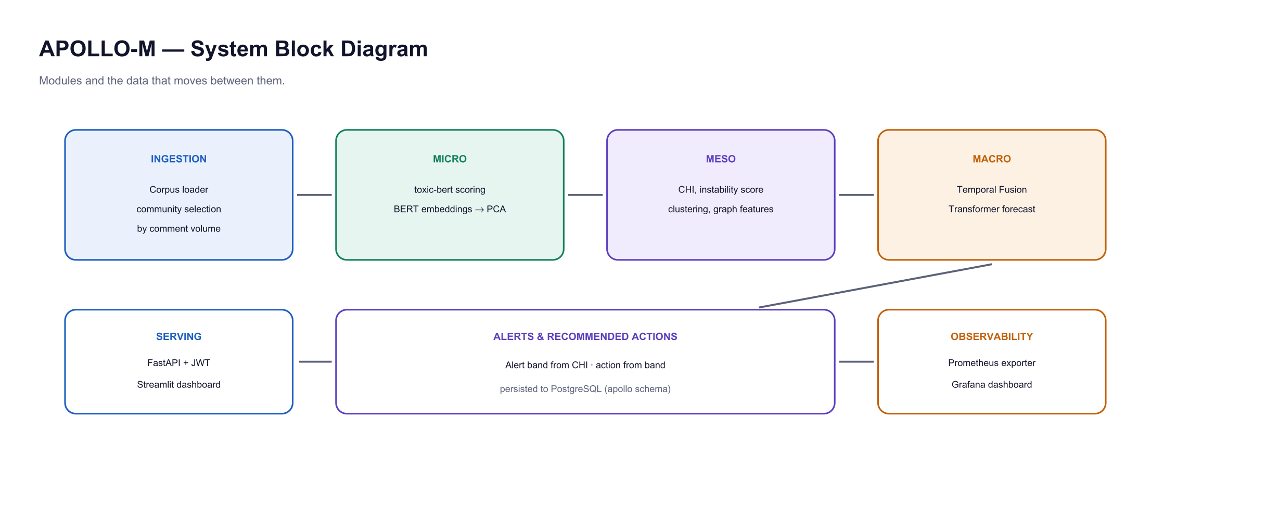
Figure 3.3: System block diagram showing the modules and the data passed between them.

3.3.1 Micro Layer
The micro layer scores each message for toxicity using unitary/toxic-bert [2], a BERT-family transformer fine-tuned on the Jigsaw toxicity corpora, which returns a calibrated probability per message. A parallel component produces sentence embeddings using BERT/RoBERTa representations [3][4], reduced by principal component analysis, which become covariates for the forecasting layer. Evaluated on a held-out split of the labelled corpus, the classifier achieves 90.1% accuracy, micro F1 0.901 and macro F1 0.702. Macro F1 is reported alongside micro F1 because the classes are imbalanced and micro F1 alone would flatter the result on the majority class.

3.3.2 Meso Layer
The meso layer converts per-message scores into per-community measures. The Community Health Index combines four normalised inputs into a bounded score on a 0 to 100 scale, where a higher value indicates a healthier community:
CHI = 100 - (35 T + 30 P + 20 C + 15 E)
(3.1)
T = mean toxicity rate of the community, 0 to 1
P = polarisation, the share of the community's hyperlinks carrying negative sentiment
C = author churn, the proportion of established authors who ceased participating
E = echo-chamber index, the local clustering coefficient of the community in the graph
Polarisation and the echo-chamber index are computed from the community's own node in the SNAP hyperlink graph. An earlier implementation computed both as global constants applied identically to every community, which meant that 45 of the 100 available penalty points were a fixed offset incapable of distinguishing one community from another; per-community computation corrected this.
The layer also computes an instability score, which measures direction of travel rather than present state. Mean toxicity over a recent window is compared against the earlier baseline for the same community, and the resulting trend is weighted above the absolute level:
Instability = 0.65 x min(1, max(0, DT / 0.25)) + 0.35 x T
(3.2)
DT = mean toxicity in the most recent quartile of the window minus the mean over the preceding period
The trend term dominates because a community whose hostility is rising is one where intervention can still change the outcome, whereas a community that is stably contentious is already known to its moderators. Section 3.6 shows this score substantially outperforms the Community Health Index at identifying destabilising communities.

3.3.3 Unsupervised Layer
Communities are grouped by behavioural profile without labels. K-Means partitions them into five clusters over the standardised health features, and DBSCAN [20] independently flags communities that belong to no dense region and are therefore behaviourally atypical. Principal component analysis provides a two-dimensional projection for visual inspection. The purpose is comparative: a community is more usefully judged against structurally similar peers than against a global average.

3.3.4 Macro Layer
The macro layer forecasts each community's toxicity five days ahead using a Temporal Fusion Transformer [7] with a fourteen-day lookback. The model is trained with a quantile loss and emits the 10th, 50th and 90th percentiles rather than a single value, so that the width of the interval communicates the confidence of the forecast. An earlier implementation requested the wrong prediction mode and returned three identical quantiles, producing confidence bands of zero width; the defect was found by inspecting the output rather than the code, and the corrected implementation produces intervals that widen with horizon as expected.

3.3.5 Act, Serve and Observe
Alert bands are derived from the Community Health Index as CRITICAL, HIGH, MEDIUM or LOW, and each band maps to a recommended moderation action from NO_ACTION through to EMERGENCY_INTERVENTION. Results are persisted to PostgreSQL, served by a FastAPI application secured with JSON Web Tokens and role-based access control, and presented in a Streamlit dashboard. A Prometheus exporter publishes system metrics, which Grafana charts for operational monitoring; the deployed API additionally serves the same series at /metrics so that any monitoring system can scrape it.

3.4 Project Diagrams

3.4.1 Database Design (ERD)
Results are persisted in PostgreSQL. The schema separates per-community measurements, alerts and forecasts so that each pipeline run appends a new observation rather than overwriting history, which is what permits trends to be computed over time.
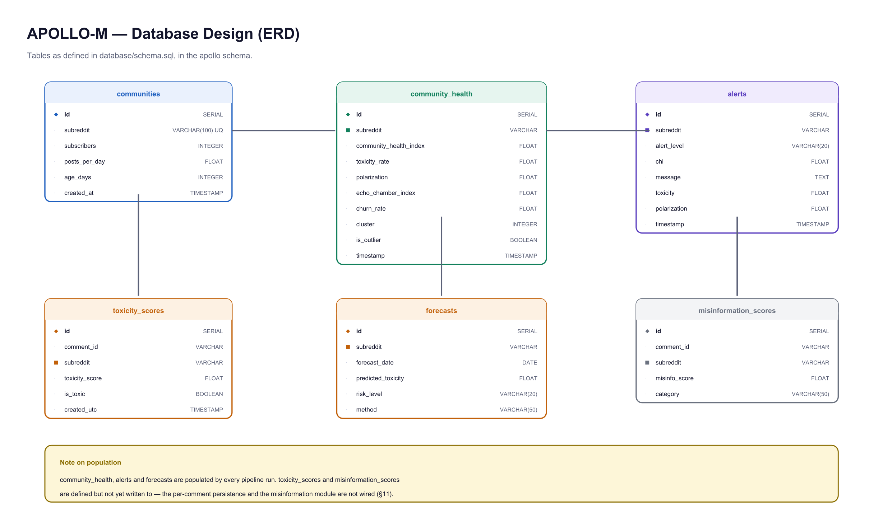
Figure 3.4: Entity relationship diagram of the apollo schema.

3.4.2 Sequence Diagram
Figure 3.5 traces a typical interaction: a moderator opens a community drill-down and requests an explanation. The ordering is significant. Every value shown to the user is read from storage before the language model is contacted, and the model receives already-computed metrics and returns only prose.
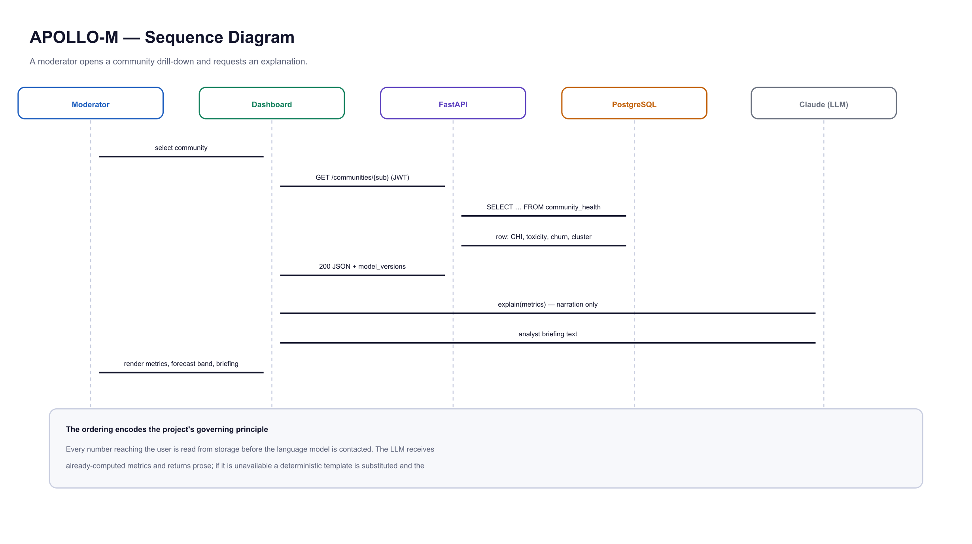
Figure 3.5: Sequence diagram for a community drill-down with explanation.

3.4.3 Context Diagram
Figure 3.6 places the system within its boundary, showing the external entities it exchanges data with and the direction of each exchange.
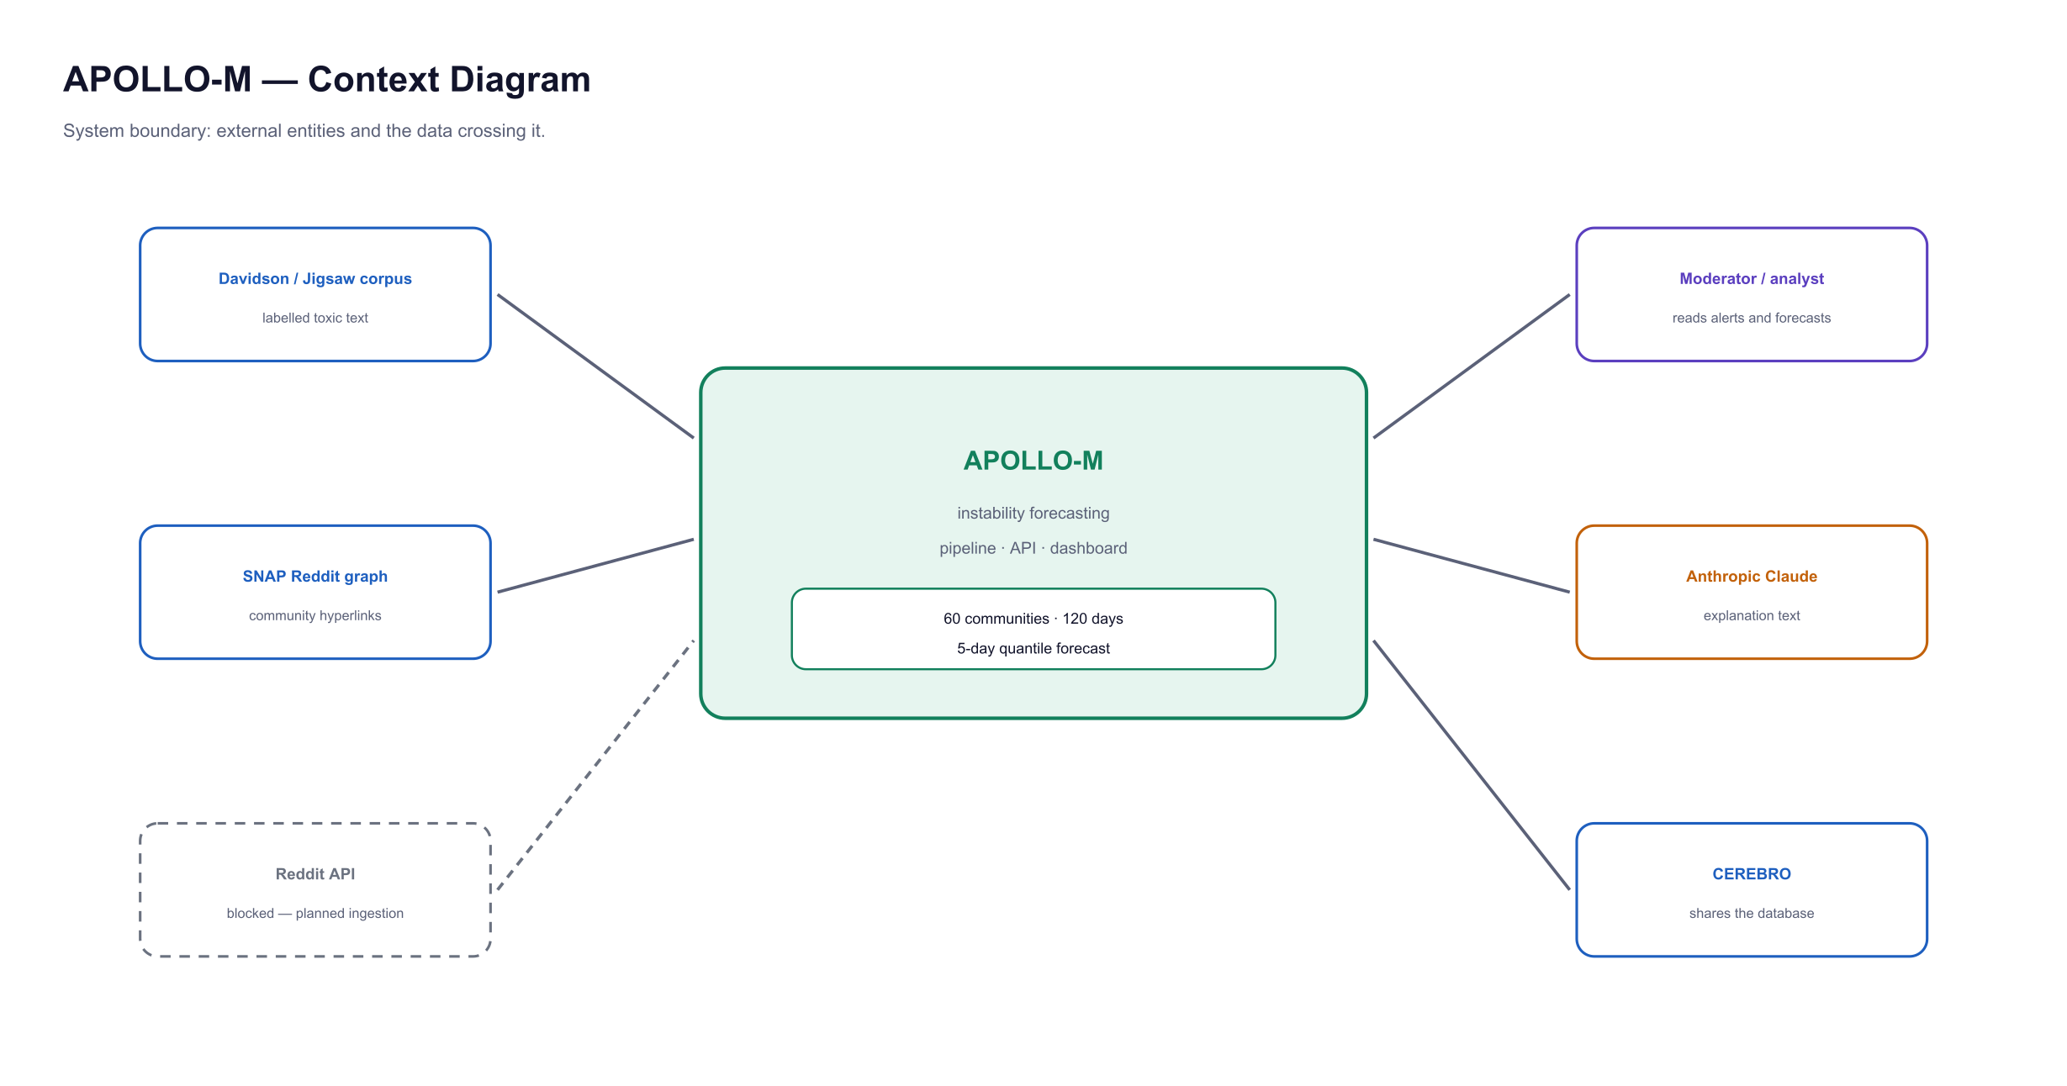
Figure 3.6: Context diagram showing the system boundary and external entities.

3.4.4 Use Case Diagram
Three roles are defined and enforced by the API through claims carried in the authentication token: viewer, analyst and administrator.
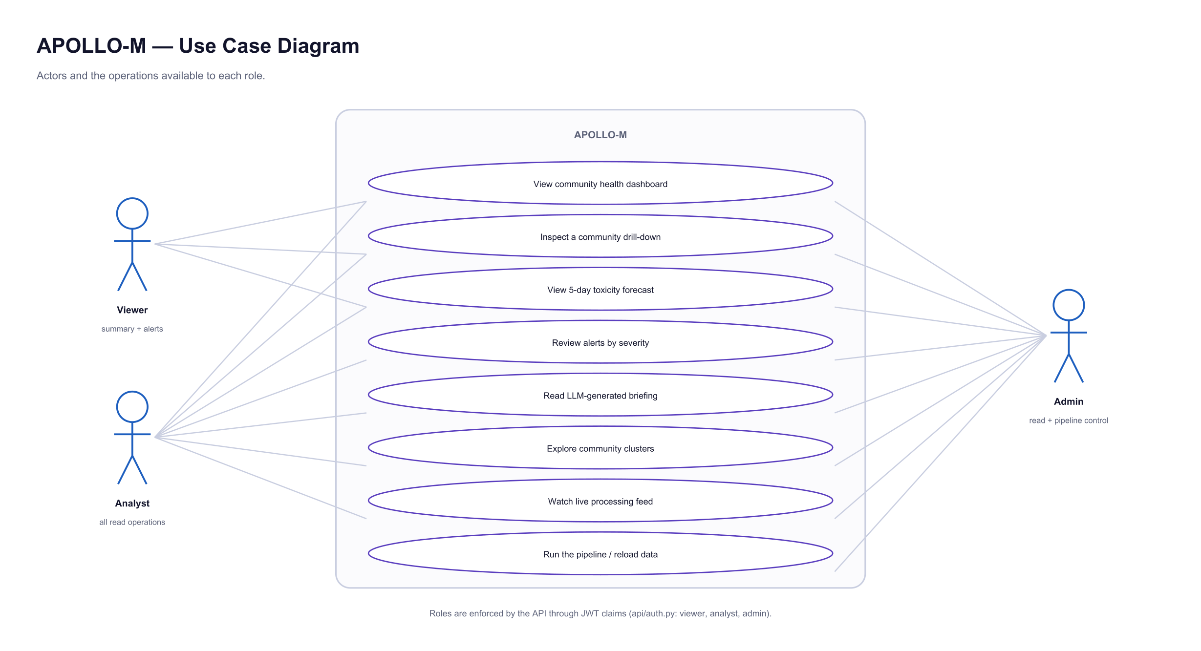
Figure 3.7: Use case diagram with role-based access.

3.5 Datasets and Data Provenance
The project draws on two established public datasets, listed in Table 3.1. Notably, they originate from different platforms: the labelled toxicity corpus is Twitter data and the community structure is Reddit data. The framework is therefore already exercised across two platforms, which supports the design claim that everything above the ingestion layer is platform-independent.
Table 3.1: Datasets Used and Their Role
Dataset | Platform | Scale | Role in APOLLO-M
Davidson / Jigsaw toxicity corpus [1] | Twitter / X | 24,783 labelled texts | Training and held-out evaluation of the toxicity classifier; supplies the scored message pool
SNAP Reddit Hyperlink Network [5] | Reddit | 35,776 nodes, 137,821 edges | Per-community polarisation and echo-chamber measures; intended GraphSAGE input
Reddit community metadata | Reddit | 8,865 communities | Community names, author populations and activity volumes

Evaluating a forecaster of community instability requires knowing which communities actually destabilised and when. No public dataset provides those labels. The project therefore adopts a standard alternative used where ground truth is unavailable: a declared simulation in which the answer is recorded in advance and withheld from the system.
Sixty communities are generated over one hundred and twenty concurrent days using real community names, author populations and activity volumes. Each is assigned a latent toxicity propensity, and a recorded subset of fifteen is given a deliberately rising trend over the final third of the window. Message toxicity is not synthetic: a pool of twelve thousand real texts is scored once by the toxicity model, and every generated message carries the genuine score for the exact text it contains. The ground-truth assignment is written to a file that no pipeline stage reads, which makes recovery of the planted signal a measurable outcome rather than an assertion.

3.6 Evaluation Methodology and Results
Two questions are asked of the system. First, does ranking communities by its measures surface the ones that were destabilised? Second, does the forecaster independently predict the direction of change? Detection is reported as ROC-AUC, which is threshold-free and therefore not sensitive to an arbitrary alert cut-off.
Table 3.2: Detection Performance Against Planted Ground Truth
Ranking signal | ROC-AUC | Interpretation
Instability score (trend-aware) | 1.0 | Separates planted communities from the rest completely
Raw toxicity rate | 0.6489 | Moderately informative
Community Health Index | 0.5748 | Barely above chance, and below one of its own inputs

The ordering in Table 3.2 is the most substantive result of this phase, and it was not the expected one. The Community Health Index, which combines four measures, ranked communities less accurately than the single toxicity measure it contains. The explanation is conceptual rather than a defect in the implementation: the index is composed entirely of present-tense quantities and therefore measures how unhealthy a community is, whereas the planted signal, like real instability, is a change over time. A community that is stably hostile scores badly and needs no intervention; one that is still healthy but deteriorating quickly is invisible to such an index. The instability score of Equation 3.2 was introduced in response and resolves the problem.
One qualification is necessary. The instability score measures a recent-versus-baseline difference and the simulation plants a monotonic ramp, so the score is searching for the shape it was given, and its ROC-AUC of 1.0 should be read as confirmation that the pipeline is correctly wired rather than as accuracy on live data. The forecasting result below carries no such qualification: the Temporal Fusion Transformer is never shown the ground-truth file.
Table 3.3: Forecasting Performance Against Planted Ground Truth
Measure | Result
Destabilising communities predicted rising | 15 / 15 (100% recall)
Slope ROC-AUC, destabilising against the rest | 0.732
Mean predicted slope, destabilising communities | +0.00235
Mean predicted slope, stable communities | +0.00092
Mean predicted slope, improving communities | -0.00078

The forecaster identified a rising trend in every one of the fifteen planted communities, and the mean predicted slopes order correctly across the three trajectory types. Recall is the appropriate headline here because the expensive error in this domain is a missed deterioration, whereas flagging a quiet community costs only a review.
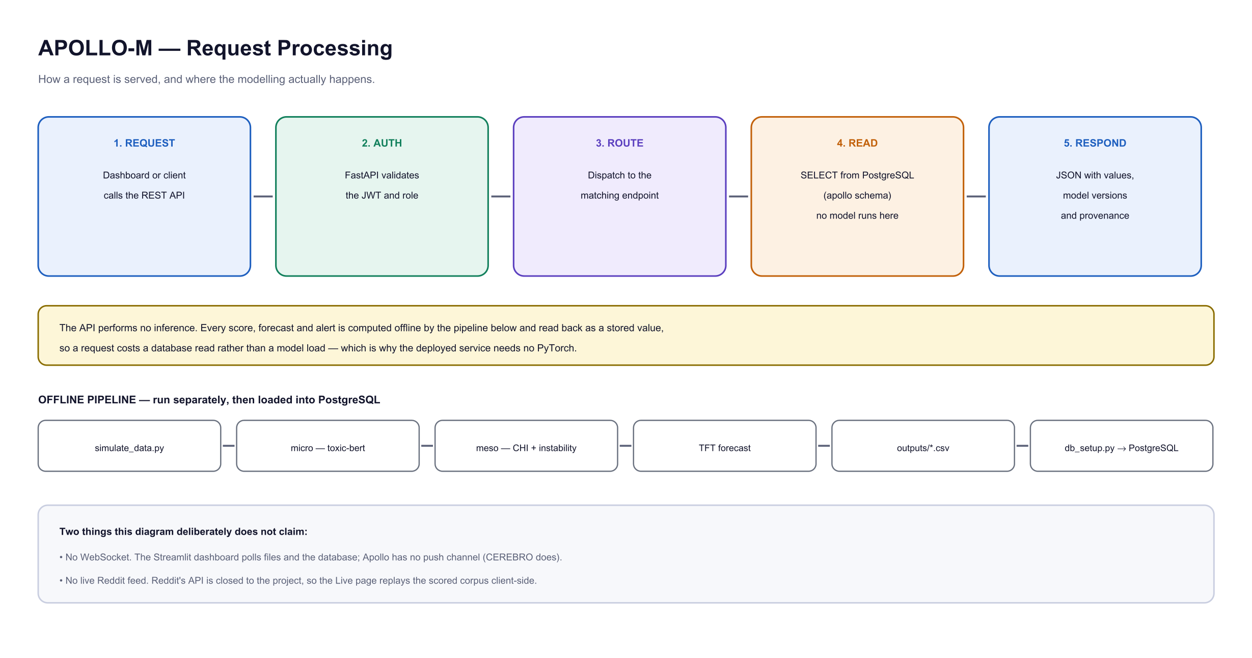
Figure 3.8: Request processing. Serving is separated from modelling: the API answers from stored values and performs no inference.

3.7 Deployed System
The system is deployed and publicly reachable. The backend and database run on Render, the dashboard on Streamlit Community Cloud, and the source is version-controlled on GitHub.
Table 3.4: Deployed Endpoints
Component | Address
Dashboard | https://apollo-m.streamlit.app
REST API | https://apollo-api-tllm.onrender.com
Interactive API documentation | https://apollo-api-tllm.onrender.com/docs
Prometheus metrics endpoint | https://apollo-api-tllm.onrender.com/metrics
Source repository | https://github.com/kashaffatimajaffrey-design/apollo-m
CEREBRO (companion system) | https://cerebro-sandy-beta.vercel.app

3.8 Integration with CEREBRO
APOLLO-M is deployed alongside CEREBRO, a companion system for threat and misinformation intelligence. The two answer different questions at different scales: CEREBRO evaluates a single item on demand, while APOLLO-M forecasts the trajectory of many communities over time. CEREBRO produces events; APOLLO-M consumes time series.
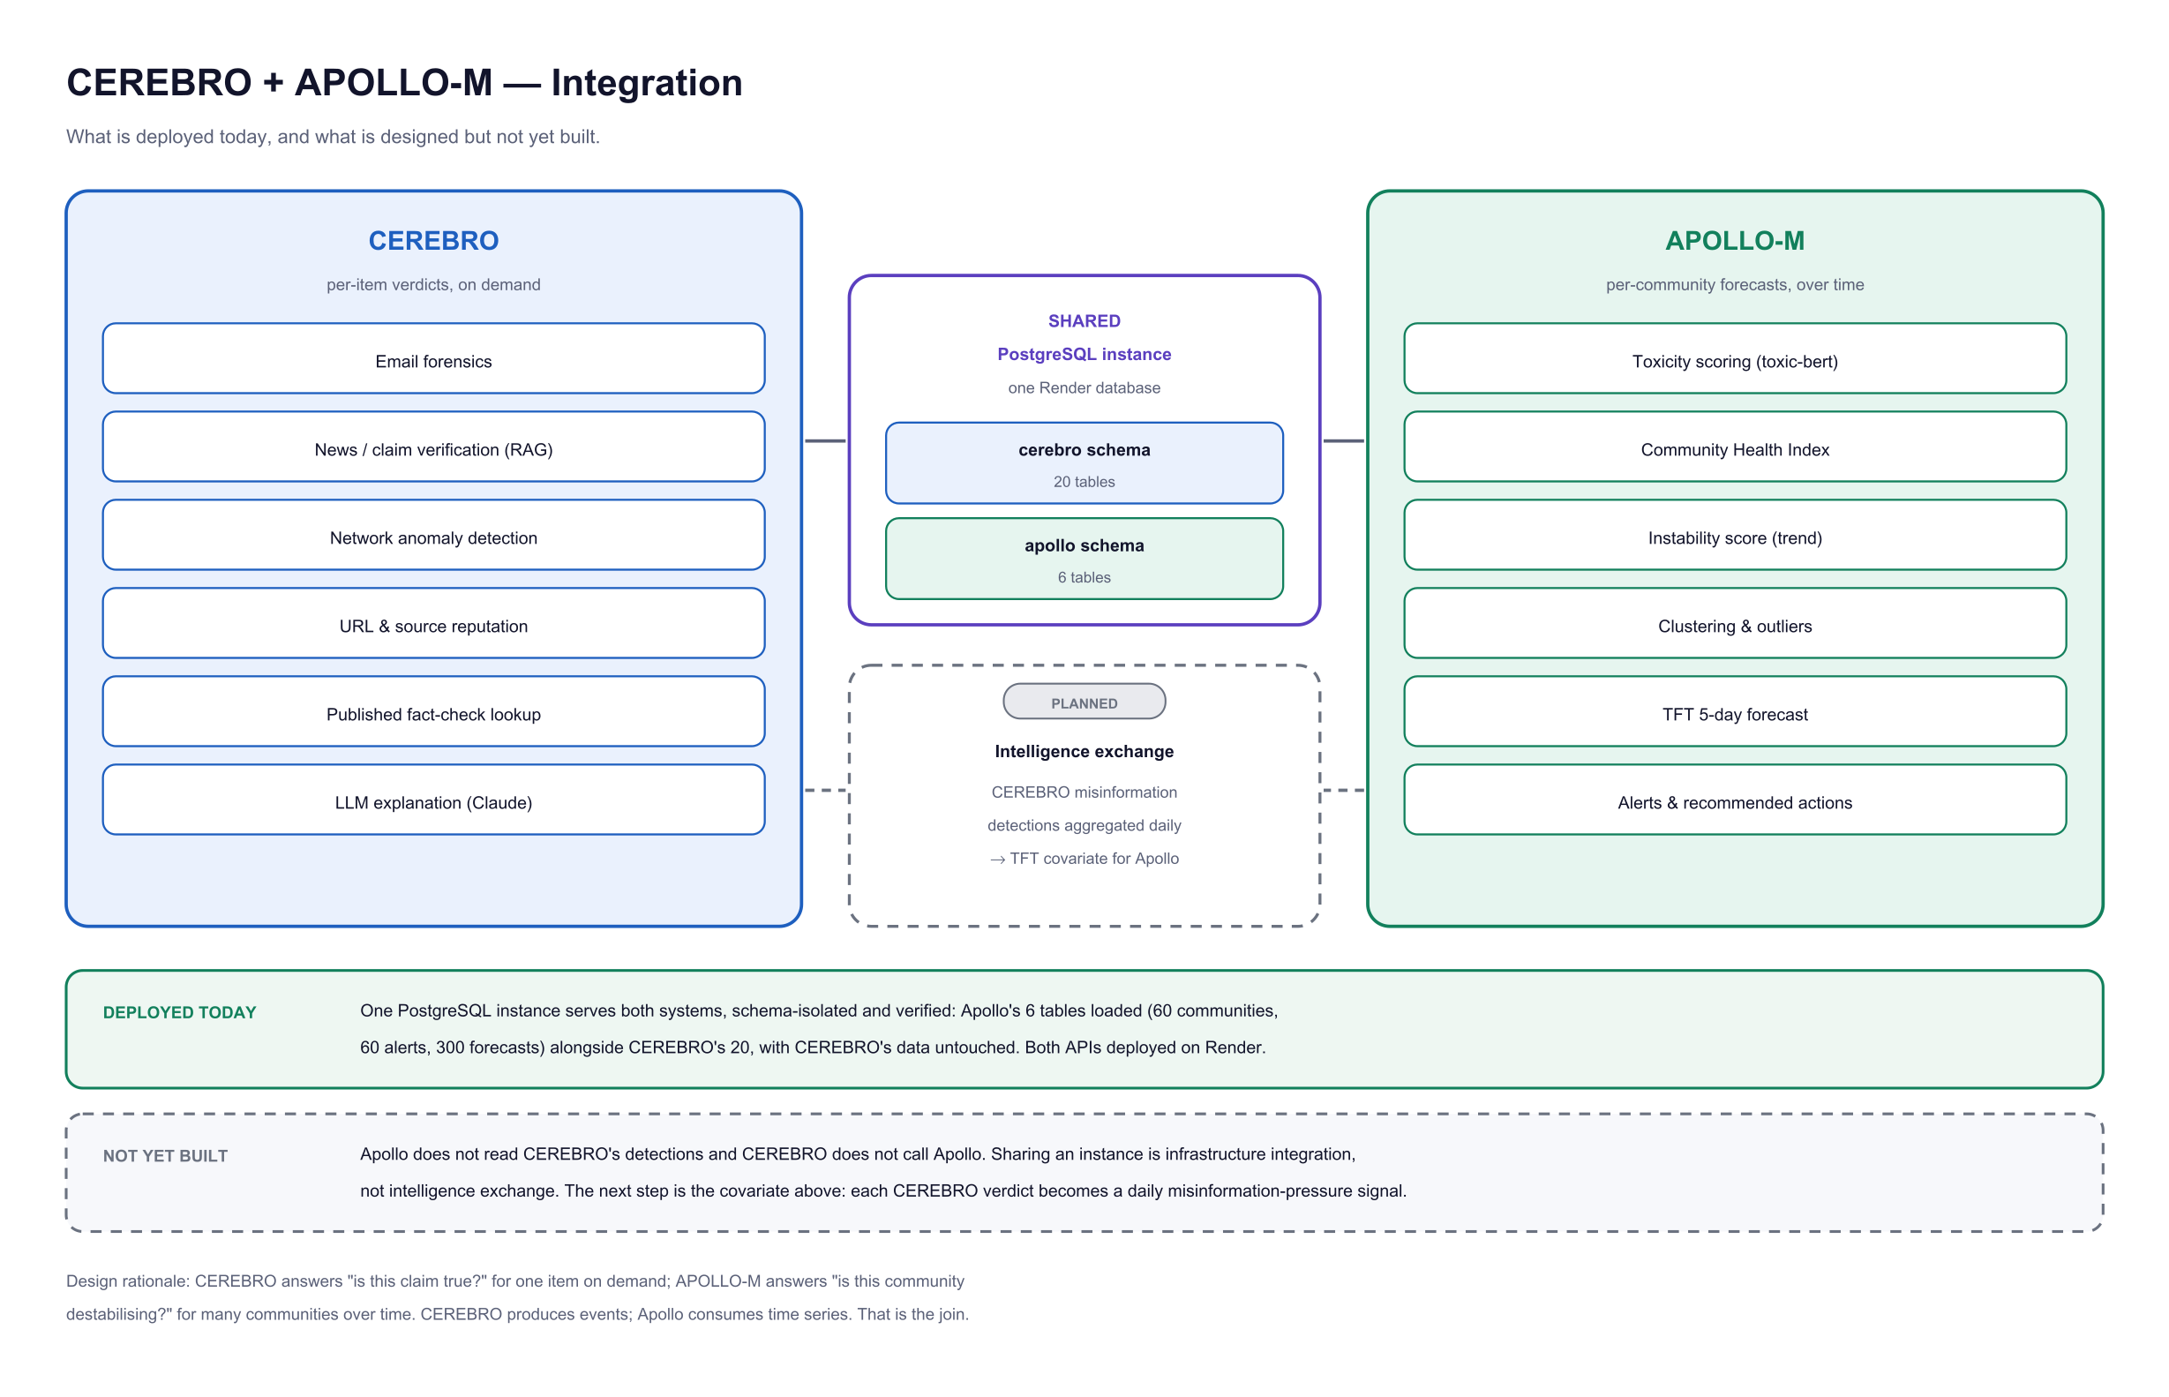
Figure 3.9: Integration with CEREBRO. A single PostgreSQL instance serves both systems in separate schemas; the intelligence exchange between them is specified and scheduled.
Integration at the infrastructure level is complete and verified: one PostgreSQL instance hosts both systems, with the apollo and cerebro schemas isolated from one another. The next step, shown dashed in Figure 3.9, is to aggregate CEREBRO's misinformation verdicts into a daily pressure signal and supply it to the forecaster as an additional covariate. The rationale is that toxicity indicates a community in conflict while misinformation indicates one being manipulated; these are distinct failure modes, and a forecaster with access to both should anticipate instability earlier than one with access to either alone.

3.9 Work Scheduled for the Next Phase
The following items are specified, and in most cases implemented, with integration scheduled for the remainder of the project. They are listed in the order in which they will be undertaken.
1. Live platform ingestion. The ingestion module is implemented against the PRAW interface and exercised end to end using corpus replay; enabling live collection requires API credentials, which are subject to account age and activity thresholds. Because every layer above ingestion consumes a normalised table of community, author, text and timestamp, adding a further platform requires one adapter and no change to the layers above it.
2. Integration of the GraphSAGE component, so that learned structural embeddings supplement the graph statistics currently used.
3. Integration of the misinformation classifier into the pipeline, and population of the corresponding table.
4. Replacement of the supervised moderation recommender's synthetic training data with recorded moderator decisions, followed by its integration.
5. The CEREBRO misinformation-pressure covariate described in Section 3.8.
6. An automated test suite covering the health-index computation, the micro layer and the API endpoints.

3.10 Chapter Summary
A layered pipeline has been designed, implemented and deployed, comprising transformer-based toxicity scoring, community-level aggregation into a health index and a trend-aware instability score, unsupervised clustering, probabilistic five-day forecasting, and graded alerting, served through an authenticated API and a public dashboard with monitoring. The framework was evaluated against recorded ground truth: the forecaster identified every planted destabilising community, and the evaluation additionally established that a present-tense health index is the wrong instrument for ranking communities by rate of change, a finding that led directly to the instability score.

CHAPTER

REFERENCES
[1] T. Davidson, D. Warmsley, M. Macy and I. Weber, “Automated Hate Speech Detection and the Problem of Offensive Language,” in Proc. 11th Int. AAAI Conf. on Web and Social Media (ICWSM), 2017, pp. 512–515.
[2] L. Hanu and the Unitary team, “Detoxify: Toxic Comment Classification with Transformers,” 2020. [Online]. Available: https://github.com/unitaryai/detoxify
[3] J. Devlin, M.-W. Chang, K. Lee and K. Toutanova, “BERT: Pre-training of Deep Bidirectional Transformers for Language Understanding,” in Proc. NAACL-HLT, 2019, pp. 4171–4186.
[4] Y. Liu et al., “RoBERTa: A Robustly Optimized BERT Pretraining Approach,” arXiv preprint arXiv:1907.11692, 2019.
[5] S. Kumar, W. L. Hamilton, J. Leskovec and D. Jurafsky, “Community Interaction and Conflict on the Web,” in Proc. World Wide Web Conf. (WWW), 2018, pp. 933–943.
[6] W. L. Hamilton, R. Ying and J. Leskovec, “Inductive Representation Learning on Large Graphs,” in Advances in Neural Information Processing Systems (NeurIPS), 2017, pp. 1024–1034.
[7] B. Lim, S. Ö. Arık, N. Loeff and T. Pfister, “Temporal Fusion Transformers for Interpretable Multi-horizon Time Series Forecasting,” International Journal of Forecasting, vol. 37, no. 4, pp. 1748–1764, 2021.
[8] A. Vaswani et al., “Attention Is All You Need,” in Advances in Neural Information Processing Systems (NeurIPS), 2017, pp. 5998–6008.
[9] E. Chandrasekharan, U. Pavalanathan, A. Srinivasan, A. Glynn, J. Eisenstein and E. Gilbert, “You Can’t Stay Here: The Efficacy of Reddit’s 2015 Ban Examined Through Hate Speech,” Proc. ACM on Human-Computer Interaction, vol. 1, no. CSCW, pp. 1–22, 2017.
[10] M. Cinelli, G. De Francisci Morales, A. Galeazzi, W. Quattrociocchi and M. Starnini, “The Echo Chamber Effect on Social Media,” Proc. National Academy of Sciences, vol. 118, no. 9, 2021.
[11] J. B. Calhoun, “Death Squared: The Explosive Growth and Demise of a Mouse Population,” Proc. Royal Society of Medicine, vol. 66, no. 1P2, pp. 80–88, 1973.
[12] E. Wulczyn, N. Thain and L. Dixon, “Ex Machina: Personal Attacks Seen at Scale,” in Proc. World Wide Web Conf. (WWW), 2017, pp. 1391–1399.
[13] A. M. Founta et al., “Large Scale Crowdsourcing and Characterization of Twitter Abusive Behavior,” in Proc. 12th Int. AAAI Conf. on Web and Social Media (ICWSM), 2018.
[14] K. Shu, A. Sliva, S. Wang, J. Tang and H. Liu, “Fake News Detection on Social Media: A Data Mining Perspective,” ACM SIGKDD Explorations Newsletter, vol. 19, no. 1, pp. 22–36, 2017.
[15] S. Zannettou, M. Sirivianos, J. Blackburn and N. Kourtellis, “The Web of False Information: Rumors, Fake News, Hoaxes, Clickbait, and Various Other Shenanigans,” ACM Journal of Data and Information Quality, vol. 11, no. 3, pp. 1–37, 2019.
[16] K. Garimella, G. De Francisci Morales, A. Gionis and M. Mathioudakis, “Quantifying Controversy on Social Media,” ACM Trans. on Social Computing, vol. 1, no. 1, pp. 1–27, 2018.
[17] M. H. Ribeiro, R. Ottoni, R. West, V. A. F. Almeida and W. Meira, “Auditing Radicalization Pathways on YouTube,” in Proc. Conf. on Fairness, Accountability and Transparency (FAT*), 2020, pp. 131–141.
[18] L. Breiman, “Random Forests,” Machine Learning, vol. 45, no. 1, pp. 5–32, 2001.
[19] F. Pedregosa et al., “Scikit-learn: Machine Learning in Python,” Journal of Machine Learning Research, vol. 12, pp. 2825–2830, 2011.
[20] M. Ester, H.-P. Kriegel, J. Sander and X. Xu, “A Density-Based Algorithm for Discovering Clusters in Large Spatial Databases with Noise,” in Proc. 2nd Int. Conf. on Knowledge Discovery and Data Mining (KDD), 1996, pp. 226–231.
[21] P. Lewis et al., “Retrieval-Augmented Generation for Knowledge-Intensive NLP Tasks,” in Advances in Neural Information Processing Systems (NeurIPS), 2020, pp. 9459–9474.
[22] A. Paszke et al., “PyTorch: An Imperative Style, High-Performance Deep Learning Library,” in Advances in Neural Information Processing Systems (NeurIPS), 2019, pp. 8024–8035.

