Task 4: Data Cleaning and Formatting :

Before vs After Comparison
Data Quality Check | Before | After
Missing Values | 5 | 0
Duplicate Records | 1 | 0
Date Format | Inconsistent | Standardized
Budget Format | Numbers | Currency
Text Values | Mixed | Standardized
Filters | Not Applied | Applied

Before Missing Values :
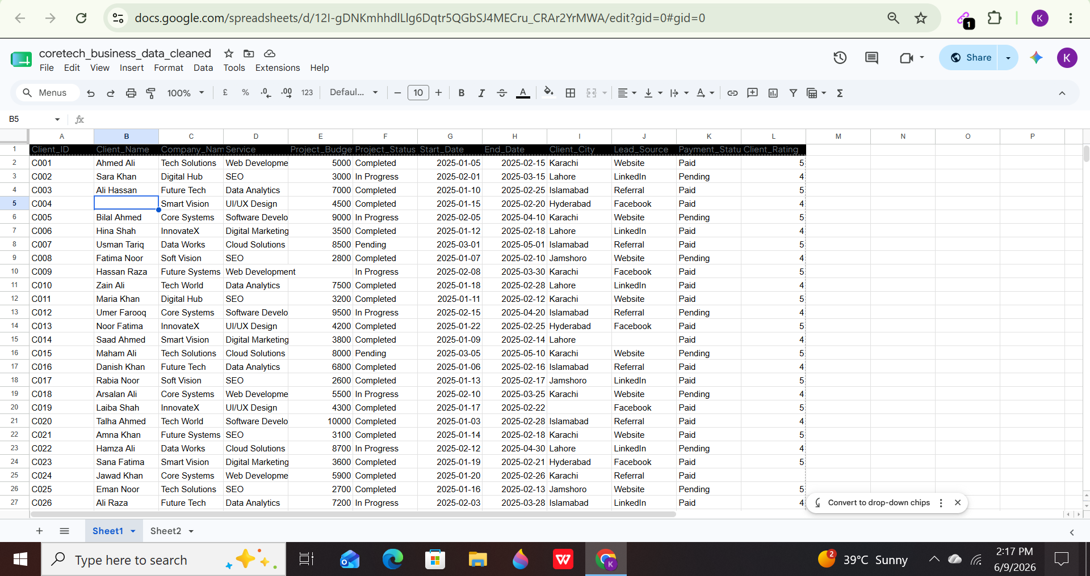

After Missing Values :
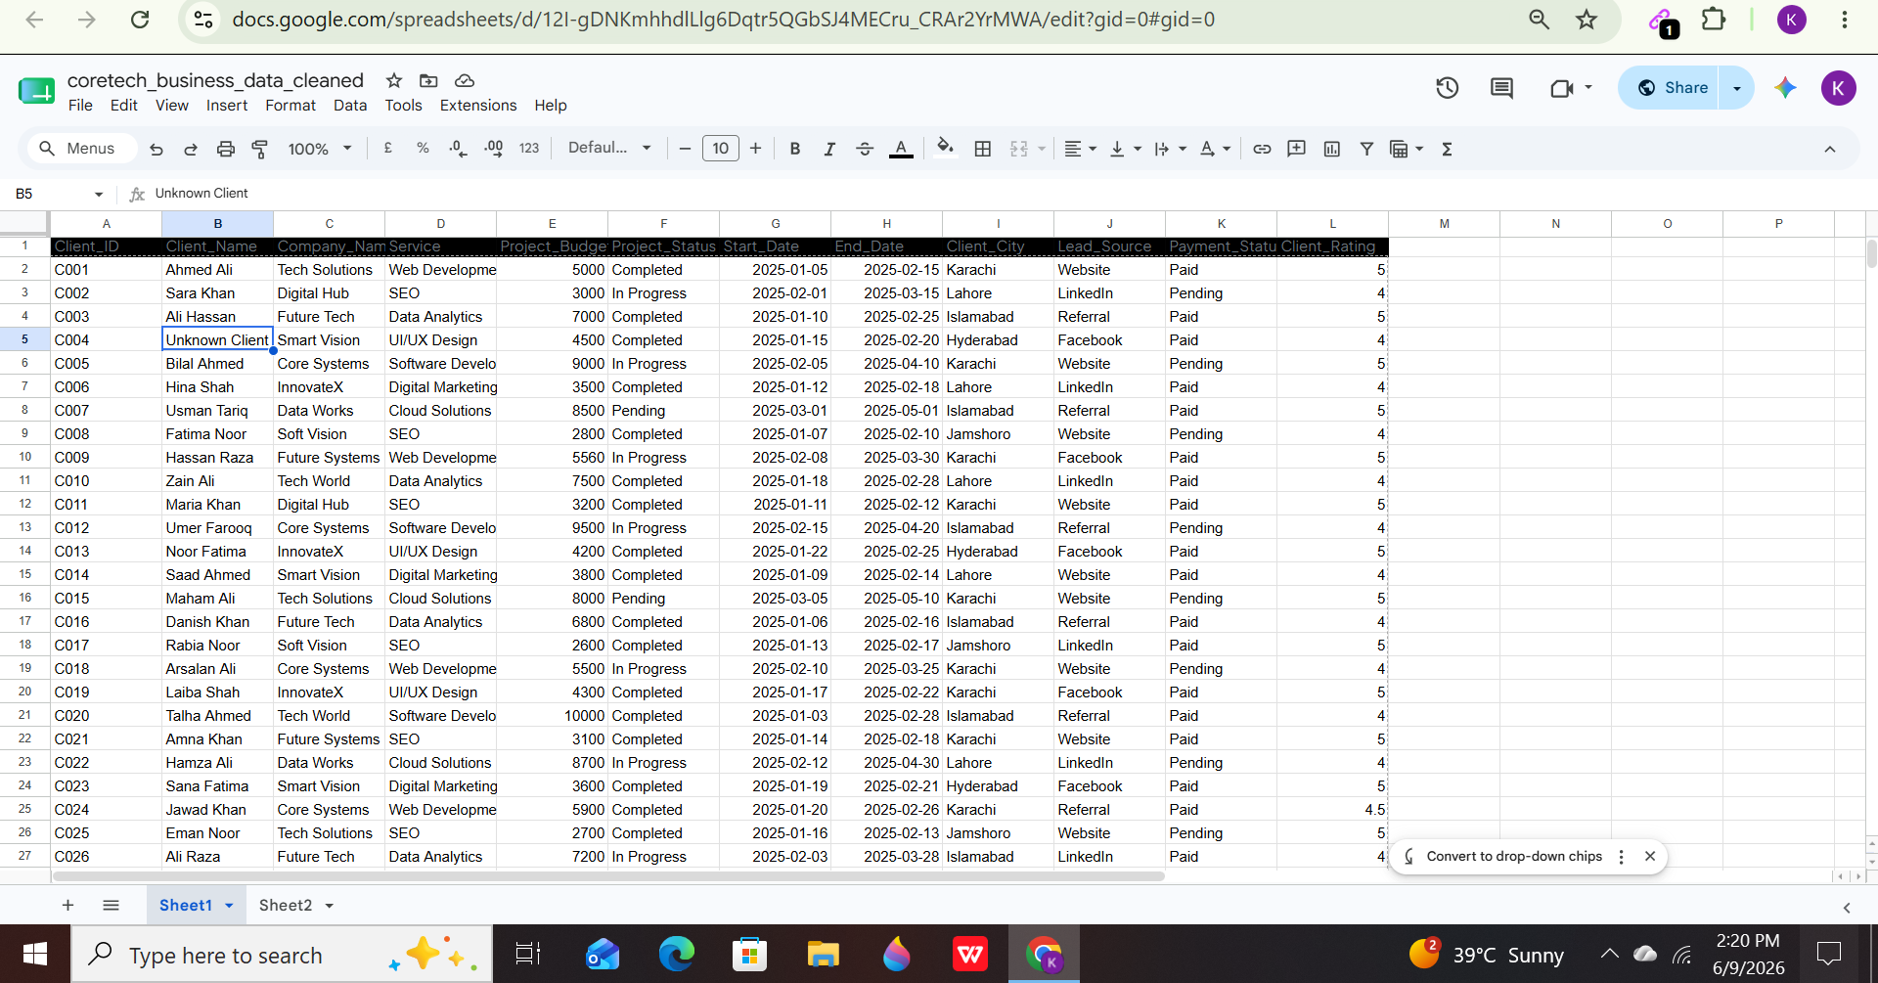

Before Duplication :
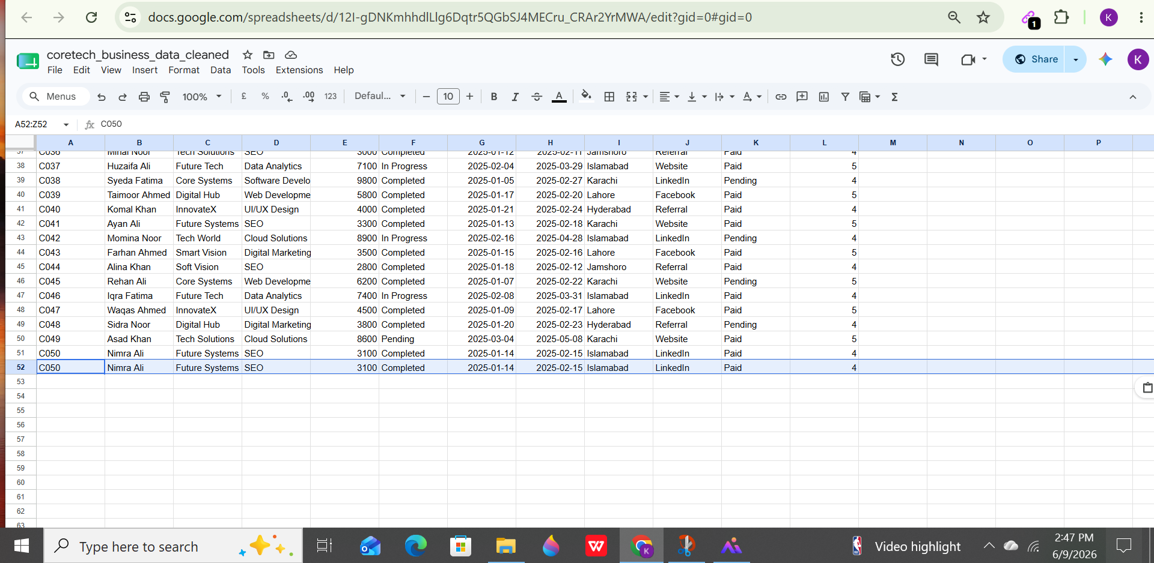

After Duplication :
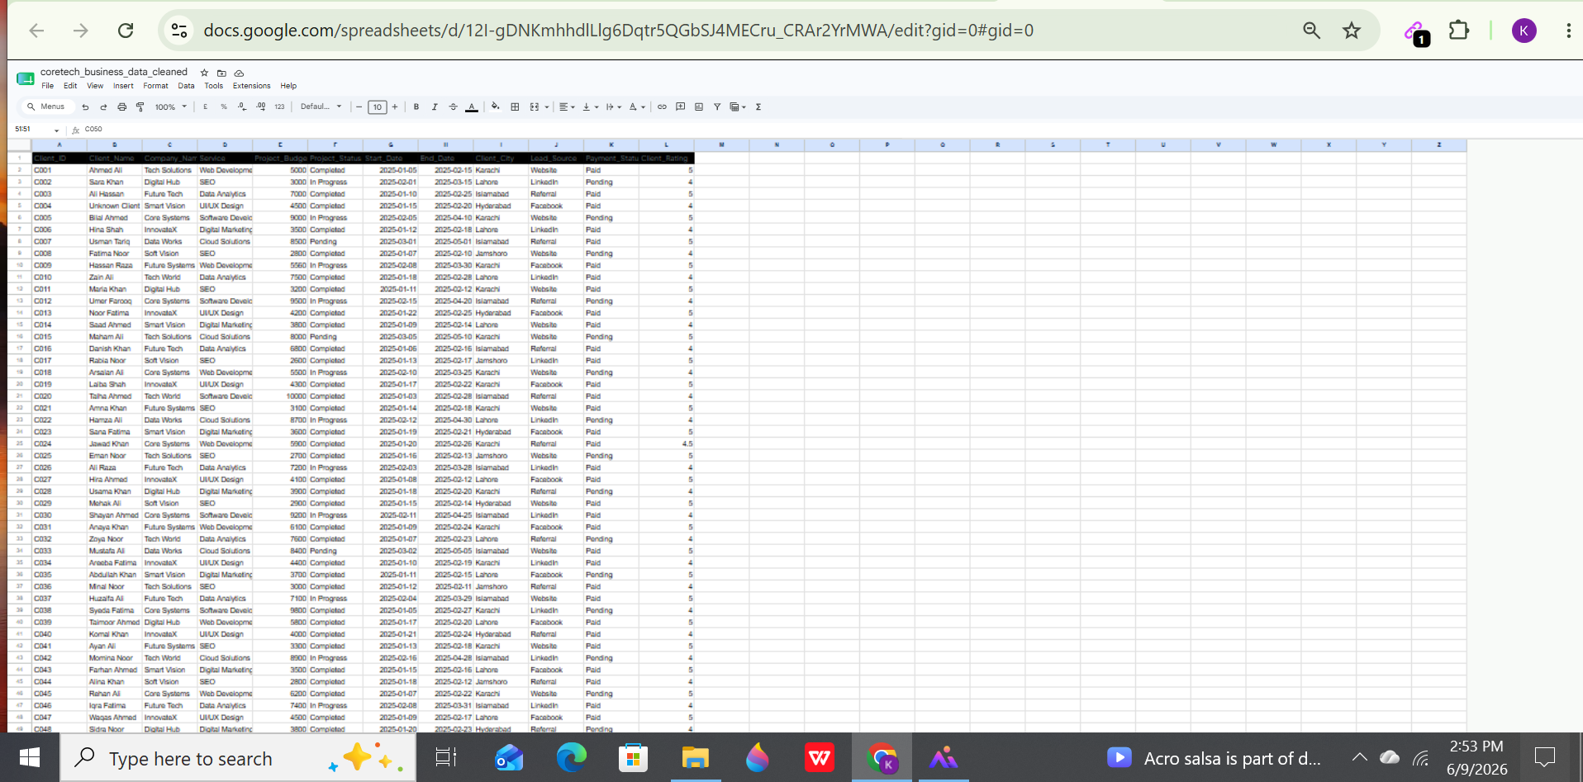

Date Format :
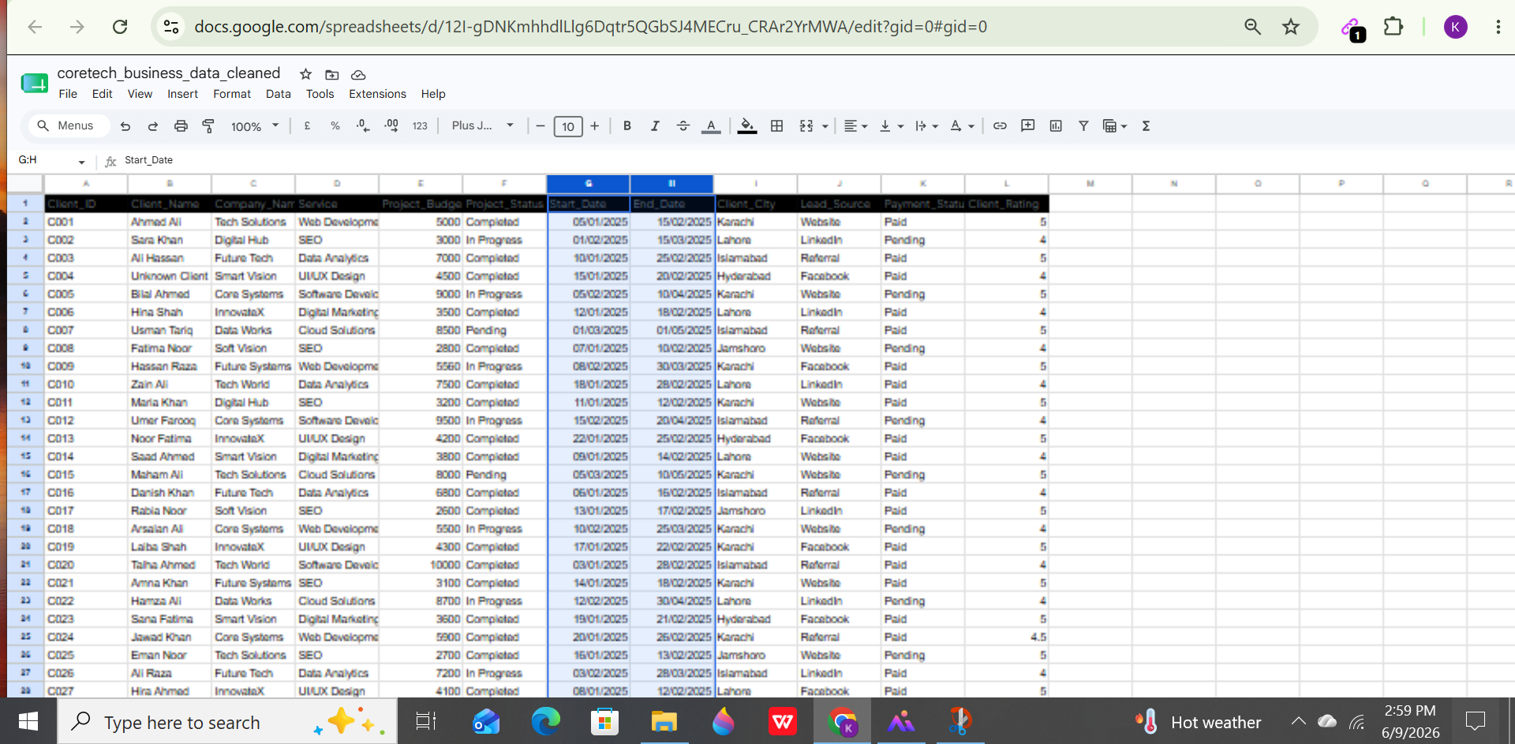

Currency Format :
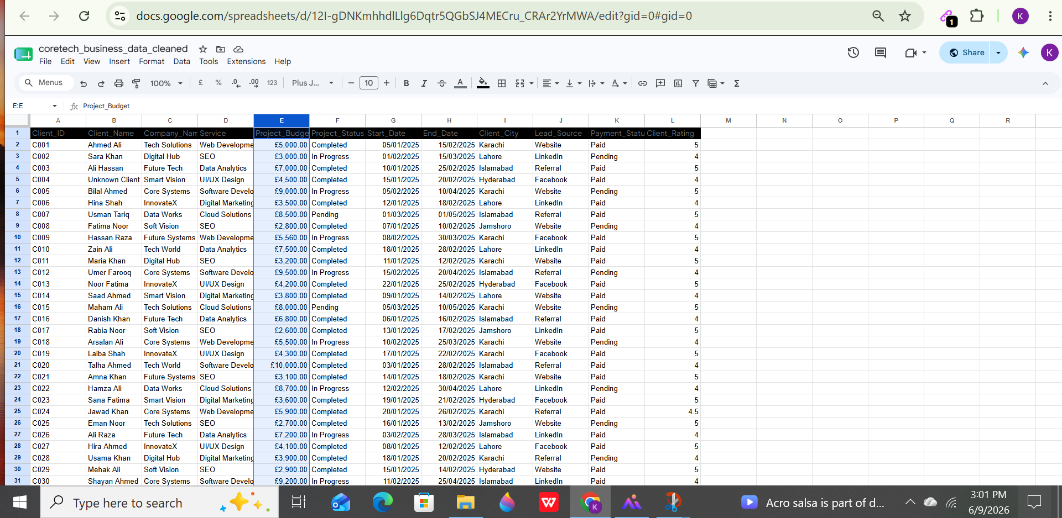

Text Standardization :
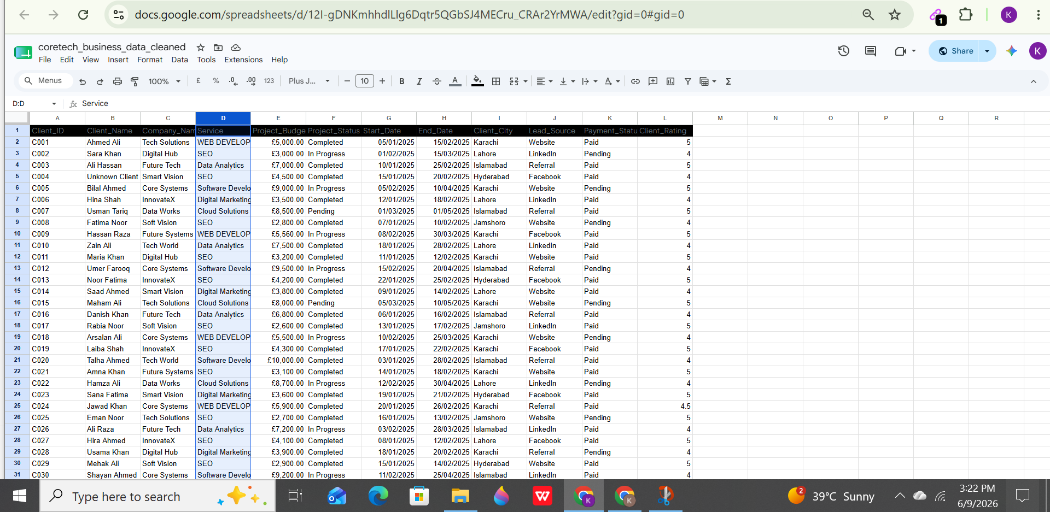

Filters Applied :

