Task 8: Power BI Dashboard — CoreTech Business Overview

Objective
The objective of this project is to analyze the CoreTech business dataset and create an interactive Power BI dashboard that provides insights into clients, revenue, project performance, and payment status. The dashboard helps management make data-driven decisions by presenting important business KPIs and visual reports.

Dataset Description
The cleaned CoreTech business dataset contains information related to:
- Clients
- Services
- Project Status
- Revenue/Budget
- Payment Status
- Client Ratings
- Cities and Locations

Dashboard Components

KPI Cards
The dashboard includes the following Key Performance Indicators (KPIs):
- Total Clients
- Total Revenue
- Completed Projects
- Pending Projects
- Average Rating
- Top Service

Visualizations Created

1. Bar Chart
Title: Revenue by Service
Purpose:
To identify which services generate the highest revenue.

2. Pie Chart
Title: Project Status Distribution
Purpose:
To analyze the percentage of completed and pending projects.

3. Column Chart
Title: Clients by City
Purpose:
To compare the number of clients from different cities.

4. Donut Chart
Title: Payment Status
Purpose:
To understand paid and unpaid project distributions.

5. Table Visual
Purpose:
To display detailed information about clients, services, project budgets, ratings, and project status.

6. Interactive Slicers
The dashboard includes the following slicers:
- Client City
- Service
- Project Status
These slicers allow users to filter the dashboard dynamically.

DASHBOARD PICTURE:
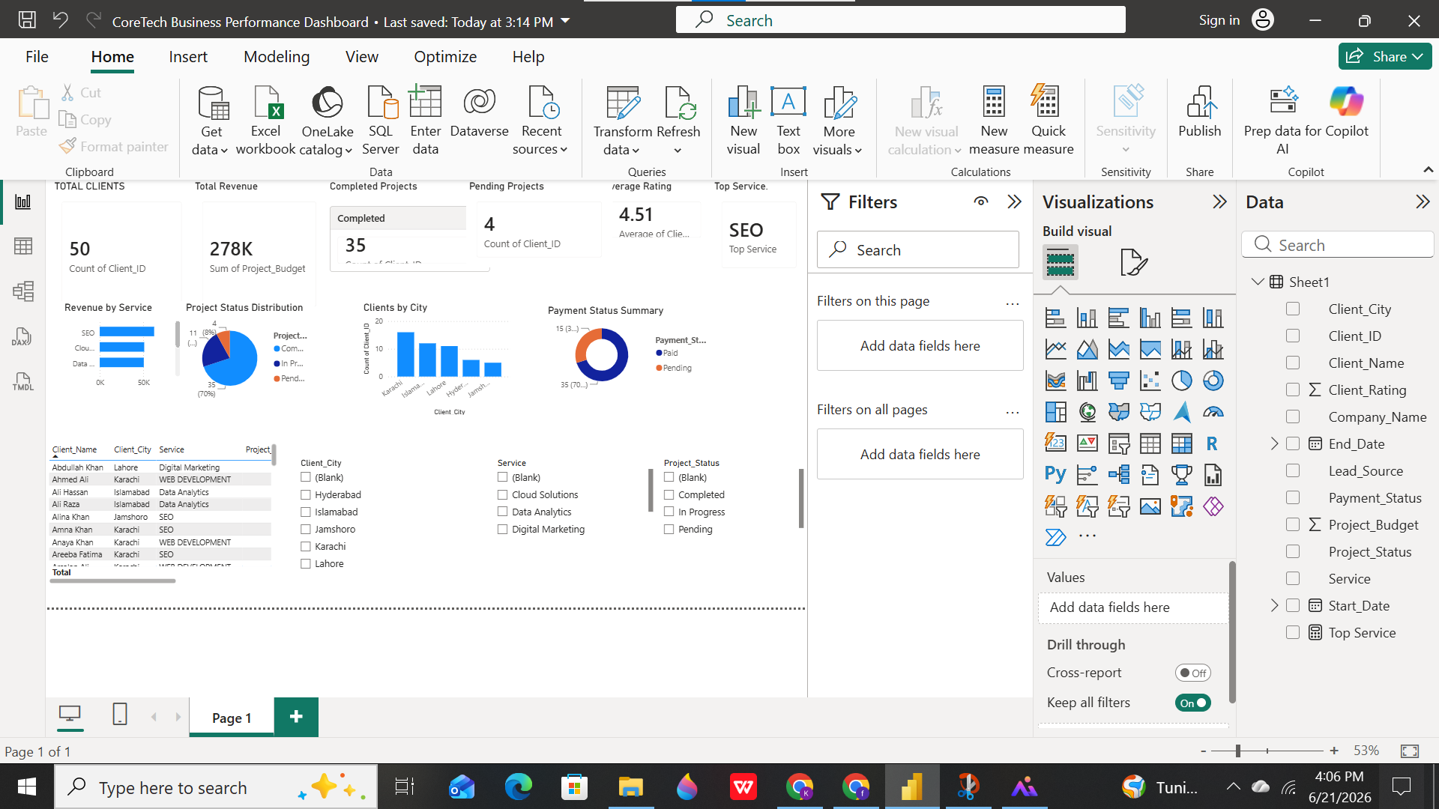

Key Insights

Insight 1
The company serves a significant number of clients, showing a strong and growing customer base.

Insight 2
Most projects have been successfully completed, indicating effective project management and delivery.

Insight 3
One specific service contributes the highest amount of revenue and can be considered the company's top-performing service.

Insight 4
Some projects are still pending, suggesting opportunities to improve project completion rates.

Insight 5
The average client rating is high, indicating good customer satisfaction and service quality.

Conclusion
The CoreTech Business Performance Dashboard successfully provides a comprehensive overview of the company's business performance. Through KPIs, charts, and interactive filters, the dashboard enables management to monitor revenue, project progress, client distribution, and customer satisfaction effectively.

