Assignment 01 Solution Document

Course: Cloud Computing (CC-F26)

Section: BSE-V(A)

Instructor: Prof. Waqas Saleem

Date: October 05, 2026

STUDENT INFORMATION
- Student Name: Kashaf Noor
- Registration Number: FA24B1-SE-029
- Course Code: CC-F26
- Section: BSE-V(A)
- Github Username: kashafnoor22

Task 1: Setting Up Gitea with Docker on Ubuntu Server

Step 1.1: Gitea Container Setup
Description: Verified that the Gitea container is up and running in Docker on the local Ubuntu Server environment.(Insert Screenshot: task1_gitea_running.png)
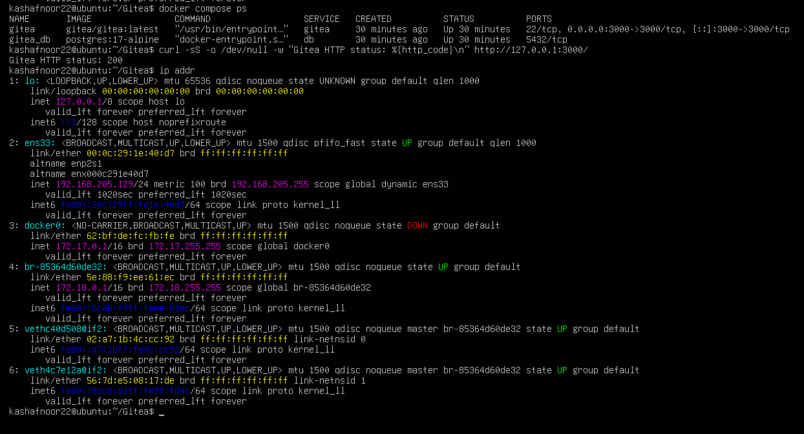

Step 1.2: First Push to Gitea
Description: Initialized the local repository and successfully performed the first git push to the Gitea remote instance.(Insert Screenshot: task1_gitea_push.png)
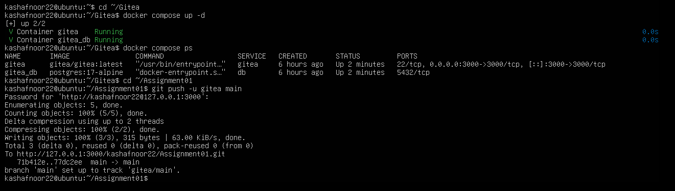

Step 1.3: Gitea Repository Web View
Description: Checked the Gitea web interface showing the pushed Assignment01 repository along with the README.md file.(Insert Screenshot: task1_gitea_repository.png)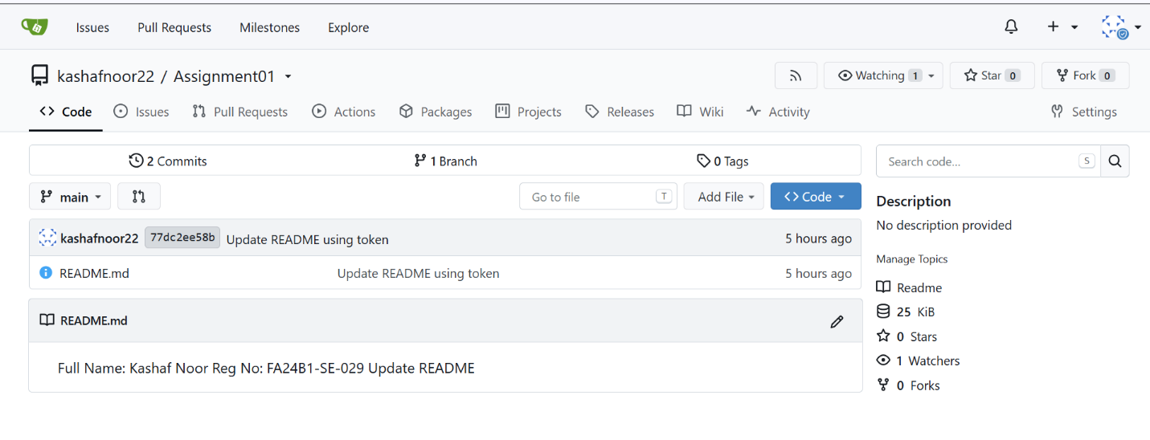

Task 2: Dual Remote Configuration & GitHub Integration

Step 2.1: Dual Remotes Setup
Description: Configured two remotes (gitea and github) in the local Git configuration using git remote -v.(Insert Screenshot: task2_remotes.png)
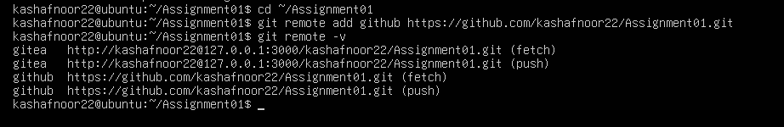

Step 2.2: Code Sync to GitHub
Description: Successfully pushed the repository source code to the GitHub remote repository using the Personal Access Token.(Insert Screenshot: task2_github_push.png)
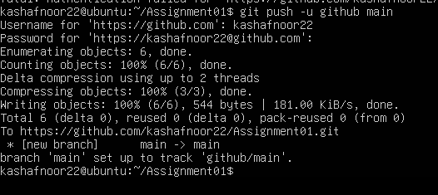

Step 2.3: GitHub Repository Web View
Description: Verified the pushed repository files on GitHub's browser interface.(Insert Screenshot: task2_github_repository.png)
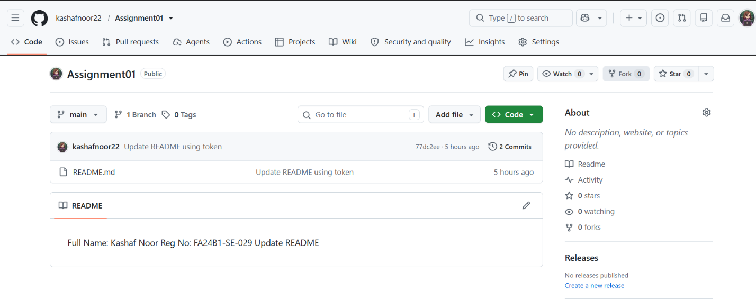

Task 3: Managing Binary Files with Git LFS

Step 3.1: Git LFS Initialization
Description: Installed Git LFS on Ubuntu Server, initialized LFS tracking for *.bin files, and verified .gitattributes.(Insert Screenshot: task3_lfs_setup.png)
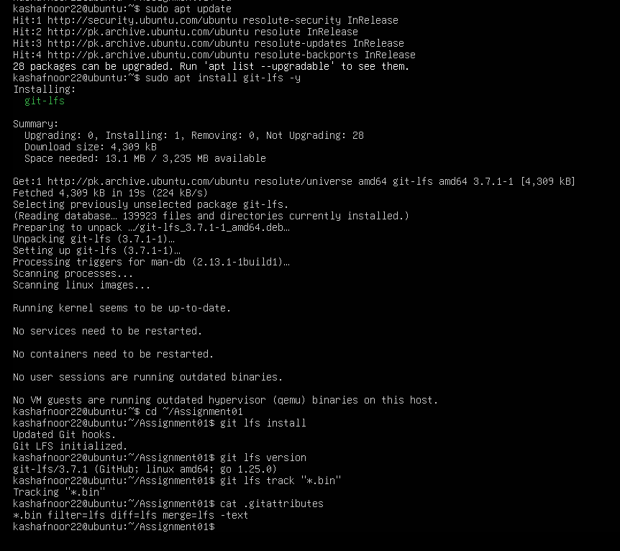

Step 3.2: Tracking Large Files
Description: Created three 10MB binary files (file1.bin, file2.bin, file3.bin) and verified tracking with git lfs ls-files.(Insert Screenshot: task3_lfs_files.png)
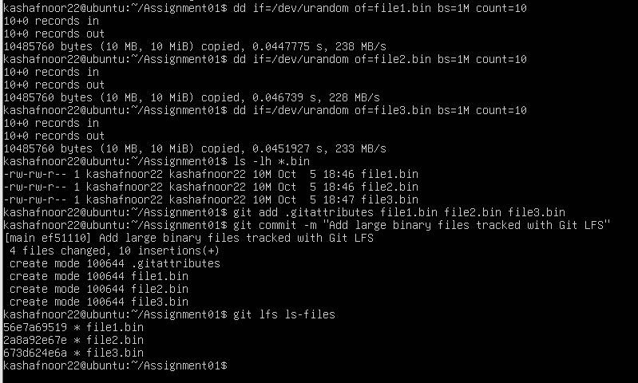

Step 3.3: LFS Object Push
Description: Successfully uploaded and pushed the Git LFS-tracked binary objects to both Gitea and GitHub remotes.(Insert Screenshot: task3_lfs_push.png)
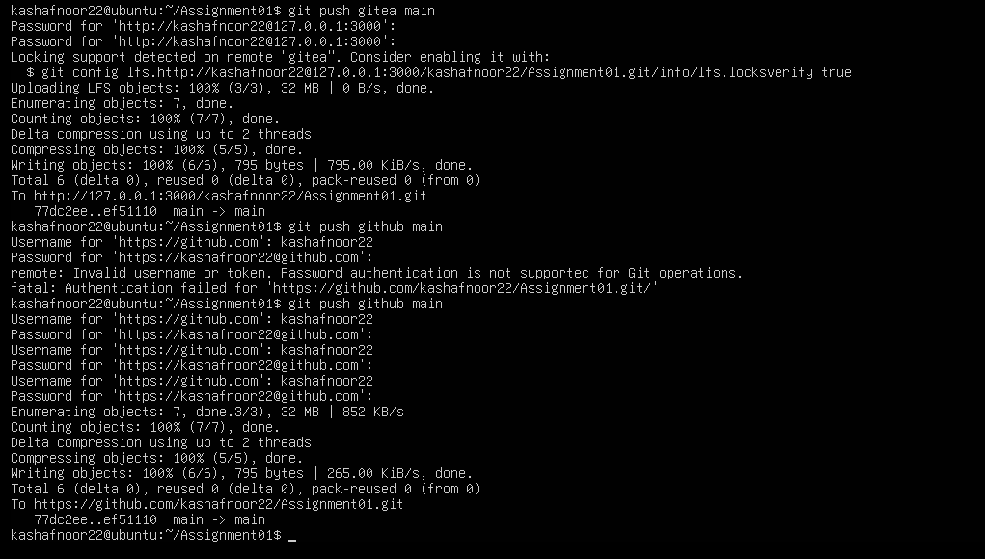

Task 4: Portfolio Deployment with GitHub Pages

Step 4.1: Portfolio Repository Creation
Description: Created the kashafnoor22.github.io repository on GitHub containing index.html and styles.css.(Insert Screenshot: task4_pages_repository.png)
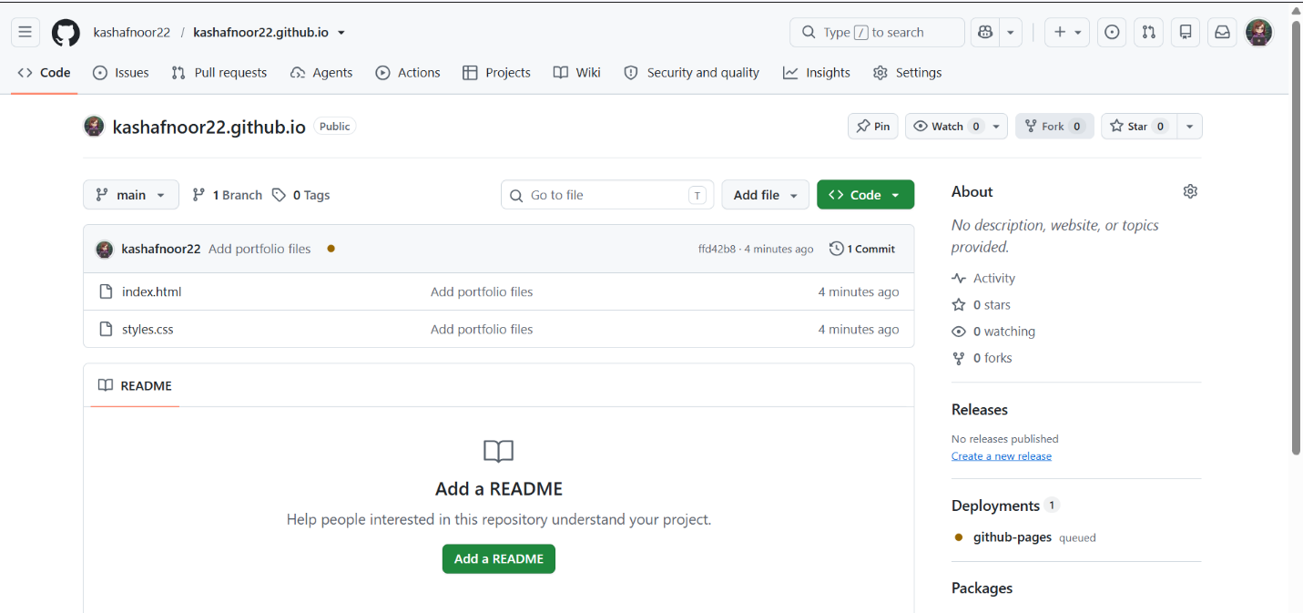

Step 4.2: GitHub Pages Activation
Description: Configured GitHub Pages settings from the main branch root folder and generated the live published site.(Insert Screenshot: task4_pages_deployment.png)
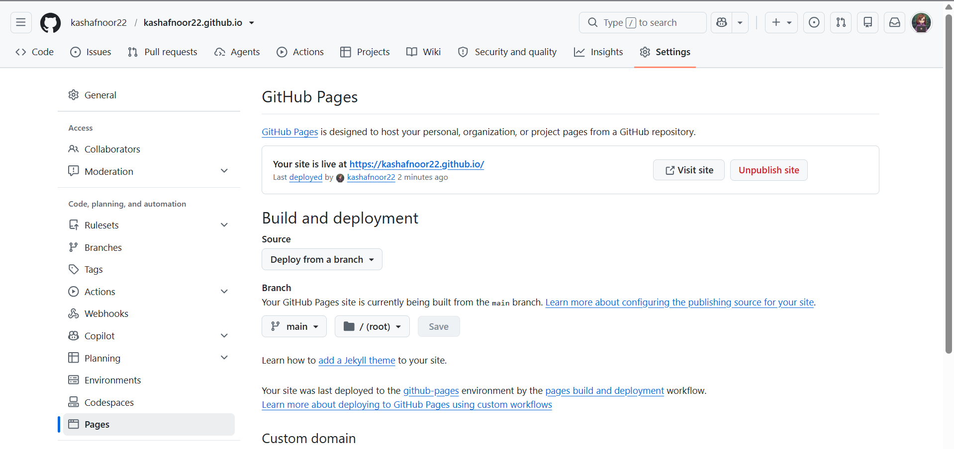

Step 4.3: Live Portfolio Verification
Description: Verified the live portfolio website running at [https://kashafnoor22.github.io/](https://kashafnoor22.github.io/) displaying all required CV sections.(Insert Screenshot: task4_portfolio_live.png)
