Project Title

Smart Expense Tracker
HTML | CSS | JavaScript

Project Type: Frontend Web Development Project
Created By: Kashaf Sarfraz

Project Description

This is a beginner-friendly expense management web application developed using HTML, CSS and JavaScript. Users can add expenses, calculate total spending, and delete expenses.

Features

- Add expense
- Delete expense
- Automatic total calculation
- Browser local storage
- Form validation

ScreenShots

Empty Dashboard

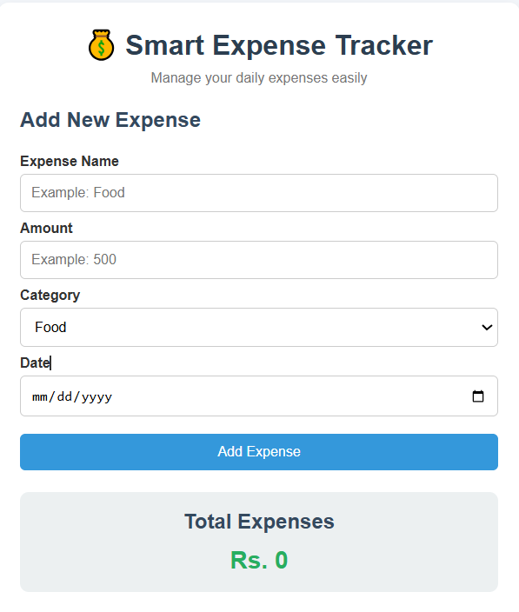

Expenses Added + Total Calculation:

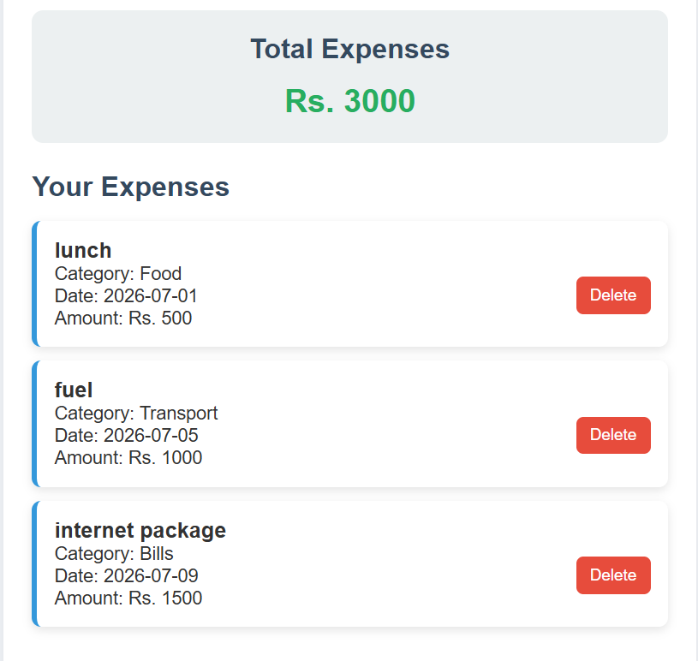

Delete Feature:

