HOSTEL ROOM MANAGEMENTS SYSTEM
Milestone 5 — Data Population (DML)
Project: Hostel Room Management System
Members: Kashaf Sher & Alishba Sadeeq
Date: 17th May 2026
Introduction
This milestone demonstrates the population of the Hostel Room Management System (HRMS) database using SQL Data Manipulation Language (DML) operations. The database tables created and normalized in previous milestones were populated with synthetic hostel data prepared during Milestone 3.
The milestone includes:
- INSERT statements for populating tables
- UPDATE and DELETE operations with WHERE conditions
- Validation queries to verify:
  - row counts
  - NULL integrity
  - foreign key consistency using JOINs
Data Population Using INSERT Statements
- Insert Data Into RoomType
Code:
INSERT INTO RoomType (type_id, type_name) VALUES
(1, 'Single'),
(2, 'Double'),
(3, 'Shared');

SELECT * FROM RoomType;
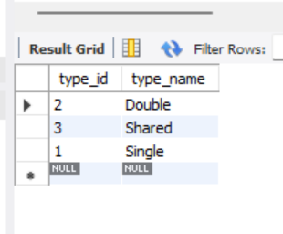

- Insert Data Into Floor
Code:
INSERT INTO Floor (floor_id, floor_number, capacity) VALUES
(1, 1, 18),
(2, 2, 16),
(3, 3, 20),
(4, 4, 14),
(5, 5, 17);

SELECT * FROM Floor;
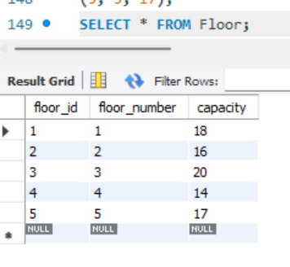
- Insert Data Into Admin
code:
INSERT INTO Admin (admin_id, name, role, email, contact) VALUES
(1, 'Maria Khan', 'Coordinator', 'maria.khan1@hostel.edu.pk', '03255614226'),
(2, 'Imran Butt', 'Coordinator', 'imran.butt2@hostel.edu.pk', '03442719583'),
(3, 'Ayesha Iqbal', 'Manager', 'ayesha.iqbal3@hostel.edu.pk', '03111533224'),
(4, 'Hira Bhatti', 'SuperAdmin', 'hira.bhatti4@hostel.edu.pk', '03329847201'),
(5, 'Saad Sheikh', 'Manager', 'saad.sheikh5@hostel.edu.pk', '03188234512');
SELECT * FROM Admin;
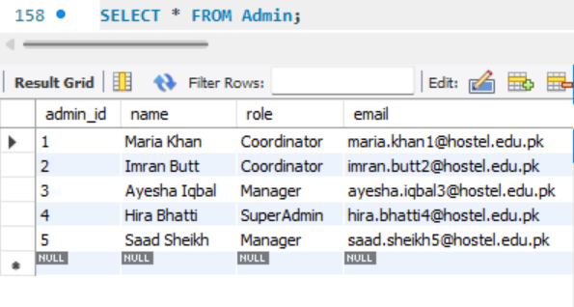

Insert Data Into Warden
code:
INSERT INTO Warden (warden_id, name, email, contact, assigned_floor_id) VALUES
(1, 'Mehwish Iqbal', 'mehwish.iqbal101@hostel.edu.pk', '03144226067', 1),
(2, 'Ali Chaudhry', 'ali.chaudhry102@hostel.edu.pk', '03155855124', 2),
(3, 'Imran Malik', 'imran.malik103@hostel.edu.pk', '03277377459', 3),
(4, 'Zara Hussain', 'zara.hussain104@hostel.edu.pk', '03344123890', 4),
(5, 'Omar Qureshi', 'omar.qureshi105@hostel.edu.pk', '03422309812', 5);

SELECT * FROM Warden;

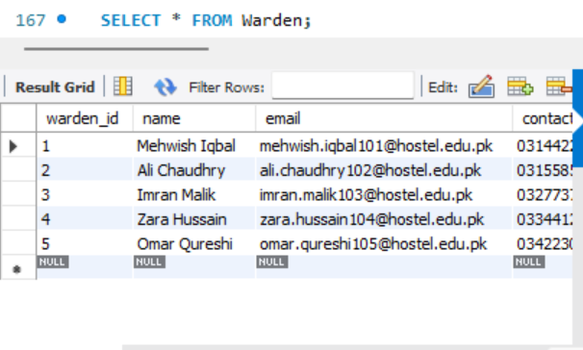

Insert Data Into Room
Code:
INSERT INTO Room (room_id, room_number, floor_id, type_id, status) VALUES
(1, '101', 1, 2, 'Occupied'),
(2, '102', 1, 2, 'Available'),
(3, '103', 1, 3, 'Occupied'),
(4, '104', 1, 1, 'Available'),
(5, '105', 1, 2, 'Occupied');

SELECT * FROM Room;
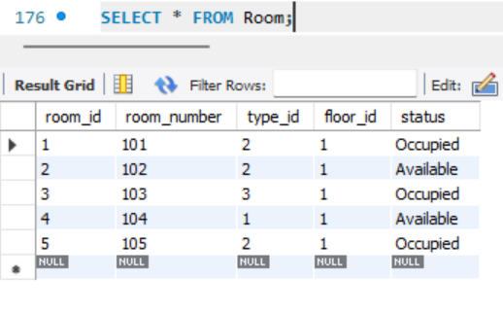

Insert Data Into Student
Code:
INSERT INTO Student (student_id, name, gender, date_of_birth, phone_number, email) VALUES
(1, 'Naveed Khan', 'Male', '2000-01-18', '03363790237', 'naveed.khan201@hostel.edu.pk'),
(2, 'Hira Javed', 'Female', '2001-05-25', '03201983738', 'hira.javed202@hostel.edu.pk'),
(3, 'Junaid Khan', 'Male', '2003-05-19', '03288633773', 'junaid.khan203@hostel.edu.pk'),
(4, 'Zara Ali', 'Female', '2002-08-10', '03411200934', 'zara.ali204@hostel.edu.pk'),
(5, 'Hassan Raza', 'Male', '1999-11-03', '03177643201', 'hassan.raza205@hostel.edu.pk');

SELECT * FROM Student;
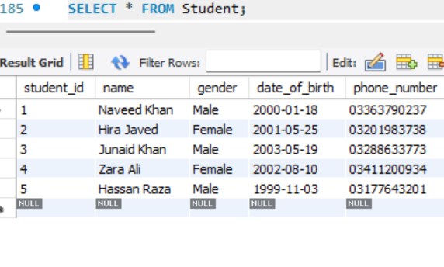
Insert Data Into Allocation
code:
INSERT INTO Allocation (allocation_id, student_id, room_id, admin_id, allocation_date, end_date) VALUES
(1, 1, 1, 2, '2024-01-10', '2024-12-10'),
(2, 2, 3, 1, '2024-02-15', '2024-11-20'),
(3, 3, 5, 4, '2024-03-01', '2025-01-01');

SELECT * FROM Allocation;
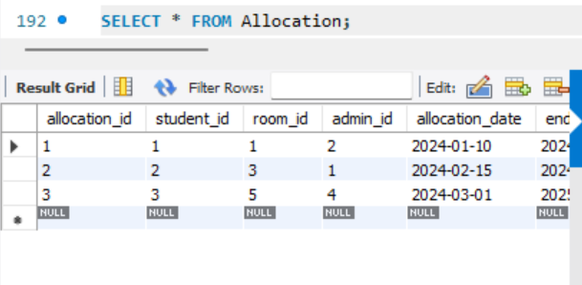
UPDATE Query
code:
UPDATE Room
SET status = 'Occupied'
WHERE room_id = 2;
Now verify:
SELECT * FROM Room
WHERE room_id = 2;
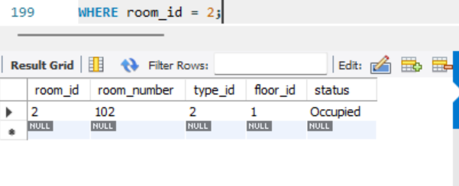

DELETE Query
code:
DELETE FROM Student
WHERE student_id = 5;
Now check:
SELECT * FROM Student;
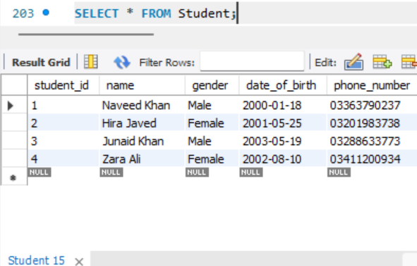

COUNT(*) Queries
code:
SELECT COUNT(*) AS total_admins FROM Admin;
SELECT COUNT(*) AS total_wardens FROM Warden;
SELECT COUNT(*) AS total_floors FROM Floor;
SELECT COUNT(*) AS total_room_types FROM RoomType;
SELECT COUNT(*) AS total_rooms FROM Room;
SELECT COUNT(*) AS total_students FROM Student;
SELECT COUNT(*) AS total_allocations FROM Allocation;

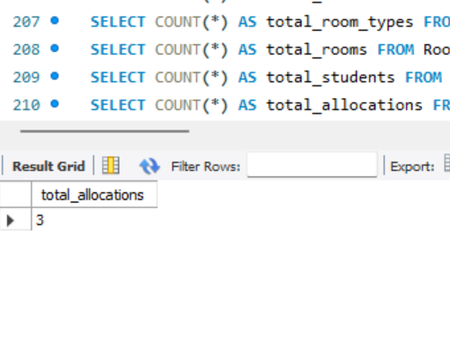
NULL Check Queries
Run:
SELECT * FROM Student
WHERE name IS NULL
OR email IS NULL;
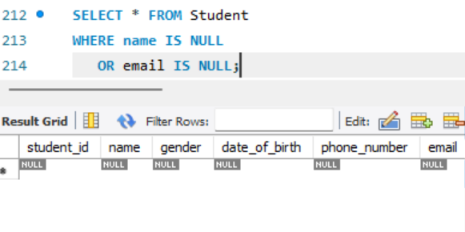

SELECT * FROM Room
WHERE room_number IS NULL
OR status IS NULL;
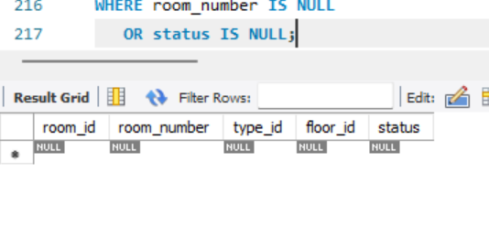
SELECT * FROM Allocation
WHERE student_id IS NULL
OR room_id IS NULL
OR admin_id IS NULL;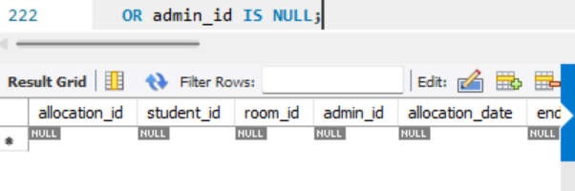

JOIN Integrity Query
SELECT
a.allocation_id,
s.name AS student_name,
r.room_number,
ad.name AS admin_name
FROM Allocation a
JOIN Student s
ON a.student_id = s.student_id
JOIN Room r
ON a.room_id = r.room_id
JOIN Admin ad
ON a.admin_id = ad.admin_id;
