Microsoft Azure Data Lake: Publishing Datasets in Data Catalog

Updated on: 12/29/2016

# Introduction

In this lab, you will learn how to register data sources stored in Azure Data Lake Store in Azure Data Catalog.

# Takeaways

By the end of this lab, you will be able to:

* Discover assets registered in Azure Data Catalog
* Register your own assets into the Azure Data Catalog

# Prerequisites

For this lab you will need:

* Access to an Azure Data Lake Store account
* Access to an Azure Data Catalog instance (one is available for all Microsoft Employees)

# Exercise 1: Browse the Azure Data Catalog for data stored in Azure Data Lake Store

## Login

* Go to [www.azuredatacatalog.com](http://www.azuredatacatalog.com) and sign in:
* You should be able to see the below page:

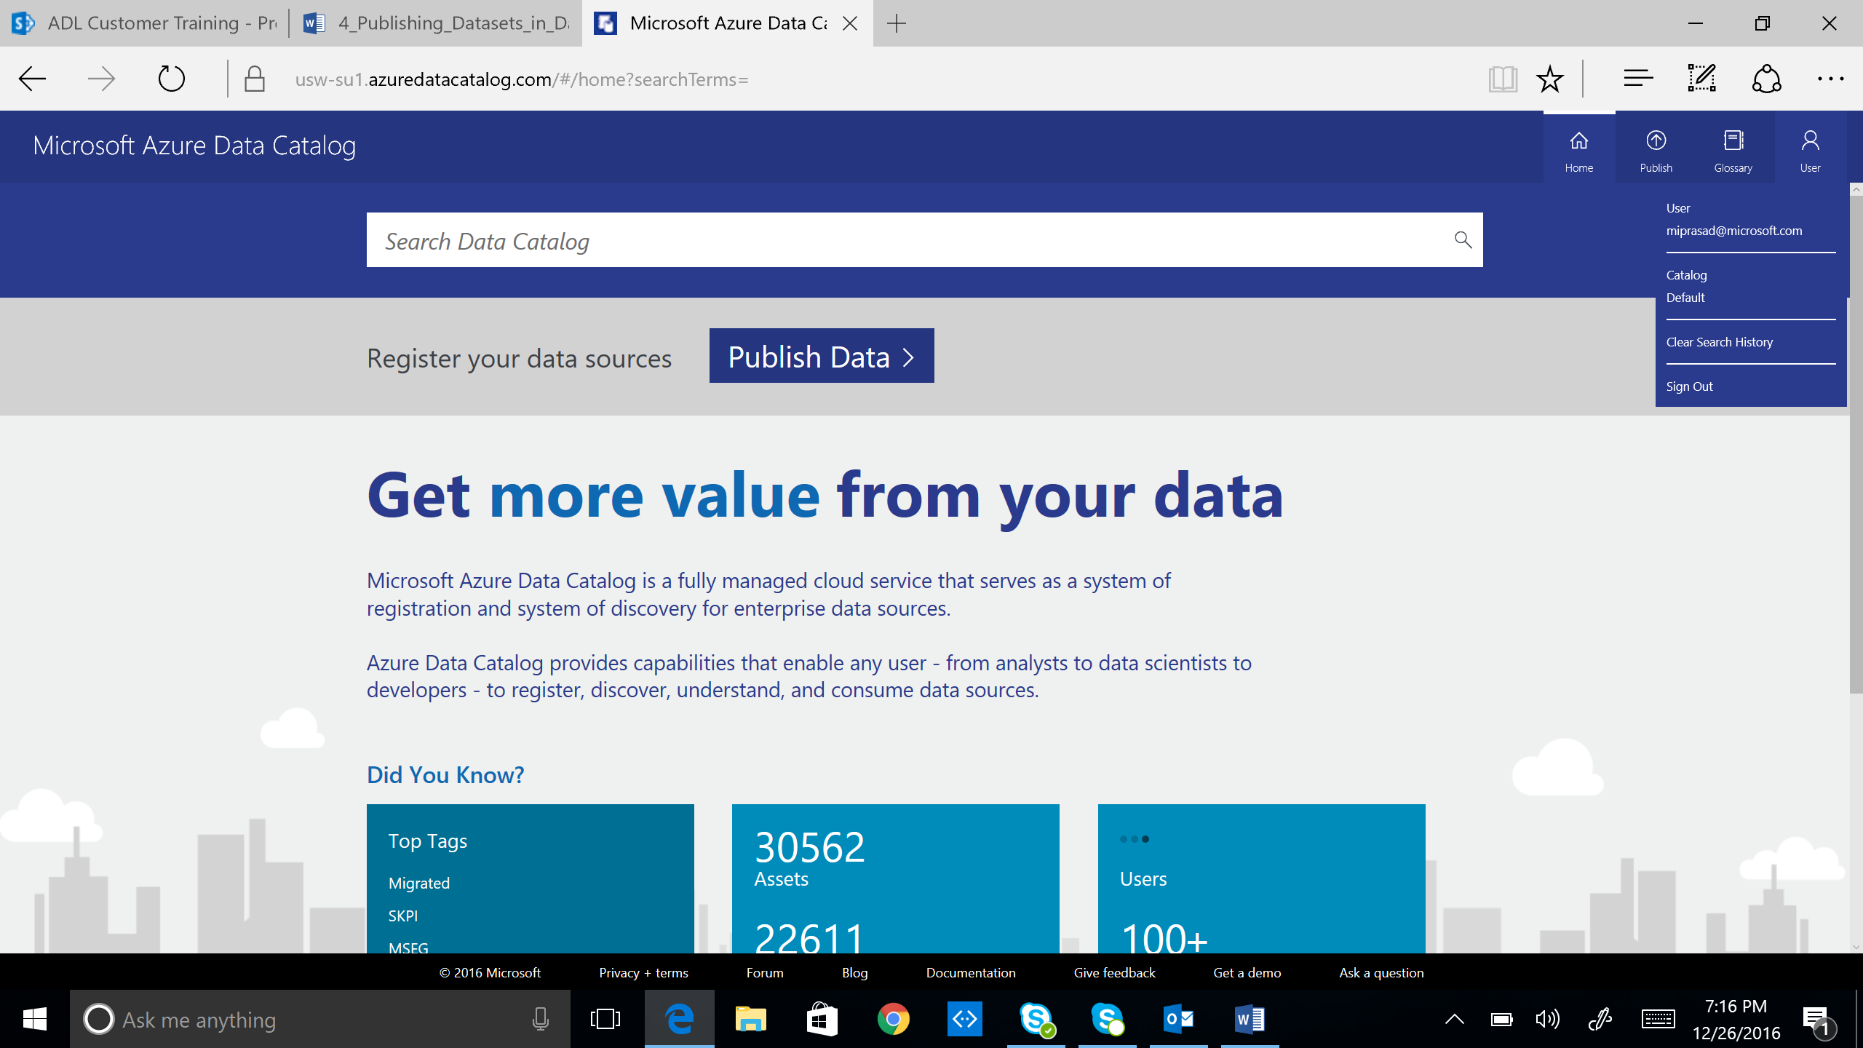

## Search the Data Catalog

Select Azure Data Lake Store in the filter ‘Source Type’

# Exercise 2: Register a data set you’re working with in the Azure Data Catalog

In this exercise, you will register your own data set into the Azure Data Catalog so other people can discover it and derive value from it.

* Go to the Azure Data Catalog portal: [www.azuredatacatalog.com](http://www.azuredatacatalog.com)
* Click Publish Data
* Click on “Launch Application” to download and run the Click-once desktop application for Azure Data Catalog
* Sign-in when the application launches. You will see the below window.

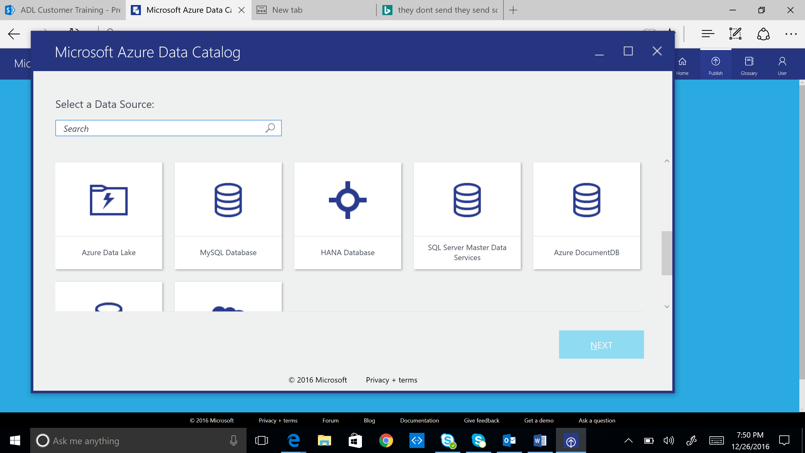

* Click Azure Data Lake
* Type in the name of an ADLS account you have access to
* Browse to your data set using the navigation tree
* Double click on the data to add to the list of objects to be registered
* Fill in any metadata about the objects
  + It’s important to provide tags or an expert so other people trying to discover data will know who to consult.
* Click Register