**Manager:**

* Not Working

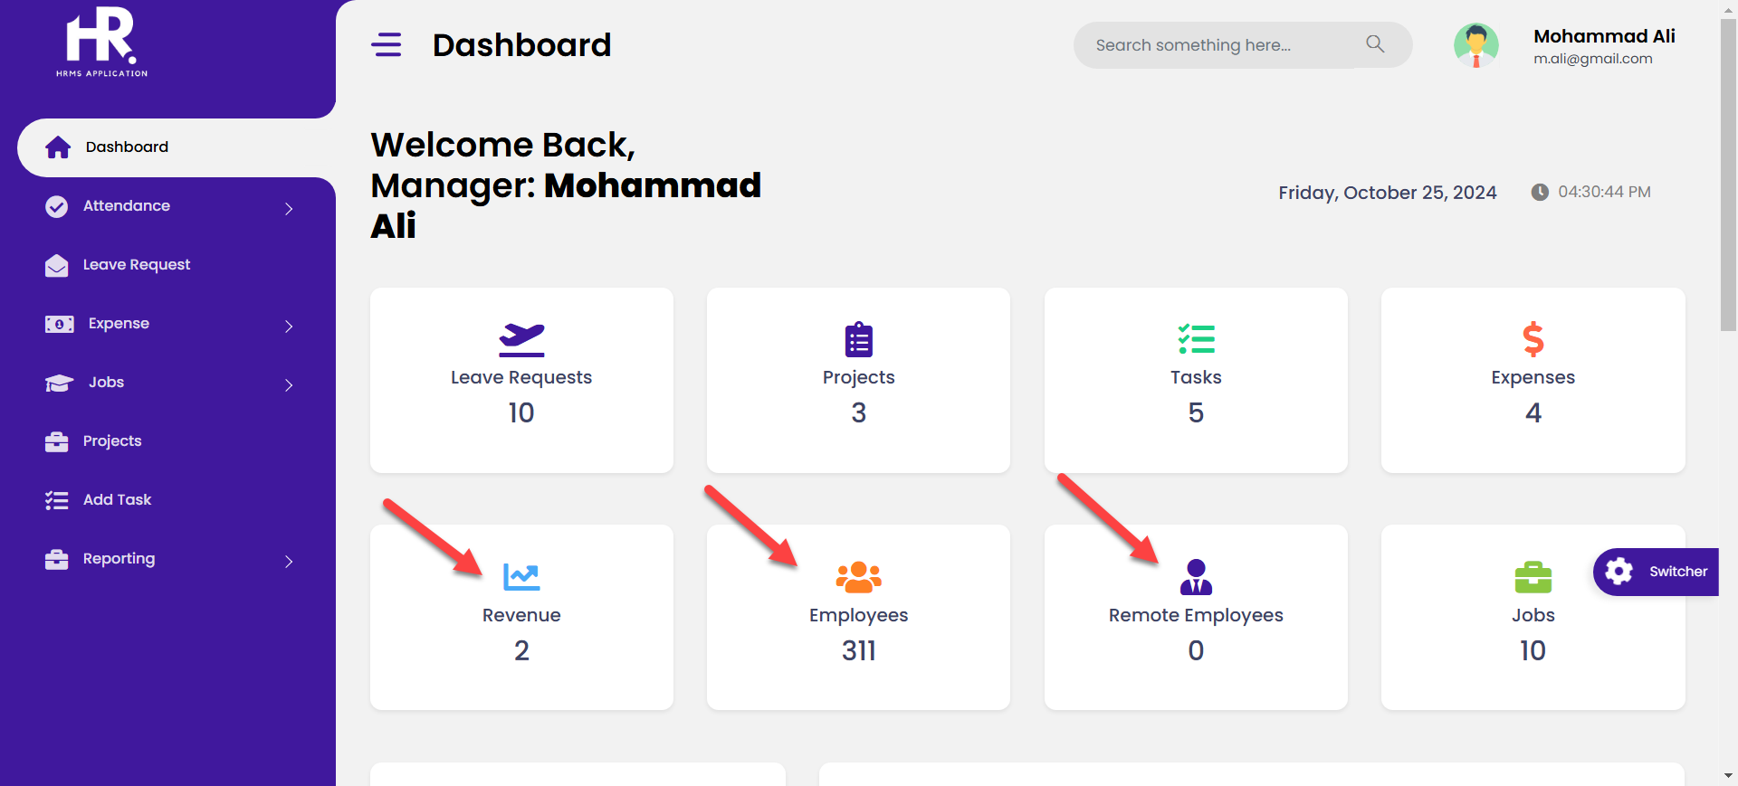

* Should be dynamic not static
* Leave request Pie chat needs more improvements, Approved and pending etc should be center-bottom. Increase chart circle size (you can decrease expense status to improve pie chart visibility).

* Should be applied to all roles i.e. HR and admin etc

* Add Edit Button to Edit records
* Add additional button to attach receipt for each expense. Do it for admin, HR and manager.

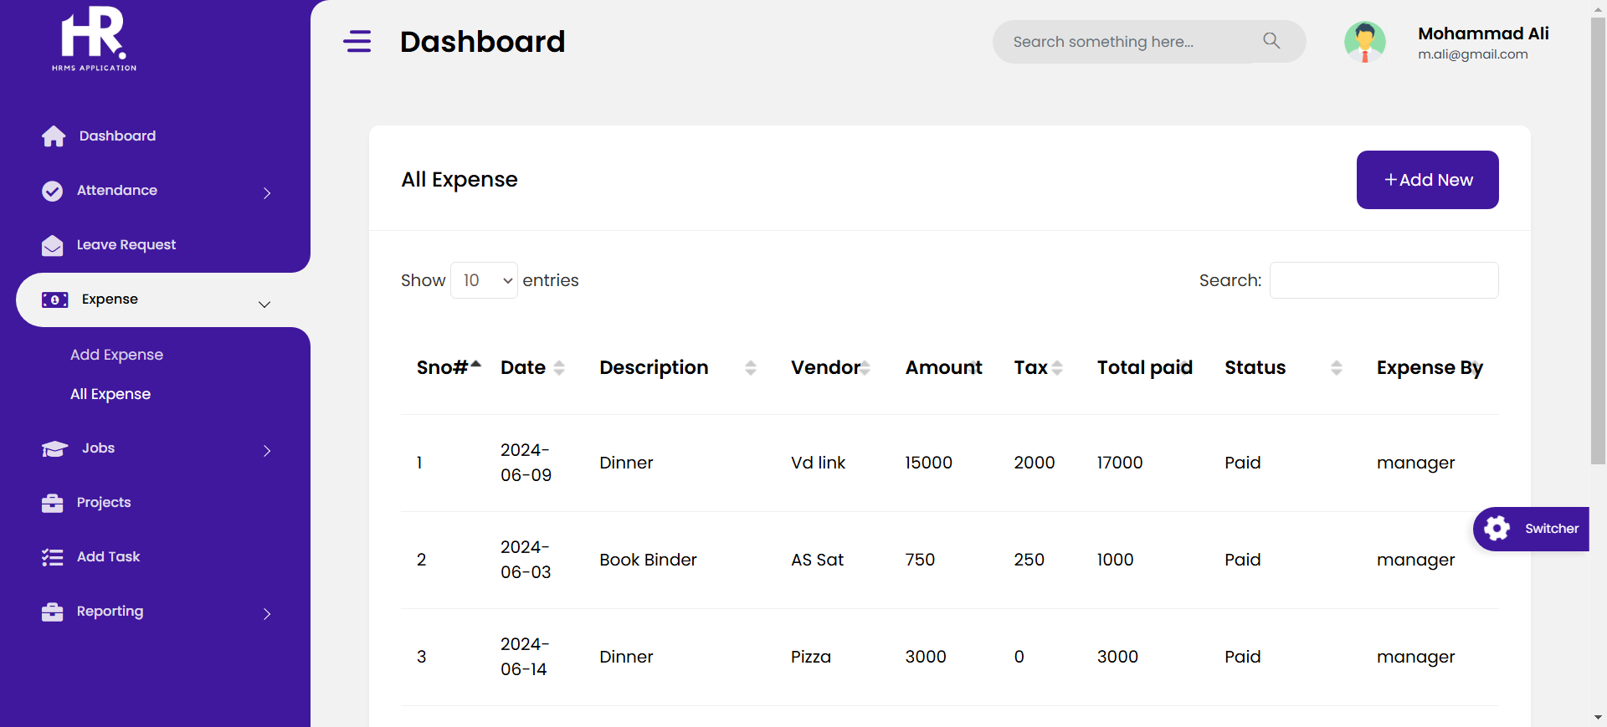

* Add MouseOver for Calender Icon, make calender Icon a little bit bigger or replace it with a good icon.
* Change ICON for all roles admin and HR etc etc



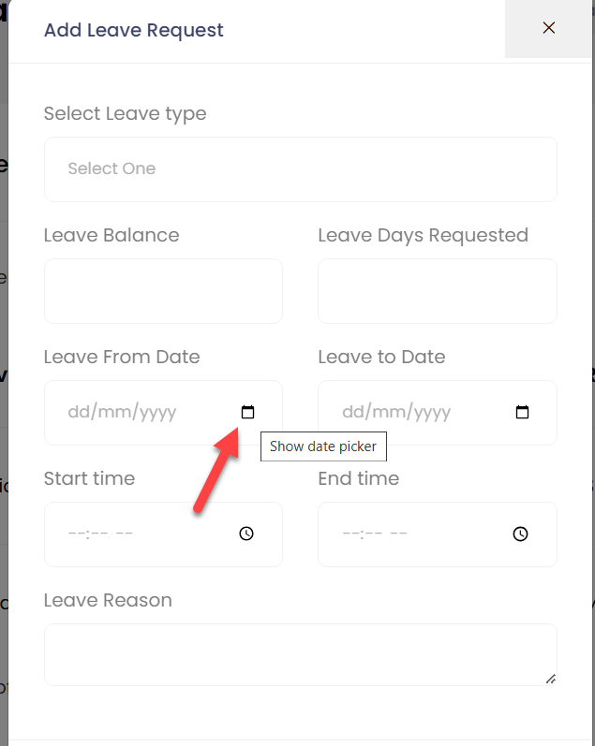

* Options for Status – Onsite, Remote, Full Time, Permanent

