**Overview**

**Kissan Card:** The cabinet reiterated its resolve to bring policies aiming at benefit for farmers, especially those with small holdings. It was emphasized that data related to small farmers and vulnerable numbers of society available with Revenue Department, Agriculture Department, Irrigation Department, Social Protection Department and Sindh People’s Housing for Flood Affected should be properly integrated for better access and coordination. It was further suggested that Kissan Cards to farmers **having holding of 12.5 acres or below should be introduced** so that any subsidy offered by the government reaches them swiftly.

**Registration Process - Ecosystem**

The process for registering farmers' Kisaan Card Process. General steps involved:

1. **Identify Eligibility Criteria**: Determine if you meet the eligibility criteria for the subsidy. This would include factors such as the size of your landholding, Form 7 availability, the type of crops you grow, your income level, and whether you meet any specific requirements set by the government or relevant authorities.
2. **Documentation**: Gather all the necessary documents required for registration. This may include proof of land ownership (Form-7), identification documents (CNIC), and any other documents i.e. passport size Photograph or specified by the authorities.
3. **Registration Process**:

**STEP -1 (Land Revenue Department, GoS)**

* 1. The Farmer then will go to the Revenue Department to confirm his/ her landholding records available with Revenue Department in his concerned districts/ Taluka office.
  2. The Revenue Department will cross-verify his/her record and enter the required data fields in the online system, provided for this specific task.
  3. Once the specific land record fields are filled, the form will automatically be transferred to the respective Agriculture Extension Field Office for further field verification and complete data required.

**STEP-2 (Agriculture Extension, Field Offices)**

1. Submission of Form: After filling out the form with the specific land record fields, you would submit it through the designated channel, which could be online or through a physical submission process.
2. Transfer to Agriculture Extension Field Office: The submitted form is then transferred to the respective Agriculture Extension Field Office responsible for conducting field verification and completing the required data.
3. Field Verification: Officials from the Agriculture Extension Field Office will visit the applicant's land for verification purposes. This verification process may include confirming land ownership or lease status, assessing the land's suitability for agricultural activities, and verifying other relevant information provided in the form.
4. **Completion of Data**: Based on the findings from the field verification, any additional data required for the subsidy application will be completed by the officials. This could involve updating land records, verifying crop types, or assessing the applicant's compliance with eligibility criteria.
5. **Review and Approval**: Once the field verification and data completion process is complete, the form will be reviewed by the relevant authorities. If everything is in order and the applicant meets the eligibility criteria, the subsidy application may be approved.
6. **Notification**: The applicant will be notified of the status of their subsidy application. If approved, they will receive further instructions on the disbursement of the subsidy amount and any other relevant details.
7. **SMS marketing:**SMS marketing quickly informs farmers of land approval or rejection. Approved farmers receive an approval SMS, while rejected ones get a rejection SMS with reasons, allowing resubmission if needed.

**Approval Notification:**In this option, farmers promptly receive an SMS confirming the approval of their land claim. This notification assures them that their claim has been successfully processed and approved, providing them with immediate peace of mind and clarity regarding the status of their land.

**Rejection Notification:**Under this option, farmers are promptly informed via SMS if their land claim has been rejected. Alongside the rejection notification, they receive specific reasons elucidating why the claim was not approved. This notification empowers farmers with clear feedback, enabling them to understand any shortcomings in their claim and, if necessary, take appropriate action for reconsideration or rectification

1. **Transfer of Data for disbursement:** Based on the Sindh Government policies from time to time, the data sets will be shared with a partner Bank for transfer of Funds to the respective bracket of farmers of Sindh i.e. (based on landholding, type of crops, districts, right bank, left bank and season based (Rabi/Kharif).

**STEP-3 (Partner Bank)**

1. The Government of Sindh will transfer the funds to a Partner Bank with specific subsidy parameters for onward disbursement of funds to farmer accounts.
2. All the respective farmers will be notified through text message on their mobile phones

**STEP-4 (Farmers Receiving Subsidy through Kisaan Card)**

1. The Farmers will be receive their subsidy through Kisaan Card using ATMs, PoS and Online App.

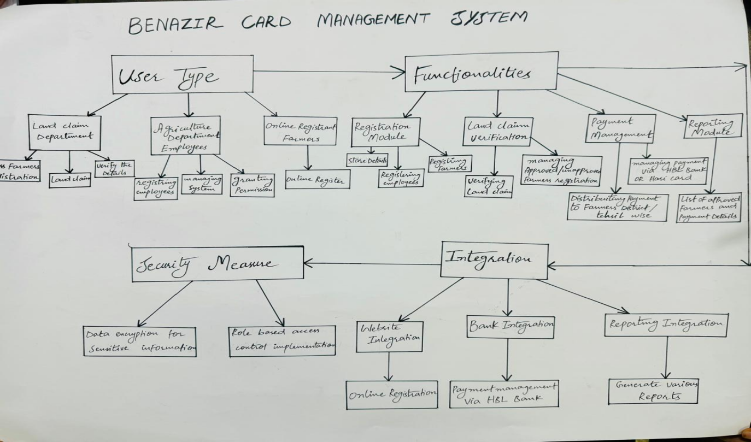

1. **User Types**:

● Agriculture Department Employees (Admin): Their responsibilities

include managing the system, registering employees, and granting

permissions.

● Land Claim Department: This department is tasked with processing

farmers' registrations and land claims.

● Online Registrants (Farmers): These individuals will register online,

and their registrations will be verified by the Land Claim department.

2. **Functionalities**:

**Registration Module**:

● Functionality for registering employees.

● Functionality for registering farmers and storing their details.

**Land Claim Verification**:

● Functionality for managing unapproved and approved farmer

registrations for the Land Claim department.

● Functionality for verifying land claims.

**Payment Management**:

● Functionality for managing payments via HBL hari card.

● Functionality for distributing payments among farmers district-wise

and tehsil-wise.

**Reporting Module**:

● Functionality for generating reports, such as lists of approved

farmers and payment details.

3. **Integration**:

**Bank Integration**: Integration with HBL bank to manage payments.

**Website Integration**: Functionality for allowing online registrations

through the website.

**Reporting Integration**: Integration with reporting tools to generate

various reports.

4. **Security Measures**:

● Implementation of data encryption to secure sensitive information.

● Implementation of role-based access control to restrict access to

specific functionalities based on user roles

**Reporting for Land Claim Department:**

* **Approved Farmers List:**This report will include details of all farmers whose land claims have been successfully approved. It will provide information such as the farmer's name, contact details, land size, and location. This report assists in tracking approved claims and ensuring transparency in the process
* **Unapproved Farmers List:**This report will list farmers whose land claims have been rejected or are pending approval. It will include reasons for rejection, if available, and other relevant details. This report helps the department prioritize pending claims and address any issues leading to rejections
* **Payment Details Report:**This report will contain payment-related information, including the amount disbursed to each approved farmer. It will also specify the district-wise and tehsil-wise distribution of payments. This report assists in tracking financial transactions and ensuring accurate payment distribution.
* **Verification Status Report:**This report will provide an overview of the verification status of land claims. It will categorize claims as approved, pending, or rejected, along with the reasons for rejection, if applicable. This report helps in monitoring the progress of land claim verifications and identifying areas for improvement in the process.

**Reporting for Agriculture Department:**

* **Employee Registry:**This report will list all registered employees of the Agriculture Department. It will include details such as their names, roles, and contact information. This report helps in managing the department's workforce and ensuring accountability.
* **Online Registrants Report:**This report will contain details of farmers who have registered online. It will include their personal information, registration status, and verification status by the Land Claim Department. This report assists the Agriculture Department in monitoring the registration process and collaborating with the Land Claim Department for verification.
* **System Permissions Report:**This report will outline the permissions granted to different employees within the system. It will specify which functionalities each employee can access and modify. This report helps in maintaining system security and ensuring appropriate access levels for employees.
* **Payment Distribution Report:**This report will provide an overview of payments made to farmers district-wise and tehsil-wise. It will include information such as the total amount disbursed, the number of farmers paid, and any discrepancies in payment distribution. This report assists in monitoring financial transactions and ensuring equitable distribution of funds.

**Complaint Management System**

The implementation of an effective Complaint Management System (CMS) aims to provide a streamlined platform for farmers across Sindh to voice their concerns, seek assistance, and address grievances promptly. This system serves as a pivotal component in enhancing agricultural support services by leveraging ICT approaches within the Agriculture Extension framework.

The CMS is designed to offer farmers a user-friendly online interface where they can easily register complaints, provide details about their issues, and track the status of their submissions. It incorporates features such as:

* **Online Complaint Registration:**Farmers can submit their complaints through a user-friendly online portal, ensuring accessibility from any location with internet connectivity. The system prompts farmers to provide essential details regarding their grievances, such as the nature of the problem, location, and any supporting documentation.
* **Complaint Tracking and Resolution:**Once a complaint is registered, farmers can track its progress in real-time. The CMS assigns unique identifiers to each complaint, allowing farmers to monitor its status, including acknowledgment, investigation, and resolution stages. Automated notifications keep farmers informed about any updates or actions taken on their complaints.
* **Escalation Mechanism:**In cases where complaints require escalation or urgent attention, the CMS incorporates an escalation mechanism. This feature ensures that unresolved issues are promptly escalated to higher authorities or relevant departments for swift resolution
* **Feedback and Resolution Confirmation:**Upon resolution of a complaint, farmers receive notifications prompting them to provide feedback on the handling of their grievances. This feedback mechanism enables continuous improvement of service delivery and ensures farmer satisfaction. Additionally, farmers receive confirmation once their complaints are successfully resolved, providing closure to their concerns

**Reporting Sections**

* **Complaints Dashboard:**This provides an overview of all registered complaints, including their status, priority level, and resolution timeline. The dashboard facilitates monitoring and management of complaints at both operational and managerial levels.
* **Trend Analysis Reports:**These reports analyze complaint data over time to identify recurring issues, geographic hotspots, and emerging trends. Such insights enable proactive measures to address systemic issues and improve service delivery.
* **Performance Metrics:**These reports track key performance indicators related to complaint resolution, such as response time, resolution rate, and customer satisfaction scores. Monitoring these metrics enables continuous evaluation of the CMS's effectiveness and informs strategic decision-making for service improvement

By implementing a robust CMS, the Agriculture Extension aims to foster transparency, accountability, and responsiveness in addressing farmers' concerns, ultimately enhancing the overall agricultural support ecosystem in Sindh.