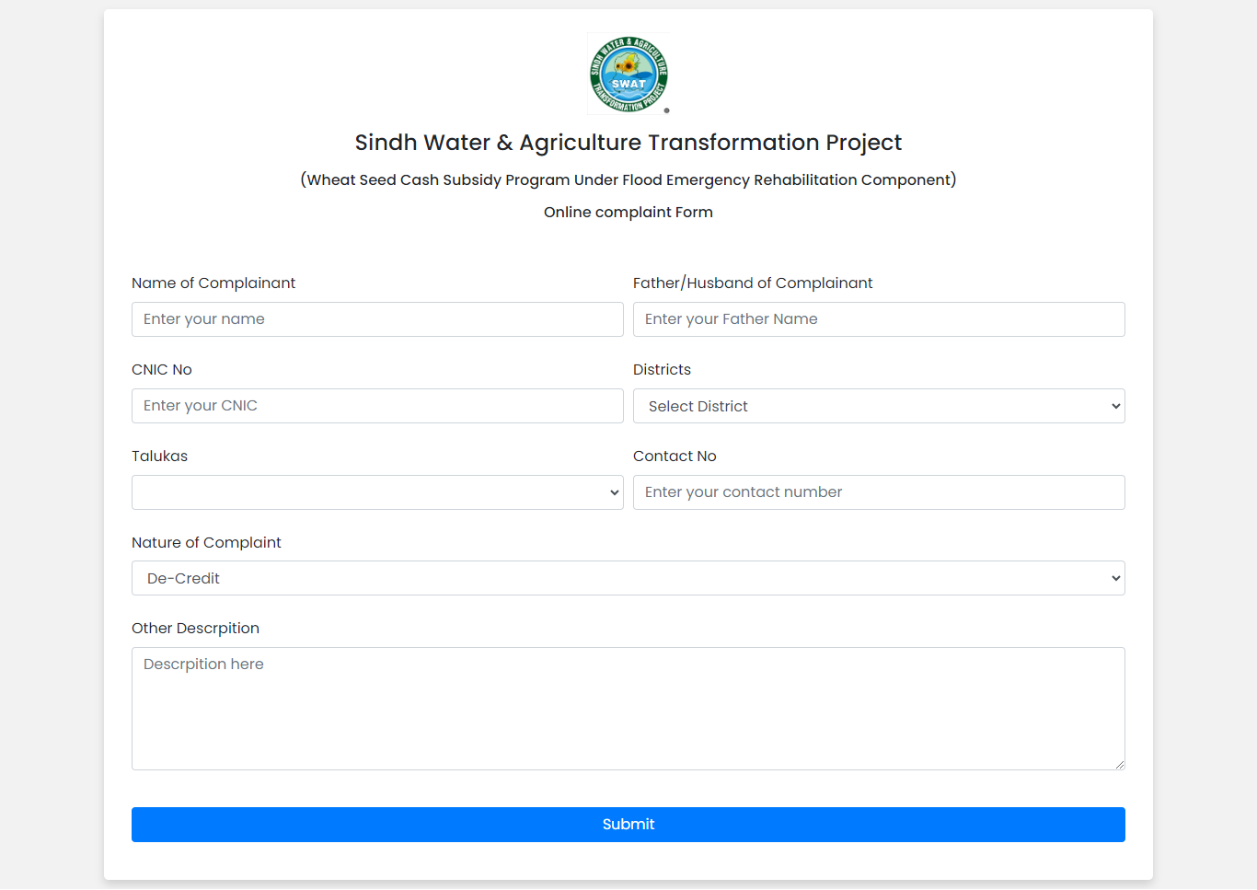

**Purpose:** This form allows users to submit complaints easily.

**Information Required:** Users provide their district, taluka, and details of their complaint.

**Ease of Use:**Designed for user-friendly input of grievances.

**Communication:** Facilitates direct communication between users and our organization.

**Streamlined Process:** Structured format ensures accurate complaint recording.

**Transparency:** Demonstrates commitment to transparency and accountability.

**Feedback Mechanism:** Allows prompt addressing of issues and service improvements.

**Confidentiality:** Assures confidentiality and sensitivity in handling complaints.

**Responsive Action:** Ensures quick and appropriate response to complaints.

**Continuous Improvement:** Helps in continuous process and service enhancement.

This complaint form enables efficient complaint submission and fosters continuous improvement in our services.

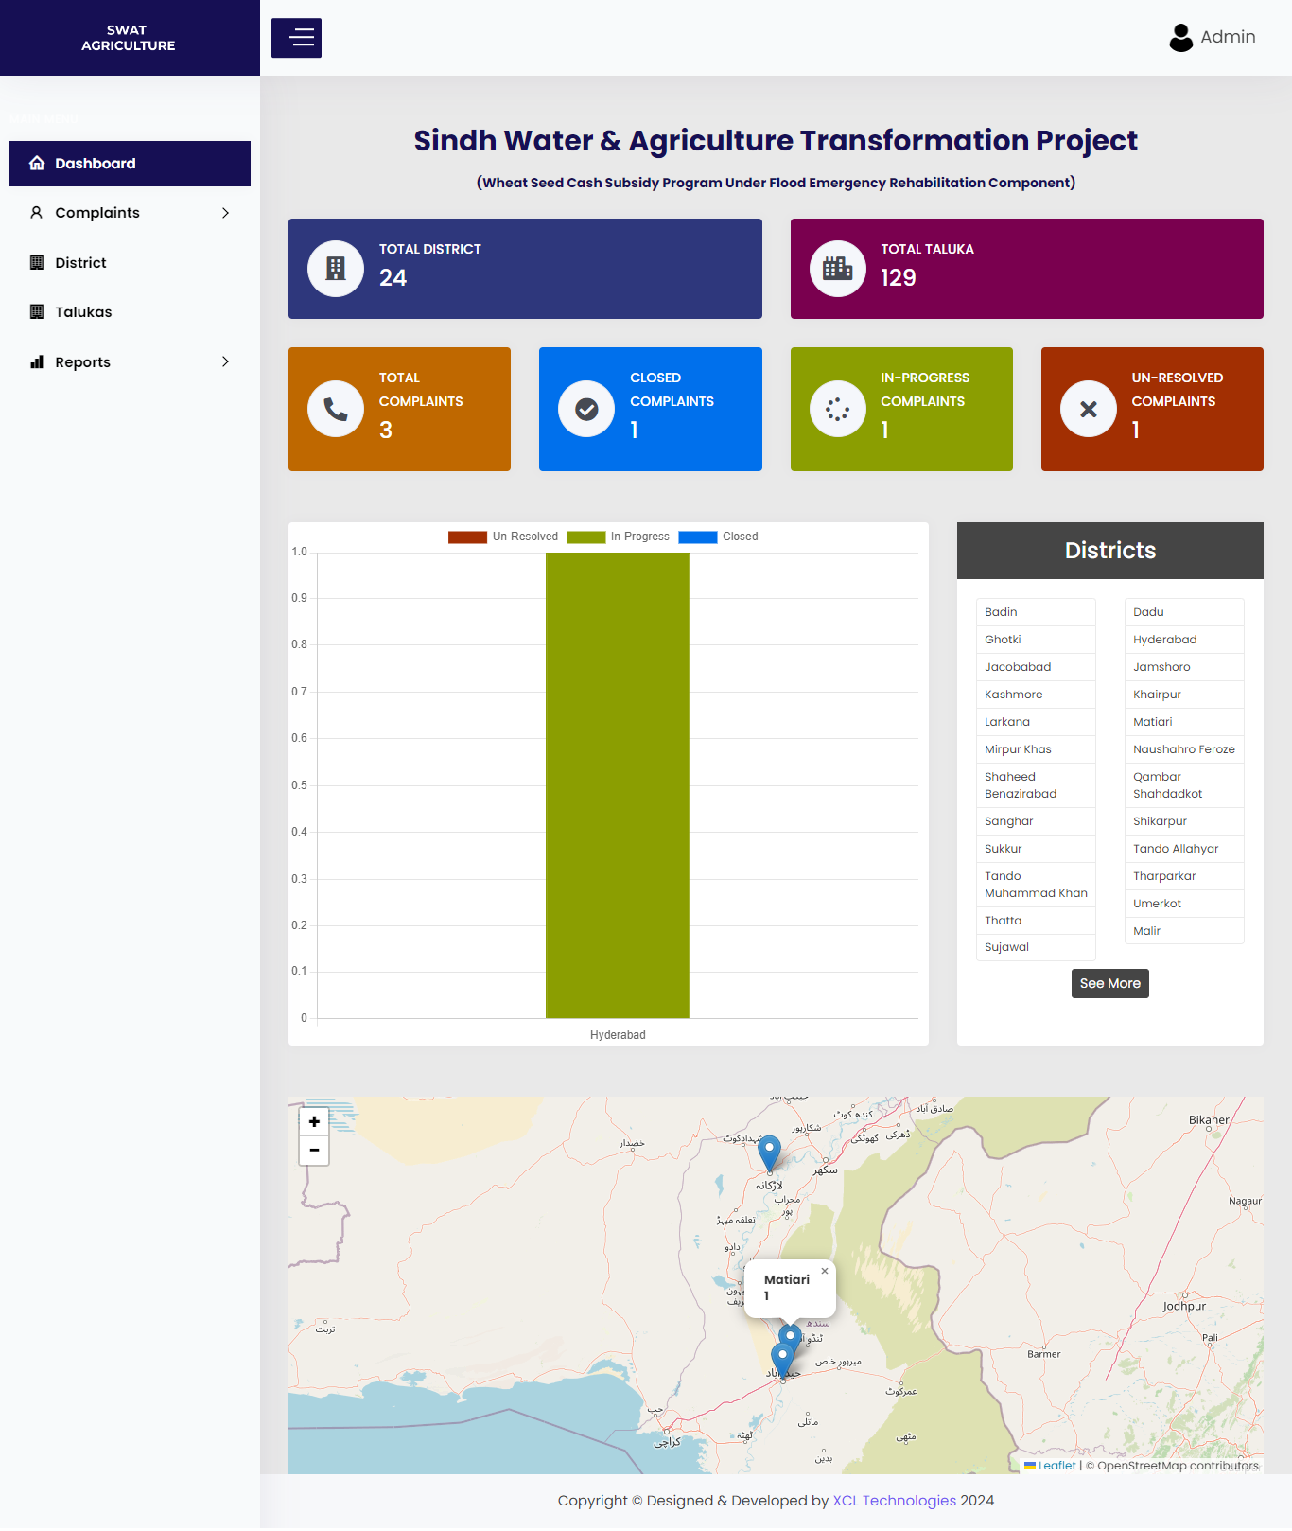

Certainly, here's a concise explanation of the features of your CMS dashboard:

**1. Complaint Counts:** Easily track the total number of complaints across districts and talukas, including those closed, unresolved, and in progress. This provides a clear overview of the status of complaints, aiding in identification and management.

**2. District-wise Charts:** View charts for each district displaying the status of complaints. With a simple click, you can see the breakdown of closed, unresolved, and in-progress complaints for any specific district, facilitating detailed analysis and monitoring.

1. **Interactive Map:** The map feature highlights districts where complaints have been registered. Each district is marked on the map, allowing you to visualize complaint distribution geographically. Clicking on a district reveals the number of complaints received from that area, offering valuable insights into regional trends.

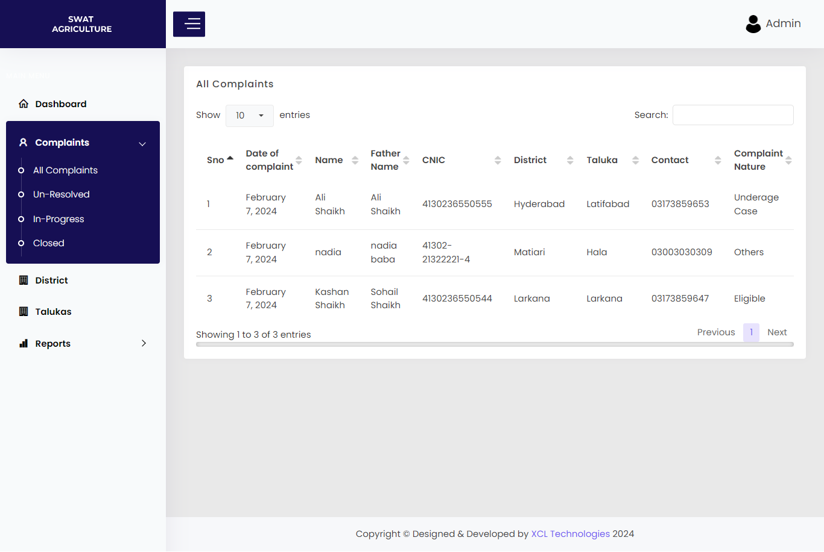

Here's a description of the additional features regarding complaint categories and individual complaint handling:

**1. Complaint Categories:** All complaints are categorized based on their nature or type, providing a structured approach to managing grievances.

**2. Complaint Details and Status:** Each complaint is accompanied by detailed information and its current status, enabling quick reference and tracking of progress.

**3. Individual Complaint View:** Users can view specific details of each complaint individually, allowing for a closer inspection of the issue at hand.

**4. Action and Status Update:** Users have the option to take action on a particular complaint. They can choose to mark it as "In Progress" or "Closed" based on the status of resolution.

**5. Remarks:** Along with updating the status, users can also provide remarks or comments related to the actions taken on the complaint. This facilitates communication and documentation of the resolution process.

This comprehensive system ensures efficient management of complaints, with clear categorization, detailed tracking, and easy action-taking capabilities for effective resolution.

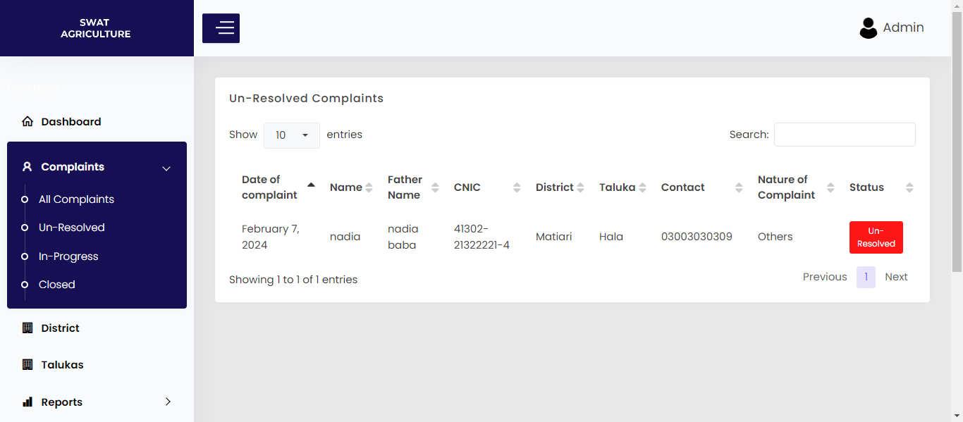

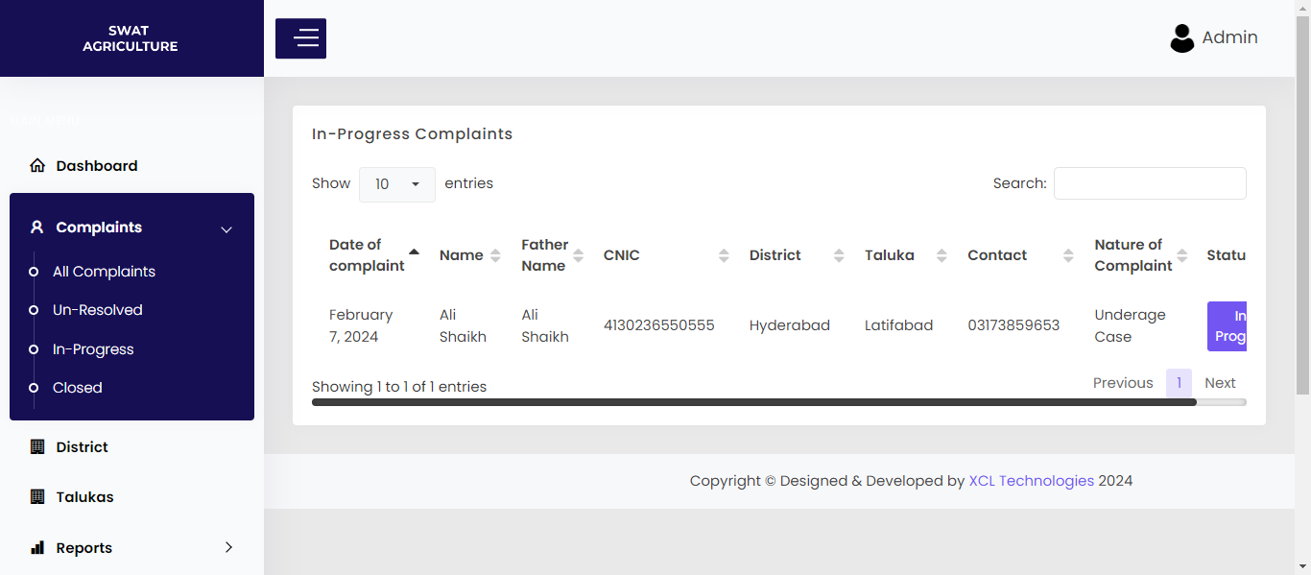

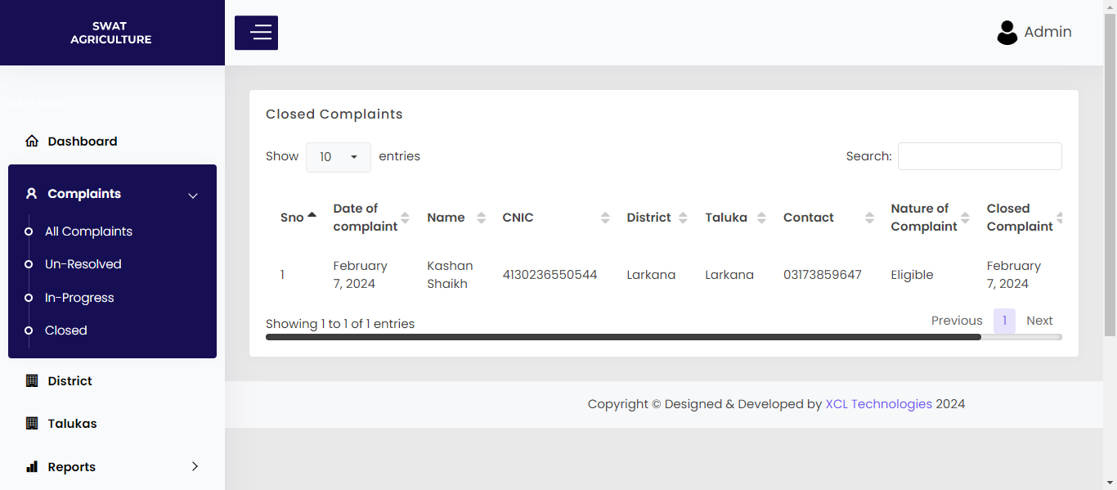

Let's expand on the details of each filtering option:

**Unresolved Complaints:**

1. This category comprises complaints where no action has been taken yet.
2. These complaints are awaiting attention or resolution from the responsible party.
3. Users can quickly identify pending grievances that need immediate action.
4. It serves as a prioritized list of issues that require follow-up to ensure timely resolution.

**In Progress:**

1. Complaints in this category are those where action has been initiated by the responsible party.
2. Users have taken steps to address these complaints, such as investigating or resolving the issue.
3. The status and remarks are updated to reflect the progress made on each complaint.
4. Users can view the history of actions taken and any comments made during the resolution process.
5. This category provides visibility into ongoing efforts to resolve complaints and ensures accountability in the resolution process.

**Closed Complaints:**

1. Closed complaints are those that have been successfully resolved and closed.
2. Users can see the closing date, indicating when the complaint was resolved.
3. Remarks provided upon closure offer insights into the actions taken to address the complaint and any additional comments made.
4. It serves as a record of completed resolutions, allowing users to track the outcome of each complaint.
5. Closed complaints signify successful resolution and contribute to maintaining a record of past grievances and their outcomes.

These filtering options offer a comprehensive view of the complaint management process, from identifying unresolved issues to tracking ongoing efforts and recording successful resolutions.

"In my system, I have a comprehensive listing of districts and their corresponding talukas (sub-districts). Each district entry is accompanied by its specific coordinates, facilitating precise location mapping on a geographic interface. When a district is selected, the system dynamically populates the associated talukas, offering users a detailed breakdown of which talukas are part of that district. This functionality enables users to gain a granular understanding of district-wise subdivisions and their geographical distribution. Such detailed insights streamline administrative tasks, enhance organizational efficiency, and aid in strategic decision-making processes."

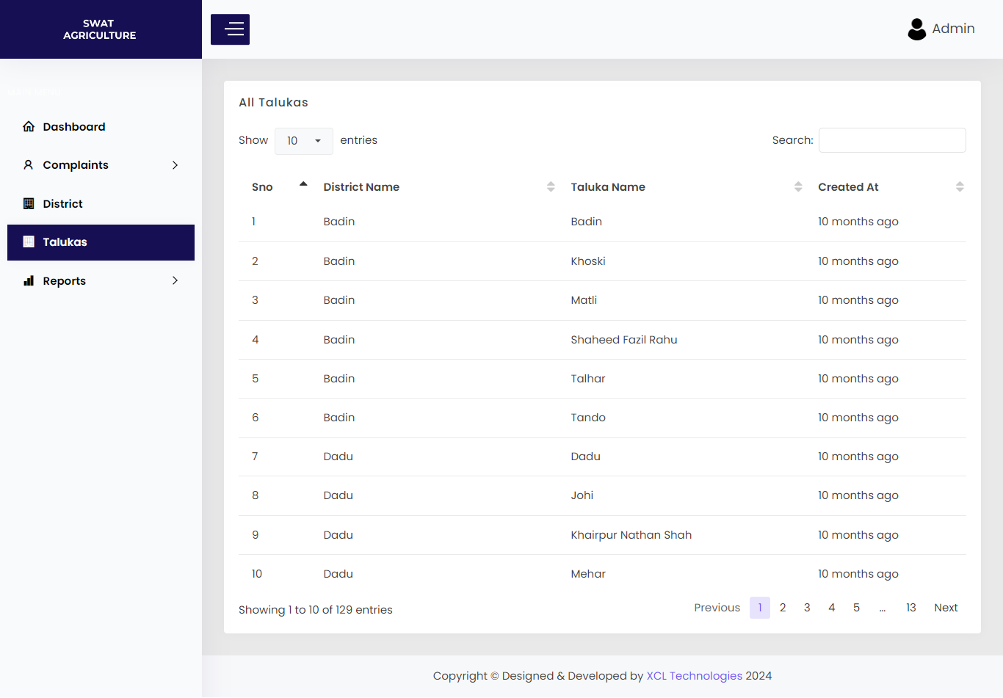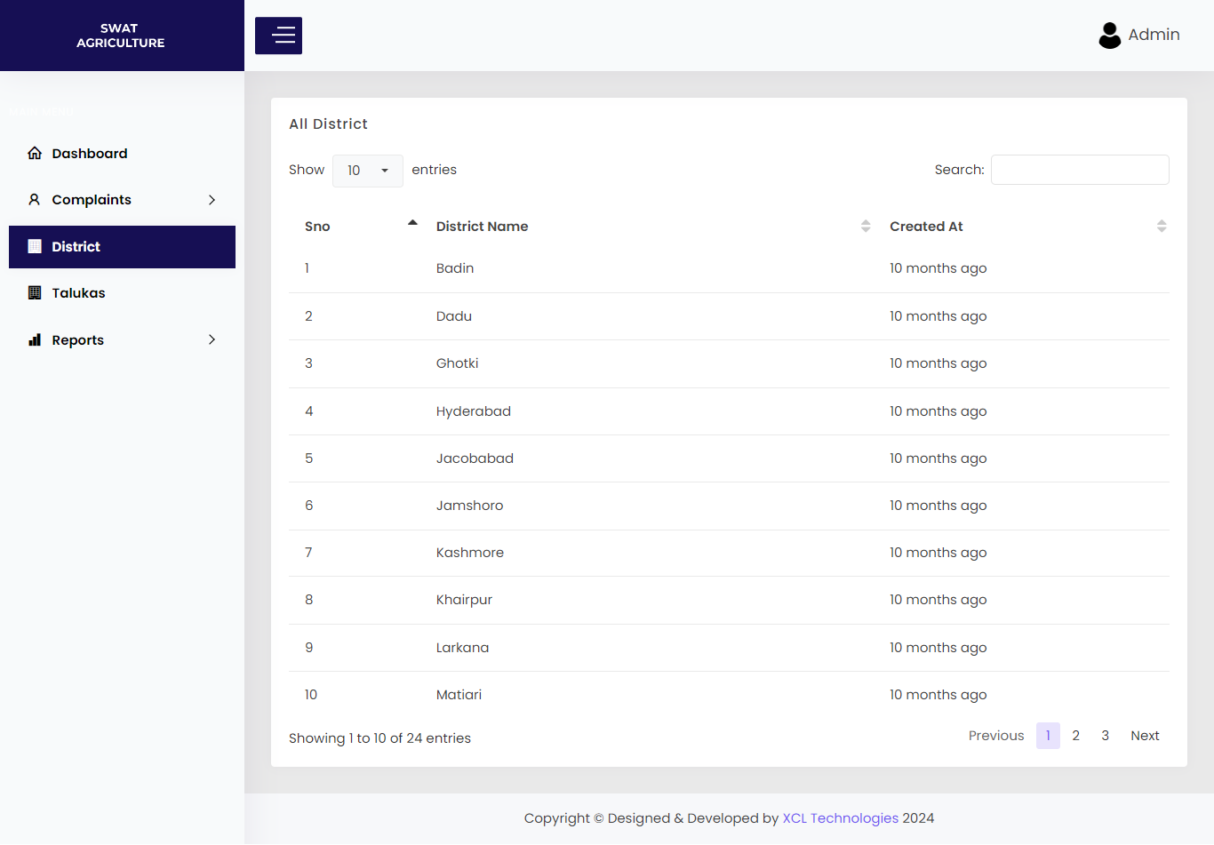

Certainly, here are the summarizing the reporting section's features:

1. **Date-wise Organization:** Reports are categorized by date, enabling users to access data based on specific dates.

2. **Custom Date Range:** Users can choose a start and end date to define the desired date range for the reports.

3. **Filtering Options:** Additional filters can be applied to refine the displayed reports according to specific criteria.

4. **Status Indicators:** Each report includes status indicators for easy identification and tracking of report statuses.

5. **Export Functionality:** Reports can be exported in multiple formats, including copy, PDF, or Excel, allowing for seamless integration with various data management tools and platforms.

This reporting section offers flexibility and efficiency in accessing, analyzing, and exporting data as per user requirements.

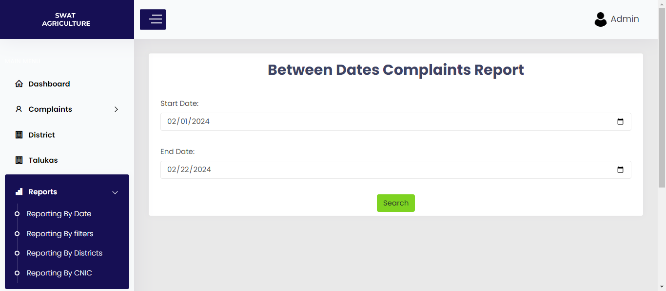

Here's a concise breakdown of the feature:

1. **District Selection:** Users choose a specific district from the available options.

2. **Taluka Append:** Upon selecting a district, all talukas associated with that district are automatically appended to the selection list.

3. **Taluka Filtering:** Users can then select a particular taluka from the appended list, narrowing down the focus to that specific area.

4. **District and Taluka Specific Report:** The system generates a report tailored to the chosen district and taluka, providing detailed insights relevant to the selected area.

5. **Export Functionality:** Users have the option to export the generated report in various formats for further analysis or sharing purposes.

This feature enhances user experience by enabling focused reporting on specific districts and talukas, ensuring that the data provided is relevant and actionable.

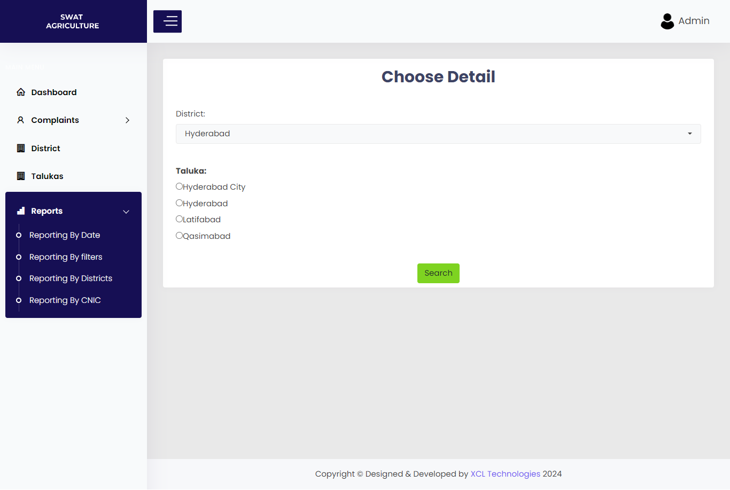

Certainly, here's the District-wise Report description:

**District-wise Report Selection:** Users have the option to select all districts at once, enabling them to generate a comprehensive report encompassing all districts within the system.

**Exportable Format:** Once the report is generated, users can seamlessly export it in their preferred format, such as PDF, Excel, or others, facilitating easy sharing and further analysis.

This feature provides users with the flexibility to generate overarching reports spanning multiple districts, streamlining data analysis and decision-making processes.

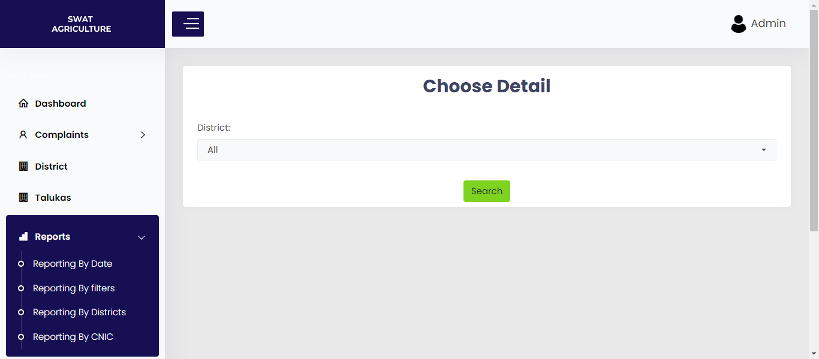

Here's a concise description of the feature:

1. **Search by CNIC Number:** Users can input a CNIC (National Identity Card) number into the system.

2. **Search Functionality:** The system conducts a search based on the entered CNIC number, retrieving the corresponding individual's details.

3. **Detailed Information:** Users can then view specific details associated with the searched CNIC number, providing relevant information as per the search criteria.

This feature allows users to quickly retrieve and review individual-specific information by simply entering their CNIC number into the system.

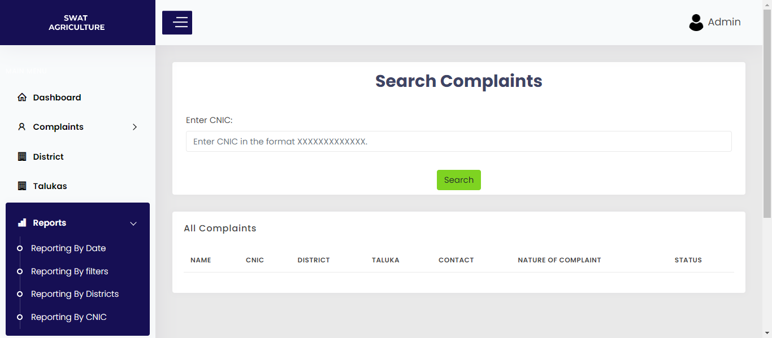

Got it, here's a concise description of the "View Complaint" page:

1. **Complaint Viewing:** Users can access detailed information about a specific complaint on this page.

2. **Action Taking:** Users have the ability to take action on the complaint directly from this page.

3. **Status Selection:** Users can choose the status of the complaint and provide remarks accordingly.

4. **Remark Storage:** The remarks provided by the user are stored and listed alongside the complaint for future reference.

This page facilitates efficient complaint management by allowing users to view, take action, and provide remarks on individual complaints, streamlining the resolution process.