

**E-project**

**Electronic Harvel**

***Team Members***

***Usman Ghani***

(student id: 1510564) ***Faculty Name***

***Kashan Fazal***

(student id: 1514768) *Muhammed Arif (Teacher)*

***Jawad Sattar***

(student id: 1508965)

**

*table of contant*

1. Acknowledgement.
2. Introduction.
3. Hardware/Software.
4. Project Duration.
5. Snap Shots

Acknowledgement

**Acknowledgment**

In the name of Allah, the Most Gracious, the Most Merciful.

I, Muhammed Arif, offer my heartfelt gratitude to Allah SWT for His endless blessings and guidance throughout the completion of this e-project. It is through His divine grace that we were able to overcome challenges and achieve success.

I am deeply grateful to my exceptional team members, whose contributions have been instrumental in bringing this project to fruition. Your dedication, expertise, and unwavering support have been invaluable. I would like to extend my sincere appreciation to each of you:

* [Kashan,jawad, emphasizing their specific contributions and skills]

Your individual talents and unwavering commitment have made this project a true testament to teamwork and collaboration. Together, we have navigated obstacles, shared ideas, and celebrated milestones. I am honored to have worked alongside such a talented and supportive group of individuals.

I would also like to express my gratitude to [mention any mentors, advisors, or instructors who provided guidance or support]. Your knowledge, experience, and encouragement have been essential to our success.

May Allah SWT continue to shower His blessings upon us all as we pursue our future endeavors. I am confident that the lessons learned and bonds formed during this project will continue to inspire and motivate us in our individual and collective pursuits.

Thank you once again for your invaluable contributions.

With sincere gratitude,

Muhammed Arif

Introduction

## Introduction: Embracing E-Commerce with Electronic Harvel

**A Journey Powered by Teamwork and Innovation**

Welcome to the captivating world of Electronic Harvel, an e-commerce platform meticulously crafted to revolutionize the online shopping experience. This project, a testament to the combined efforts of Usman Ghani, Jawad, Kashif, and myself under the esteemed guidance of Professor Muhammed Arif, represents the culmination of months of dedication, creativity, and unwavering passion for the ever-evolving landscape of e-commerce.

**Electronic Harvel:** A Name Steeped in Meaning

The very name "Electronic Harvel" evokes a sense of dynamism and innovation. The word "Electronic" signifies our embrace of cutting-edge technology, promising a seamless and secure online shopping experience. "Harvel," a Sindhi term for a bustling marketplace, encapsulates our vision of creating a vibrant online space where buyers and sellers converge, fostering a thriving community of commerce.

**Our Inspiration: Bridging the Gap and Empowering Communities**

The impetus behind Electronic Harvel stemmed from a desire to bridge the gap between local businesses and a wider consumer base. We envisioned a platform that would empower local entrepreneurs, artisans, and craftsmen to showcase their unique products to a global audience. By eliminating geographical barriers and providing a user-friendly interface, Electronic Harvel aspires to be a catalyst for economic growth and empowerment, particularly in underserved communities.

**A Collaborative Tapestry Woven with Expertise**

The journey of bringing Electronic Harvel to life has been a tapestry woven with the diverse threads of our team's individual expertise. Usman Ghani, with his unwavering focus on web development, meticulously crafted the platform's infrastructure, ensuring a robust and scalable foundation. Jawad, armed with his keen eye for design, breathed life into the website's aesthetics, creating an interface that is both intuitive and visually captivating. Kashif, the marketing maestr

software/hardware

Hardware:

* A minimum computer system that will help ypu access all tools in tha courses is a pentinum 166 or better
* 64 Megabytes of RAM or better

Software:

* Sublime/Note pade/HTML editor CoffeeCup p
* Chrome/MS edge/fire fox/Saffari

Project Duration

* **ANALYSIS 2 DAYS**
* **DESIGN 4 DAYS**
* **DEVELOPMENT 2 WEEKS**
* **TESTING 3 DAYS**
* **DOCUMENTATION 1 DAY**

duration Table

|  |  |  |  |  |
| --- | --- | --- | --- | --- |
| No. | Task | Days | Team mate Name | statustatus |
| 1 | Desing | 3days | Usman ghani |  |
| 2 | Development | 2 week | Usman ghani/kashan/jawad |  |
| 3 | Testing | 1day | Kashan/usman |  |
| 4 | Documentation | 1day | Usman ghani |  |



Snap Shots

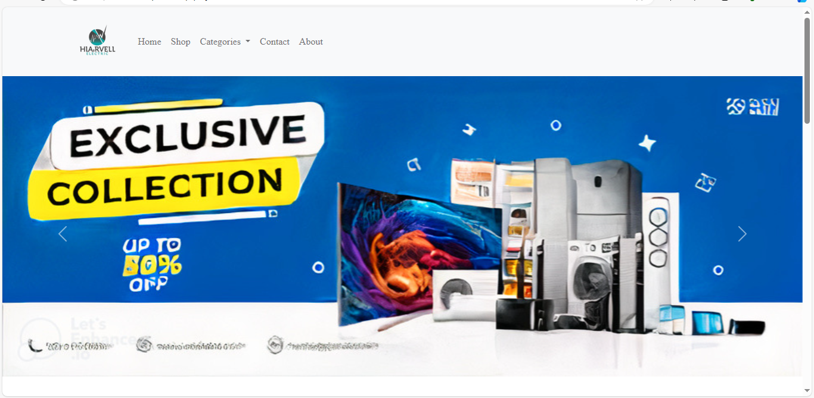Home:

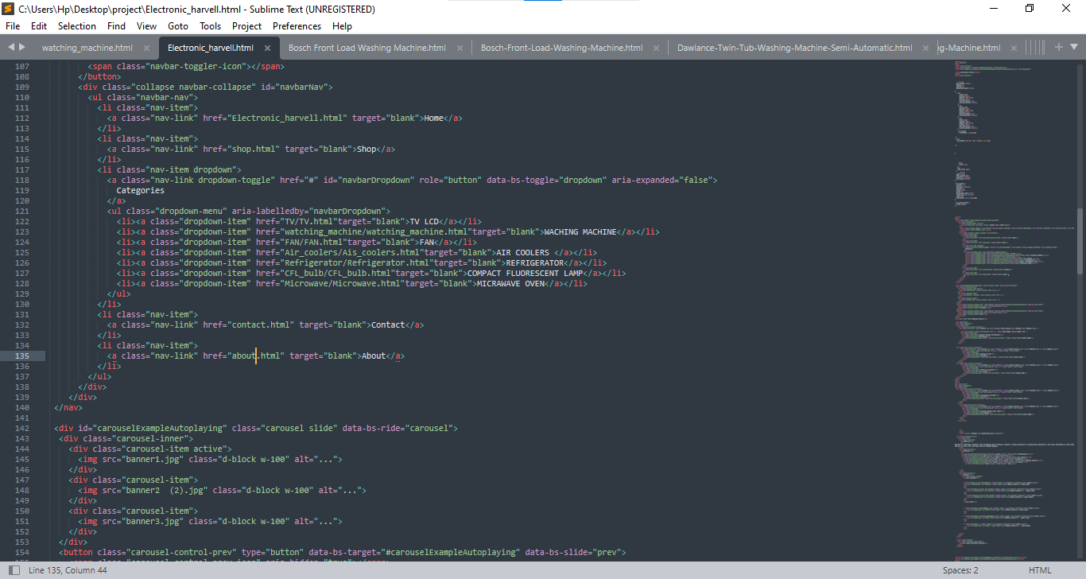There code

shop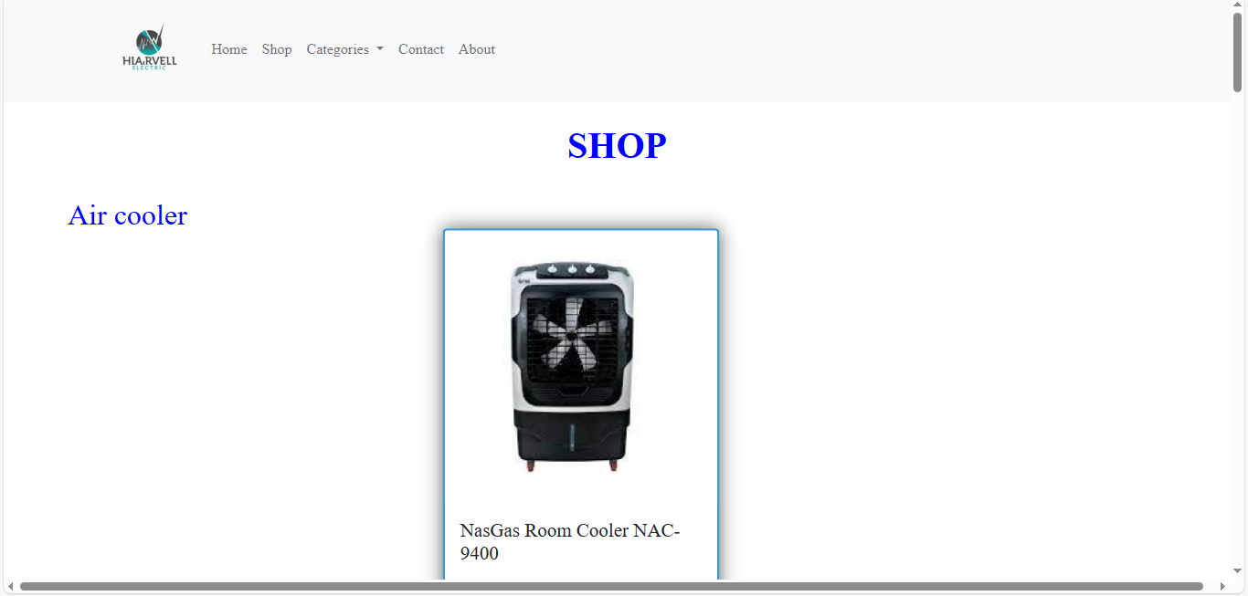

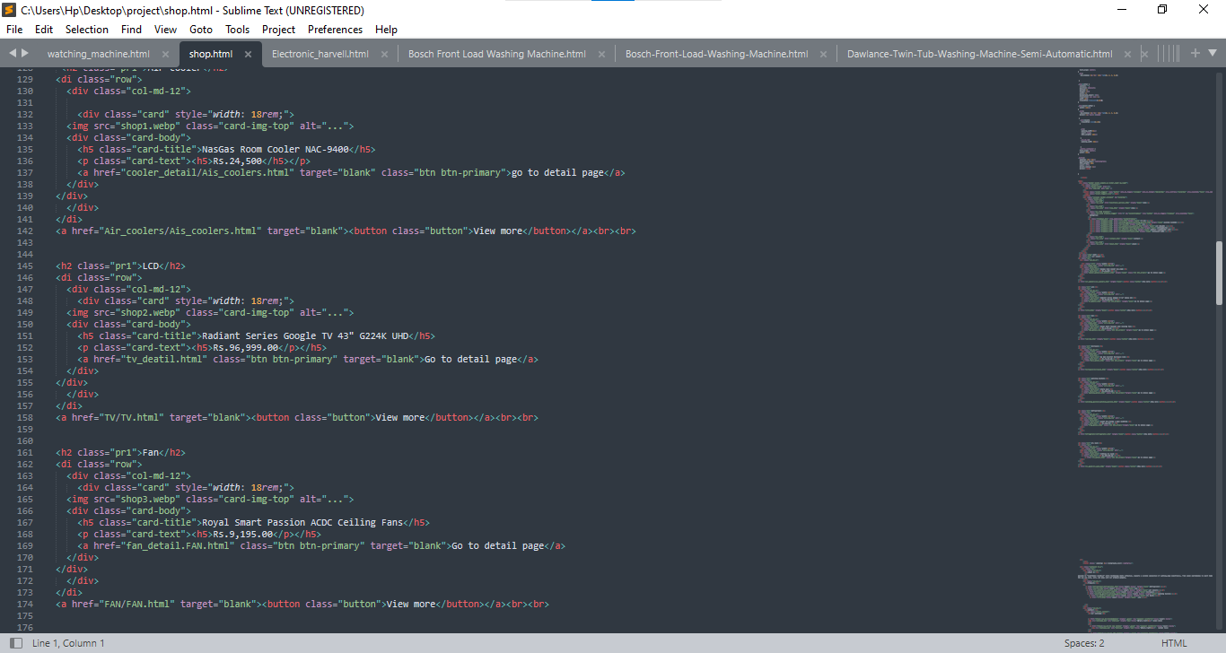there code

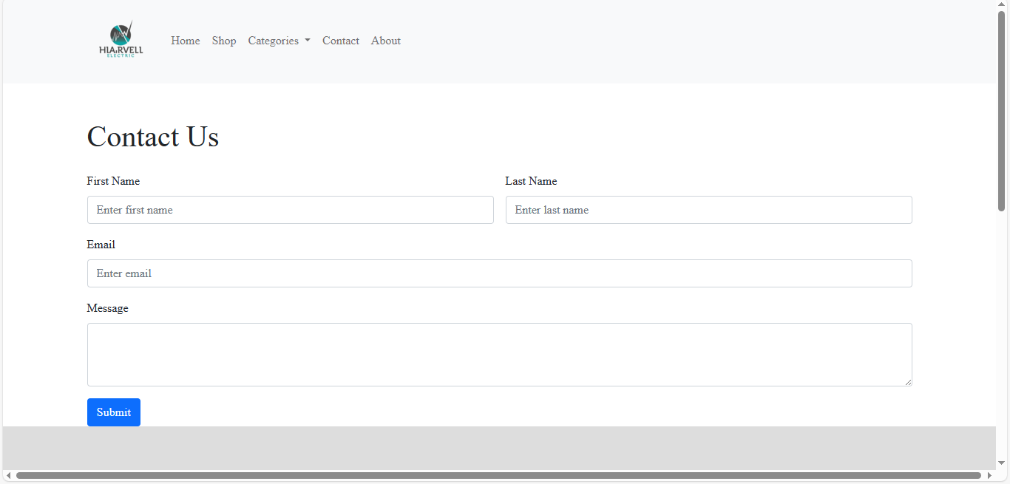contact page

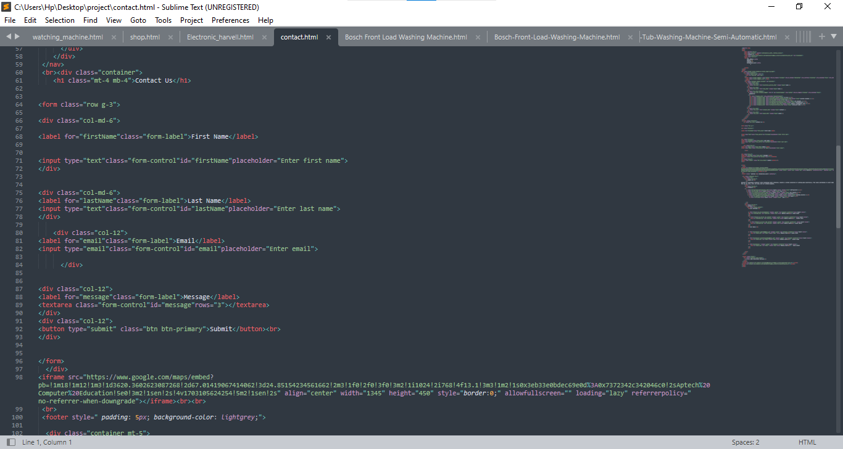there code

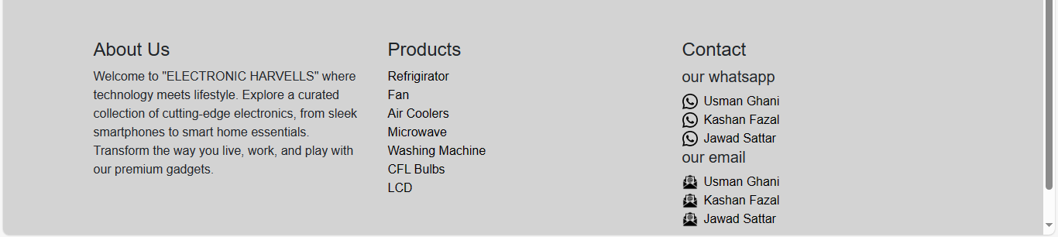footer

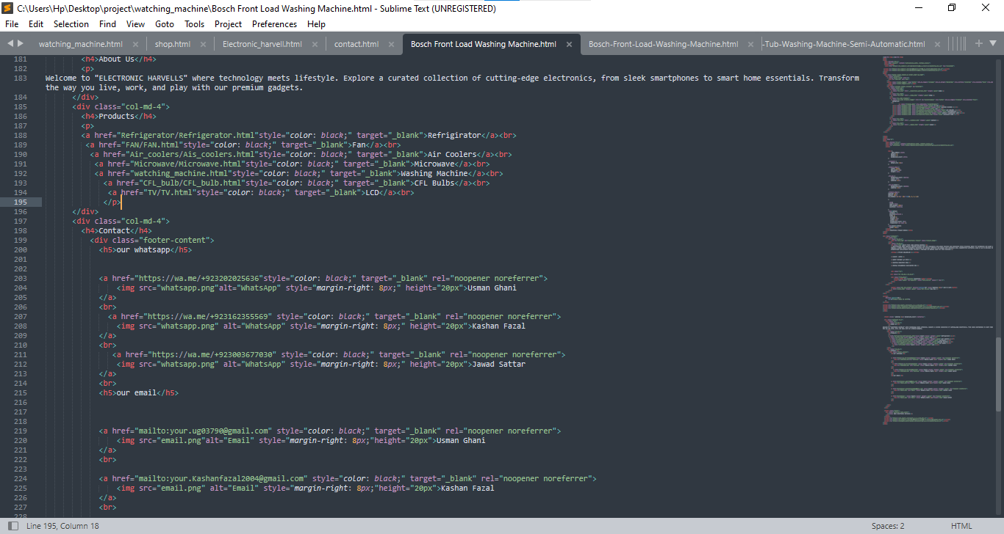 there code

navbar and

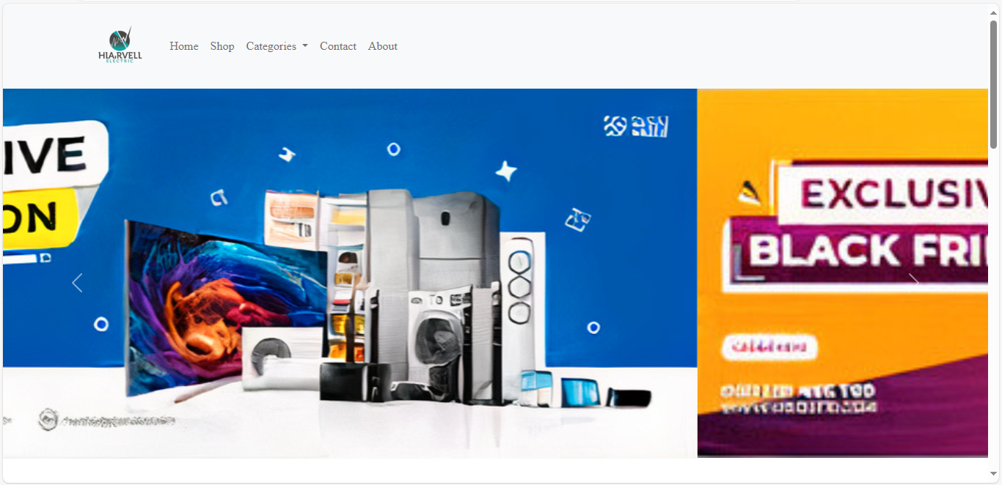 banner

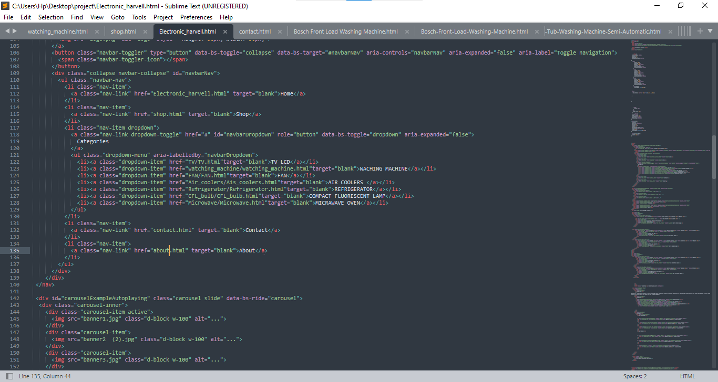there code



TEAM MEMBERS:

**Usman ghani**

( Student id: 1510564)

**Kashan fazal**

( Student id: 1514768)

**Usman ghani**

( Student id: 1508965)

Submit to

( Muhammed Arif)