Task: Jenkins Document

Submitted by:
Kashan Zulfiqar

Dated : 03/13/2026
Jenkins Overview/Installation
Jenkins
Jenkins is an open source automation server that is used to automate tasks.it helps developers automate the process of building testing deploying softwares.with jenkins we can automate complete development life cycle.it was initially created for java only but now supports most of the languages.it automates repatetive taks like builging testing deploying and monitoring.jenkins use its plugins to extnd kits functionality.it supports a vide range of plugins that can be used to automate almost any task.it also supports integration with other tools.
Key features:-
- Continuous integration and continuous delivery.
- Cicd benefit is that when we make any change in the software it automatically builds tests and deploys the app this insures our app is always uptodate.
Jenkins pipelines.
- Jenkins pipelines are written in grove language.allows you to define complex workflows conditions etc.
- We automate tasks so developer can focus on writing code.

Installation:-
- Jenkins is built on java so to install jenkins we need java installed.
- Now to to install jenkins
- Import the repository key: sudo wget -O /etc/yum.repos.d/jenkins.repo https://pkg.jenkins.io/redhat-stable/jenkins.repo
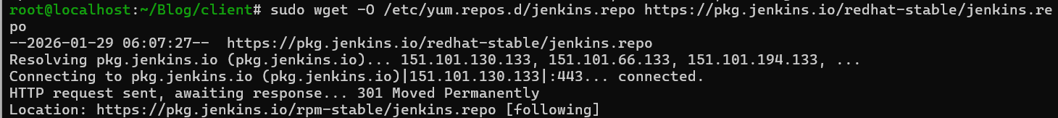
- Now install jenkins from repo using
- sudo dnf install jenkins -y this command
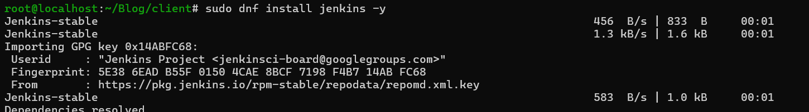
- Now check status
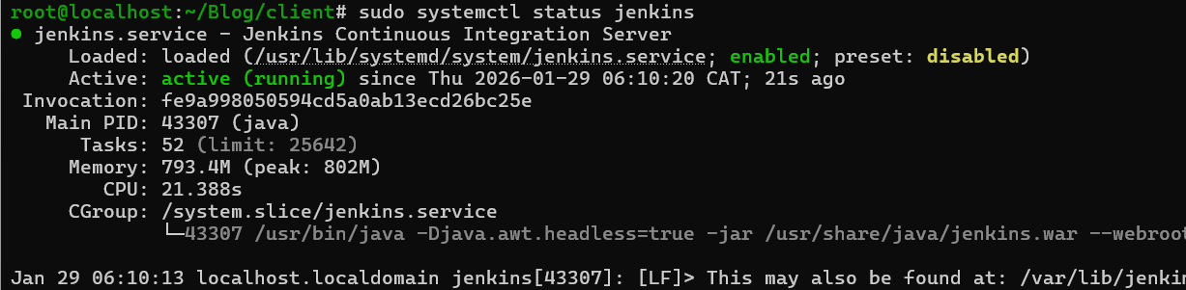
- Now we add port 8080 in firewall because its default port is 8080.

- Installing plugins
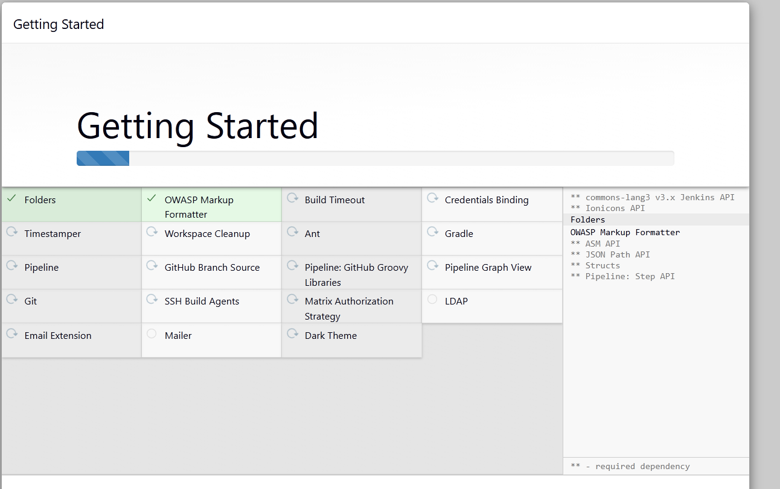

Jenkins Jobs
- In jenkins each new project is called a new job.To create a new job we click on newitem then select the required option like pipeline .
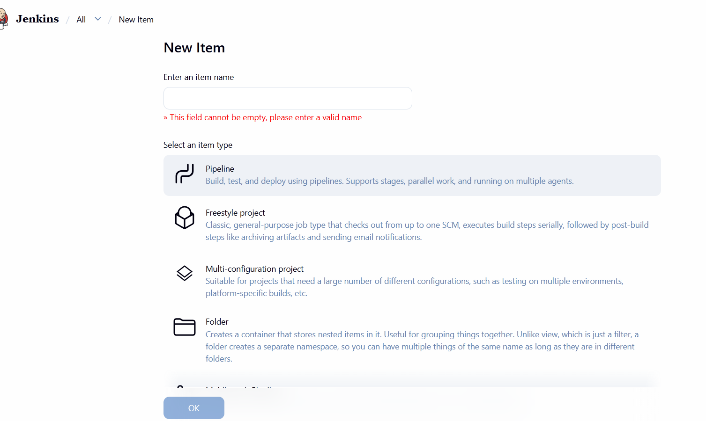
- Then we select trigger condition like run pipeline
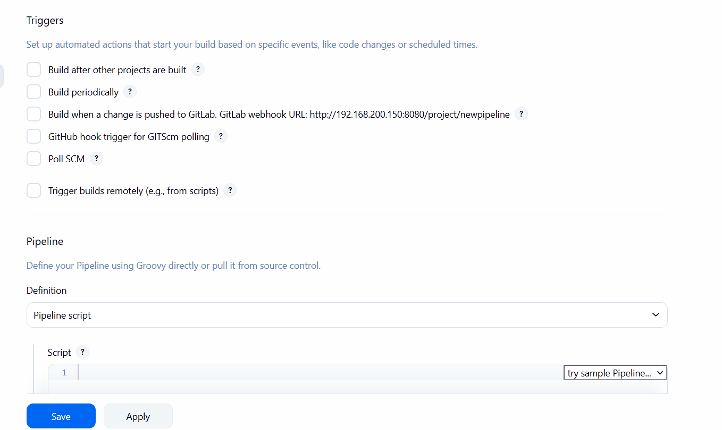
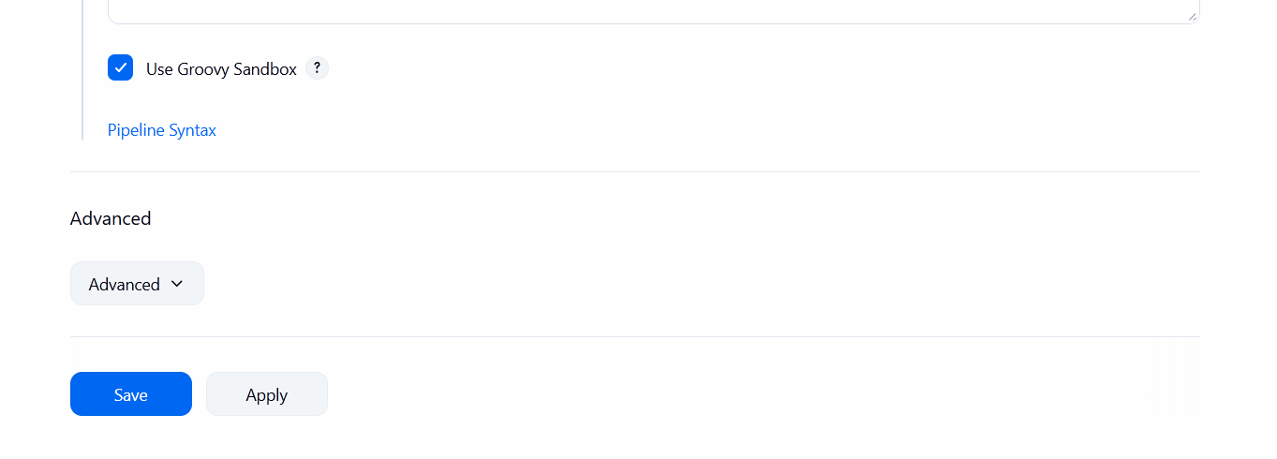
Jenkins Plugins
Jenkins Plugins option is available in manage setting section.
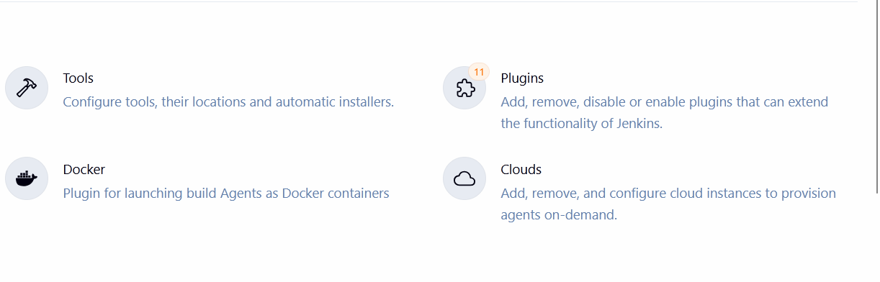
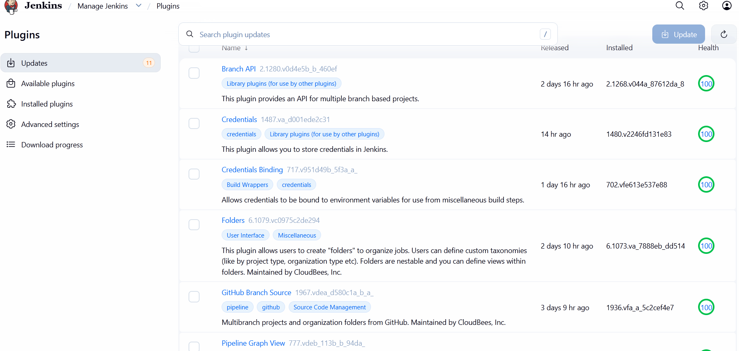
- Plugins are modular pieces of software that extend Jenkins' functionality, allowing it to connect to almost any tool in the software development lifecycle.
- Like Connecting to GitHub, GitLab, or Bitbucket.

Jenkins triggers

- SCM Polling:-
Jenkins "checks" your Git repository at a regular interval (e.g., every 5 minutes) to see if there is new code.
- Webhooks (Push Events):-
Instead of Jenkins asking the Git server if there is news, the Git server (GitHub/GitLab) "calls" Jenkins the second a push happens.
- Periodic Builds (cron):-
Runs the build at specific times, regardless of whether the code has changed.
- Upstream Triggers (upstream):-
This creates a chain reaction. When "Project A" finishes successfully, "Project B" starts automatically.
- GitHub hook trigger for GITScm polling:-
It combines github trigger with scm polling when jenkins receives a webhook request from github jenkins checks whats chnages if ther is a new commit in the repo pipiline runs.
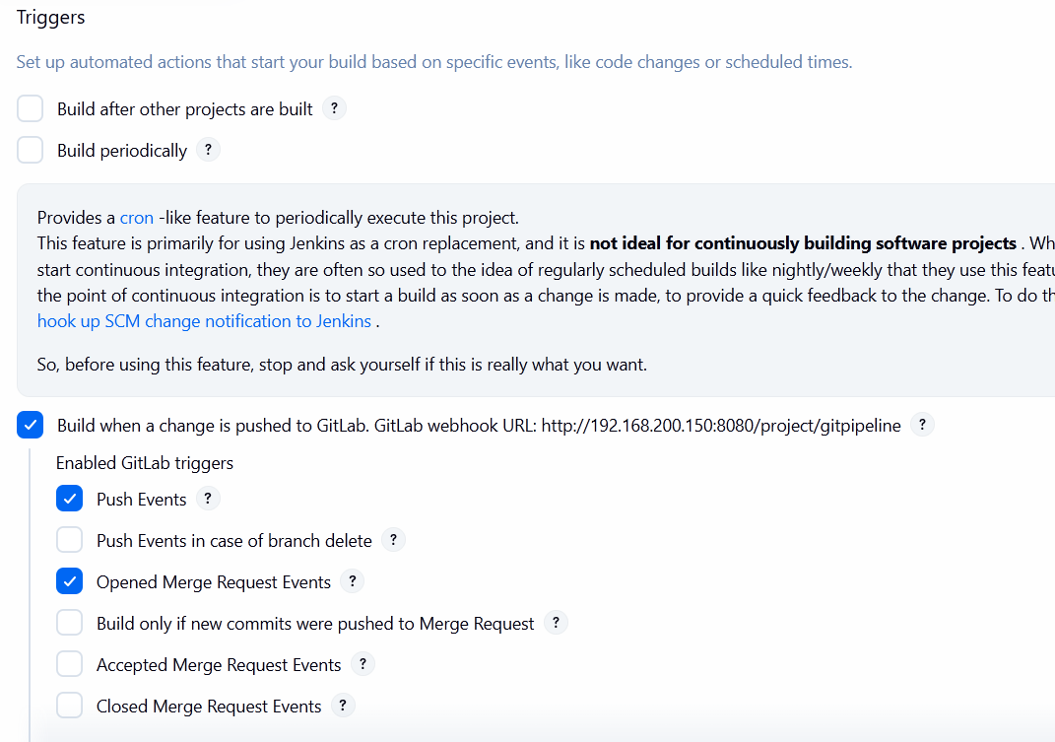

Integration with docker and git
- Docker and git can be integrated with in jenkins pipline using plugins.
- By integrating docker or git hub we can use webhooks. Pull code from github or gitlab make build using docker then push built to the docker hub for deployment purpose .
- Docker login inside ci/cd
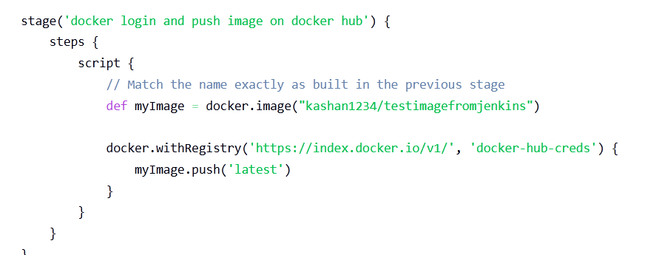
- Clone repo from gitlab
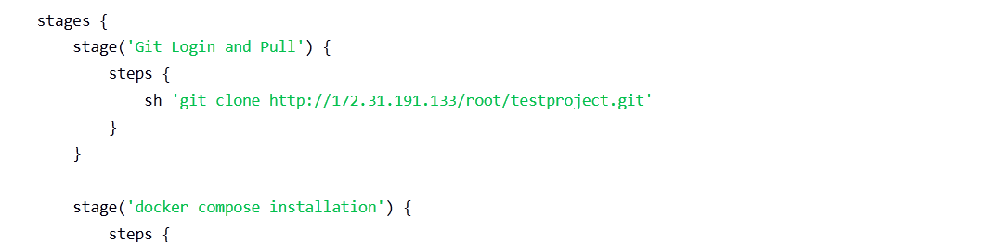
- Git lab push trigger is from gitlab plugin.
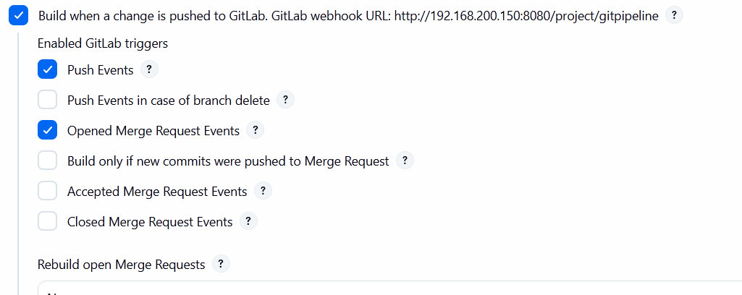
Jenkins Pipeline
- A Jenkins Pipeline is a suite of plugins that allows you to define your entire build process as code.
- Benefit of jenkins pipiline is we can use complex logics uisng if statements we can also use loops inside our pipeline.so we can implement any logic we want in a jenkins file.
- Example jenkins pipeline.
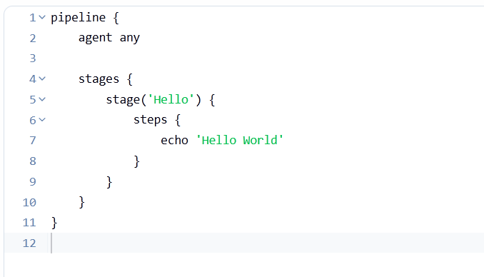
Jenkins Security
- Jenkins contains keys to all the infrastructure because deployment is done in its pipeline if it is compromised all our infrastructure will be at risk. So we only allow right person to login and can only do specific tasks.
- For role based access we can use Role-Based Strategy Plugin which allows us to assign roles to users based on their job.
· Admin: Full control.
· Developer: Can build and configure jobs in specific folders.
· Viewer: Can only see build results.

Credential Management (The Vault)
- We never hardcode passwords in pipeline instead we use jenkins credential manager so our passwords api keys are hidden.
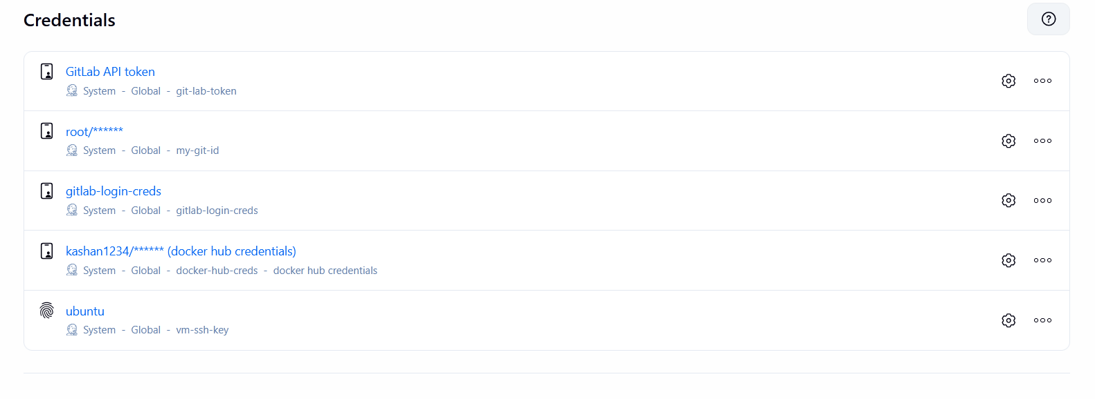
For more security we can create a user without admin permissions we only assign the permissions that we want to
To create a user we can go to manage jenkins and click on user from there we can click on create user.
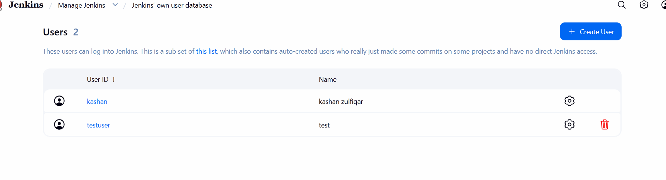
Then we giv user a name a password type full name and email and clikc create user to create a user.
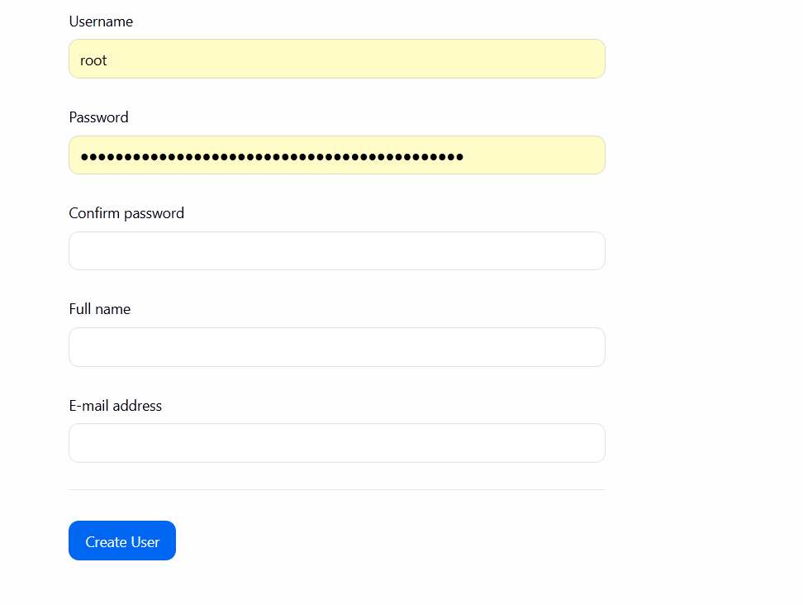
Now for security we again go to manage jenkins and then security now from authorization section we select matrix based security.
From this section we can add group or user and assign specific permission to user or group.
