**Question1**:

Write a Python language program that can count the word in the text file.

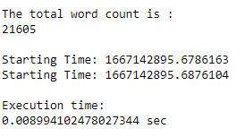

**Question2**:

Write a Python language program that takes two inputs from user, first the name of the text file and second input number of instances (of the map function)that will run on the system.

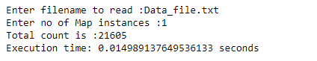

**Question3**:

Execute above Python program for the following table and write the time each program takes.

|  |  |  |
| --- | --- | --- |
| S. No: | Instances. | Execution Time (Seconds) |
| 1 | 1 | 0.014989137649536133 |
| 2 | 2 | 0.019989728927612305 |
| 3 | 3 | 0.017991065979003906 |
| 4 | 4 | 0.019147872924804688 |
| 5 | 5 | 0.018988847732543945 |
| 6 | 6 | 0.01818227767944336 |
| 7 | 7 | 0.019872188568115234 |
| 8 | 8 | 0.020008325576782227 |
| 9 | 9 | 0.02198314666748047 |
| 10 | 10 | 0.020674943923950195 |
| 11 | 100 | 0.04859423637390137 |
| 12 | 200 | 0.06726813316345215 |

**Question4:**

Draw the graph of the above using table between Number of instances and program execution time.

