ClimaTrack Inc.: Detailed Data Analysis Report on Climate Change and Logistics Risk

Kashav Piya
Avinash Goud Parkala
Amey Pawar
Anjana Susmitha Penmatsa
Vijay Sai Krishna Penugonda
Bhargavi Ponnuru

Indiana Wesleyan University
DTAN-505: Data Visualization
Professor Frank Zeng
October 13, 2026

ClimaTrack Inc.: Detailed Data Analysis Report on Climate Change and Logistics Risk
Group Number: 5
Team Leader: Kashav Piya
Date: 10/18/2026

Introduction and Overview
ClimaTrack Inc. operates in a global business environment in which changing climate conditions may affect transportation networks, facilities, suppliers, workforce safety, energy systems, and long-term operational planning. This report analyzes historical temperature trends and their potential implications for ClimaTrack’s logistics operations. The analysis uses annual and monthly temperature-anomaly data from the National Oceanic and Atmospheric Administration’s National Centers for Environmental Information Climate at a Glance.
The team developed six visualizations and three supporting tables to examine global, land, ocean, hemispheric, continental, and regional temperature patterns. The findings show that warming has become increasingly concentrated in recent years and is occurring at different rates across geographic areas. Land, the Northern Hemisphere, Europe, Asia, and the Arctic show particularly strong changes. These results indicate that ClimaTrack should not treat climate exposure as uniform across its operations. Instead, climate information should be considered when evaluating facilities, suppliers, transportation routes, inventory strategies, and business-continuity plans.

Background Context
Climate change is a significant global issue that can influence markets, supply chains, infrastructure, workforce conditions, and operating costs. Higher temperatures do not automatically produce a specific logistics disruption, but they can increase the importance of evaluating heat exposure, energy demand, facility resilience, supplier concentration, and the reliability of transportation networks.
The annual dataset covers 1850 through 2025, while the monthly dataset extends from January 1850 through August 2026. The values are reported as temperature anomalies in degrees Celsius relative to the 1901–2000 average. A positive anomaly means that the observed period was warmer than the twentieth-century average, while a negative anomaly means it was cooler. The analysis compares global trends, land and ocean temperatures, the Northern and Southern Hemispheres, continental warming rates, monthly patterns, and long-term regional change. Historical trend rates describe what has occurred in the available data and should not be interpreted as guaranteed forecasts of future temperatures or individual business disruptions.

Key Findings and Analysis
1. Data Visualization Insights
The NOAA temperature data was analyzed, and the following key trends were identified.
1. Visualization 1: Global Temperature Anomalies Over Time
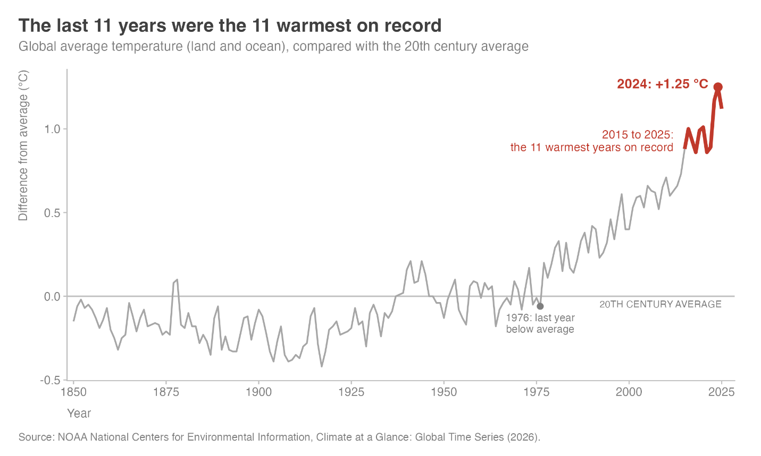
Analysis:
The global temperature record shows a clear long-term upward pattern, with the strongest anomalies concentrated in recent years. In the project dataset, 2024 was the warmest year at 1.25°C above the 1901–2000 average. The 11 warmest years were 2015 through 2025, demonstrating that the recent warming pattern is sustained rather than the result of one isolated year.

2. Visualization 2: Land and Ocean Warming Trends
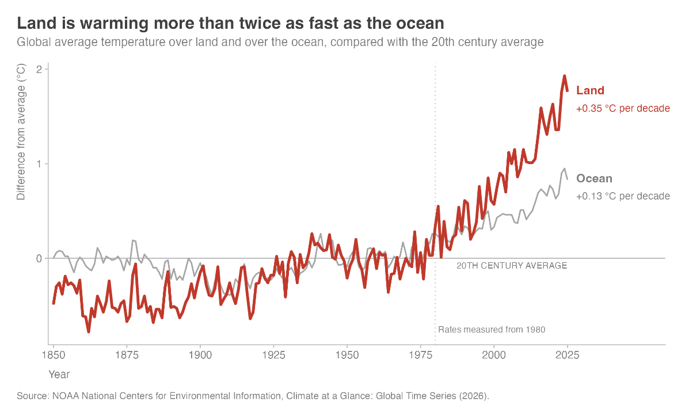
Analysis:
Land areas have warmed considerably faster than oceans. Since 1980, the land temperature anomaly has increased by approximately 0.35°C per decade, compared with approximately 0.13°C per decade for the ocean. The land warming rate is therefore about 2.7 times the ocean rate. This difference is important because ClimaTrack’s warehouses, roads, employees, suppliers, and most supporting infrastructure are land-based. The finding suggests that operational planning should consider land exposure rather than relying only on a combined global average.

3. Visualization 3: Northern and Southern Hemisphere Warming
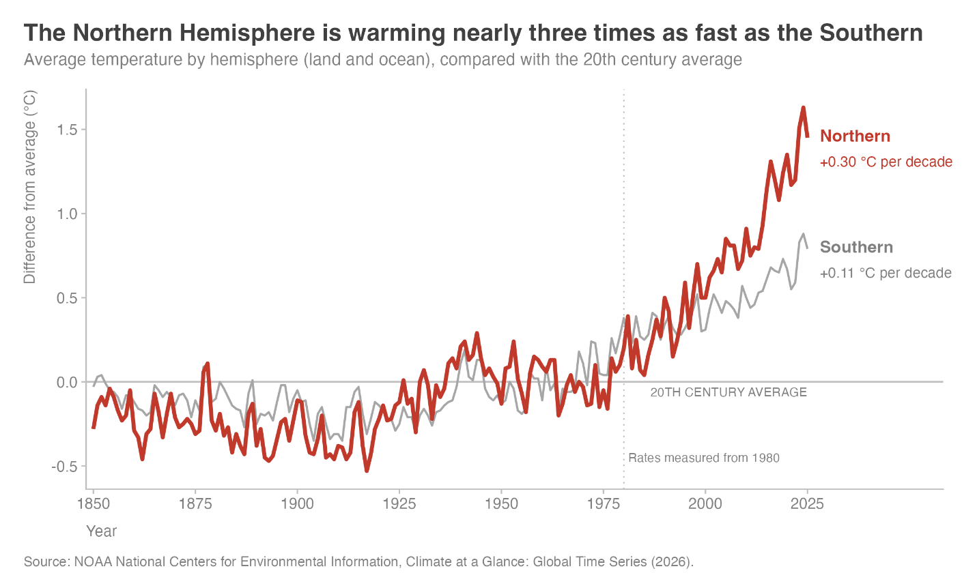
Analysis:
The Northern Hemisphere has warmed more rapidly than the Southern Hemisphere. Since 1980, the Northern Hemisphere trend has been approximately 0.30°C per decade, compared with approximately 0.11°C per decade in the Southern Hemisphere. The Northern rate is nearly three times the Southern rate. Because major industrial, population, supplier, and transportation networks are concentrated in the Northern Hemisphere, ClimaTrack should evaluate whether its most important operations are concentrated in areas experiencing relatively faster change.

4. Visualization 4: Warming Rates by Continent
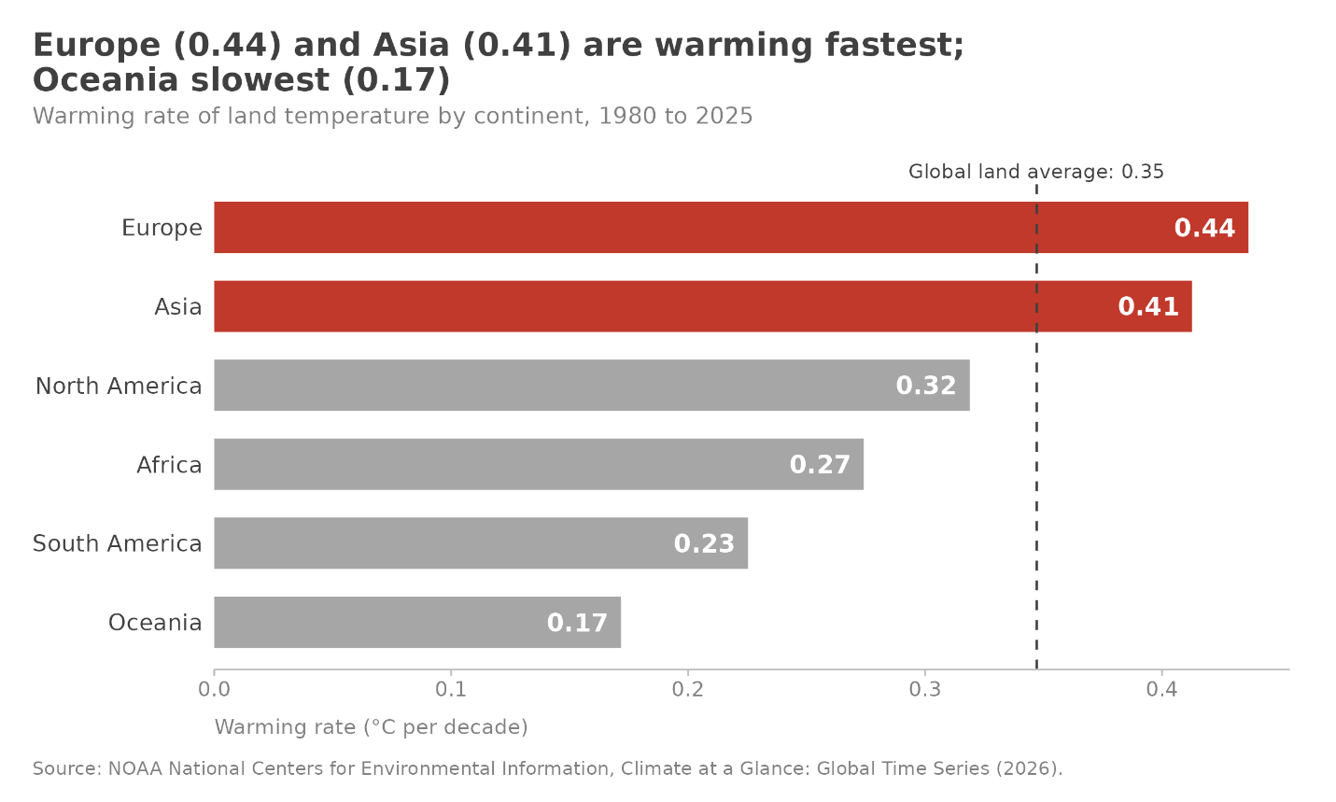
Analysis:
The continental comparison demonstrates that warming is geographically uneven. Europe has the fastest observed continental trend at approximately 0.44°C per decade since 1980, followed by Asia at approximately 0.41°C per decade. Oceania has the slowest rate among the analyzed continents at approximately 0.17°C per decade. These differences indicate that one company-wide assumption about climate exposure would be insufficient. ClimaTrack should assess facilities, suppliers, and routes according to regional conditions and the importance of each location to the overall supply chain.

5. Visualization 5: Northern Hemisphere Monthly Temperature Heatmap
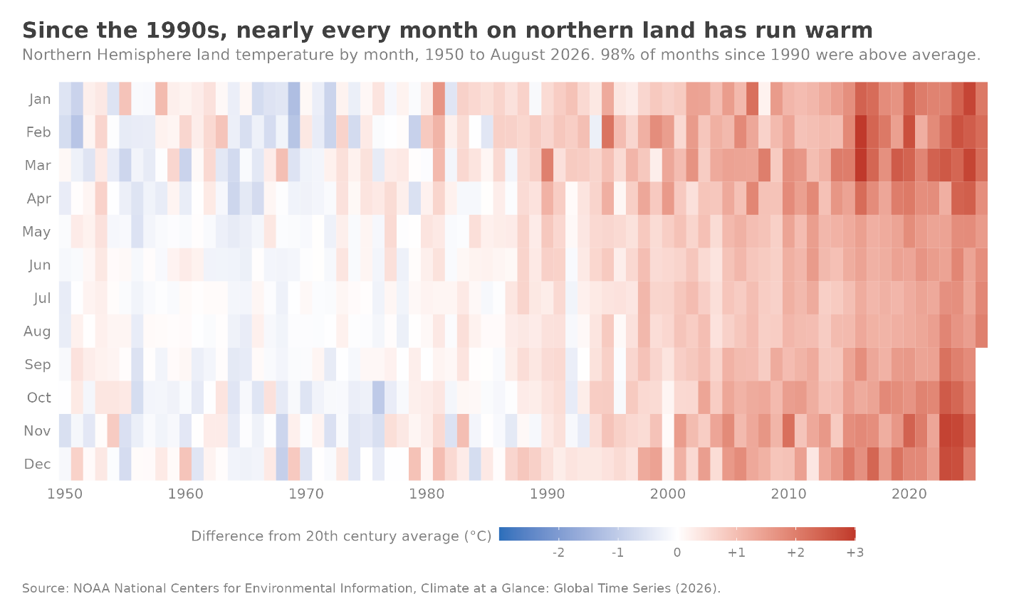
Analysis:
The monthly heatmap shows that recent warming is persistent across seasons rather than limited to a small number of unusually hot months. Since 1990, 430 of 440 Northern Hemisphere land months, or approximately 97.7%, were warmer than the twentieth-century average. This consistency suggests that businesses should not view higher temperature exposure as an occasional or seasonal exception. ClimaTrack may need to consider year-round implications for cooling requirements, workforce safety, transportation reliability, and energy demand.

6. Visualization 6: Long-Term Temperature Change by Region
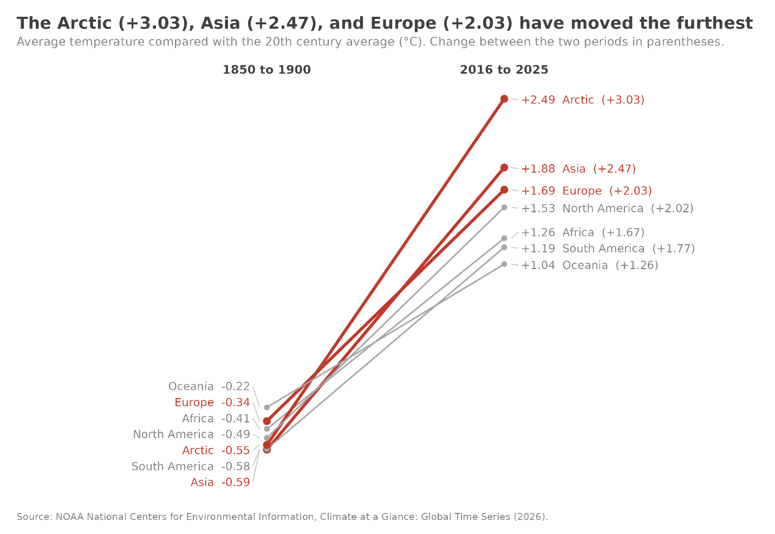
Analysis:
The comparison between the 1850–1900 and 2016–2025 periods shows substantial differences among regions. The Arctic experienced an increase of approximately 3.03°C, Asia increased by approximately 2.47°C, and Europe increased by approximately 2.03°C. These changes are larger than the global average and demonstrate that climate exposure can be concentrated geographically. The results do not establish that ClimaTrack has already experienced specific losses in these regions, but they identify areas where a more detailed review of facilities, suppliers, and transportation dependencies may be appropriate.

Supporting Data Tables
To provide additional context, three tables were created to present a more comprehensive view of the NOAA dataset.
1. Table 1: Average Temperature Anomalies by Decade, 1850–2025
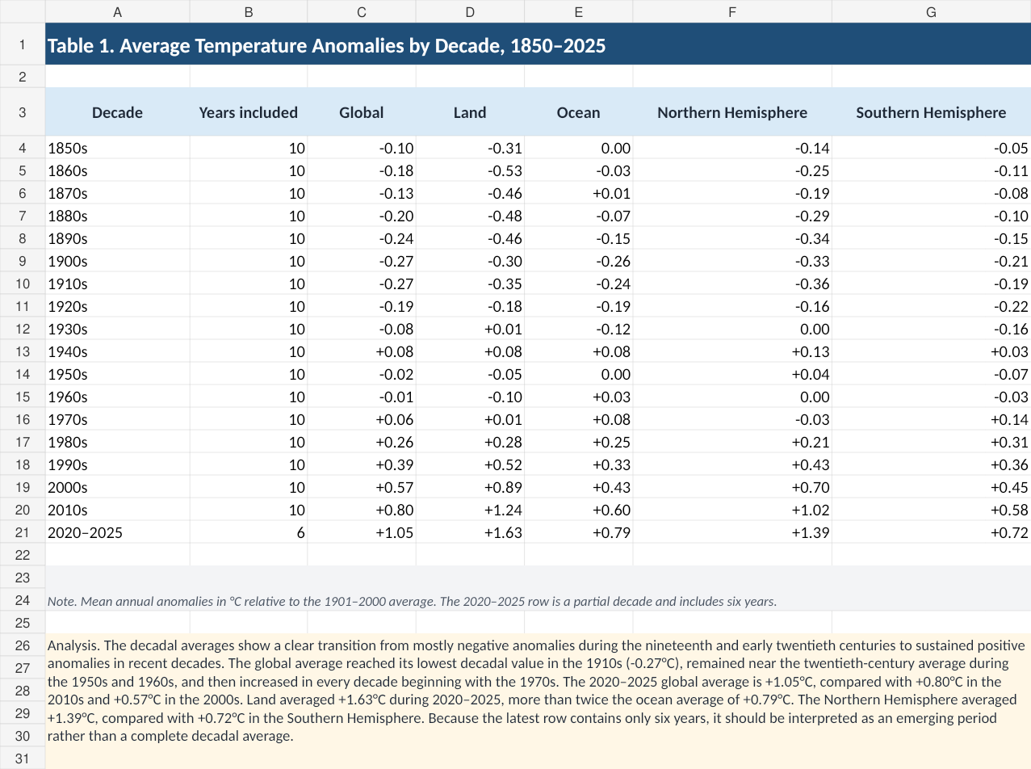
Analysis:
The decade averages show a major shift from generally negative anomalies during the nineteenth and early twentieth centuries to consistently positive and increasing anomalies during recent decades. The global average increased from −0.24°C in the 1890s to 0.26°C in the 1980s, 0.57°C in the 2000s, 0.80°C in the 2010s, and 1.05°C during 2020–2025. The most recent period is incomplete and contains six years, but it remains the warmest period in the table. Land reached an average anomaly of 1.63°C during 2020–2025, compared with 0.79°C for the ocean. The Northern Hemisphere averaged 1.38°C, compared with 0.72°C in the Southern Hemisphere. These results reinforce the finding that recent warming is strongest over land and in the Northern Hemisphere.

2. Table 2: Regional Temperature Trend and Change Summary
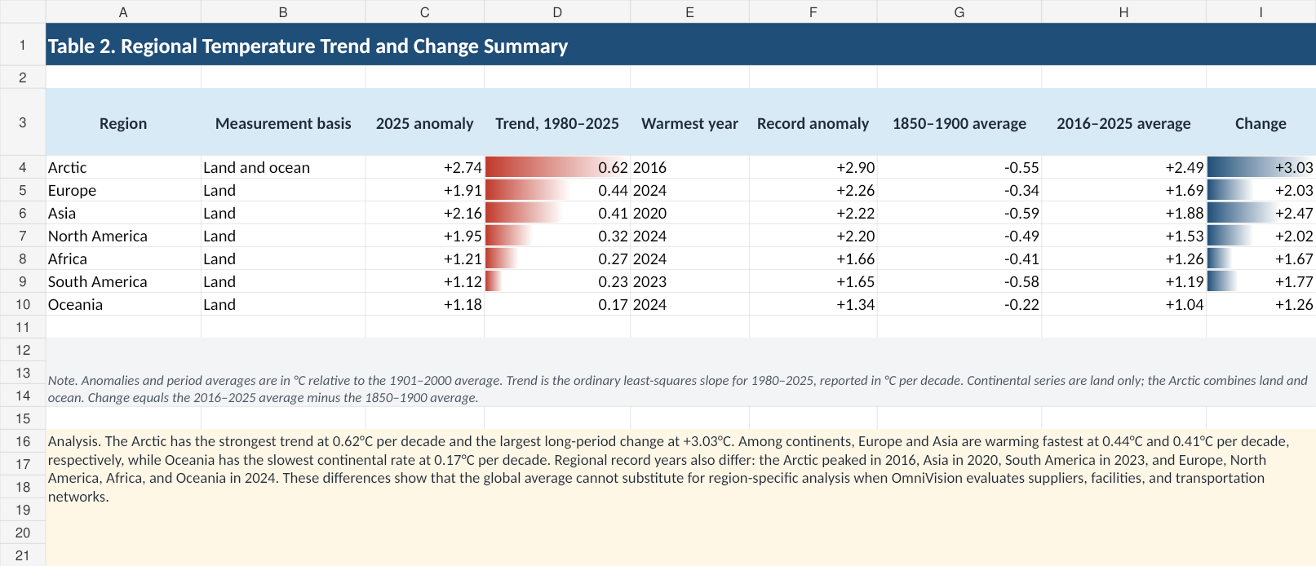
Analysis:
The regional summary combines recent anomalies, historical warming rates, record years, and long-period changes. The Arctic has the fastest trend since 1980 at approximately 0.62°C per decade and the largest change between the 1850–1900 and 2016–2025 periods at approximately 3.03°C. Europe and Asia follow with trends of approximately 0.44°C and 0.41°C per decade and long-period increases of approximately 2.03°C and 2.47°C, respectively. North America has increased by approximately 2.02°C between the selected periods, while Oceania has the lowest regional trend at approximately 0.17°C per decade. Record years are concentrated in the most recent part of the dataset, particularly between 2020 and 2024. The variation among regions supports a location-specific approach to climate-risk assessment.

3. Table 3: Top 20 Warmest Global Years and Regional Rankings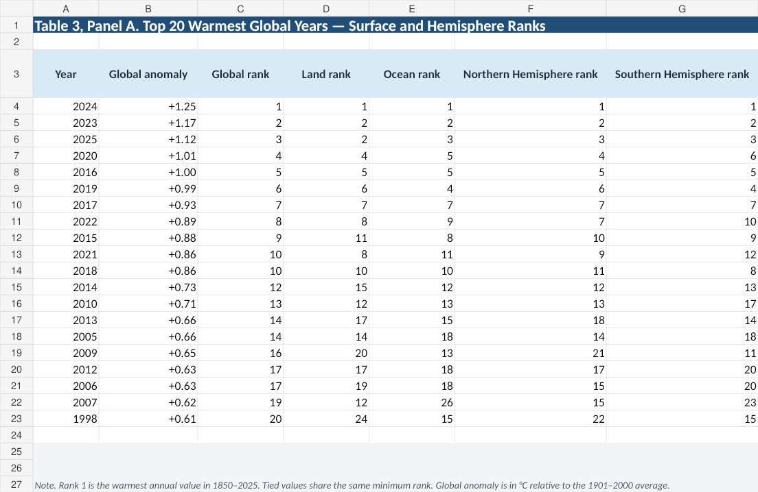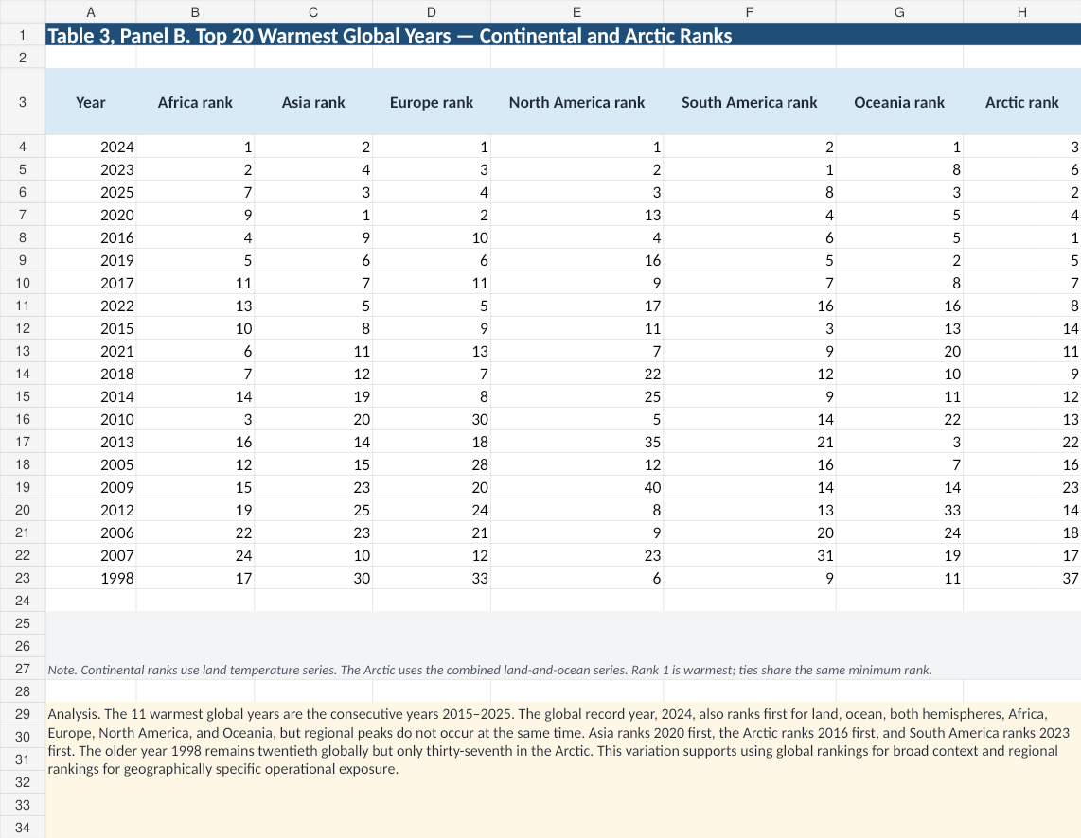
Analysis:
The ranking table shows that the warmest global years are heavily concentrated in the most recent period. The three highest global anomalies occurred in 2024, 2023, and 2025, while 2015 through 2025 make up the 11 warmest years in the dataset. However, regional rankings are not identical. For example, 2020 ranks fourth globally but first in Asia, while 2023 ranks second globally and first in South America. This variation demonstrates that global rankings can hide important regional differences. For ClimaTrack, the implication is that a globally warm year may not affect every operating region in the same way or with the same relative intensity. Regional rankings should therefore be evaluated alongside the importance of specific facilities, suppliers, and routes.

Conclusions and Recommendations
Based on the six visualizations and three supporting tables, the analysis concludes that warming is persistent, increasingly concentrated in recent years, and unevenly distributed across land, oceans, hemispheres, and regions. These patterns create a need for location-specific operational planning rather than a single global assumption about climate risk.
Based on the findings, the following actions are recommended for ClimaTrack Inc.:
1. Map Operational Climate Exposure – Overlay the locations of major facilities, suppliers, distribution centers, transportation routes, and critical inventory with regional climate and weather-risk information. This process would help management identify operational concentrations in faster-warming regions.
2. Strengthen Logistics and Supplier Contingency Plans – Review alternate transportation routes, backup suppliers, inventory buffers, facility cooling capacity, power backup, emergency communications, and employee heat-safety procedures for critical operations.
3. Prioritize High-Exposure Operations – Conduct more detailed assessments of operations located in faster-warming regions, particularly where those locations support essential products, have limited supplier alternatives, or depend on vulnerable transportation networks.
4. Establish Ongoing Climate Monitoring – Incorporate climate indicators into annual reviews of facilities, suppliers, capital investments, and logistics strategy. A regularly updated climate-risk dashboard could help decision makers identify changes in regional exposure.
5. Combine Climate and Internal Business Data – Integrate the NOAA findings with ClimaTrack’s internal data on facilities, supplier locations, shipment volumes, inventory criticality, energy demand, previous disruptions, and recovery costs. This would allow the company to move from general climate exposure to specific operational priorities.
The temperature data does not predict the timing, location, or financial cost of an individual disruption. However, it provides a defensible basis for identifying where further investigation should begin. By incorporating climate information into logistics and business-continuity planning, ClimaTrack can improve operational resilience and make more informed long-term decisions.

Bias & Validation Note
Data Limitations
The NOAA NCEI dataset has a few caveats. The early records (mid-19th - early 20th century) include fewer and more widely scattered stations, and therefore should be used as general estimates, not exact measurements, for this time period. Before the 1950's, Antarctic coverage is sparse, and this can lead to Antarctic averages being influenced. Continent-level data are land only, and do not include oceans; for logistics this is important as ocean warming impacts storm intensity and sea-level rise. Further, the 2020s decade average includes only 6 years (2020-2025). It is important to note that NOAA's Climate.gov is retired in June 2025, and that all data are cited directly from NCEI. Lastly, all values are deviations from the 20th century mean and not actual temperature and operational thresholds such as days above 35°C are not included.

Methodological Limitations
The warming rates shown in Charts 4 and 6 are for the linear trend 1980-2025 and vary depending on the start year. The heatmap (Chart 5) represents monthly anomalies in the color scale, being diverging and not an exact comparison between the actual numbers. The slopegraph (Chart 6) shows two multi-decade averages (1850–1900 and 2016–2025), which reduces fluctuation but increases the uncertainty during the earlier time frame. The tables are based on the same data set and are subject to the same limitations as described above.

AI-Assisted Work Validation
The use of AI tools (ChatGPT and Claude) helped to draft R code, create initial table structures, and edit prose. All the computer code produced with the aid of the AI was tested against raw NOAA CSV files, and those results that did not match had to be rewritten by hand. Prose written by AI was compared to source data and NOAA documentation. The correctness of table structures and missing data were confirmed. The data has not been generated by, or changed by, the use of AI, and the responsibility for the accurate data on each group member's section lies with them.
Data Processing and Overall Confidence
Data were analyzed in R, with use of packages tidyverse. There are two scripts; they read the CSV files, calculate summaries and trends and save a PNG at 300dpi; the code is commented and reproducible. Although the restrictions noted are present, there is a high level of confidence in the primary results. Warming trends are well evident across different data sets and regions for different time periods and are consistent with the larger scientific literature. The data can be used to inform leadership about a general climate trajectory; greater spatial resolution or temperatures extremes would require further downscaling of the projection.

References
Anthropic. (2025). Claude (Sonnet 4 version) [Large language model]. https://claude.ai
Intergovernmental Panel on Climate Change. (2021). Climate change 2021: The physical science basis. Contribution of Working Group I to the Sixth Assessment Report of the Intergovernmental Panel on Climate Change. Cambridge University Press. https://doi.org/10.1017/9781009157896
Knaflic, C. N. (2015). Storytelling with data: A data visualization guide for business professionals. Wiley.
NOAA National Centers for Environmental Information. (2026). Climate at a Glance: Global time series [Data set]. https://www.ncei.noaa.gov/access/monitoring/climate-at-a-glance/global/time-series
NOAA National Centers for Environmental Information. (2025). U.S. billion-dollar weather and climate disasters [Data set]. https://www.ncei.noaa.gov/access/billions/
National Oceanic and Atmospheric Administration, National Centers for Environmental Information. (n.d.). Climate at a Glance: Global time series. Climate at a Glance.
OpenAI. (2025). ChatGPT (GPT-4o version) [Large language model]. https://chat.openai.com
R Core Team. (2025). R: A language and environment for statistical computing (Version 4.5.0) [Computer software]. R Foundation for Statistical Computing. https://www.R-project.org/
Wickham, H. (2016). ggplot2: Elegant graphics for data analysis (2nd ed.). Springer. https://doi.org/10.1007/978-3-319-24277-4

Member Appendix
Name (as in Brightspace) | Student ID | Role | Contribution
Kashav Piya | 2954307 | Team Leader; Visualization Specialist | Coordinated the team, set up the shared data and repository, built Charts 1 to 3 in R, and assembled the final files
Anjana Susmitha Penmatsa | [ID] | Visualization Specialist | Built Charts 4 to 6 in R
Amey Pawar | [ID] | Data Analyst | Prepared the three supporting data tables and wrote their analysis paragraphs
Vijay Sai Krishna Penugonda | [ID] | Data Quality Assurance Lead | Wrote the Bias & Validation Note and checked data sources and AI-assisted work
Bhargavi Ponnuru | [ID] | Executive Summary Writer | Wrote the Executive Summary and compiled the detailed report
Avinash Goud Parkala | [ID] | Report Designer | Prepared the title page and member appendix, and ran the final formatting check

