(Section: Combinational Logic)

Digital Comparator and Magnitude Comparator
Data comparison is needed in digital systems while performing arithmetic or logical operations. This comparison determines whether one number is greater than, equal, or less than the other number. A digital comparator is widely used in combinational system and is specially designed to compare the relative magnitudes of binary numbers.
These are also available in IC form with different bit comparing configurations such as 4-bit, 8-bit, etc. More than one comparator can also be connected in cascade arrangement to perform comparison of numbers of longer lengths. Whenever we want to compare the two binary numbers, first we have to compare the most significant bits.
If these MSBs are equal, then only we need to compare the next significant bits. But if the MSBs are not equal, then it would be clear that either A is greater than or less than B and the process of comparison ceases.
For example, the two 2-bit number are A = A1A0 and B=B1B0. If A1 is not equal to B1, then it is clear that A is greater than B for A1 =1 & B1= 0 or else A is less than B for A0= 0 & B0 =1. At this stage the process of comparison ceases.
If the MSBs are equal, i.e., A1=B1 only then we need to compare the next significant bits A0 and B0 and decide whether the number is greater than, less than or equal. So, the comparator produces three outputs as L, E and G corresponds to less than, equal and greater than comparisons.
Digital comparators can be of two types
Identity Comparator
Comparators that have only one output terminal and produces the output either low or high are identity comparators.
Magnitude Comparator
Comparators with three output terminals and checks for three conditions i.e greater than or less than or equal to is magnitude comparator.

Digital Magnitude Comparator
A magnitude digital comparator is a combinational circuit that compares two digital or binary numbers (consider A and B) and determines their relative magnitudes in order to find out whether one number is equal, less than or greater than the other digital number.
Three binary variables are used to indicate the outcome of the comparison as A>B, A<B, or A=B. The below figure shows the block diagram of a n-bit comparator which compares the two numbers of n-bit length and generates their relation between themselves.
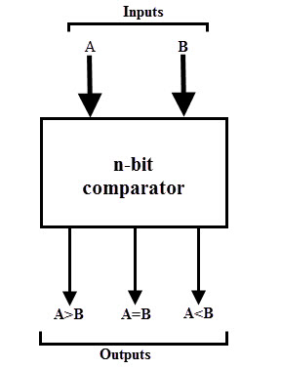
These comparators can compare 2-bit, 4-bit and 8-bit numbers depending on the application requirement. These are available in TTL as well as CMOS logic family ICs and some of these ICs include IC 7485 (4-bit comparator), IC 4585 (4-bit comparator in CMOS family) and IC 74AS885 (8-bit comparator).

Single Bit Magnitude Comparator
A comparator used to compare two bits, i.e., two numbers each of single bit is called a single bit comparator. It consists of two inputs for allowing two single bit numbers and three outputs to generate less than, equal and greater than comparison outputs.
The figure below shows the block diagram of a single bit magnitude comparator. This comparator compares the two bits and produces one of the 3 outputs as L (A<B), E (A=B) and G (A>B).
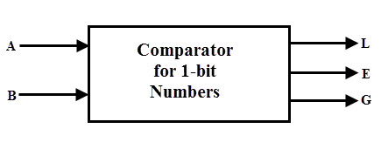
The truth table for the single bit comparator is given below. When A0 B0 = 00 & 11, both inputs are equal, therefore A=B output will be high. When A0 B0 = 01, B is more than A and hence AB is active.
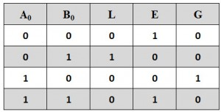
From the truth table logical expressions for each output can be expressed as
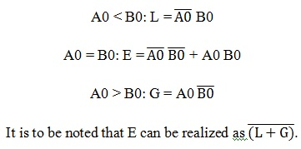
By using these Boolean expressions, we can implement a logic circuit for this comparator using two AND gates, one NOT gate and one Ex-NOR gate as shown in below figure. AND gates are used to find whether a binary digit is less than greater than another bit whereas Ex-NOR gate is used to find whether two binary numbers are equal or not.
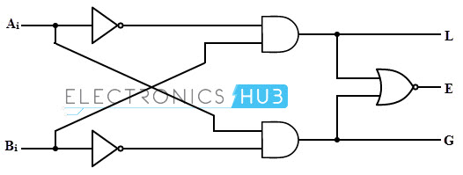
In the figure, one AND gate has inputs of A0 (B0) ̅ and another has inputs (A0) ̅ B0. Therefore, one AND gate output is 1 if A0 > B0 (i.e., A0 =1 and B0 =0) and is zero if A0 < B0 (i.e., A0 =0 and B0 =1). Similarly, other AND gate output is one if A0 < B0 (i.e., A0 =0 and B0 =1) and is zero if A0 > B0 (i.e., A0 =1and B0 =0).
The Ex-NOR gate has inputs A0 B0, hence the output of the Ex-NOR gate will be 1 if A0 = B0 and the output will be 0 if A0 is not equal to B0.

2-Bit Comparator
A 2-bit comparator compares two binary numbers, each of two bits and produces their relation such as one number is equal or greater than or less than the other. The figure below shows the block diagram of a two-bit comparator which has four inputs and three outputs.
The first number A is designated as A = A1A0 and the second number is designated as B = B1B0. This comparator produces three outputs as G (G = 1 if A>B), E (E = 1, if A = B) and L (L = 1 if A<B).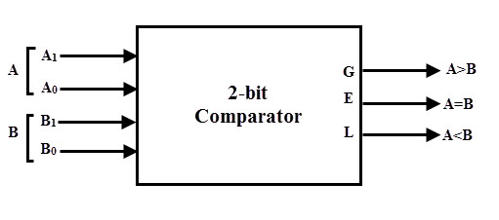The truth table of this comparator is shown below which depicting various input and output states.
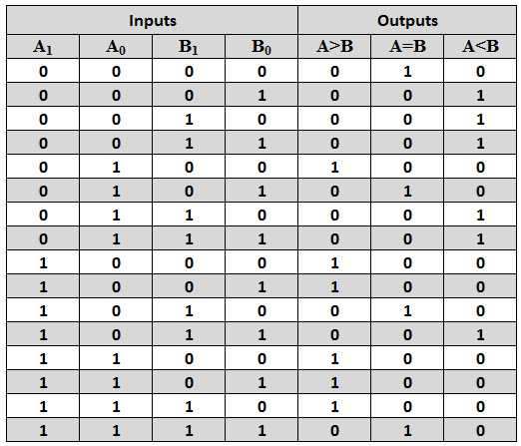
The k-map simplification for the above truth table is as follows.
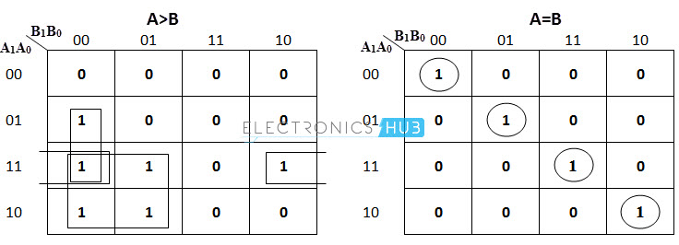
From the above k-map simplification, each output can be expressed as
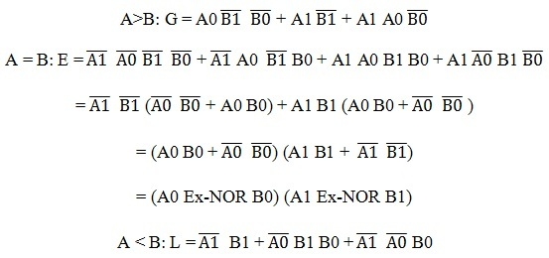
By using above obtained Boolean equation for each output, the logic diagram can be implemented by using four NOT gates, seven AND gates, two OR gates and two Ex-NOR gates.
The figure below shows the logic diagram of a 2-bit comparator using basic logic gates. It is also possible to construct this comparator by cascading of two 1-bit comparators.
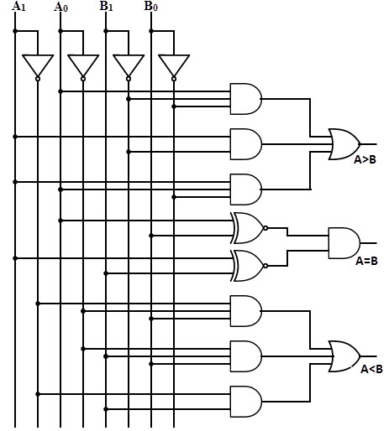
Identity Comparator
