Week 3: Advanced Security and Final Reporting
Github Repo link : https://github.com/MaryamAmjad-tech/ServerSecure.git
- Basic Penetration Testing: Use Nmap + manual browser tests.
- Logging: Set up winston for console + file logging.
- Checklist: Input validation, HTTPS, hashed passwords, security headers, regular testing.
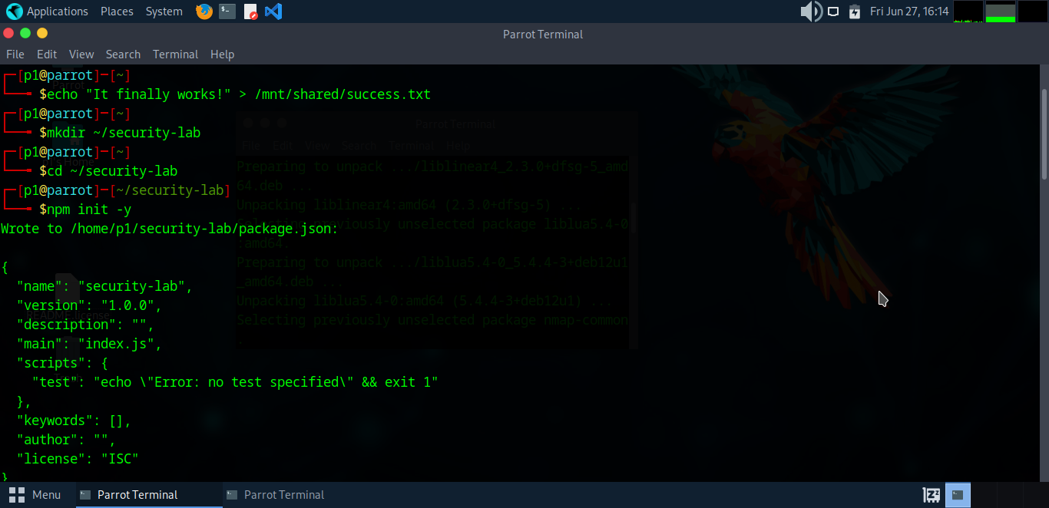

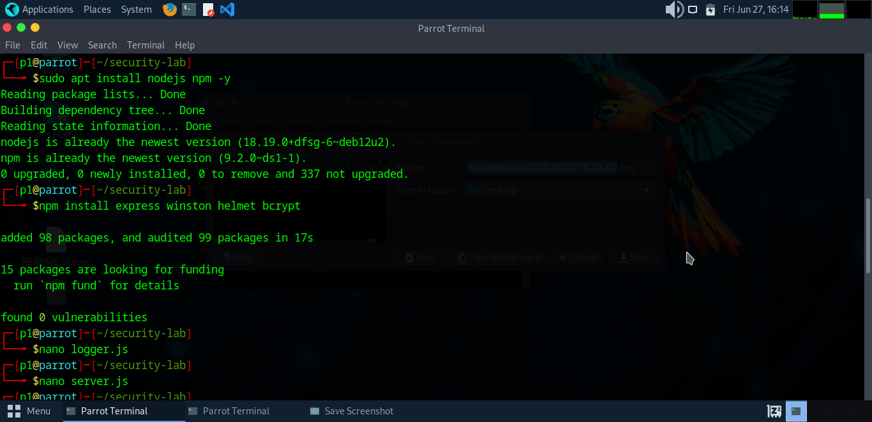

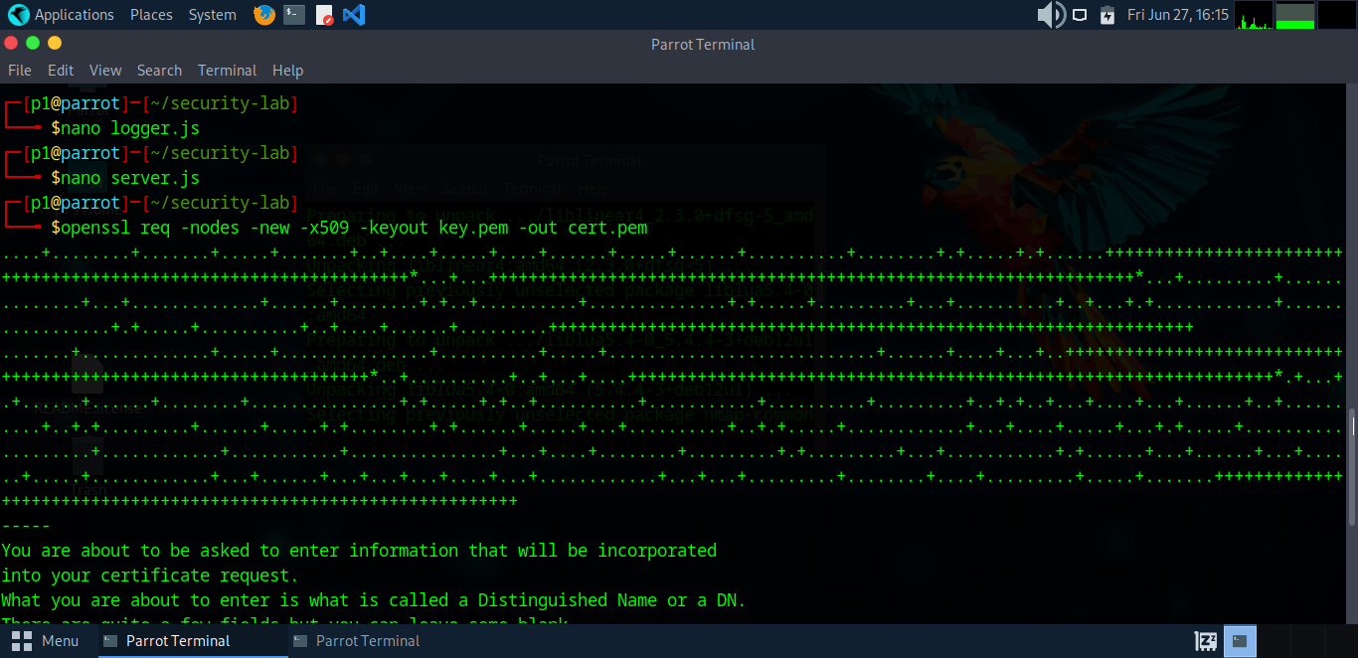

Running the HTTPS Server
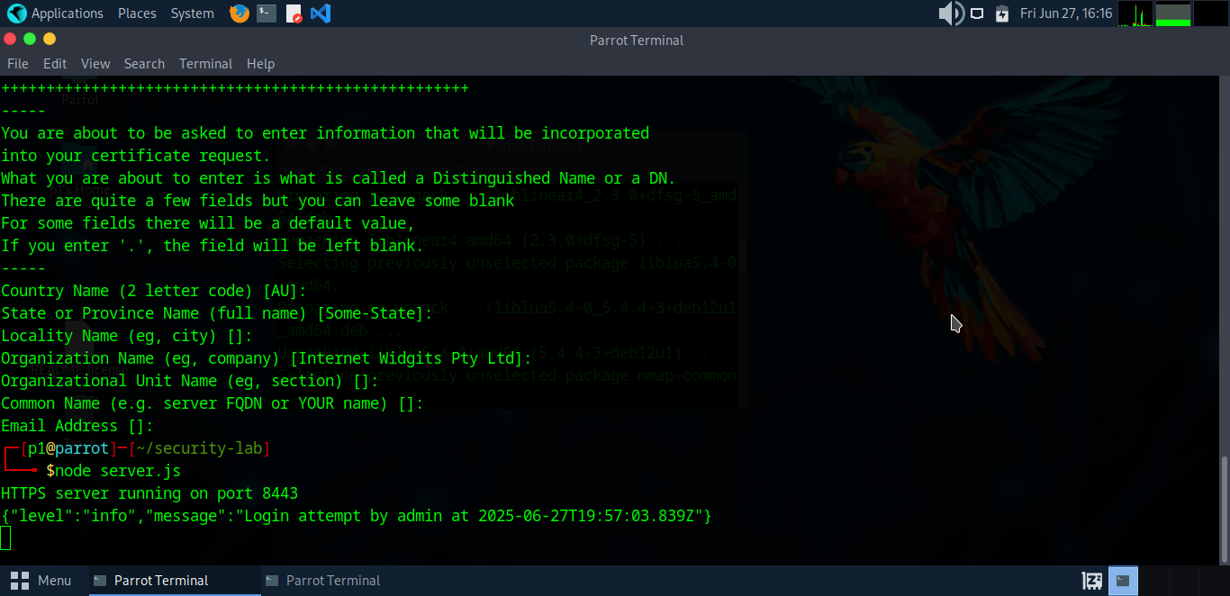

Sending Login Request via
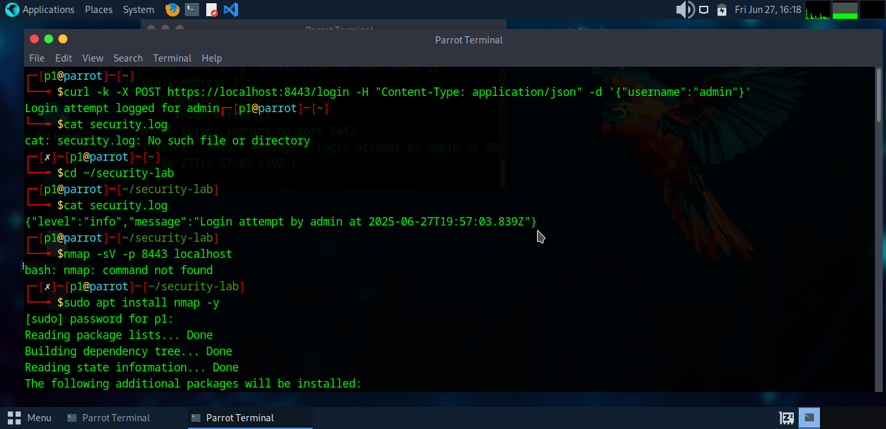

Nmap scans
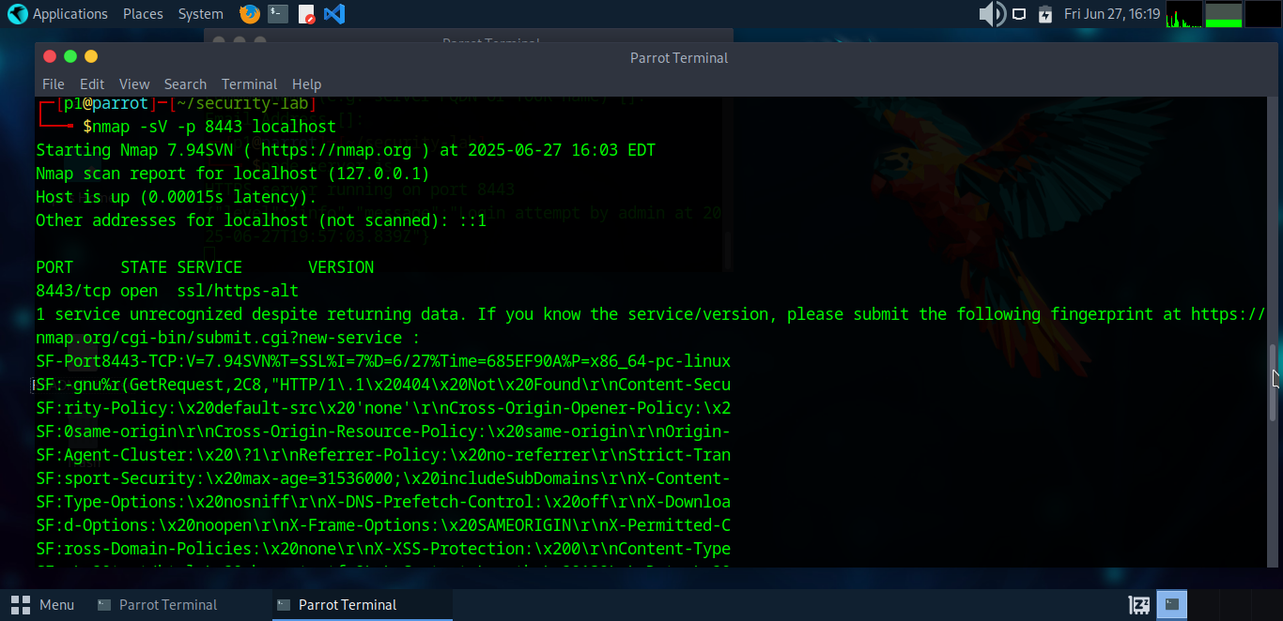

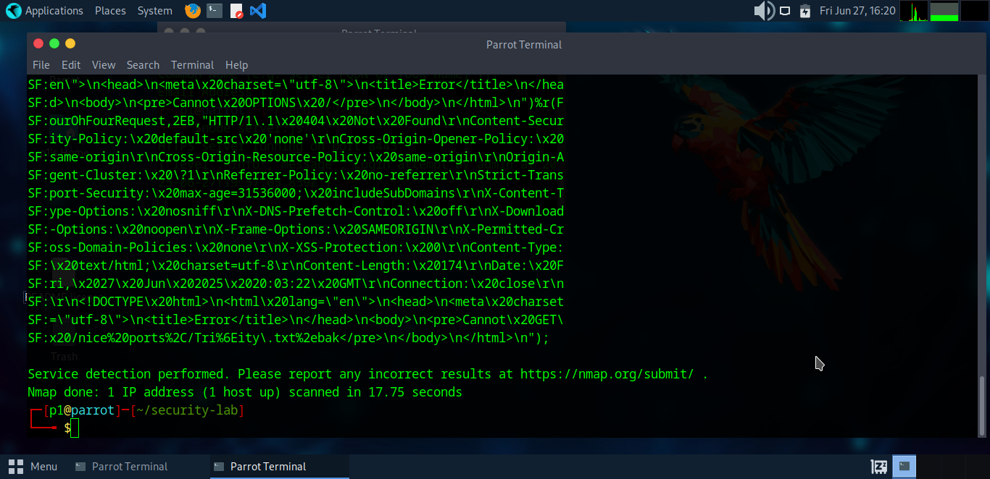

Tree structure
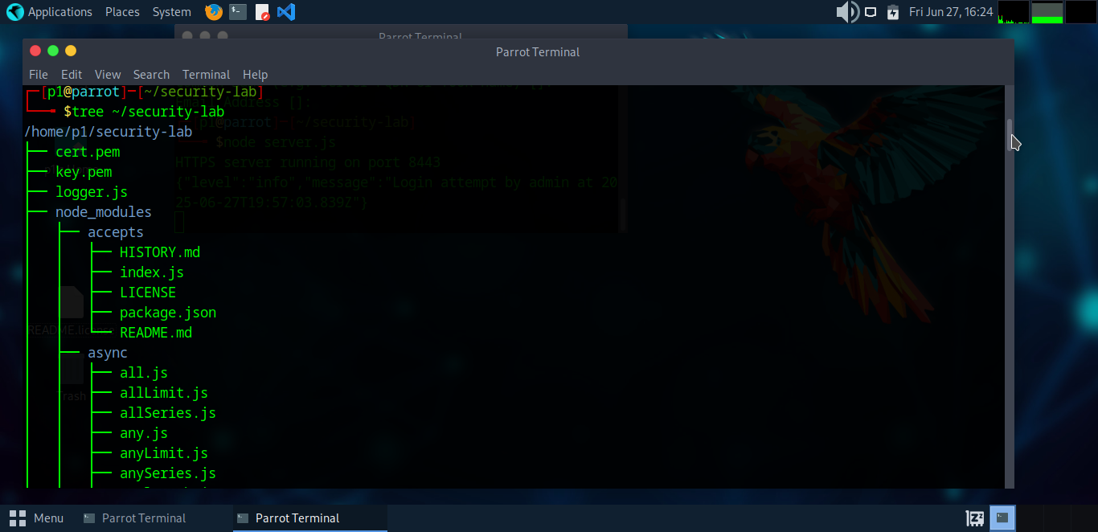

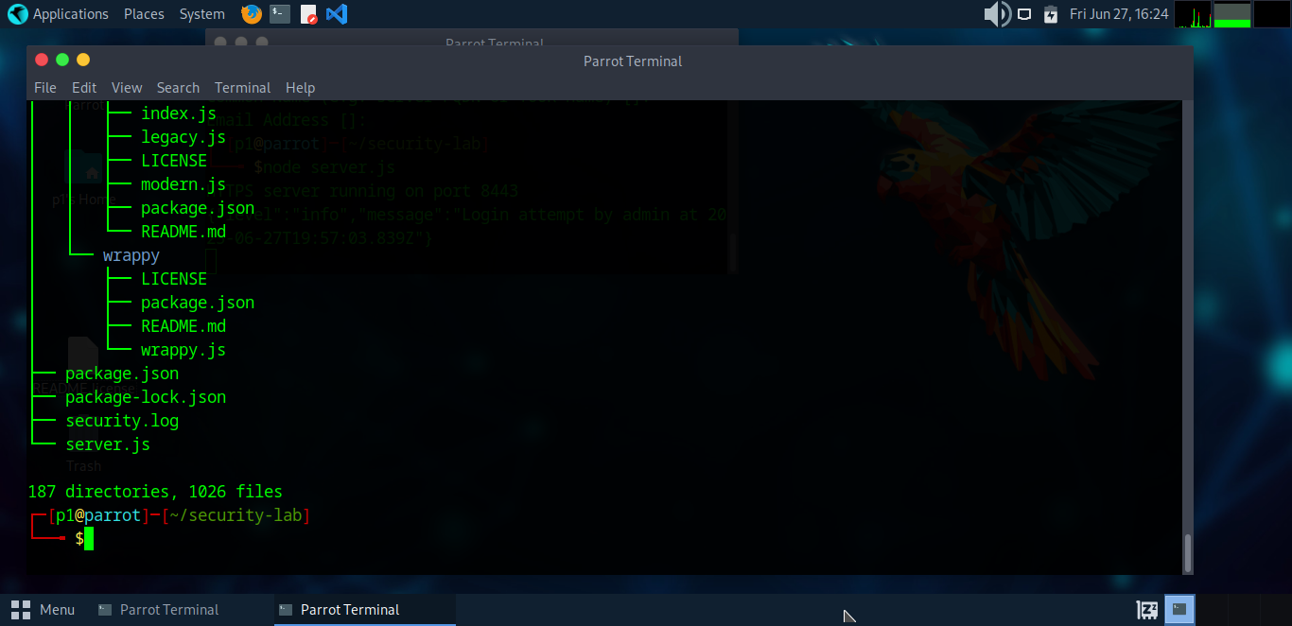cd ~

