**Instructions**

Congratulations! You've decided to treat yourself to a long holiday vacation in Honolulu, Hawaii. To help with your trip planning, you decide to do a climate analysis about the area. The following sections outline the steps that you need to take to accomplish this task.

**Part 1: Analyze and Explore the Climate Data**

In this section, you’ll use Python and SQLAlchemy to do a basic climate analysis and data exploration of your climate database. Specifically, you’ll use SQLAlchemy ORM queries, Pandas, and Matplotlib. To do so, complete the following steps:

1. Note that you’ll use the provided files (climate_starter.ipynb and hawaii.sqlite) to complete your climate analysis and data exploration.
2. Use the SQLAlchemy create_engine() function to connect to your SQLite database.
3. Use the SQLAlchemy automap_base() function to reflect your tables into classes, and then save references to the classes named station and measurement.
4. Link Python to the database by creating a SQLAlchemy session.

**IMPORTANT**

Remember to close your session at the end of your notebook.

1. Perform a precipitation analysis and then a station analysis by completing the steps in the following two subsections.

**Precipitation Analysis**

1. Find the most recent date in the dataset.
2. Using that date, get the previous 12 months of precipitation data by querying the previous 12 months of data.

**HINT**

1. Select only the "date" and "prcp" values.
2. Load the query results into a Pandas DataFrame. Explicitly set the column names.
3. Sort the DataFrame values by "date".
4. Plot the results by using the DataFrame plot method, as the following image shows:

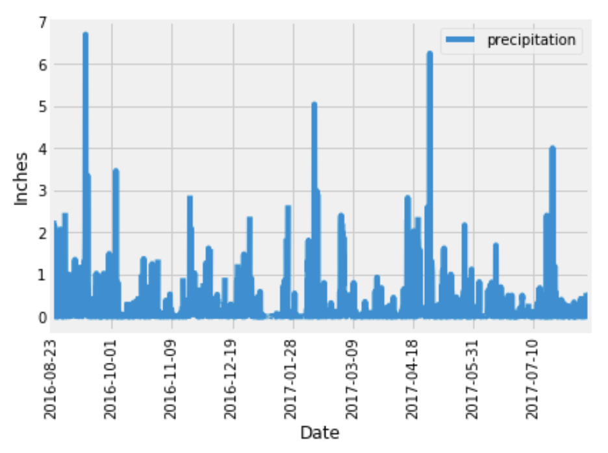

1. Use Pandas to print the summary statistics for the precipitation data.

**Station Analysis**

1. Design a query to calculate the total number of stations in the dataset.
2. Design a query to find the most-active stations (that is, the stations that have the most rows). To do so, complete the following steps:
   * List the stations and observation counts in descending order.

**HINT**

* + Answer the following question: which station id has the greatest number of observations?

1. Design a query that calculates the lowest, highest, and average temperatures that filters on the most-active station id found in the previous query.

**HINT**

1. Design a query to get the previous 12 months of temperature observation (TOBS) data. To do so, complete the following steps:
   * Filter by the station that has the greatest number of observations.
   * Query the previous 12 months of TOBS data for that station.
   * Plot the results as a histogram with bins=12, as the following image shows:

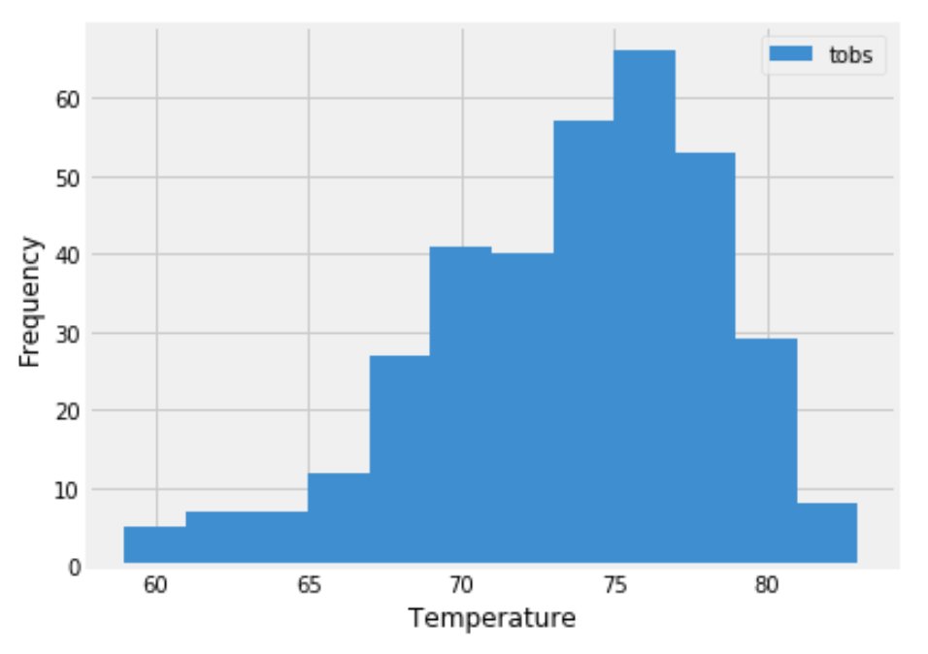

1. Close your session.

**Part 2: Design Your Climate App**

Now that you’ve completed your initial analysis, you’ll design a Flask API based on the queries that you just developed. To do so, use Flask to create your routes as follows:

1. /
   * Start at the homepage.
   * List all the available routes.
2. /api/v1.0/precipitation
   * Convert the query results from your precipitation analysis (i.e. retrieve only the last 12 months of data) to a dictionary using date as the key and prcp as the value.
   * Return the JSON representation of your dictionary.
3. /api/v1.0/stations
   * Return a JSON list of stations from the dataset.
4. /api/v1.0/tobs
   * Query the dates and temperature observations of the most-active station for the previous year of data.
   * Return a JSON list of temperature observations for the previous year.
5. /api/v1.0/<start> and /api/v1.0/<start>/<end>
   * Return a JSON list of the minimum temperature, the average temperature, and the maximum temperature for a specified start or start-end range.
   * For a specified start, calculate TMIN, TAVG, and TMAX for all the dates greater than or equal to the start date.
   * For a specified start date and end date, calculate TMIN, TAVG, and TMAX for the dates from the start date to the end date, inclusive.

**Hints**

* Join the station and measurement tables for some of the queries.
* Use the Flask jsonify function to convert your API data to a valid JSON response object.

**Requirements**

**Jupyter Notebook Database Connection (10 points)**

**To receive all points, you must**

* Use the SQLAlchemy create_engine() function to connect to your SQLite database (1 point)
* Use the SQLAlchemy automap_base() function to reflect your tables into classes (3 points)
* Save references to the classes named station and measurement (4 points)
* Link Python to the database by creating a SQLAlchemy session (1 point)
* Close your session at the end of your notebook (1 point)

**Precipitation Analysis (16 points)**

**To receive all points, you must**

* Create a query that finds the most recent date in the dataset (8/23/2017) (2 points)
* Create a query that collects only the date and precipitation for the last year of data without passing the date as a variable (4 points)
* Save the query results to a Pandas DataFrame to create date and precipitation columns (2 points)
* Sort the DataFrame by date (2 points)
* Plot the results by using the DataFrame plot method with date as the x and precipitation as the y variables (4 points)
* Use Pandas to print the summary statistics for the precipitation data (2 points)

**Station Analysis (16 points)**

**To receive all points, you must**

* Design a query that correctly finds the number of stations in the dataset (9) (2 points)
* Design a query that correctly lists the stations and observation counts in descending order and finds the most active station (USC00519281) (2 points)
* Design a query that correctly finds the min, max, and average temperatures for the most active station (USC00519281) (3 points)
* Design a query to get the previous 12 months of temperature observation (TOBS) data that filters by the station that has the greatest number of observations (3 points)
* Save the query results to a Pandas DataFrame (2 points)
* Correctly plot a histogram with bins=12 for the last year of data using tobs as the column to count. (4 points)

**API SQLite Connection & Landing Page (10 points)**

**To receive all points, your Flask application must**

* Correctly generate the engine to the correct sqlite file (2 points)
* Use automap_base() and reflect the database schema (2 points)
* Correctly save references to the tables in the sqlite file (measurement and station) (2 points)
* Correctly create and binds the session between the python app and database (2 points)
* Display the available routes on the landing page (2 points)

**API Static Routes (15 points)**

**To receive all points, your Flask application must include**

A **precipitation route** that:

* Returns json with the date as the key and the value as the precipitation (3 points)
* Only returns the jsonified precipitation data for the last year in the database (3 points)

A **stations route** that:

* Returns jsonified data of all of the stations in the database (3 points)

A **tobs route** that:

* Returns jsonified data for the most active station (USC00519281) (3 points)
* Only returns the jsonified data for the last year of data (3 points)

**API Dynamic Route (15 points)**

**To receive all points, your Flask application must include**

A **start route** that:

* Accepts the start date as a parameter from the URL (2 points)
* Returns the min, max, and average temperatures calculated from the given start date to the end of the dataset (4 points)

A **start/end route** that:

* Accepts the start and end dates as parameters from the URL (3 points)
* Returns the min, max, and average temperatures calculated from the given start date to the given end date (6 points)

**Coding Conventions and Formatting (8 points)**

**To receive all points, your code must**

* Place imports at the top of the file, just after any module comments and docstrings, and before module globals and constants. (2 points)
* Name functions and variables with lowercase characters, with words separated by underscores. (2 points)
* Follow DRY (Don't Repeat Yourself) principles, creating maintainable and reusable code. (2 points)
* Use concise logic and creative engineering where possible. (2 points)

**Deployment and Submission (6 points)**

**To receive all points, you must**

* Submit a link to a GitHub repository that’s cloned to your local machine and contains your files. (2 points)
* Use the command line to add your files to the repository. (2 points)
* Include appropriate commit messages in your files. (2 points)

**Comments (4 points)**

**To receive all points, your code must**

* Be well commented with concise, relevant notes that other developers can understand. (4 points)