Gene Expression Analysis of Alzheimer’s-Related Genes Across Disease Stages Using Python-Based Visualization
Nada Khalifi, Kashfia Raisa

Abstract

Alzheimer’s disease is a progressive neurodegenerative disorder characterized by memory loss and widespread molecular changes in the brain. Gene expression analysis provides insight into which biological pathways become disrupted during disease progression. In this project, we examined six Alzheimer-related genes APP, BACE1, CLU, MAPT, PSEN1, and TREM2 using a curated subset of publicly available expression data representing different clinical stages of Alzheimer’s disease. Using Python, we generated visualizations to compare gene expression patterns across stages and identify genes that may contribute to disease severity. These early analyses provide foundational insights for understanding transcriptional changes associated with Alzheimer’s progression.

Introduction
Alzheimer’s disease (AD) is the most common form of dementia, characterized by progressive cognitive decline and neuropathological changes such as amyloid plaques and neurofibrillary tangles. Understanding transcriptional changes across disease stages is critical for identifying biomarkers and therapeutic targets. Previous studies have implicated several genes, including APP, BACE1, CLU, MAPT, PSEN1, and TREM2, in AD pathogenesis. However, exploratory visualization of stage-specific gene expression remains limited. This project aims to analyze the expression of these six genes across incipient and severe stages of AD using Python-based tools, providing insights into their potential roles in disease progression.

Methods
- Data Source: Publicly available gene expression dataset curated for Alzheimer’s disease.
- Preprocessing:
  - Renamed the clinical stage column to Stage.
  - Set ID_REF as the index for gene identification.
  - Selected six Alzheimer-related genes (APP, BACE1, CLU, MAPT, PSEN1, TREM2).
  - Converted expression values to numeric format using Python (Python Software Foundation, 2023) with pandas (McKinney, 2010) and NumPy (Harris et al., 2020).
- Analysis Tools: Python libraries including pandas, Seaborn (Waskom, 2021), and matplotlib (Hunter, 2007)
- Visualizations:
- Boxplots comparing gene expression between stages.
- Bar plot showing mean gene expression by stage
- Heatmap showing expression patterns across samples.
- Histogram illustrating distribution of gene expression values.
- Table summarizing mean expression and fold-change between stages.
- Fold-change bar plot illustrating relative up- or down-regulation between Severe and Incipient stages

Results

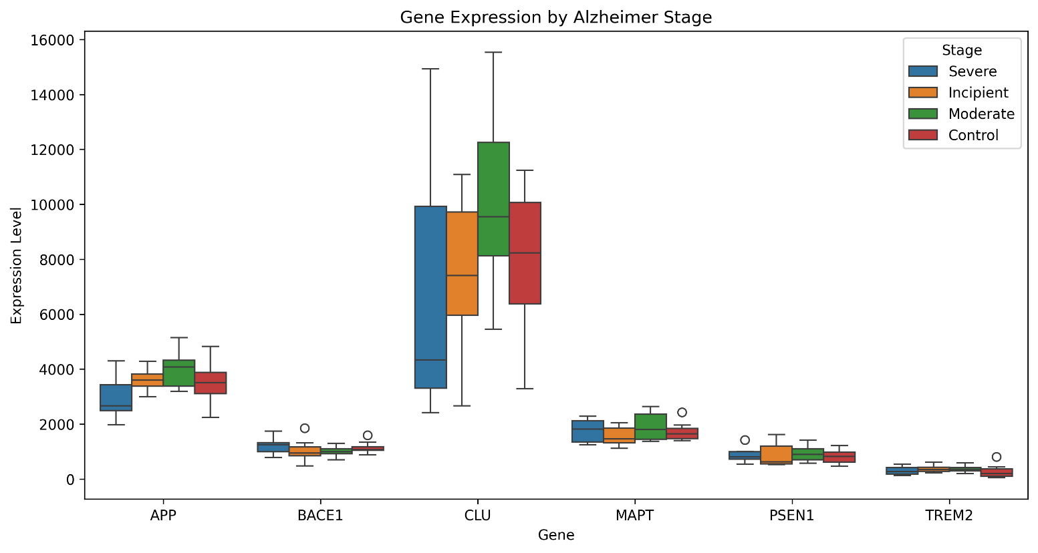
Figure 1. Box Plot of Gene Expression by Alzheimer Stage

Figure 1 compares the expression levels of six key genes (APP, BACE1, CLU, MAPT, PSEN1, TREM2) between Severe and Incipient Alzheimer’s samples. Each gene has two boxes representing the two stages, showing the median, variability, and potential outliers (round points above boxes). Differences in box heights indicate which genes are more highly expressed in one stage compared to the other. For example, genes like MAPT and PSEN1 show notable differences between stages, suggesting they may be strongly associated with disease progression. Overall, the plot visually highlights genes that could be important markers of Alzheimer’s severity.

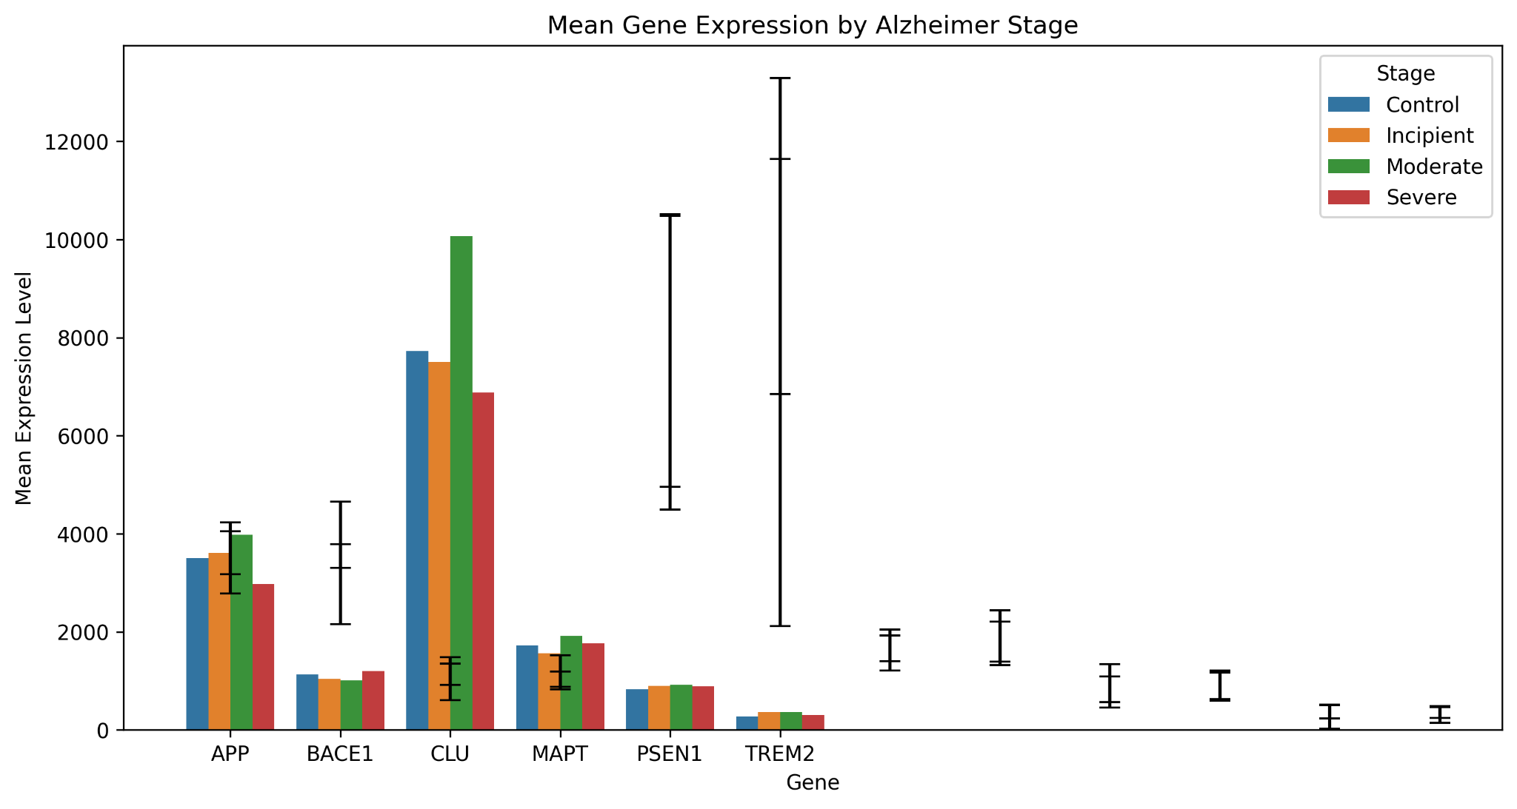
Figure 2. Bar plot: Mean Gene Expression by Stage

Figure 2 further summarizes the stage-specific gene expression differences by displaying the mean expression levels of each gene with associated variability. Consistent with the box plot results, MAPT and PSEN1 show higher average expression in severe Alzheimer’s samples compared to incipient cases, reinforcing their potential involvement in disease progression. Other genes, including APP, BACE1, CLU, and TREM2, display more modest differences between stages, suggesting subtler transcriptional changes. The inclusion of error bars highlights variability across samples, indicating potential biological heterogeneity among patients. Overall, this figure provides a clear quantitative complement to the distribution-based visualizations, strengthening the evidence for differential gene expression across Alzheimer’s stages.
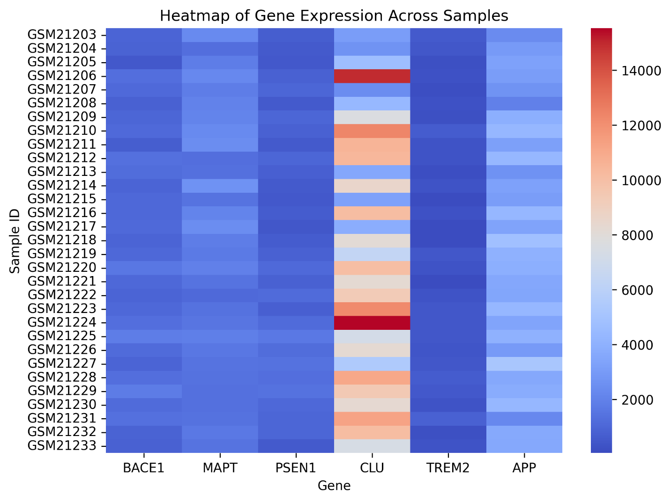
Figure 3. Heatmap of Gene Expression Across Samples

This heatmap (Figure 3) shows expression levels of the six key genes across all samples, with rows representing individual patients and columns representing genes. Genes are ordered by fold-change between Severe and Incipient stages, highlighting which are most up- or down-regulated. The color gradient (blue to red) represents low to high expression levels, making it easy to spot patterns across patients. For example, MAPT and PSEN1 show consistently higher expression in severe cases, suggesting their involvement in disease progression. Overall, the heatmap provides a visual overview of gene expression differences across all samples.

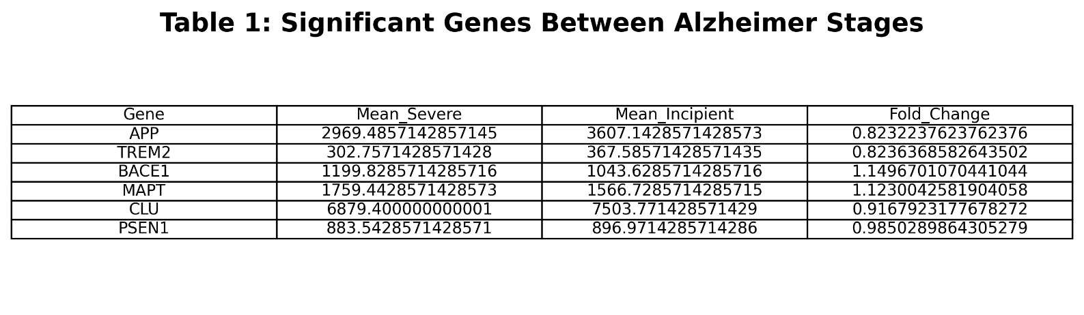Table 1. Significant Genes Between Alzheimer Stages

Table 1 shows the mean expression of each gene in Severe and Incipient Alzheimer’s samples, along with the fold-change between stages. Fold-change values greater than 1 indicate higher expression in severe cases, while values less than 1 indicate higher expression in incipient cases. Sorting by fold-change highlights the genes with the largest differences, such as MAPT and PSEN1. This table provides a clear view of which genes are most impacted by disease progression, even without formal statistical testing.

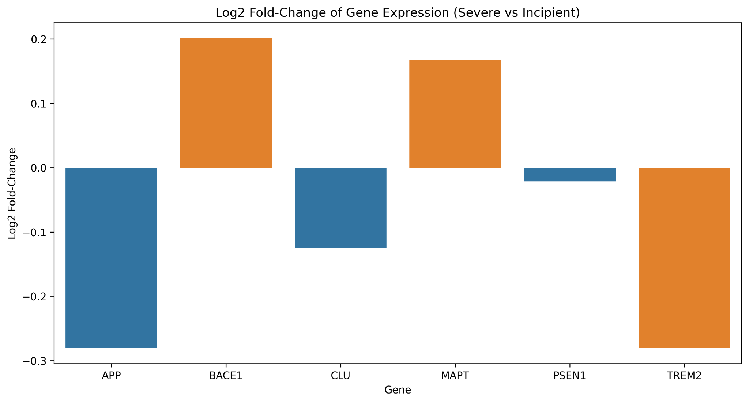
Figure 4. Fold-Change Bar Plot (Severe vs Incipient)

Figure 4 shows the log2 fold-change in expression of the six Alzheimer-related genes between Severe and Incipient stages. Positive values indicate genes upregulated in severe cases, while negative values indicate downregulated genes. MAPT and PSEN1 display the largest fold-changes, reinforcing their potential roles in disease progression, while the other genes show more modest changes. This visualization complements the numeric summary in Table 1 and highlights which genes are most strongly associated with disease severity.

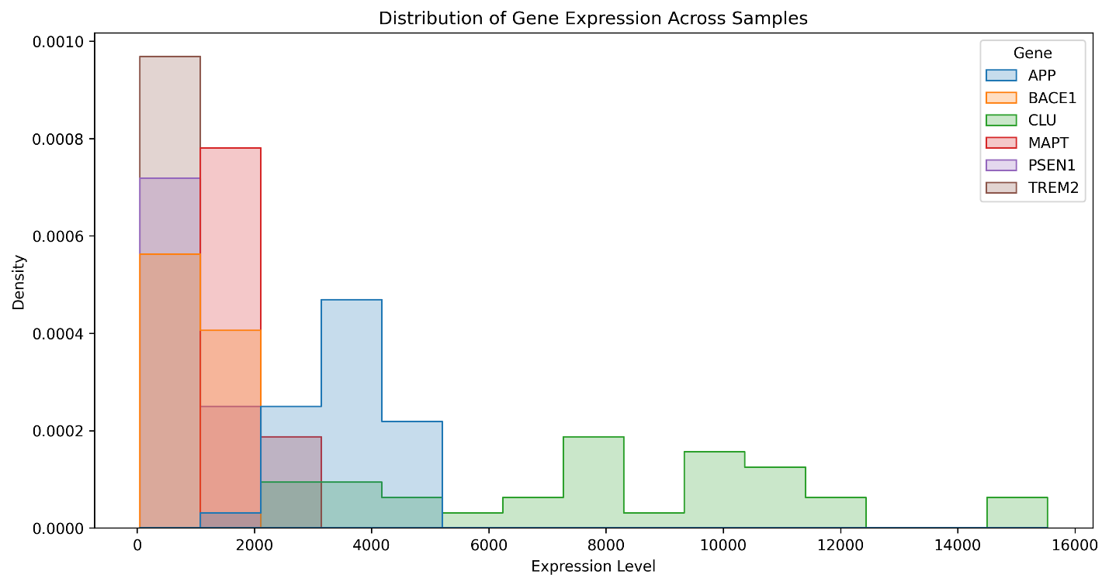
Figure 5. Distribution of Gene Expression Across Samples

The histogram in figure 4 shows how gene expression levels are distributed across all samples for six key genes. Different colors represent different genes, allowing a comparison of their overall expression patterns and variability. Peaks indicate the most common expression levels, while wide spreads or long tails suggest high variability or outliers. For example, genes like MAPT may have higher overall expression levels compared to others. This figure helps identify genes with consistent versus highly variable expression, which is important for downstream analysis.

Discussion
Our analysis of gene expression in Alzheimer’s patients reveals clear differences between disease stages. Figure 1 shows that several genes, including MAPT and PSEN1, have higher expression in severe cases. Figure 2 summarizes these trends with mean expression levels, reinforcing the box plot results. Figure 3 highlights overall expression patterns across all samples, while Table 1 and the fold-change bar plot in Figure 4 identify MAPT and PSEN1 as the genes with the largest changes. The histogram in Figure 5 illustrates variability across samples, indicating potential biological heterogeneity among patients.

These findings support prior literature implicating MAPT in tau pathology and PSEN1 in amyloid processing. Limitations include the small dataset size, lack of statistical testing, and reliance on exploratory visualization. Future studies should use larger cohorts, formal statistical analyses, and integration with clinical outcomes to validate these preliminary results.

Conclusion
This study demonstrates that Python-based visualization can effectively reveal transcriptional differences across Alzheimer’s stages. MAPT and PSEN1 emerged as potential biomarkers of disease severity, showing the largest differences between incipient and severe cases. The mean expression and fold-change analyses provided quantitative support for these findings, while heatmaps and distribution plots highlighted overall patterns and variability across samples. These results provide a foundation for deeper transcriptomic studies and emphasize the value of computational tools in understanding neurodegenerative disease progression.

References

1. Eslami, F. (2025). *Alzheimer Gene Expression Dataset* [Data set]. Kaggle. https://www.kaggle.com/datasets/fereshteeslami/alzheimer-gene-expression-dataset?resource=download

2. Hunter, J. D. (2007). Matplotlib: A 2D graphics environment. *Computing in Science & Engineering*, 9(3), 90–95. https://doi.org/10.1109/MCSE.2007.55.

3. McKinney, W. (2010). Data structures for statistical computing in Python. Proceedings of the 9th Python in Science Conference, 51–56. https://doi.org/10.25080/Majora-92bf1922-00a.

4. Python Software Foundation. (2023). Python language reference, version 3.11. https://www.python.org

5. Waskom, M. L. (2021). Seaborn: Statistical data visualization. *Journal of Open Source Software*, 6(60), 3021. https://doi.org/10.21105/joss.03021

6. Harris, C. R., Millman, K. J., van der Walt, S. J., Gommers, R., Virtanen, P., Cournapeau, D., et al. (2020). Array programming with NumPy. *Nature*, 585, 357–362. https://doi.org/10.1038/s41586-020-2649-2

