Comp 3133
Name: Kashfi Mehbuba
ID: 101474002
Lab 04 Screenshots
- Validation Error when Body is empty
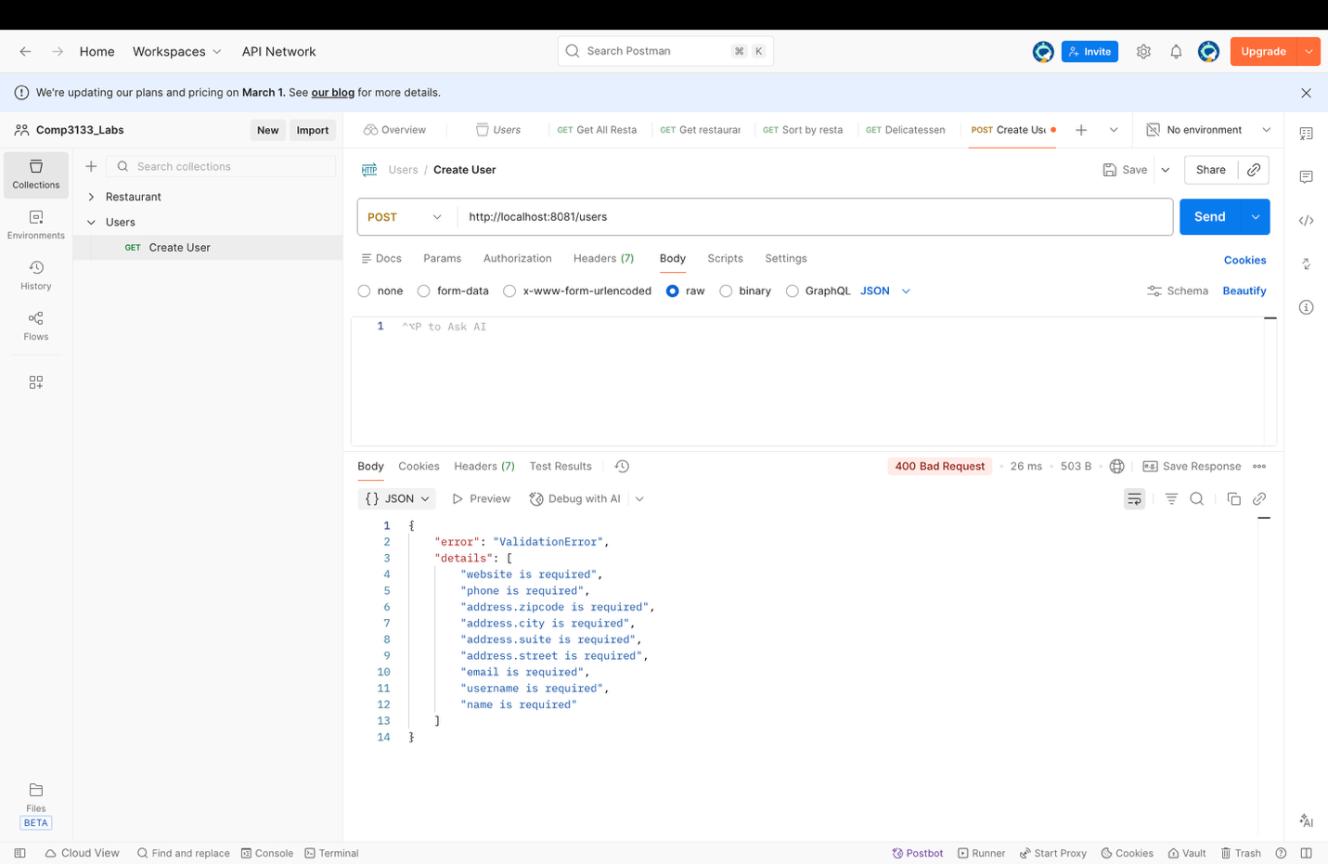

- User Created Successfully
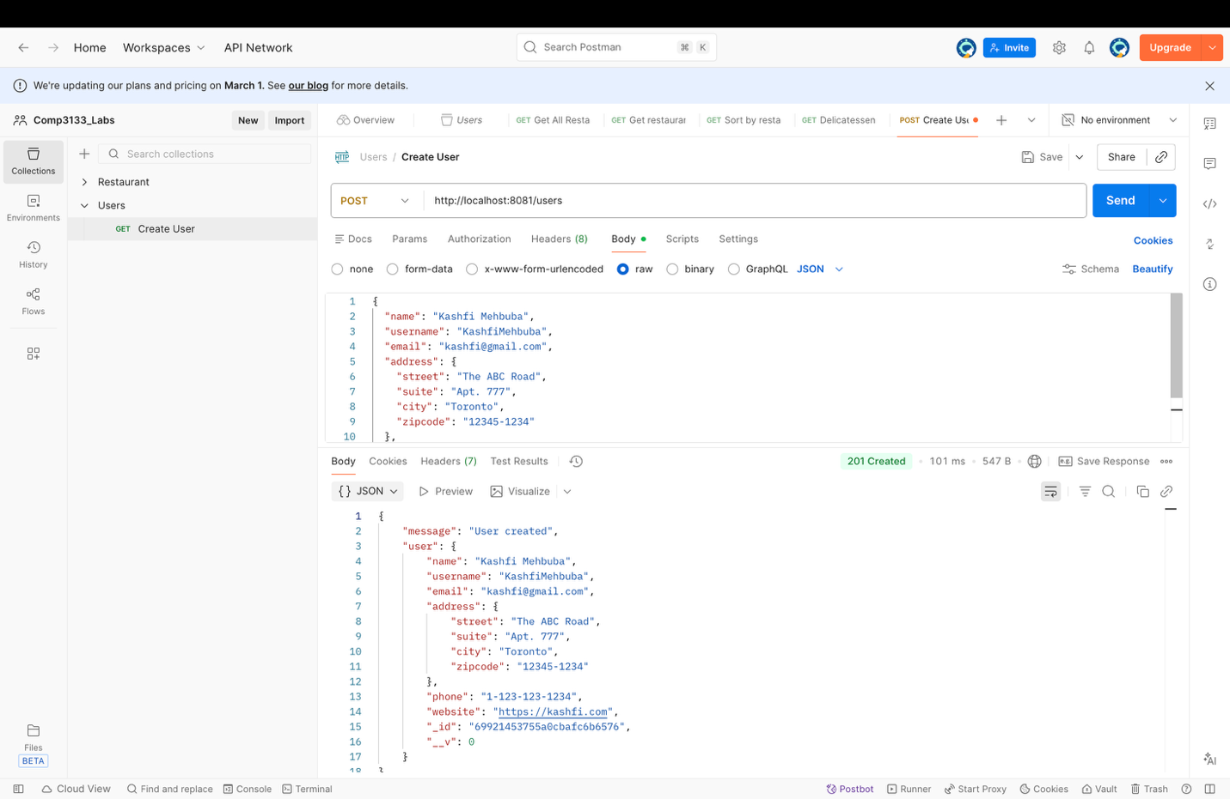

- Username Too Short
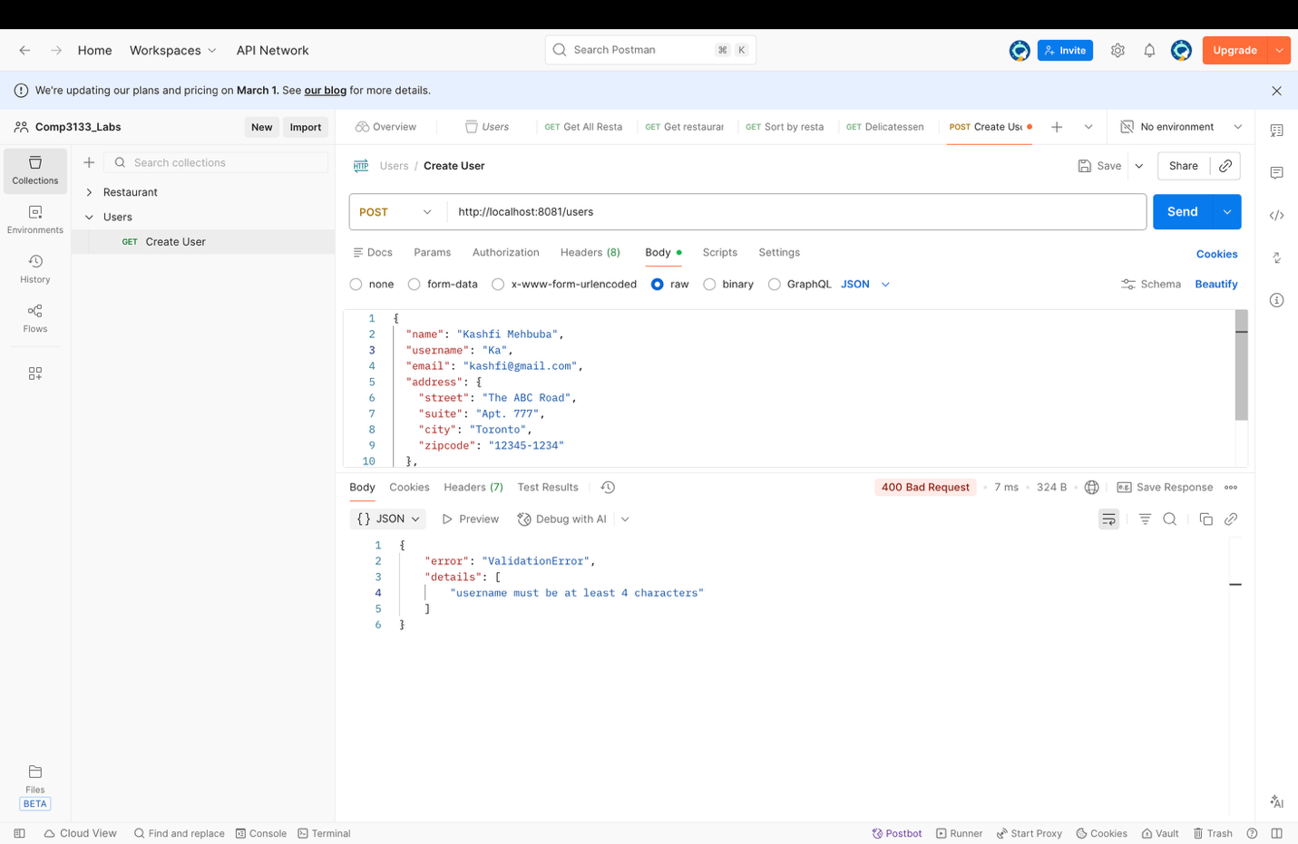

- Invalid Email
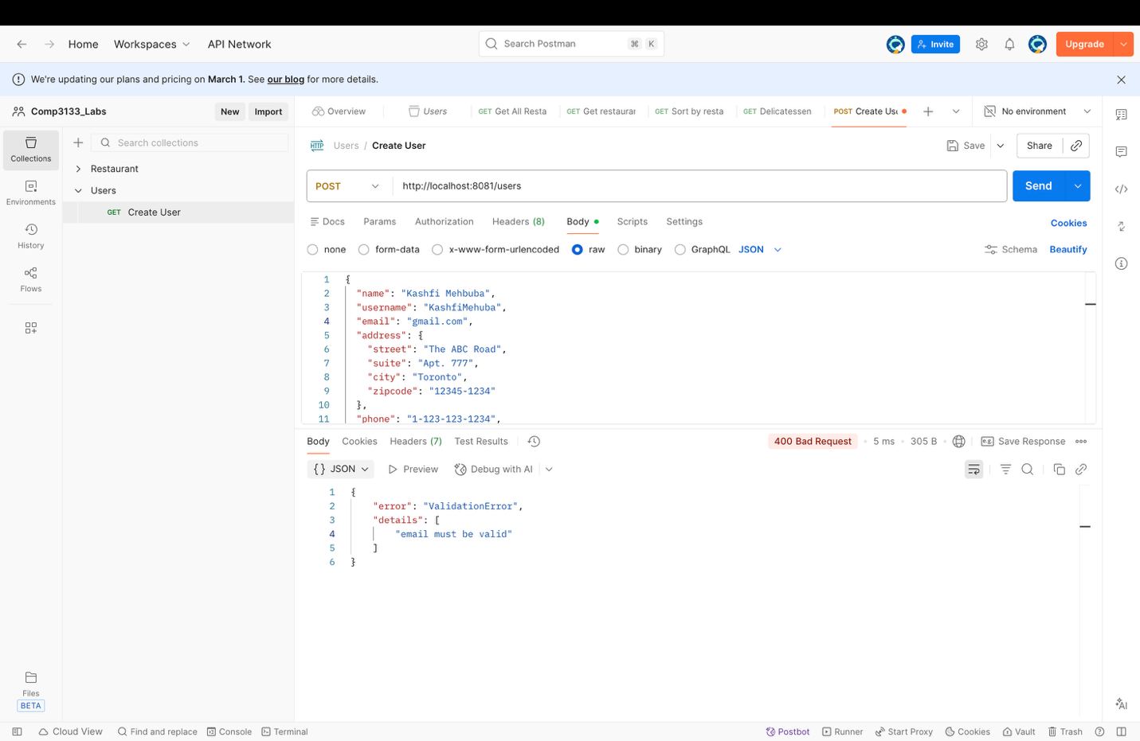

- Invalid City Name
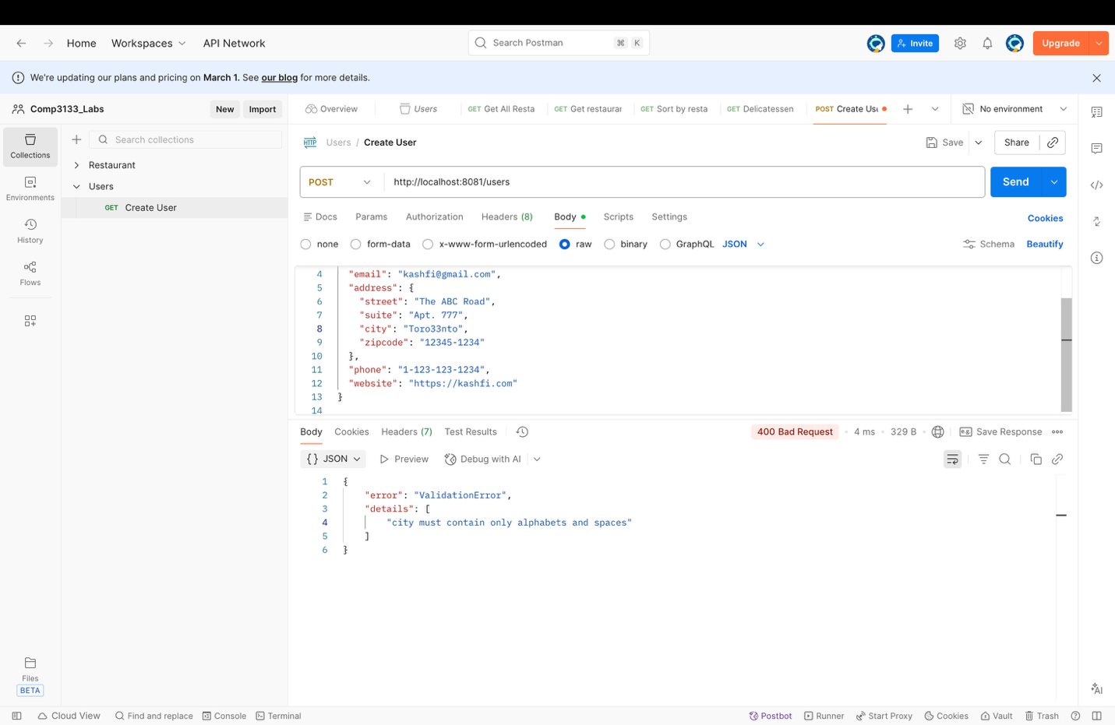

- Invalid Number
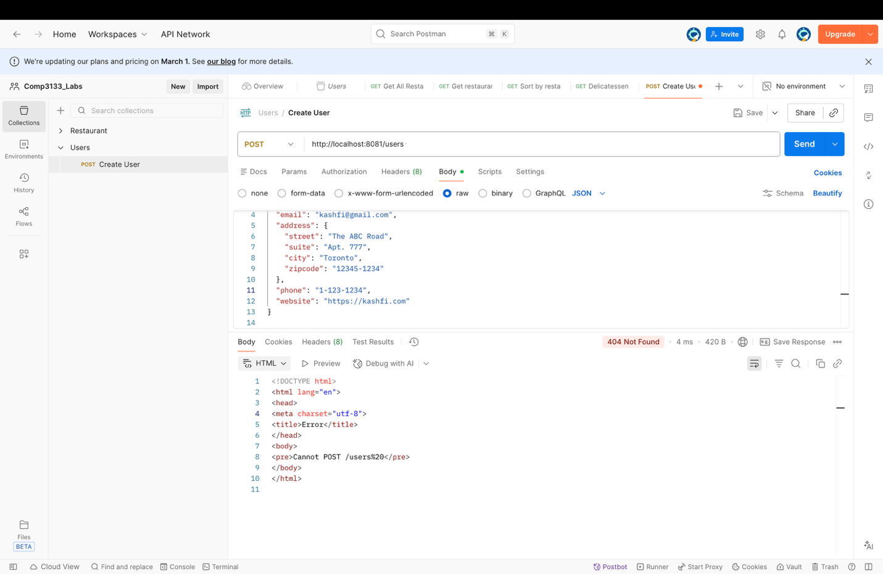

- Invalid Zip code
