LIBRARY MANAGEMENT SYSTEM

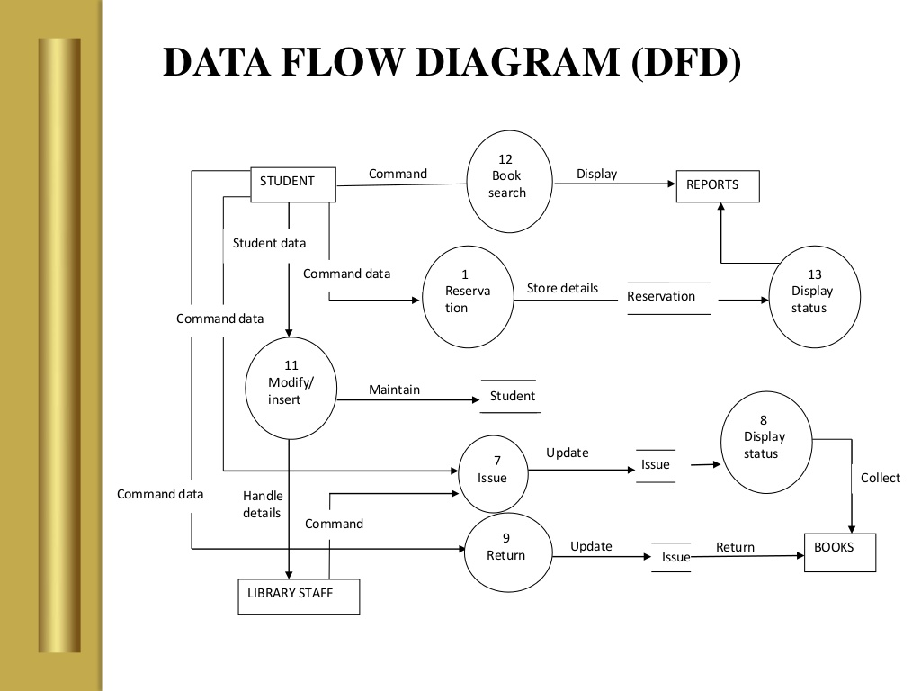

ONLINE SHOPPING SYSTEM:

