

**NAME** :  *KASHIF MAJID DAR*

**BRANCH**:  *CS B-1*

**BATCH**: *2019-23*

**PRN:**  *19070122084*

***Programming and Problem Solving Lab***

*Assignment 6*

1.Create two lists and then create a third list by picking an even-index element from the first list and odd index elements from second.

list1=[]

print("Insert 5 values for list1:-")

for i in range(0,5):

A=int (input())

list1.append(A)

print("List1=",list1)

list2=[]

print("Insert 5 values for list2:-")

for j in range(0,5):

B=int(input())

list2.append(B)

print("List2=",list2)

list3=[]

for k in range(0,5):

if (k%2==0):

list3.append(list1[k])

else:

list3.append(list2[k])

print("List3=",list3)

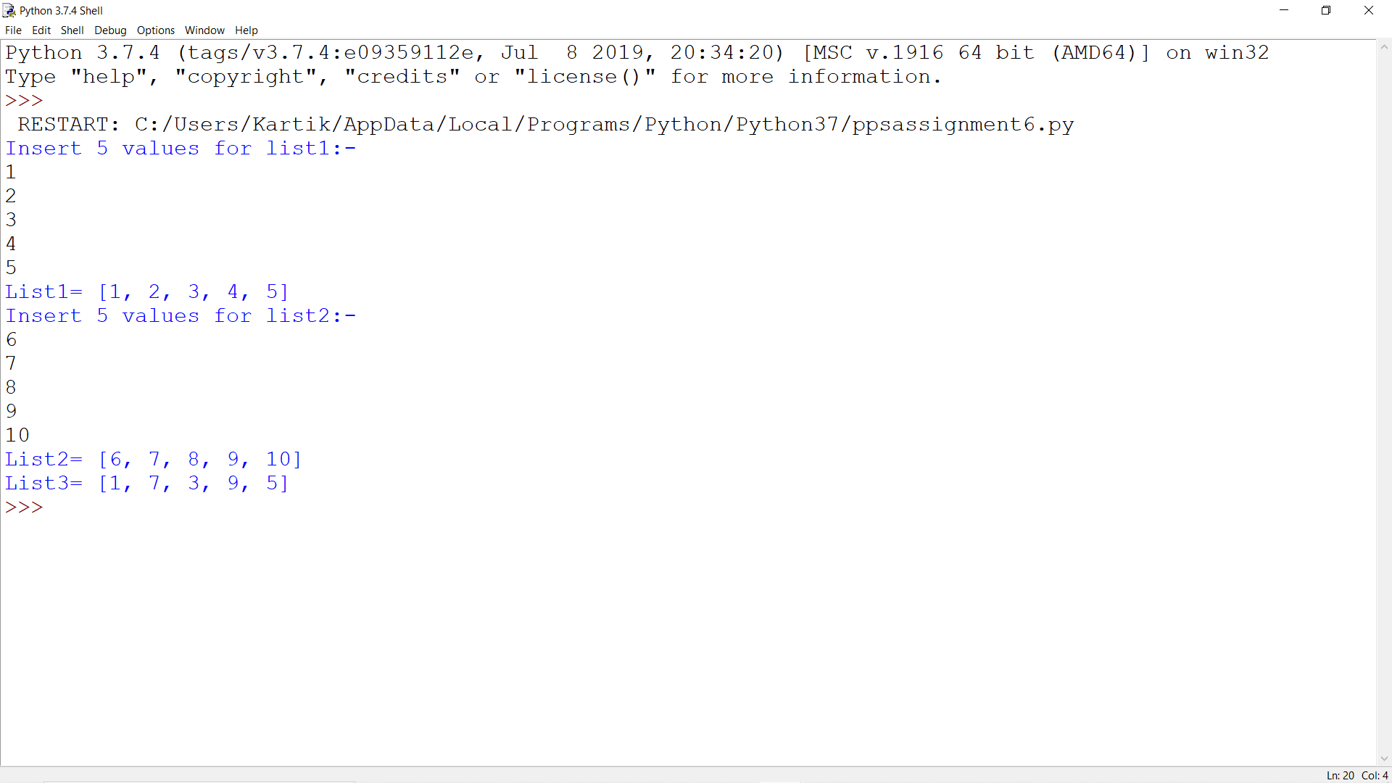

2. For created input list removes the element at index 5 and add it to the 3rd position and also, at the end of the list.

list1=[]

print("Insert 10 values for list1:-")

for i in range(0,10):

A=int (input())

list1.append(A)

print("List1=",list1)

k=list1[5]

list1.remove(k)

list1.insert(2,k)

list1.append(k)

print("List1 after Modifying Acc. to the Question:-",list1)

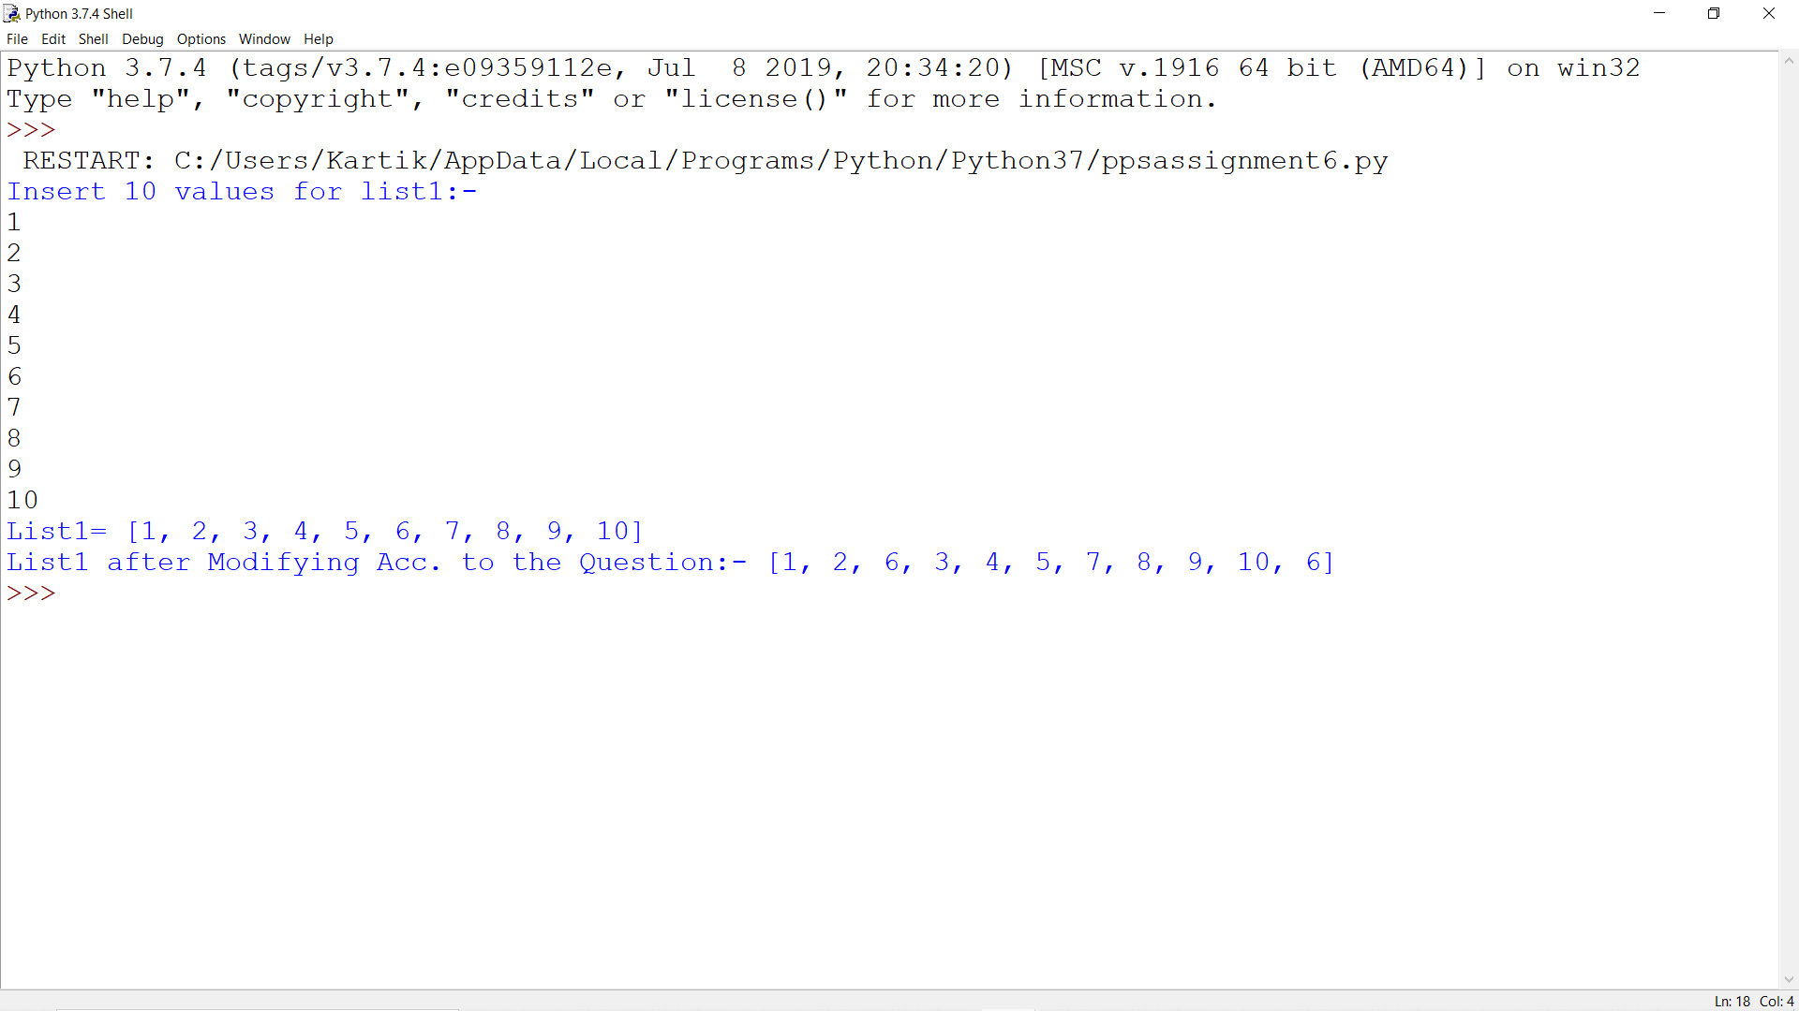

3. Given a list slice it into a 4 equal chunks and reverse each list.

list1=[]

print("Insert 12 values for list1:-")

for i in range(0,12):

A=int (input())

list1.append(A)

print("List1=",list1)

chunk1=list1[:3]

chunk1.reverse()

chunk2=list1[3:6]

chunk2.reverse()

chunk3=list1[6:9]

chunk3.reverse()

chunk4=list1[9:12]

chunk4.reverse()

print("Chunk1:-",chunk1)

print("Chunk2:-",chunk2)

print("Chunk3:-",chunk3)

print("Chunk4:-",chunk4)

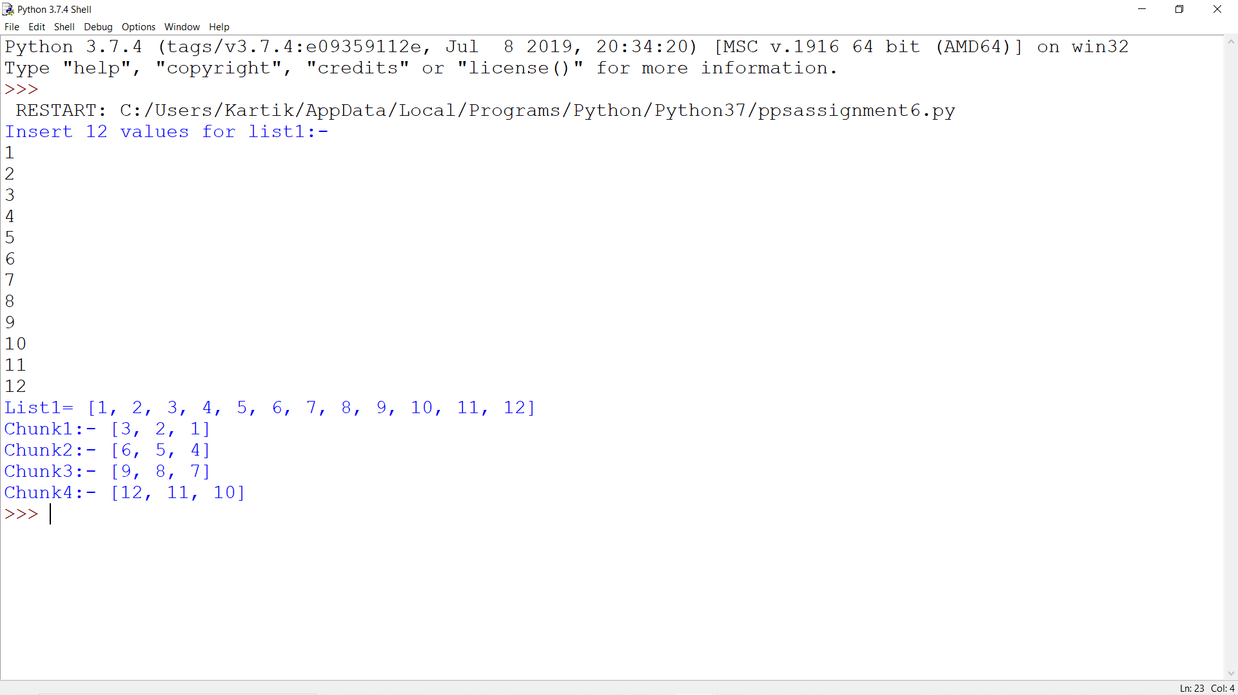

4. Given a two list of equal size create a set such that it shows the element from both lists in the pair.

list1=[]

print("Insert 5 values for list1:-")

for i in range(0,5):

A=int (input())

list1.append(A)

print("List1=",list1)

list2=[]

print("Insert 5 values for list2:-")

for j in range(0,5):

B=int(input())

list2.append(B)

print("List2=",list2)

list3=[]

for k in range(0,5):

C=list1[k],list2[k]

list3.append(C)

print("List3=",list3)

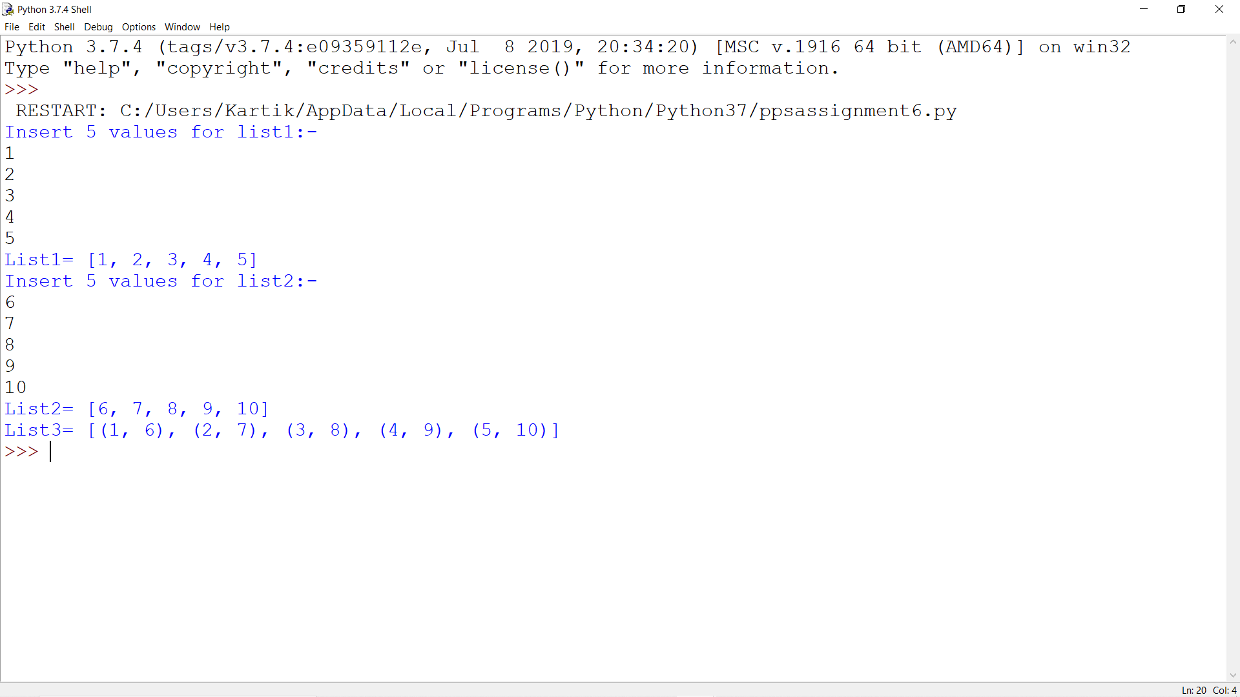

5. Iterate a given list and Check if a given element already exists in another list if not in the second list delete it from the first list.

list1=[1,2,3,4,5,6,7,8,9,10]

for i in list1:

print(i)

list2=[]

print("Insert 10 values for list2:-")

for j in range(0,10):

B=int(input())

list2.append(B)

if(B in (list1)):

list1.remove(B)

print("List1=",list1)

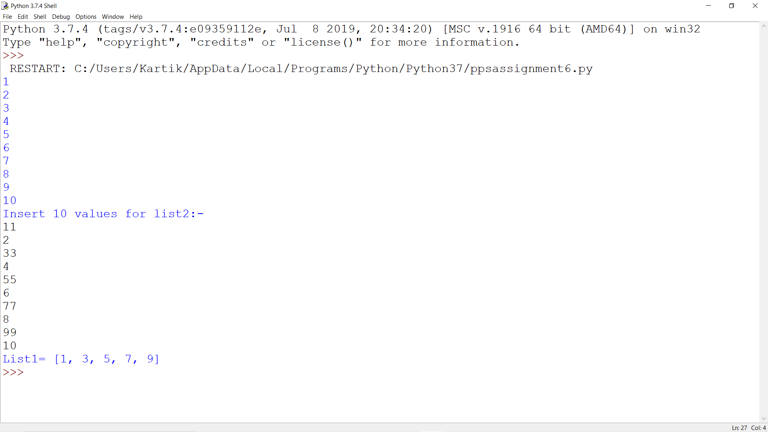

6. Remove duplicate from a list and create a new list and find the minimum and maximum Number.

list1=[]

print("Insert 10 values for list1:-")

for i in range(0,10):

A=int (input())

list1.append(A)

print("List1=",list1)

B=[]

for j in list1:

if j not in B:

B.append(j)

print("List1 after removing Duplicates:-",B)

print("Greatest Number=",max(B))

print("Smallest Number=",min(B))

