

**NAME: KASHIF MAJID**

**BATCH: *CS B1***

**PRN:*19070122084***

**ASSIGNMENT 9**

Question 1:

Write a function called showNumbers that takes a parameter called limit. It should print all the numbers between 0 and limit with a label to identify the even and odd numbers.

For example, if the limit is 3, it should print:

0 EVEN

1 ODD

2 EVEN

3 ODD

Ans:

def showNumbers(limit):

i = 0

while i <= limit:

print(i, end = " ")

if(i % 2 == 0):

print("EVEN")

else:

print("ODD")

i += 1

showNumbers(9)

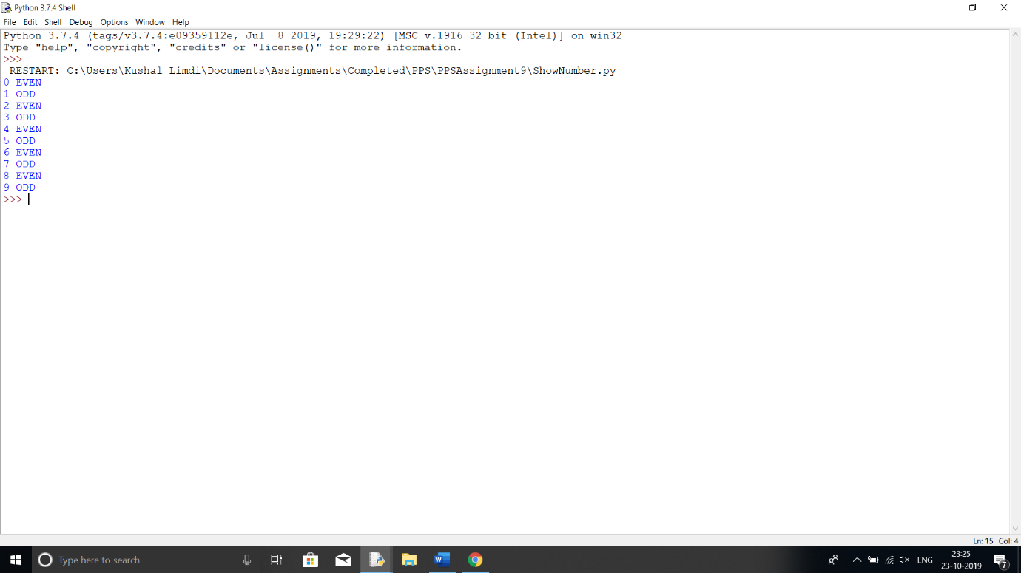

Question 2:

Write a function called fizz_buzz that takes a number.

I. If the number is divisible by 3, it should return “Fizz”.

II. If it is divisible by 5, it should return “Buzz”.

III. If it is divisible by both 3 and 5, it should return “FizzBuzz”.

IV. Otherwise, it should return the same number

Ans:

def fizz_buzz(num):

fibu = "Fizz"

if num % 3 != 0:

if num % 5 == 0:

fibu = "Buzz"

else:

fibu = str(num)

elif num % 5 == 0:

fibu += "Buzz"

return fibu

print(fizz_buzz(30))

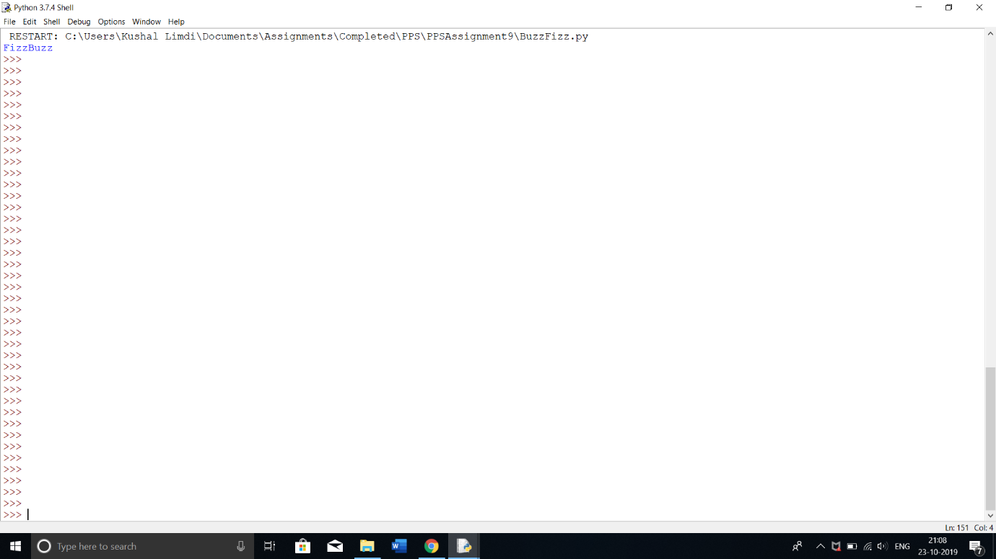

Question 3:

Write a function that prints all the prime numbers between 0 and limit where limit is a parameter.

Ans:

ef primeNum(limit):

for i in range(1, limit):

ctr = 0

for j in range(1, i):

if i % j == 0:

ctr += 1

if ctr > 1:

break

if ctr == 1:

print(i)

primeNum(50)

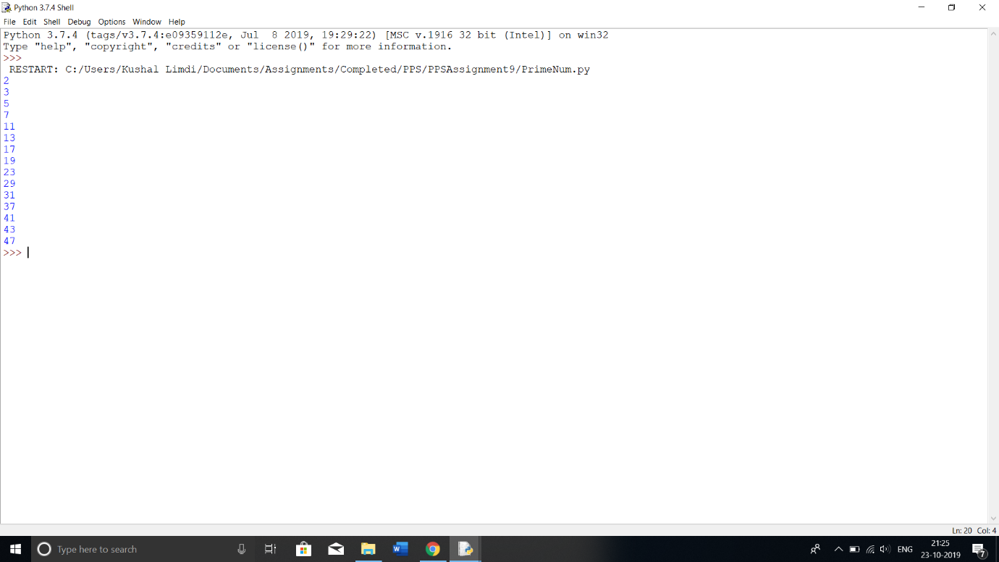

Question 4

Write a recursive function for sum of digits of given number (e.g. 123 = 1+2+3=5)

Ans:

def summationOfDigits(num):

if num == 0:

return 0

return (num % 10 + summationOfDigits(int(num / 10)))

print(summationOfDigits(1234567890))

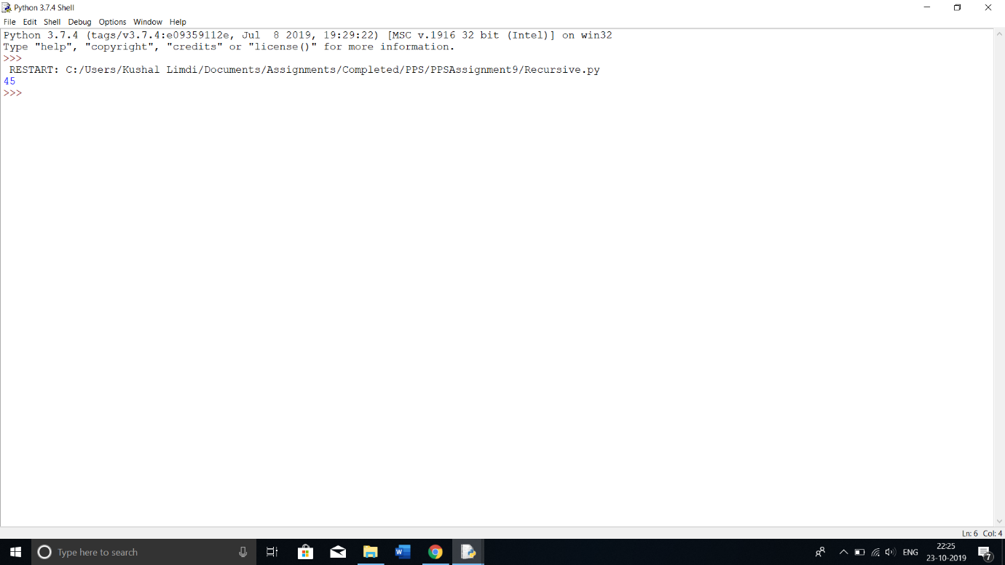

Question 5

Perform following operations on matrices using function:

I. Read Matrix

II. Print Matrix

III. Addition of matrices

IV. Finding sum of rows

V. Subtraction of matrices

Ans:

def readMatrix(matrix):

return matrix

def printMatrix(matrix):

print(matrix)

def addMatrix(matrix1, matrix2):

if len(matrix1) == len(matrix2):

matrix3 = []

for i in range(len(matrix1)):

matrix3.append(matrix1[i] + matrix2[i])

return matrix3

else:

return "Invalid"

def subMatrix(matrix1, matrix2):

if len(matrix1) == len(matrix2):

matrix3 = []

for i in range(len(matrix1)):

matrix3.append(matrix1[i] - matrix2[i])

return matrix3

else:

return "Invalid"

printMatrix([2, 2, 3, 3])

print(addMatrix([2, 2, 3, 3], [2, 2, 3, 3]))

print(subMatrix([2, 2, 3, 3],[2, 2, 3, 3]))

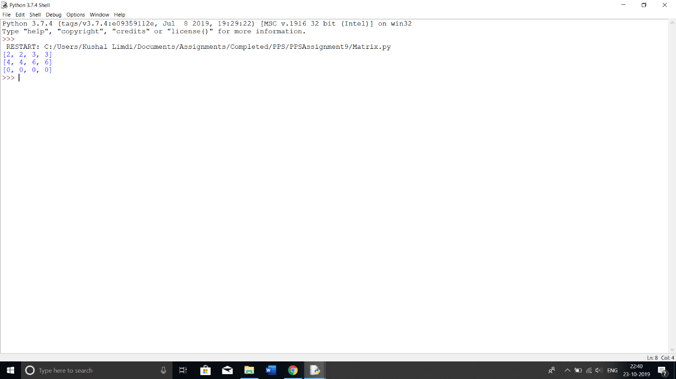

Question 6

Write a function dups to find all duplicates in the list.

Ans:

def dup(list1):

list2 = []

listdup =[]

for i in range(len(list1)):

if list1[i] not in list2:

list2.append(list1[i])

else:

listdup.append(list1[i])

return listdup

print(dup([2,2,4,5,7,66,3,5,4]))

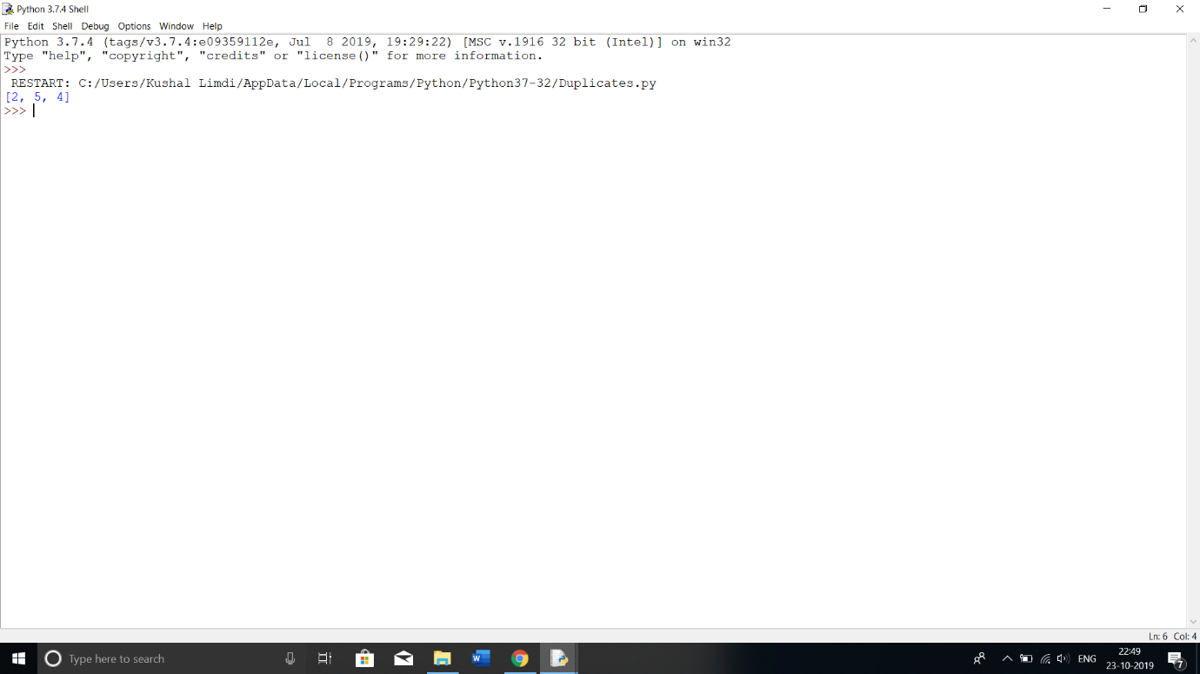

Question 7

Write a function unique to find all the unique elements of a list.

Ans:

def unique(list1):

list2 = []

for i in range(len(list1)):

if list1[i] not in list2:

list2.append(list1[i])

return list2

print(unique([2,2,4,5,7,66,3,5,4]))

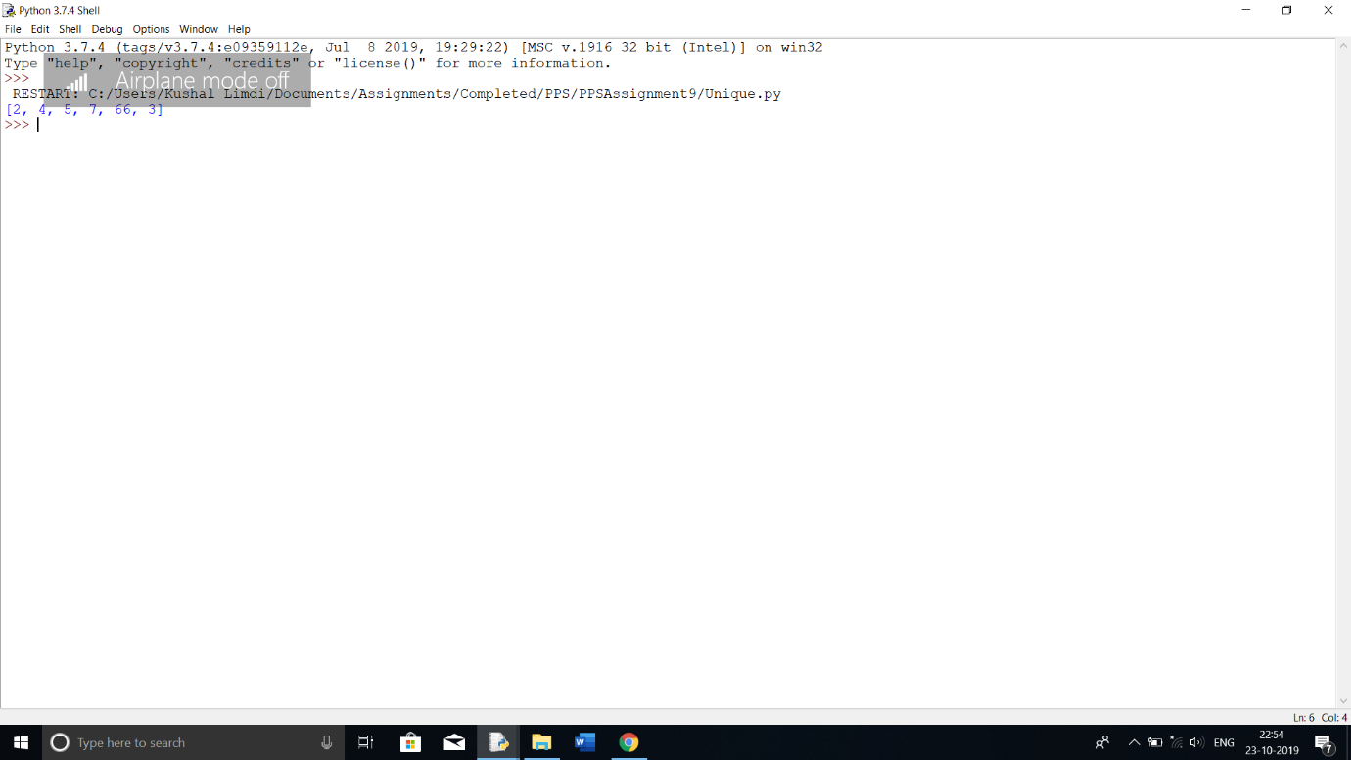

Question 8

Write a function ball_collide that takes two balls as parameters and computes if they are colliding. Your function should return a Boolean representing whether or not the balls are colliding.

Hint: Represent a ball on a plane as a tuple of (x, y, r), r being the radius If (distance between two balls centres) <= (sum of their radii) then (they are colliding).

Ans:

def checkCollision(ball1, ball2): #ball1 & ball2 are tuples with format (x, y, r)

if ((ball1[0] - ball2[0])**2 + (ball1[1] - ball2[1]) ** 2)**0.5 <= (ball1[2] + ball2[2]):

return True

else:

return False

print(checkCollision((0,0,2), (0,0,1)))

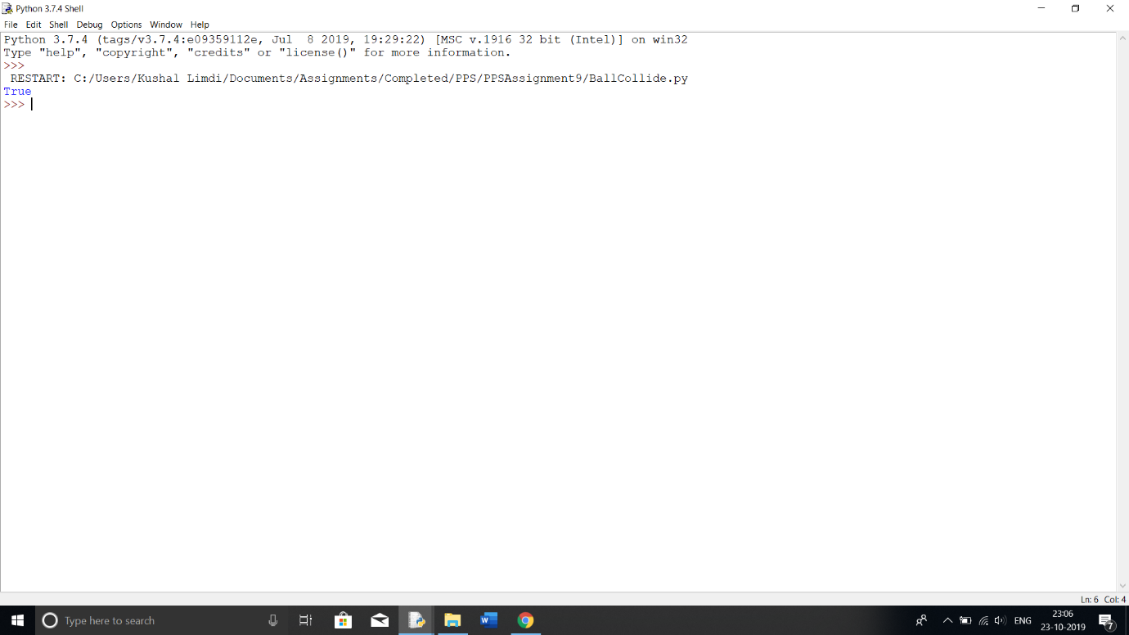

Question 9

Write a program that uses lambda function to multiply two numbers.

Ans:

x = lambda a,b : a * b

print(x(4,5))

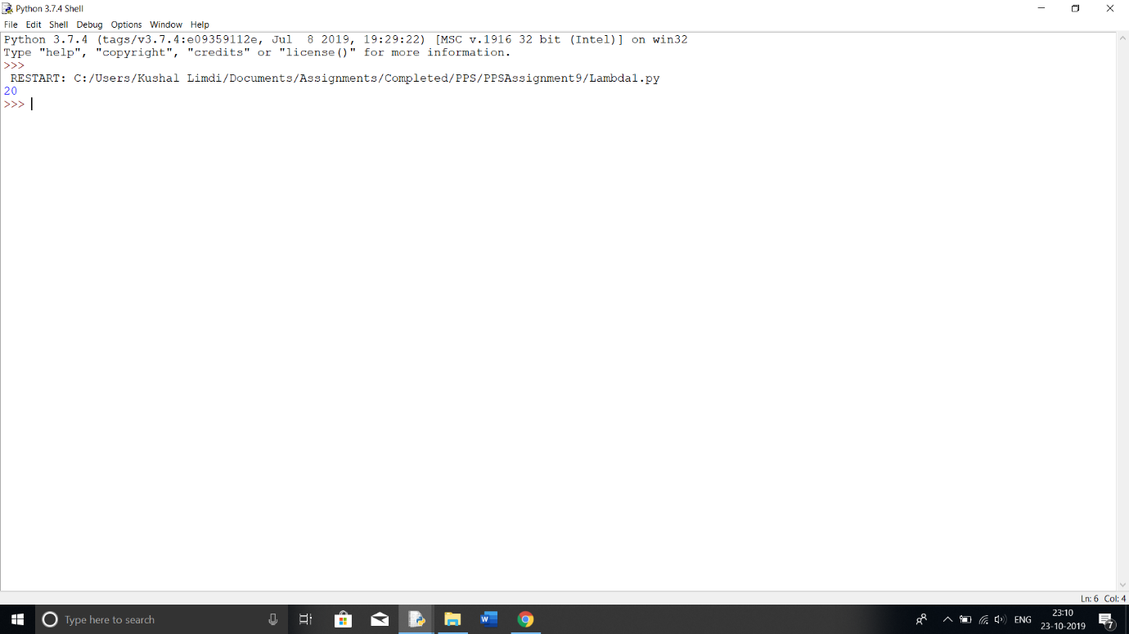

Question 10

Write a program that passes lambda function as an argument to another function to compute the cube of a number.

Ans:

cube = lambda a : a ** 3

def printcube(x):

print(x)

printcube(cube(3))

