**CIA-2**

**MN KASHIFKHAN**

**727721EUIT072**

**EXERCISE1:**

**package Cia2;**

**import org.openqa.selenium.By;**

**import org.openqa.selenium.WebDriver;**

**import org.openqa.selenium.chrome.ChromeDriver;**

**import org.openqa.selenium.chrome.ChromeOptions;**

**import org.testng.annotations.Test;**

**import io.github.bonigarcia.wdm.WebDriverManager;**

**public class Cia2_1 {**

**WebDriver driver;**

***@Test***

**public void f() throws InterruptedException{**

**ChromeOptions co=new ChromeOptions();**

**co.addArguments("--remote-allow-origins=*");**

**WebDriverManager.*chromedriver*().setup();**

**WebDriver driver=new ChromeDriver(co);**

**driver.get("https://www.trivago.in/");**

**driver.manage().window().maximize();**

**String currtitle=driver.getTitle();**

**System.*out*.println(currtitle);**

**driver.findElement(By.*xpath*("//*[@id=\"input-auto-complete\"]")).click();**

**Thread.*sleep*(3000);**

**driver.findElement(By.*xpath*("//*[@id=\"suggestion-list\"]/ul/li[1]/div/div")).click();**

**Thread.*sleep*(3000);**

**driver.findElement(By.*xpath*("//*[@id=\"__next\"]/div[1]/div[1]/section/div[2]/div[3]/div/div[2]/div/div/div/div[2]/div/div[1]/div[2]/button[24]/time")).click();**

**Thread.*sleep*(3000);**

**driver.findElement(By.*xpath*("//*[@id=\"__next\"]/div[1]/div[1]/section/div[2]/div[3]/div/div[2]/div/div/div/div[2]/div/div[1]/div[2]/button[26]/time")).click();**

**Thread.*sleep*(3000);**

**driver.findElement(By.*xpath*("//*[@id=\"__next\"]/div[1]/div[1]/section/div[2]/div[3]/div/div[2]/div/div/div[1]/div/div[1]/div[1]/div/button[2]")).click();**

**Thread.*sleep*(3000);**

**driver.findElement(By.*xpath*("//*[@id=\"__next\"]/div[1]/div[1]/section/div[2]/div[3]/div/div[2]/div/div/div[1]/div/div[1]/div[3]/div/button[2]")).click();**

**Thread.*sleep*(3000);**

**driver.findElement(By.*xpath*("/html/body/div[1]/div[1]/div[1]/section/div[2]/div[3]/div/div[2]/div/div/div[1]/div/div[2]/div[2]/input")).click();**

**Thread.*sleep*(3000);**

**driver.findElement(By.*xpath*("//*[@id=\"__next\"]/div[1]/div[1]/section/div[2]/div[3]/div/div[2]/div/div/div[2]/div/button[2]")).click();**

**}**

**}**

**OUTPUT:**

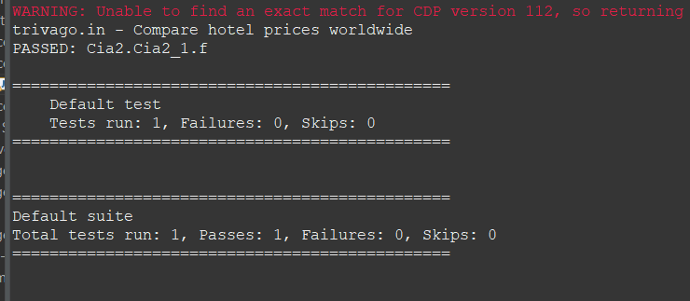

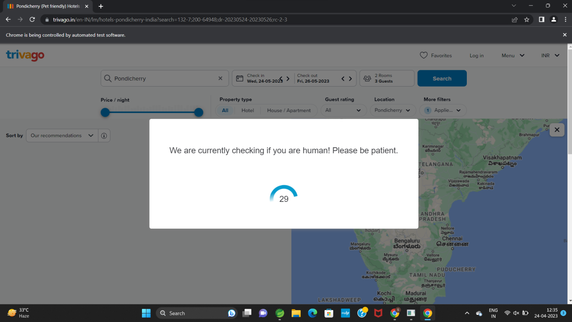

**EXERCISE2:**

**package Cia2;**

**import org.openqa.selenium.By;**

**import org.openqa.selenium.WebDriver;**

**import org.openqa.selenium.WebElement;**

**import org.openqa.selenium.chrome.ChromeDriver;**

**import org.openqa.selenium.chrome.ChromeOptions;**

**import org.testng.annotations.Test;**

**import io.github.bonigarcia.wdm.WebDriverManager;**

**public class Cia2_2 {**

**WebDriver driver;**

***@Test***

**public void f() throws InterruptedException{**

**ChromeOptions co=new ChromeOptions();**

**co.addArguments("--remote-allow-origins=*");**

**WebDriverManager.*chromedriver*().setup();**

**WebDriver driver=new ChromeDriver(co);**

**driver.get("https://www.trivago.in/");**

**driver.manage().window().maximize();**

**String currtitle=driver.getTitle();**

**System.*out*.println(currtitle);**

**driver.findElement(By.*xpath*("//*[@id=\"input-auto-complete\"]")).click();**

**Thread.*sleep*(3000);**

**driver.findElement(By.*xpath*("//*[@id=\"suggestion-list\"]/ul/li[1]/div/div")).click();**

**Thread.*sleep*(3000);**

**driver.findElement(By.*xpath*("//*[@id=\"__next\"]/div[1]/div[1]/section/div[2]/div[3]/div/div[2]/div/div/div/div[2]/div/div[1]/div[2]/button[24]/time")).click();**

**Thread.*sleep*(3000);**

**driver.findElement(By.*xpath*("//*[@id=\"__next\"]/div[1]/div[1]/section/div[2]/div[3]/div/div[2]/div/div/div/div[2]/div/div[1]/div[2]/button[26]/time")).click();**

**Thread.*sleep*(3000);**

**driver.findElement(By.*xpath*("//*[@id=\"__next\"]/div[1]/div[1]/section/div[2]/div[3]/div/div[2]/div/div/div[1]/div/div[1]/div[1]/div/button[2]")).click();**

**Thread.*sleep*(3000);**

**driver.findElement(By.*xpath*("//*[@id=\"__next\"]/div[1]/div[1]/section/div[2]/div[3]/div/div[2]/div/div/div[1]/div/div[1]/div[3]/div/button[2]")).click();**

**Thread.*sleep*(3000);**

**driver.findElement(By.*xpath*("/html/body/div[1]/div[1]/div[1]/section/div[2]/div[3]/div/div[2]/div/div/div[1]/div/div[2]/div[2]/input")).click();**

**Thread.*sleep*(3000);**

**driver.findElement(By.*xpath*("//*[@id=\"__next\"]/div[1]/div[1]/section/div[2]/div[3]/div/div[2]/div/div/div[2]/div/button[2]")).click();**

**Thread.*sleep*(40000);**

**driver.findElement(By.*xpath*("//*[@id=\"sorting-selector\"]")).click();**

**driver.findElement(By.*xpath*("//*[@id=\"sorting-selector\"]/option[4]")).click();**

**WebElement name=driver.findElement(By.*xpath*("//*[@id=\"__next\"]/div[1]/main/div[5]/section/div/div/ol/li[1]/div/article/div[2]/div[1]/section/h2/button/span"));**

**WebElement price=driver.findElement(By.*xpath*("//*[@id=\"__next\"]/div[1]/main/div[5]/section/div/div/ol/li[1]/div/article/div[2]/div[1]/section/h2/button/span"));**

**WebElement stays=driver.findElement(By.*xpath*("//*[@id=\"__next\"]/div[1]/main/div[5]/div[3]/div/div[2]/div[1]/div/div[2]/div[2]/div/div/div[1]/span[2]/strong"));**

**WebElement sites=driver.findElement(By.*xpath*("//*[@id=\"__next\"]/div[1]/main/div[5]/div[3]/div/div[2]/div[1]/div/div[2]/div[2]/div/div/div[2]/span[2]/strong"));**

**System.*out*.print("Hotel Name : "+name.getText());**

**System.*out*.print("Hotel Price : "+price.getText());**

**System.*out*.print("Stays Found : "+stays.getText());**

**System.*out*.print("Number of Booking sites Searched : "+sites.getText());**

**}**

**}**

**OUTPUT:**



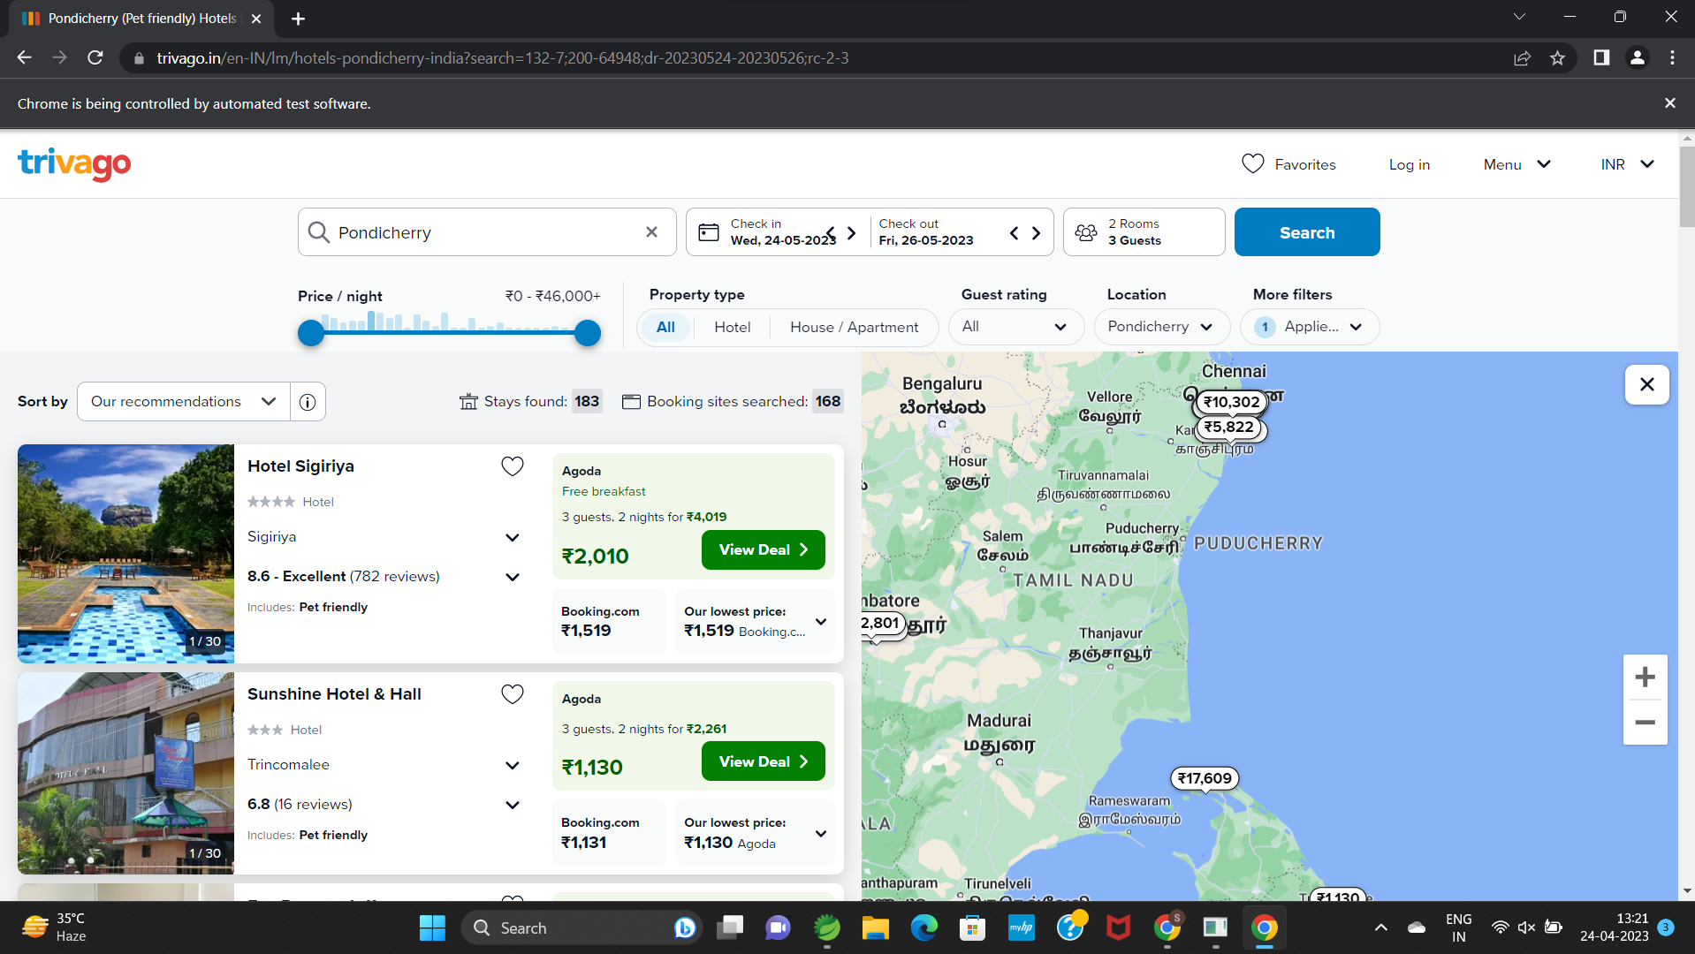

**EXERCISE3:**

**package Cia2;**

**import java.util.List;**

**import org.openqa.selenium.By;**

**import org.openqa.selenium.WebDriver;**

**import org.openqa.selenium.WebElement;**

**import org.openqa.selenium.chrome.ChromeDriver;**

**import org.openqa.selenium.chrome.ChromeOptions;**

**import org.testng.annotations.Test;**

**import io.github.bonigarcia.wdm.WebDriverManager;**

***@Test***

**public class Cia2_3 {**

**WebDriver driver;**

**public void TC_003() {**

**WebDriverManager.*chromedriver*().setup();**

**ChromeOptions co=new ChromeOptions();**

**co.addArguments("--remote-allow-origins=*");**

**driver=new ChromeDriver(co);**

**driver.get("https://www.trivago.in/");**

**driver.manage().window().maximize();**

**String txt1=driver.findElement(By.*xpath*("//*[@id=\"search\"]/div[1]/div[1]/div/span[1]/div[1]/div[3]/div/div/div/div/div/div/div/div[2]/div/div/div[1]/h2/a/span")).getText();**

**System.*out*.println(txt1);**

**String txt2=driver.findElement(By.*xpath*("//*[@id=\"search\"]/div[1]/div[1]/div/span[1]/div[1]/div[4]/div/div/div/div/div/div/div/div[2]/div/div/div[1]/h2/a/span")).getText();**

**System.*out*.println(txt2);**

**String txt3=driver.findElement(By.*xpath*("//*[@id=\"search\"]/div[1]/div[1]/div/span[1]/div[1]/div[5]/div/div/div/div/div/div[2]/div/div/div[1]/h2/a/span")).getText();**

**System.*out*.println(txt3);**

**String txt4=driver.findElement(By.*xpath*("//*[@id=\"search\"]/div[1]/div[1]/div/span[1]/div[1]/div[6]/div/div/div/div/div/div[2]/div/div/div[1]/h2/a/span")).getText();**

**System.*out*.println(txt4);**

**String txt5=driver.findElement(By.*xpath*("//*[@id=\"search\"]/div[1]/div[1]/div/span[1]/div[1]/div[7]/div/div/div/div/div/div[2]/div/div/div[1]/h2/a/span")).getText();**

**System.*out*.println(txt5);**

**driver.findElement(By.*xpath*("//*[@id=\"sorting-selector\"]/option[3]")).click();**

**String currentprice=driver.findElement(By.*xpath*("//*[@id=\"__next\"]/div/div[1]/main/div[3]/div[1]/div/div[3]/div/div/ol/li/div/article/div[2]/div[2]/div[1]/div/div[3]/div[1]/div/p")).getText();**

**String expectedprice="trivago.in - Compare hotel prices worldwide";**

**System.*out*.println(currentprice);**

**if(currentprice.equals(expectedprice)) {**

**System.*out*.println("price Matched");**

**}**

**else {**

**System.*out*.println("price not Matched");**

**}**

**driver.findElement(By.*xpath*("//*[@id=\"__next\"]/div/div[1]/main/div[3]/div[1]/div/div[3]/div/div/ol/li/div/article/div[2]/div[2]/div[1]/div/div[3]/div[2]/button/span/span[1]")).click();**

**driver.findElement(By.*xpath*("//*[@id=\"contentContainer\"]/div[3]/ol/li[1]/div[2]/a/div/div[2]/div")).click();**

**driver.findElement(By.*xpath*("//*[@id=\"hotelNavBar\"]/div/ul/li[2]/button/span")).click();**

**driver.findElement(By.*xpath*("//*[@id=\"ChildRoom-Ch8I2vnABhACIA4ojuUhMARAAUoJN0QxTl8xMDBQUJgFEgIIARoGEAIoBDAB\"]/div/div[4]/div[2]/div/div[1]/button/div")).click();**

**WebElement txtBoxl=driver.findElement(By.*xpath*("//*[@id=\"Fullname\"]"));**

**txtBoxl.sendKeys("Sabari");**

**}**

**}**

**OUTPUT:**



