**DEPARTMENT OF LIFELONG LEARNING , DAVV, INDORE**

**ACTIVITIES REPOERT-June – 2021**

|  |  |  |  |  |  |
| --- | --- | --- | --- | --- | --- |
| **s.n.** | **Name of the activities** | **Place** | **Date** | **No. of Participants** | **Report no.** |
|  | **String Art workshop**  Instructor – Mrs. Anita Pal | Google meet – http://meet.google.com/nft-hqnh-bup | 28 May – 2 June 2021 | 12 Students of Diploma in Interior Designing | Attached flayer --1  <https://youtu.be/I5AZGHFIAR2s> |
|  | **Success Journey with Super Senior** – My Achievements , Dolll Alumni Association,  Mrs. Ashwani Ghodke , Batch -2008-10 |  | 4 June 2021 | 83 students and faculties | Attached Flyer- 2 |
|  | **Success Journey with Super Senior** – **workshop**- Vastu in Interior , Dolll Alumni Association,  Mr. Rohit Chaudhry , Batch -2019-20 |  | 8- 10 June 2021 |  | Attached Flyer- 3 |
|  | **Workshop** – Cup Garden Decoration  Instructor- Mrs. Swarna Modi | <https://zoom.us/j/240892833j?pwd> | 12 June 2021 |  | Attached Flyer-4 |
|  | Workshop- Decorative Plate creation –  Instructor- Mrs. Swarna Modi | <https://zoom.us/j/2645779685?pwd> | 19 June 2021 |  | Attached Flyer-5 |
| 6. | **Workshop-** Cookies special - Instructor - Mrs. Swarna Modi | Zoom-https://zoom.us/j/2702117228?pwd | 24 June 2021 | 64 ( home makers- open for all) | Attached Flyer-6 |
|  |  |  |  |  |  |
|  |  |  |  |  |  |

Flyer no. 1 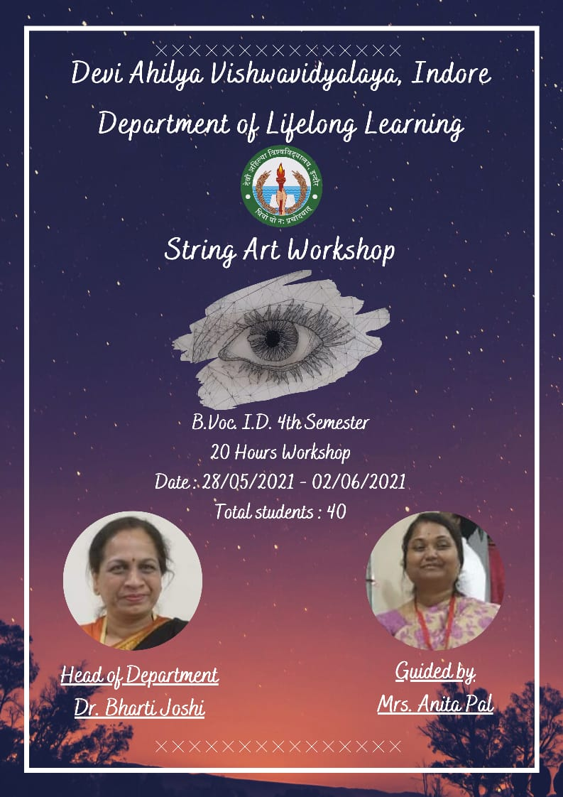

Flyer no. 2

