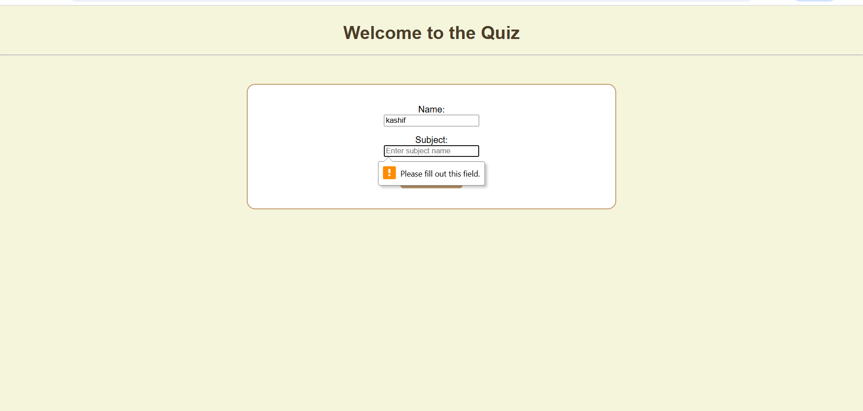
When you do leave any input field empty.and I am using html and css.
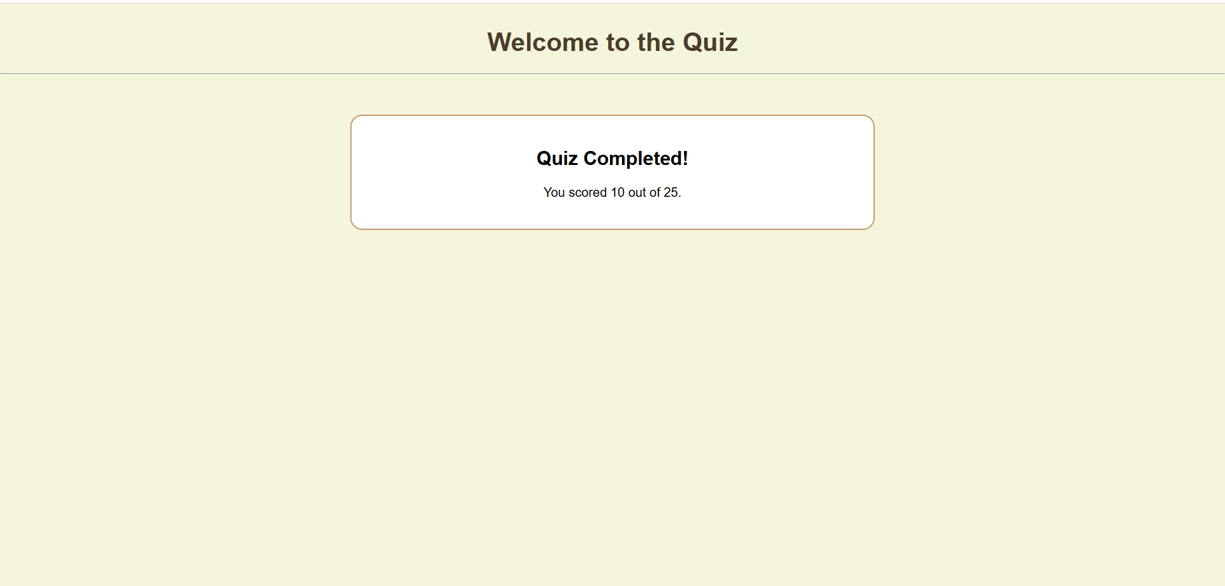
Every feature is working .
CODE:
<!DOCTYPE html>
<html lang="en">
<head>
<meta charset="UTF-8">
<meta name="viewport" content="width=device-width, initial-scale=1.0">
<title>Quiz App</title>
<style>
body {
font-family: Arial, Helvetica, sans-serif;
background-color: #F5F5DC;
margin: 0;
padding: 0;
}

h1 {
text-align: center;
margin-top: 30px;
color: #4b3d2a;
}

.container {
width: 40%;
background-color: white;
border: 2px solid #C19A6B;
border-radius: 15px;
margin: 50px auto;
padding: 20px;
text-align: center;
}

.innerbox {
margin: 15px 0;
}

button {
background-color: #C19A6B;
color: white;
border: none;
padding: 10px 15px;
border-radius: 5px;
cursor: pointer;
font-size: 18px;
}

button:hover {
background-color: #a67b5b;
}

.question-box {
display: none;
}

.timer {
font-weight: bold;
margin-bottom: 10px;
color: darkred;
}

.feedback {
font-weight: bold;
margin-top: 10px;
}
</style>
</head>
<body>
<h1>Welcome to the Quiz</h1>
<hr>

<div class="container" id="form-container">
<form id="quizForm">
<div class="innerbox">
<label for="name">Name:</label><br>
<input type="text" id="name" placeholder="Enter your full name" required>
</div>

<div class="innerbox">
<label for="subject">Subject:</label><br>
<input type="text" id="subject" placeholder="Enter subject name" required>
</div>

<button type="submit">Start Quiz</button>
<p id="formMsg" style="color:red; font-weight:bold;"></p>
</form>
</div>

<div class="container question-box" id="quiz-container">
<div id="timers">
<p>Question Timer: <span id="questionTimer">10</span>s</p>
<p>Total Timer: <span id="totalTimer">50</span>s</p>
</div>

<div id="question-text"></div>
<div id="options"></div>
<div class="feedback" id="feedback"></div>
</div>

<div class="container question-box" id="result-container">
<h2>Quiz Completed!</h2>
<p id="result"></p>
</div>

<script>
const quizForm = document.getElementById("quizForm");
const formMsg = document.getElementById("formMsg");
const formContainer = document.getElementById("form-container");
const quizContainer = document.getElementById("quiz-container");
const resultContainer = document.getElementById("result-container");

const questionText = document.getElementById("question-text");
const optionsDiv = document.getElementById("options");
const feedbackDiv = document.getElementById("feedback");

const questionTimerEl = document.getElementById("questionTimer");
const totalTimerEl = document.getElementById("totalTimer");
const resultEl = document.getElementById("result");

const questions = [
{ q: "What does HTML stand for?", options: ["HyperText Markup Language", "Home Tool Markup", "Hyperlinks Markup Language", "Hyper Tag Making Language"], answer: 0 },
{ q: "Which CSS property changes text color?", options: ["font-color", "text-color", "color", "text-style"], answer: 2 },
{ q: "What keyword declares a variable in JavaScript?", options: ["var", "variable", "v", "letvar"], answer: 0 },
{ q: "What is the extension for JavaScript files?", options: [".js", ".java", ".py", ".txt"], answer: 0 },
{ q: "Which tag is used to link CSS in HTML?", options: ["<link>", "<style>", "<css>", "<src>"], answer: 0 }
];

let score = 0;
let currentQuestion = 0;
let questionTimer = 10;
let totalTimer = 50;
let qInterval, totalInterval;

quizForm.addEventListener("submit", (e) => {
e.preventDefault();
const name = document.getElementById("name").value.trim();
const subject = document.getElementById("subject").value.trim();

if (name === "" || subject === "") {
formMsg.textContent = "Please fill all fields before starting.";
return;
}

formContainer.style.display = "none";
quizContainer.style.display = "block";
startQuiz();
});

function startQuiz() {
startTotalTimer();
showQuestion();
}

function startTotalTimer() {
totalInterval = setInterval(() => {
totalTimer--;
totalTimerEl.textContent = totalTimer;
if (totalTimer <= 0) {
clearInterval(totalInterval);
endQuiz();
}
}, 1000);
}

function showQuestion() {
if (currentQuestion >= questions.length) {
endQuiz();
return;
}

let q = questions[currentQuestion];
questionText.textContent = `${currentQuestion + 1}. ${q.q}`;
optionsDiv.innerHTML = "";
feedbackDiv.textContent = "";
questionTimer = 10;
questionTimerEl.textContent = questionTimer;

q.options.forEach((opt, i) => {
const btn = document.createElement("button");
btn.textContent = opt;
btn.style.display = "block";
btn.style.margin = "5px auto";
btn.onclick = () => checkAnswer(i);
optionsDiv.appendChild(btn);
});

qInterval = setInterval(() => {
questionTimer--;
questionTimerEl.textContent = questionTimer;
if (questionTimer <= 0) {
clearInterval(qInterval);
feedbackDiv.textContent = "Time out! Question skipped.";
nextQuestion();
}
}, 1000);
}

function checkAnswer(selected) {
clearInterval(qInterval);
let correct = questions[currentQuestion].answer;
if (selected === correct) {
score += 5;
feedbackDiv.textContent = "Correct!";
} else {
feedbackDiv.textContent = "Incorrect!";
}
setTimeout(nextQuestion, 1000);
}

function nextQuestion() {
currentQuestion++;
showQuestion();
}

function endQuiz() {
clearInterval(totalInterval);
quizContainer.style.display = "none";
resultContainer.style.display = "block";
resultEl.textContent = `You scored ${score} out of 25.`;
}
</script>
</body>
</html>

