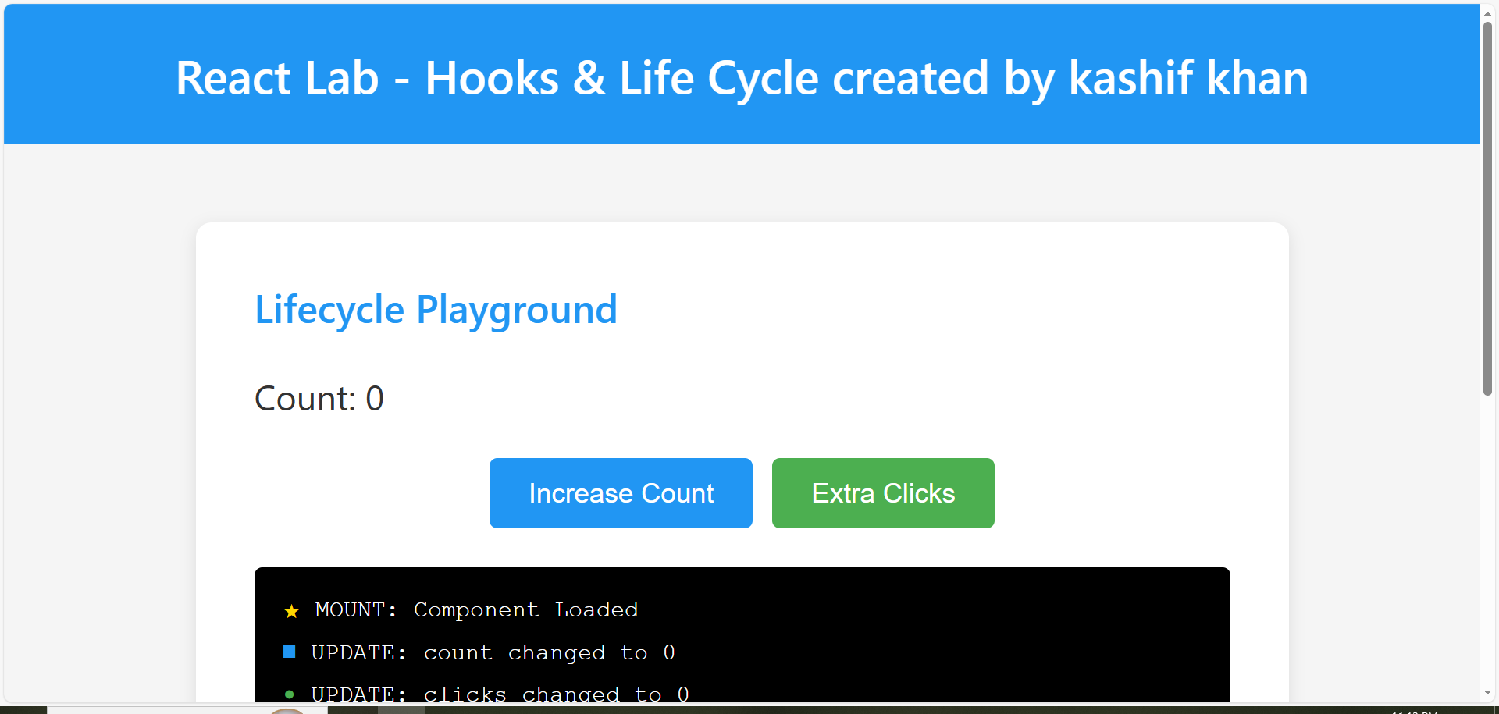
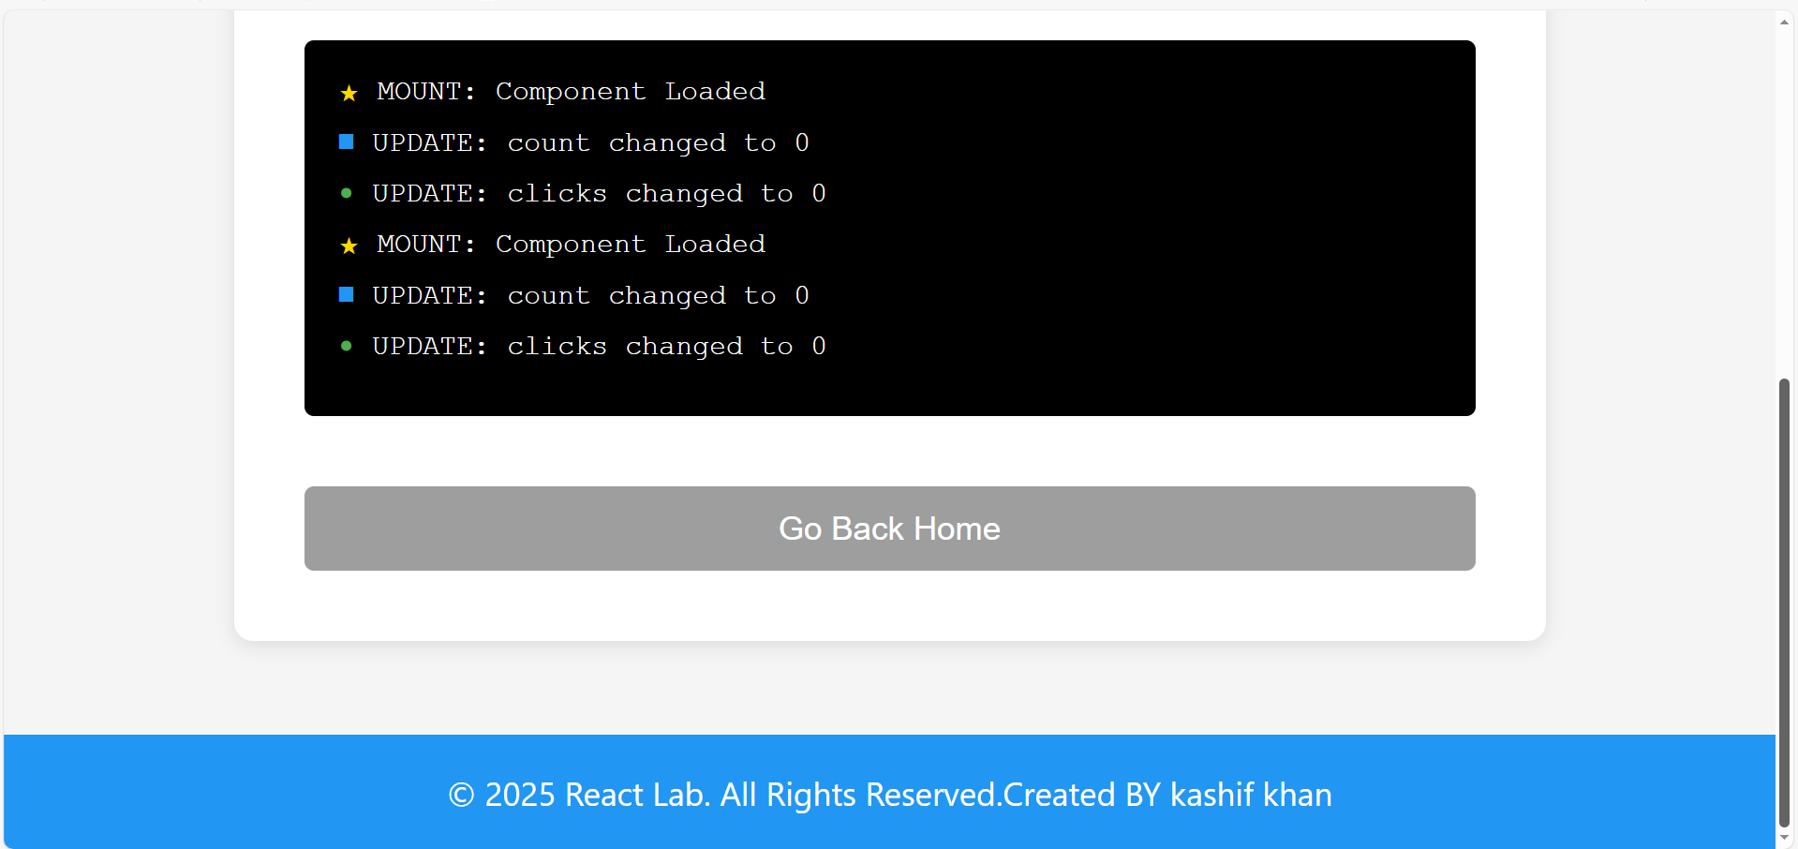

- Now lets increase count and also extra clicks
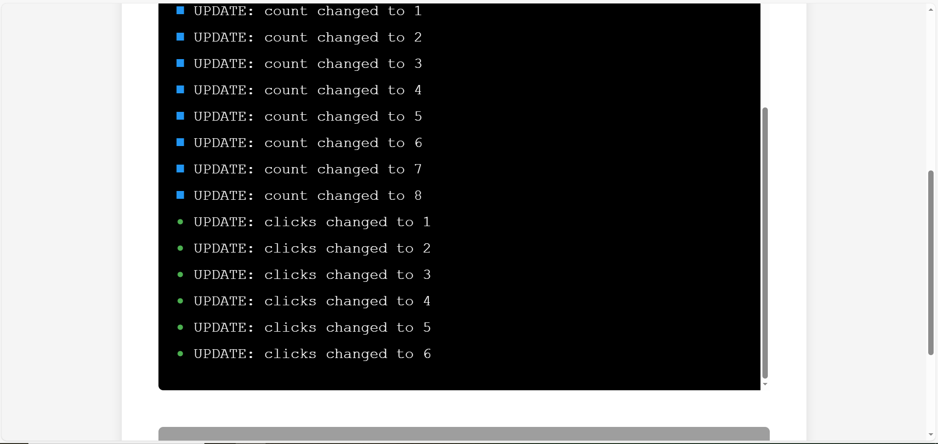
analysis:
The useState hook manages component state (count and clicks), enabling dynamic UI updates when values change. The useEffect hook handles side effects at different lifecycle stages: an empty dependency array [] runs code once on component mount, dependency arrays like [count] trigger effects when specific values change, and cleanup functions (returned from useEffect) execute when components unmount. Multiple state variables can be tracked independently, each with their own effects, showing how React's functional component pattern replaces class component lifecycle methods. The dependency array is crucial—it controls when effects run, preventing infinite loops while ensuring effects respond to the right state changes.

