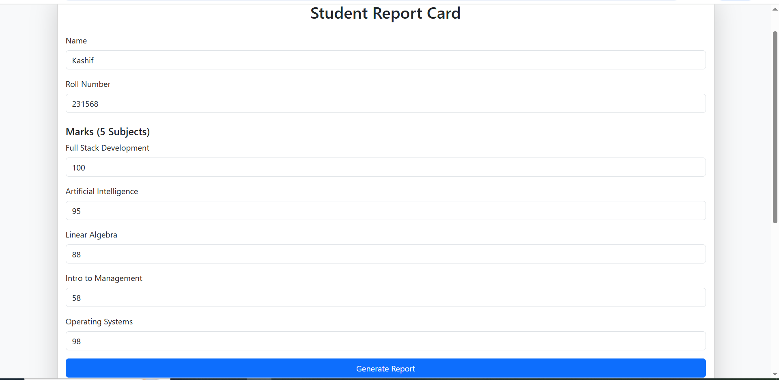

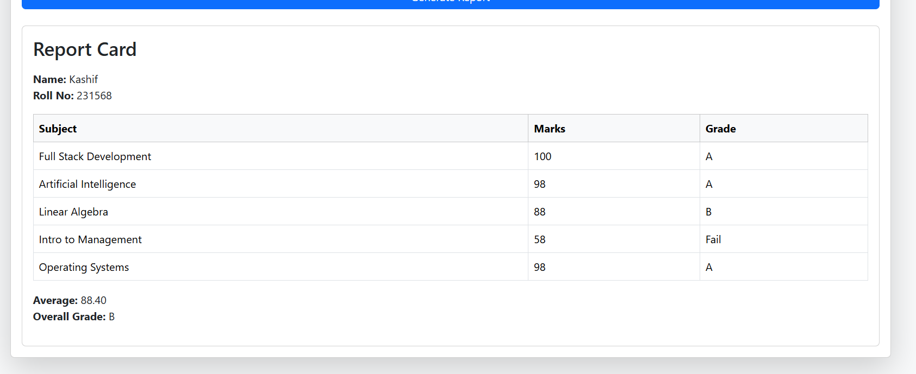

**CODE:**

<!DOCTYPE html>

<html lang="en">

<head>

<meta charset="UTF-8">

<meta name="viewport" content="width=device-width, initial-scale=1.0">

<title>Student Report Card</title>

<link href="https://cdn.jsdelivr.net/npm/bootstrap@5.3.3/dist/css/bootstrap.min.css" rel="stylesheet">

</head>

<body class="bg-light">

<div class="container my-5">

<div class="card shadow-lg">

<div class="card-body">

<h2 class="text-center mb-4">Student Report Card</h2>

<form onsubmit="event.preventDefault(); displayCard();">

<div class="mb-3">

<label class="form-label">Name</label>

<input type="text" class="form-control" id="name" required>

</div>

<div class="mb-3">

<label class="form-label">Roll Number</label>

<input type="number" class="form-control" id="roll" required>

</div>

<h5 class="mt-4">Marks (5 Subjects)</h5>

<div class="mb-3">

<label class="form-label">Full Stack Development</label>

<input type="number" class="form-control" id="fsd">

</div>

<div class="mb-3">

<label class="form-label">Artificial Intelligence</label>

<input type="number" class="form-control" id="ai">

</div>

<div class="mb-3">

<label class="form-label">Linear Algebra</label>

<input type="number" class="form-control" id="la">

</div>

<div class="mb-3">

<label class="form-label">Intro to Management</label>

<input type="number" class="form-control" id="im">

</div>

<div class="mb-3">

<label class="form-label">Operating Systems</label>

<input type="number" class="form-control" id="os">

</div>

<button type="submit" class="btn btn-primary w-100">Generate Report</button>

</form>

<div id="report" class="mt-4"></div>

</div>

</div>

</div>

<script>

const subjects = {

fsd: "Full Stack Development",

ai: "Artificial Intelligence",

la: "Linear Algebra",

im: "Intro to Management",

os: "Operating Systems"

};

const assignGrade = (marks) => {

if (marks >= 90) return "A";

else if (marks >= 75) return "B";

else if (marks >= 60) return "C";

else return "Fail";

};

const calculate_avg = (marksArr) => {

let sum = 0;

marksArr.forEach(m => sum += m);

return sum / marksArr.length;

};

function displayCard() {

const name = document.getElementById("name").value;

const roll = document.getElementById("roll").value;

let marksArr = [];

let details = [];

for (let id in subjects) {

let marks = parseInt(document.getElementById(id).value) || 0;

marksArr.push(marks);

details.push({

subject: subjects[id],

marks: marks,

grade: assignGrade(marks)

});

}

let avg = calculate_avg(marksArr);

let overallGrade = assignGrade(avg);

const student = {

name: name,

roll: roll,

marks: marksArr,

average: avg,

grade: overallGrade

};

console.log("Student Object:", student);

let table = `

<div class="card mt-3">

<div class="card-body">

<h3 class="mb-3">Report Card</h3>

<p><b>Name:</b> ${student.name} <br> <b>Roll No:</b> ${student.roll}</p>

<table class="table table-bordered">

<thead class="table-light">

<tr><th>Subject</th><th>Marks</th><th>Grade</th></tr>

</thead>

<tbody>`;

details.forEach(d => {

table += `<tr>

<td>${d.subject}</td>

<td>${d.marks}</td>

<td>${d.grade}</td>

</tr>`;

});

table += `</tbody></table>

<p><b>Average:</b> ${student.average.toFixed(2)} <br>

<b>Overall Grade:</b> ${student.grade}</p>

</div>

</div>`;

document.getElementById("report").innerHTML = table;

}

</script>

</body>

</html>