Methodology

The Framework of this project uses the CNN models which are trained on ImageNet dataset and applies CAM visualization techniques such as Grad-CAM, Grad-CAM++, Eigen-CAM, and XGrad-CAM. to visualize important regions in the input image.
Framework overview
After installing all the necessary modules for this project, the framework consists of five sections:
- Importing Modules:
In this section all the necessary modules are imported which include Pytorch, numpy, requests, warnings, PIL and matplotlib. Apart from these modules we also imported the GitHub repository by Jacob gill named ‘’pytorch_grad_cam’’
Using this repository all the CAM visualization techniques such as Grad-CAM, Grad-CAM++, Eigen-CAM, and XGrad-CAM are also imported.

- Defining Functions:
In this section three necessary functions which are used in the whole framework are defined which include:
- image_transform function: This function takes an image URL as input. It opens the image from the provided URL, resizes it, and converts it into an input tensor according to data preprocessing which is suitable for model prediction.
- Predict_and_get_target_class function: This function takes a pre-trained model and an input image tensor as inputs. It uses the input tensor to make predictions with the model and saves the label index number of the highest scoring prediction. The function then uses this label index number to determine the corresponding label name from the ImageNet dataset, which contains 1000 classes. Finally, the function returns both the label index number and the label name as outputs.
- Get_conv_layer function: This function takes a pre-trained model as input and counts the number of convolutional layers in the model. It then prompts the user to specify which layer they want to visualize. The function returns the user's selected layer for further processing.
- Importing image and model:
In this section, a pre-trained CNN model (e.g. densenet121 or Resnet18) is selected for its performance on image classification task. Image URL is defined, and all the functions are used to get the image and input tensor form the image URL, model prediction, and layer number from the model are also stored in respective variables.
- CAM visualization techniques:
This section uses visualization techniques such as Grad-CAM, Grad-CAM++, Eigen-CAM, and XGrad-CAM. When applied each technique takes the model and layer number as input and generate a heat map which highlights the regions in the image that contribute most to the target class prediction.

- Visualization:
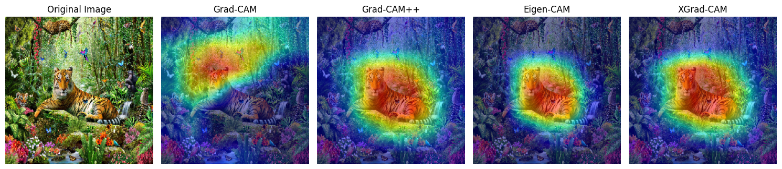
In this section the heat maps from the each CAM technique are masked on the image as shown below:
Fig. visualization of model prediction
Data preparation
The data utilized in this project is publicly available. Images from Google are used for classification tasks. These images were retrieved through google search and used to demonstrate explainability techniques. The URL of the image was copied and loaded into NumPy array by first using the ‘’requests’’ library to retrieve the image data and the image is opened with ‘’Image.open’’ method from PIL library and subsequently converting it in NumPy array.
The image is then resized to 224x224 pixels using the ‘’cv2.resize’ function from the OpenCV library. The image is then normalized by converting it into float32 NumPy array and the pixel values are scaled into the range of [0,1]. After this the image is preprocessed using ‘’preprocess_image’’ function form Jacobs gills github reprository pytorch_grad_cam.utils.image which standardizes the image into a tensor with mean of [0.485, 0.456, 0.406] and standard deviation of [0.229, 0.224, 0.225] to match the expected input format of pretrained models. The values used for mean and standard deviation are used for all models which are trained on ImageNet dataset.
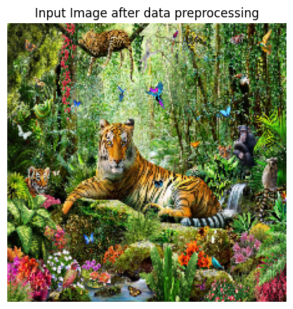
So, we processed raw URL of an image into the input tensor which is then fed to the model to make prediction and retrieve the label only for Grad-cam visualization.
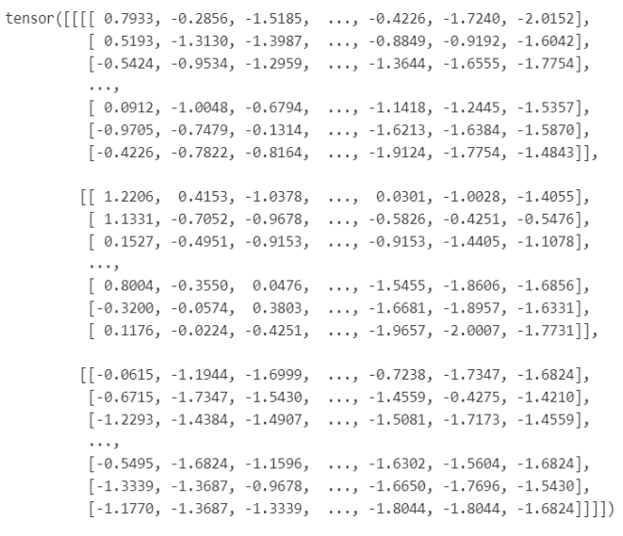

Fig a) input tensor from of URL image after preprocessing b) input image after preprocessing

Evaluation Metrics
The effectiveness of the visualizations created by the framework is evaluated by looking at how well they highlight the important areas in the input image that influence the model's prediction. Each visualization is checked to see how clear, easy to understand, and relevant it is. By examining these visualizations, we can see which parts of the image are most important for the model's decisions.

Future scope
In the future the project can be improved in various areas to overcome some of the problems which we faced during our work. Below are the detailed suggestions:
- Improved image preprocessing for diverse models:
Currently our framework only preprocesses the image according to ImageNet dataset standards therefore limiting our model selection range.
To overcome this limitation an automated preprocessing adjustment should be implemented that detects the models input data shape and type required and adjusts the preprocessing steps accordingly.
- Expanding Explainable AI to NLP:

The current work focuses on image classification CNN model but this can be expanded to NLP models. These techniques can be applied to NLP models to highlight the words and phrases which influence model’s predictions.

- Framework for multi-layer sequence highlighting:
The current framework is designed to work with the single layer at a time which limits its depth of interpretability, but it can be enhanced such that the framework should be able to handle sequence of layers to provide comprehensive understanding of model’s decision making process.
By adding these features to the framework, it will become more robust, versatile and it will support wider range of models making it a powerful tool for enhancing the transparency and trustworthiness of AI systems

Summary
This study was focused on class activation mappings (CAM) to show the transparency and interpretability of AI systems involving convolutional neural networks. The key findings in this study are.
- All the visualization methods surpass each other in different criteria’s such as localization accuracy, clarity and interpretability of the heatmaps.
- Grad- CAM provides a good balance of performance and interpretability but sometime is less precise and produces noisy heatmaps
- Grad-CAM++ shows good performance involving multiple objects and generally provides better localization and sharper heatmaps than Grad-CAM.
- Eigen-CAM shows those features which the network deems important without constraining itself to a particular class.
- XGrad-CAM provides more precise visualization compared to standard Grad-CAM. However, the results suggest that it might not always outperform Grad-CAM.
In conclusion if our primary goal is to obtain the most precise and interpretable heatmap Grad-CAM ++ is often considered the better choice than Grad-CAM. However, our localization is not tied to specific class Eigen-CAM is better choice than the rest.

Results and discussions
The class activation mapping (CAM) techniques were implemented on various pre-trained models, including DenseNet121, ResNet18, and VGG, each with a different number of convolutional layers. For analysis, the mappings were examined with ddifferent layer numbers: the first, middle, and last convolutional layers of each model. The CAM techniques were applied to a diverse set of images, including both single-label and multi-label images, to evaluate the consistency and robustness of the explanations provided by these models.
The following heatmaps were obtained from each model.
- Densnet121: Densnet Model gas 120 convolutional layers.
    - First Layer (1):
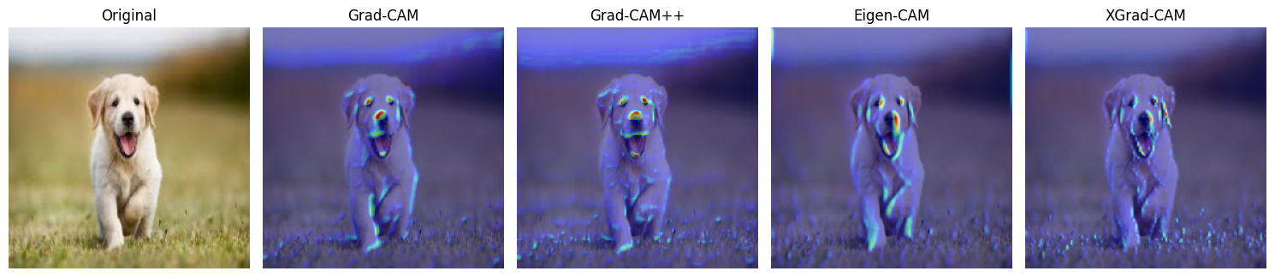

    - Middle layer (layer number 60):
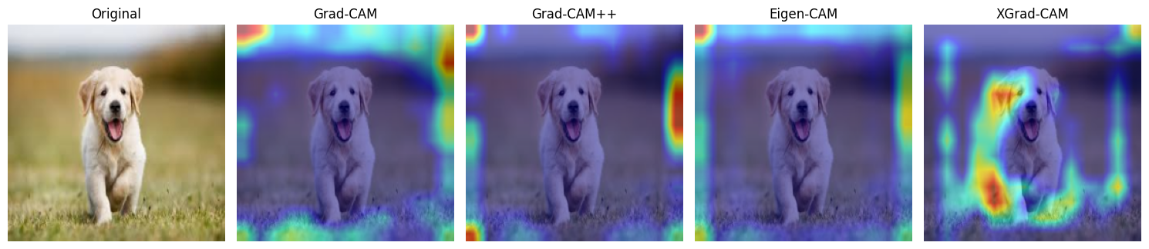

    - Last Layer (layer number 120):
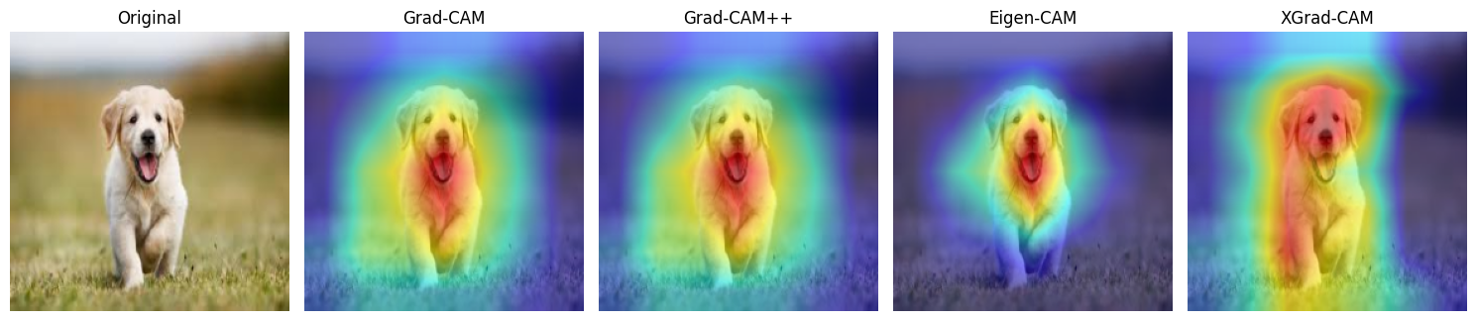

- Resnet18; resnet model has

