Instruction Document
- Introduction
Welcome to the Event Registration System. This document will guide you through using our web application for managing event registrations.
- Registration Form
To register for an event please enter the following details in respective locations:
- Event Name.
- Event Date.

- Organizer's Name.
- Capacity.

- Email Address.

- After filling in all the details press ‘Add registration button’ to register for an event.

Note: please ensure all fields are filled out correctly to proceed.

- Event Registrations Table
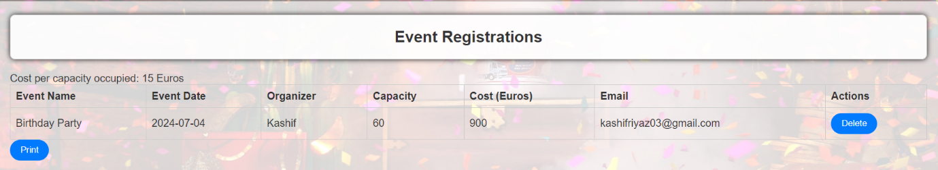
The table displays all registered events:
- View event details such as Event Name, Event Date, Organizer, Capacity, Cost, and Email.
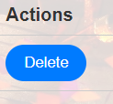
- Use the Delete button to remove registrations as needed.

- Click the Print button to print the table for reference.


- Statistics Section
The Statistics section provides insights into registered events:
- Total Events: Number of events currently registered.
- Average Cost: Average cost per event based on capacity.


