**NEXTTAG**

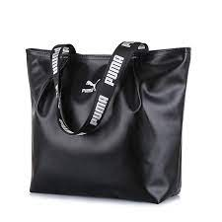 **PUMA**

# **PUMA Women's Evercat Jane Tote**

* Zipper closure
* Interior drop-in pocket
* Zippered main compartment
* Quick access pocket
* Reinforced base panels

# **Rs;23,000**