**NEXTTAG**

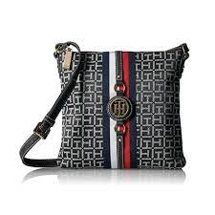 **TOMMY HILFIGER**

# **Tommy Hilfiger Women's Jaden Crossbody Bag**

* Crossbody bags for women featuring the Tommy Hilfiger women signature flag stripe and gold TH hardware.
* Adjustable crossbody strap with gold hardware details. Top zip closure.
* Lined nylon interior with wall zip pocket and slip pocket.
* This Tommy Hilfiger bag is a versatile essentital, the perfect crossbody bag for work or travel. Our timeless Tommy Hilfiger handbag is a stylish addition to your collection of crossbody handbags.
* 9-5/8" length; 9-1/4" height; 7/8" width; 23-1/2" drop.

# **Rs;19,000**