**NEXTTAG**

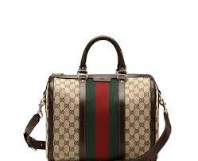 **GUCCI**

# **Ophidia medium GG tote**

Mirroring the material's historic origins, GG Supreme is introduced in a timeless mix of blue and beige for Gucci Love Parade. With a low environmental impact, the canvas has come to the front of each collection decade after decade to become a hallmark of the House. Here, the classic palette defines this medium-sized Ophidia tote bag, completed by the Web stripe in red and blue.

# **Rs;21,000**