**NEXTTAG**

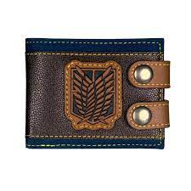 **TITAN**

# **men wallet**

Attack on Titan Fashionable high quality men's wallets designer women purse DFT1434

* BrandName：TUIDONGDIQIU
* MainMaterial：PU
* WalletLength：Short
* ItemWeight：61g
* LiningMaterial：Polyester
* ItemHeight：8.5cm
* MaterialComposition：pu
* PatternType：GEOMETRIC
* Style：Fashion
* ModelNumber：1434

# **Rs;9,000**