**NEXTTAG**

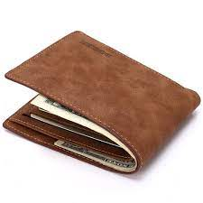

# **LEATHER WALLET**

With a low environmental impact, the canvas has come to the front of each collection decade after decade to become a hallmark of the House

* ItemWeight：61g
* LiningMaterial：Polyester
* ItemHeight：8.5cm
* MaterialComposition：pu
* PatternType：GEOMETRIC
* Style：Fashion

# **Rs;12,000**