**NEXTTAG**

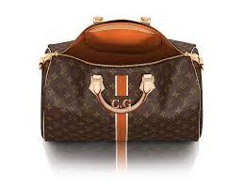**LOUIS VUITTON**

NEVERFULL MM

Part of the Monogram Empreinte line, this Neverfull MM tote bag is made from a bold mix of colored Monogram-embossed leathers. The supple cowhide leather and slim handles mean it’s comfortable to carry. The inside zipped pouch, in a different-colored Monogram Empreinte leather, can be removed and carried separately.

# **Rs;21,000**