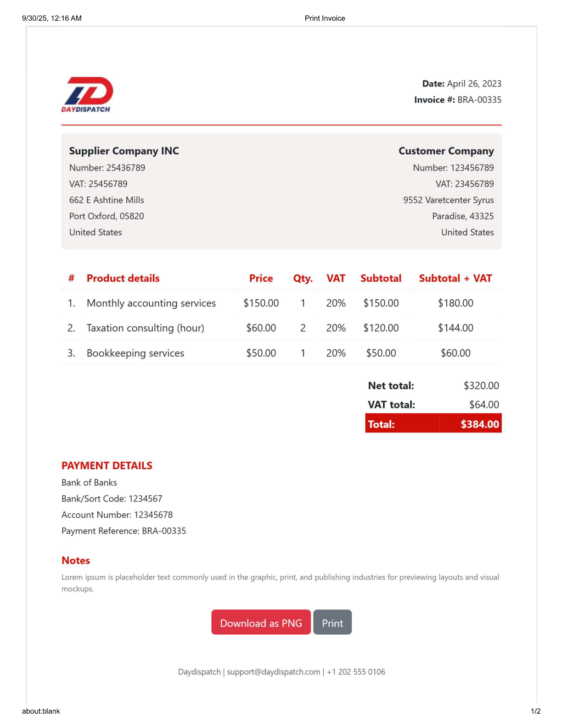
9/30/25,12:16 AM
Print Invoice
Date:April26,2023
Invoice#:BRA-00335
DAYDISPATCH
Supplier Company INC
Customer Company
Number:25436789
Number:123456789
VAT:25456789
VAT:23456789
662EAshtineMills
9552VaretcenterSyrus
Port Oxford,05820
Paradise,43325
UnitedStates
UnitedStates
#
Product details
Price
Qty.
VAT
Subtotal
Subtotal + VAT
1.
Monthlyaccountingservices
$150.00
1
20%
$150.00
$180.00
2.
Taxation consulting (hour)
$60.00
2
20%
$120.00
$144.00
3.
Bookkeepingservices
$50.00
1
20%
$50.00
$60.00
Net total:
$320.00
VAT total:
$64.00
Total:
$384.00
PAYMENTDETAILS
BankofBanks
Bank/SortCode:1234567
AccountNumber:12345678
Payment Reference:BRA-00335
Notes
mockups.
Download as PNG
Print
Daydispatch|support@daydispatch.com|+12025550106
about:blank
1/2


9/30/25, 12:16 AM
Print Invoice
about:blank
2/2

