VisionPlus CRM
User Reference Manual

Version 1.0 | June 2026

VisionPlus Technologies Pvt. Ltd.
visionplus.com.pk

Table of Contents
1. About This Manual
2. System Overview
3. Roles & Permissions
4. Getting Started
5. Dashboard
6. Lead Management
7. Lead Status Workflow & Locking
8. Lead Sources
9. Status Reasons (Close Reasons)
10. Follow-ups & Calendar
11. WhatsApp Messages
12. Reports
13. Employee Management
14. User Profile
15. System Flow Diagrams
16. Troubleshooting
17. Appendix A: Default Users
18. Appendix B: Lead Status Reference

1. About This Manual
This manual provides end-users with complete instructions for using the VisionPlus CRM system. It covers all features, workflows, and responsibilities for each user role.

Who Should Read This:
• Sales Officers — Lead management, follow-ups, messaging
• Managers — All Sales Officer features + Reports, Lead Sources
• Administrators — All features + Employee management, Status Reasons, system configuration

Conventions Used:
Bold text — UI elements (buttons, labels, menu items)
Blue text — URLs, file paths
⚠️ — Important note or warning

Support: Contact your System Administrator for login issues or bugs.

2. System Overview
VisionPlus CRM is a web-based sales pipeline management system that helps track leads through their complete lifecycle — from initial contact to closed won or lost.

Technology Stack:
• Frontend: React SPA (Single Page Application)
• Backend: .NET 10 Web API
• Database: PostgreSQL
• Messaging: WhatsApp integration via n8n

Access URLs:
Environment | URL
Production | https://crm.visionplusapps.com
Development | https://opencode.visionplusapps.com

System Architecture:
User (Browser) → Nginx (SSL) → React Frontend → .NET API → PostgreSQL | n8n → WhatsApp

3. Roles & Permissions
Role Definitions:
Role | Description
Administrator | Full system access. Manages users, lead sources, close reasons. Can modify closed leads.
Manager | All leads, reports, lead sources. Cannot modify closed leads.
Sales Officer | Own leads only. No reports, sources, or employee access.

Permission Matrix:
Feature | Admin | Manager | Sales Officer
Dashboard | ✅ All | ✅ All | Own only
Leads — View | All | All | Own only
Leads — Create | ✅ | ✅ | ✅
Leads — Edit | Any | Any | Own only
Leads — Delete | ✅ | ❌ | ❌
Status Change (open) | ✅ | ✅ | Own only
Status Change (closed) | ✅ | ❌ | ❌
Modify Closed Leads | ✅ | ❌ | ❌
Follow-ups | Any | Any | Own only
Lead Sources | CRUD | CRUD | ❌
Status Reasons | CRUD | ❌ | ❌
Reports | ✅ | ✅ | ❌
Employees | CRUD | ❌ | ❌
WhatsApp | Any | Any | Own only
Profile Edit | Self | Self | Self

4. Getting Started

Login to the System
1. Open your browser and go to https://crm.visionplusapps.com
2. You will see the login page with branding and login form
3. Enter your registered Email and Password
4. Click Sign In (or press Enter)

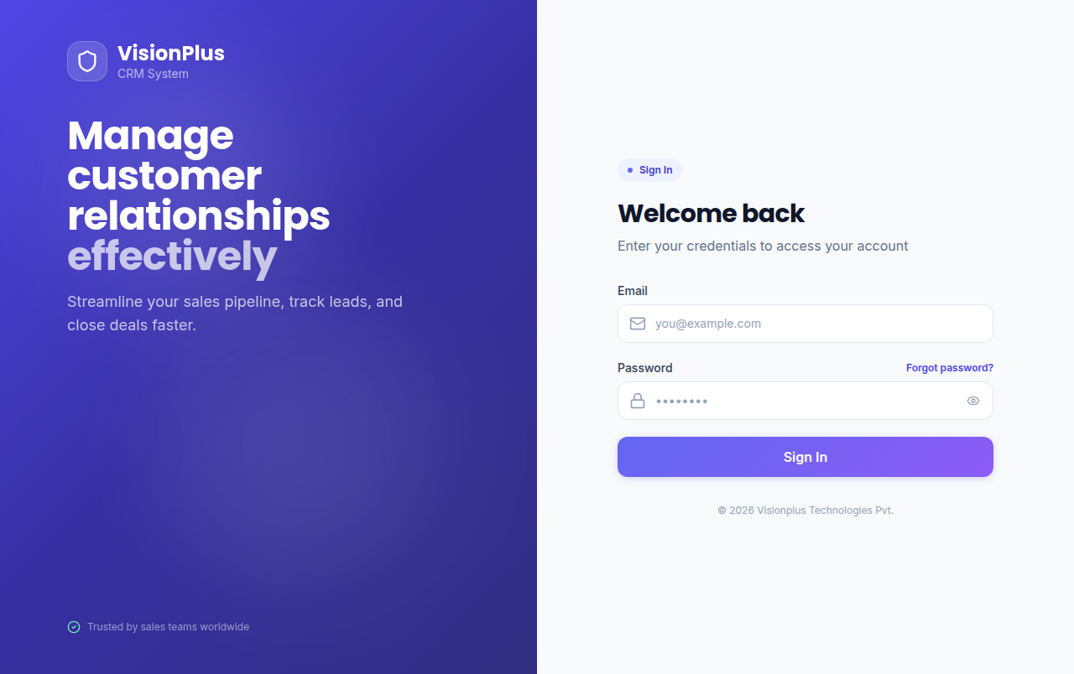
Figure 1: VisionPlus CRM Login Page

Navigation Overview:
After login, the interface has three parts:
1. Sidebar (left) — Main menu: Dashboard, Leads, Messages, Calendar, Reports, Administration
2. Page Header (top) — Breadcrumb, action buttons, user menu
3. Main Content Area — Active page content

Mobile: On screens < 992px, sidebar collapses. Tap hamburger (☰) to open.
Logout: Click your avatar in the sidebar footer → Logout.

5. Dashboard
Access: Click Dashboard in the sidebar. The dashboard provides a real-time overview of your sales pipeline.
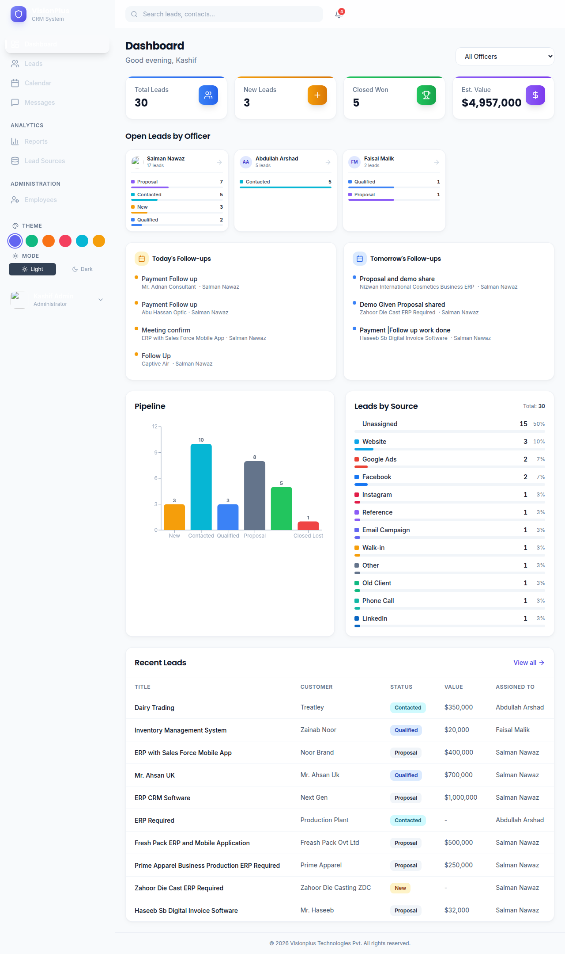
Figure 2: Dashboard with KPI cards, charts, and recent leads

KPI Cards (Top Row):
Card | Description
Total Leads | Count of all leads
New Leads | Leads with status New
Closed Won | Won deals
Estimated Value | Sum of estimated values

Follow-ups Section:
• Today's Pending (yellow) / Tomorrow's Pending (blue) — click any to open lead

Charts:
• Pipeline Bar Chart — Lead count by status, color-coded bars
• Source Doughnut Chart — Lead distribution by source

Recent Leads: Last 10 updated leads. Click to edit.
Manager/Admin: Sales Officer filter dropdown, Lead Distribution, Conversion, Quick Actions.

6. Lead Management

Lead List (Table View)
Access: Click Leads in the sidebar. The default view shows a sortable, filterable table.
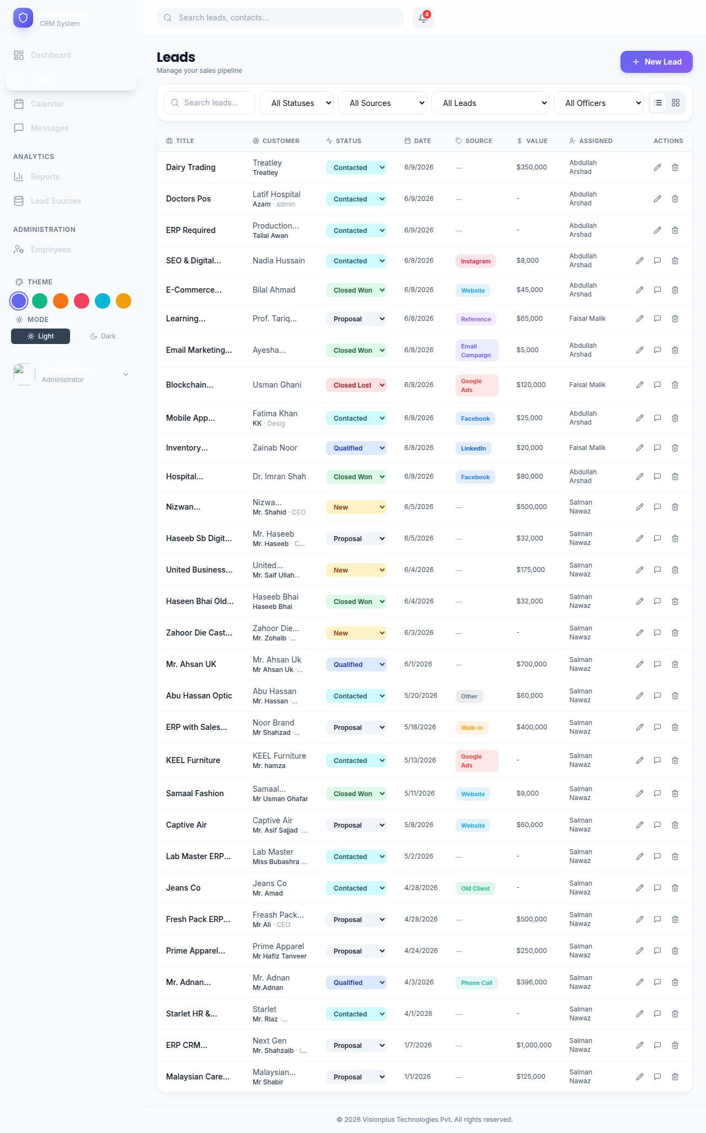
Figure 3: Leads list page with filters, table view, and status badges

Columns:
Column | Description
Title | Clickable link to edit page
Customer | Name + contact person
Status | Dropdown to change status (colored badge)
Date | Lead creation date
Source | Colored pill
Value | USD estimated value
Assigned | Sales Officer
Actions | Edit, WhatsApp, Delete (Admin only)

Filters:
Status, Source, Sales Officer (Mgr/Admin), Search, Win/Lost date range.

Kanban View
Toggle to Kanban using the grid/list button. Drag-and-drop columns: New → Contacted → Qualified → Proposal → Closed Won → Closed Lost.
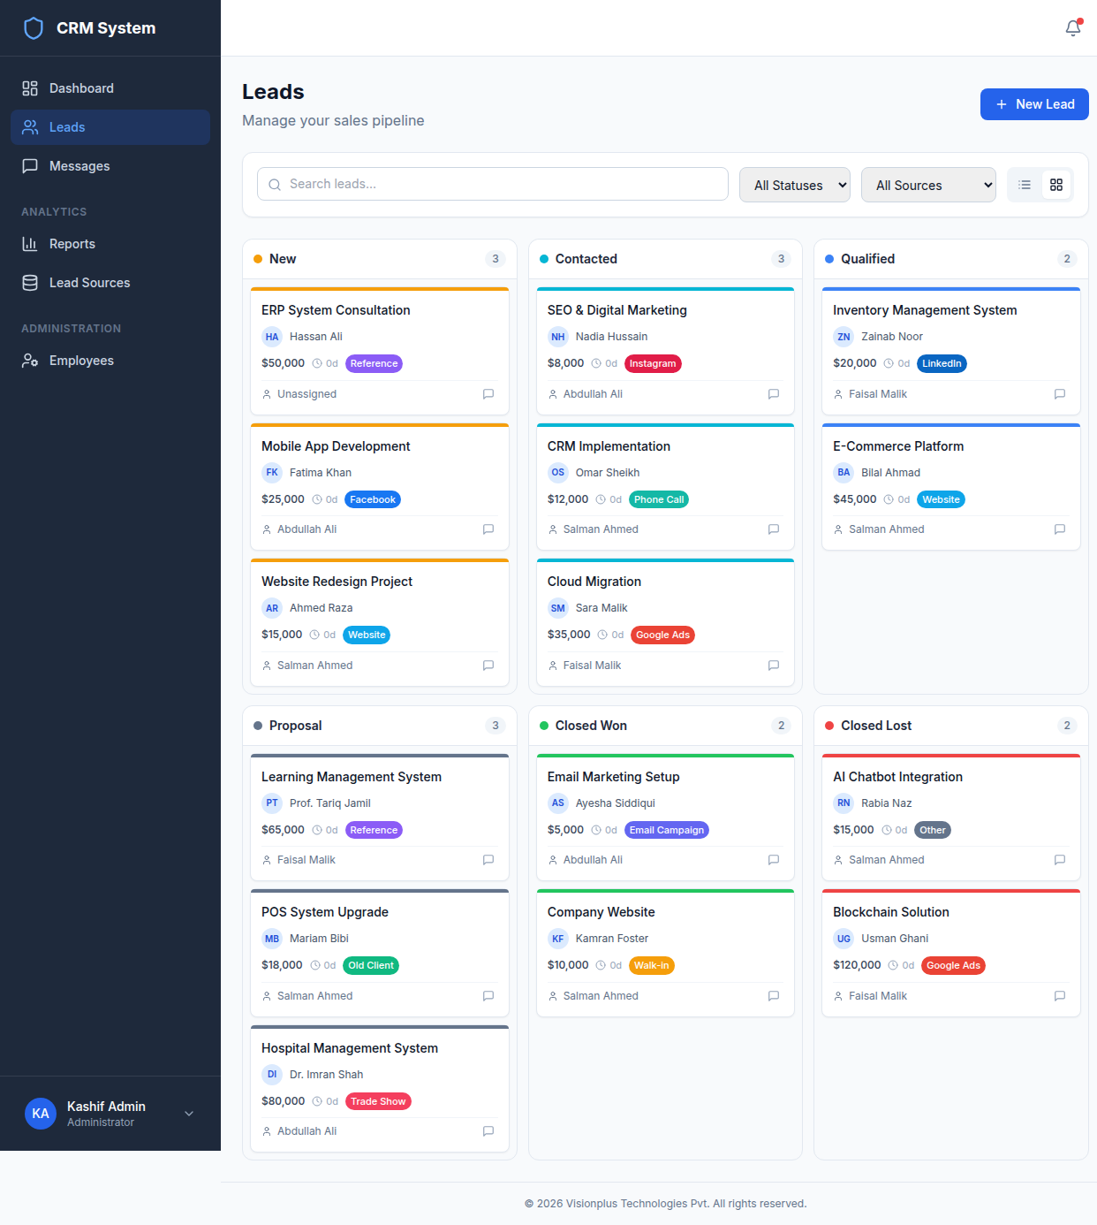
Figure 4: Kanban board with drag-and-drop pipeline columns

Create Lead
Click New Lead (top-right). Complete the form and click Create Lead.
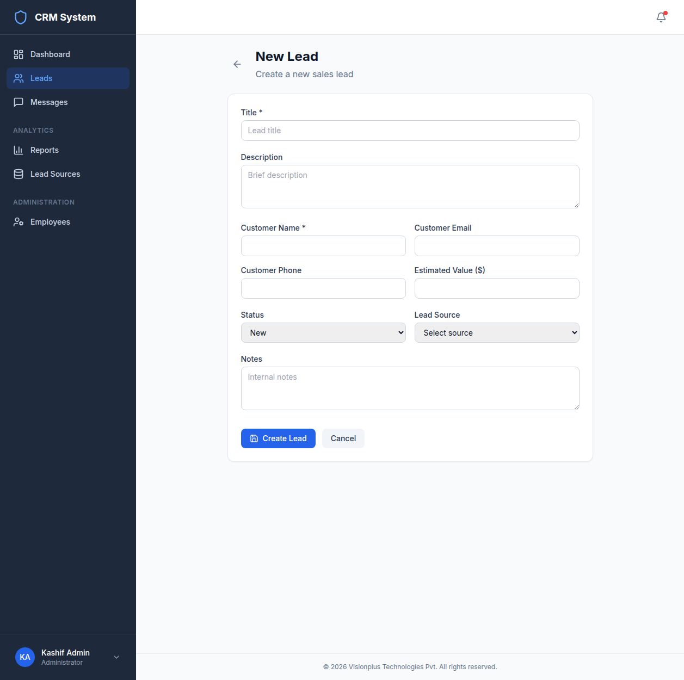
Figure 5: Lead creation form with all fields

Edit Lead
Click a lead title or Edit icon. The edit page has 3 tabs with full details.
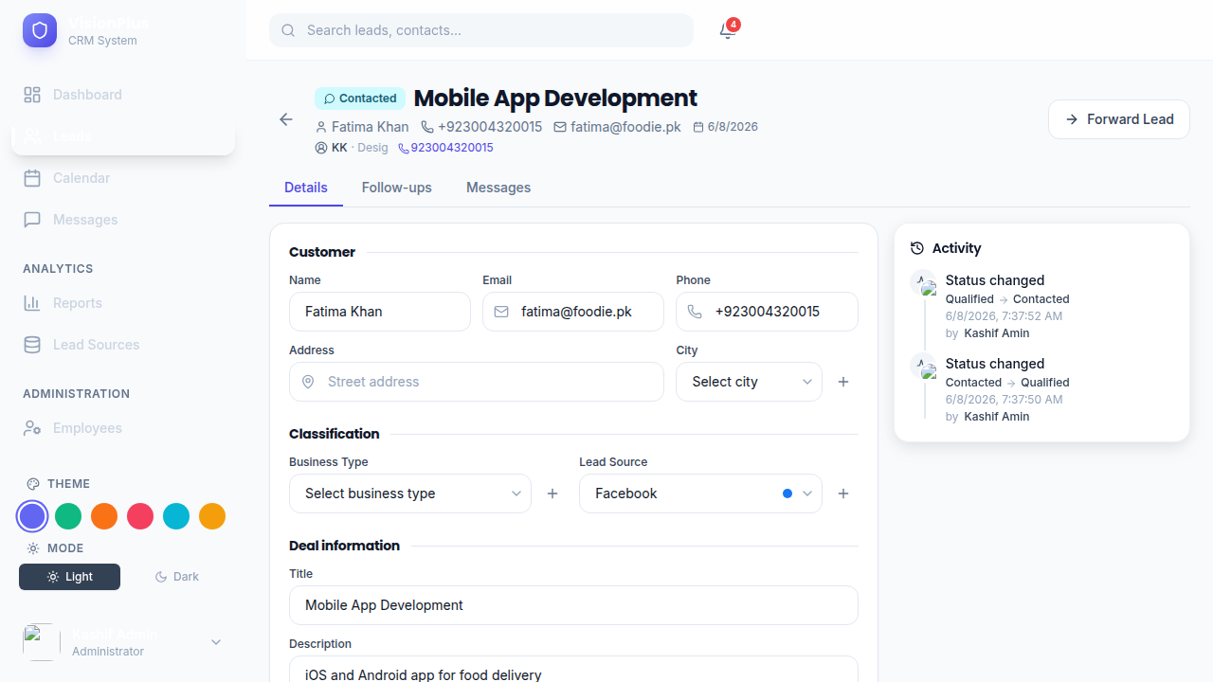
Figure 6: Lead edit page showing Details tab with activity timeline sidebar

7. Lead Status Workflow & Locking

Pipeline Stages
New (0) → Contacted (1) → Qualified (2) → Proposal (3) → Closed Won (4) or Closed Lost (5)

Changing Status
Method 1: Table dropdown • Method 2: Kanban drag • Method 3: Edit page dropdown

Closing a Lead (Won or Lost)
When moving to Closed Won/Lost, a modal appears:
1. Select Reason from dropdown
2. Enter Remark (minimum 10 characters)
3. Click Confirm (or Ctrl+Enter)
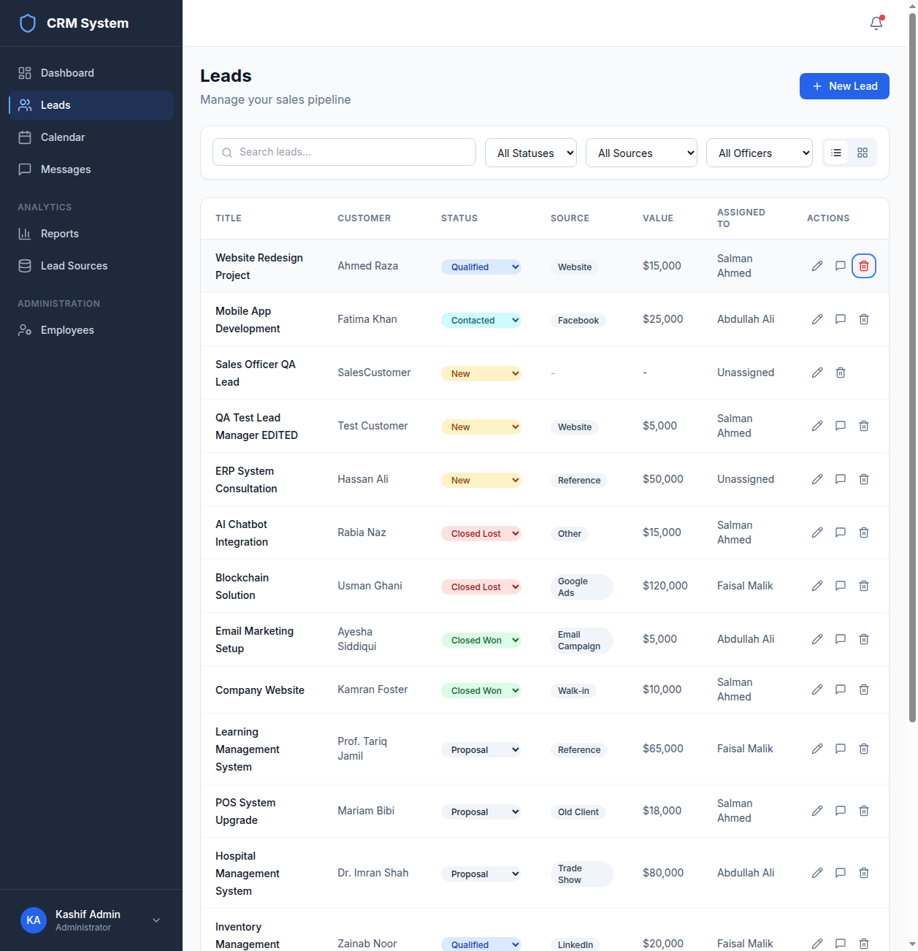
Figure 7: Status Change Modal — reason selection and remark entry

Important: Reason is required. Remark must be at least 10 characters.

Locked Lead Behavior
Once Closed Won or Closed Lost:
• Sales Officers / Managers: All fields disabled, status locked, no follow-ups/messages
• Lock banner: 'Only System Administrator can modify a closed lead'
• Kanban: Closed cards cannot be dragged
• Administrators: Full access — reopen, edit, change status, or delete

Activity Audit: Every status change is recorded with from→to status, reason, remark, performer, and timestamp.

8. Lead Sources
Access: Lead Sources in sidebar (Manager/Admin only). 12 default sources available.
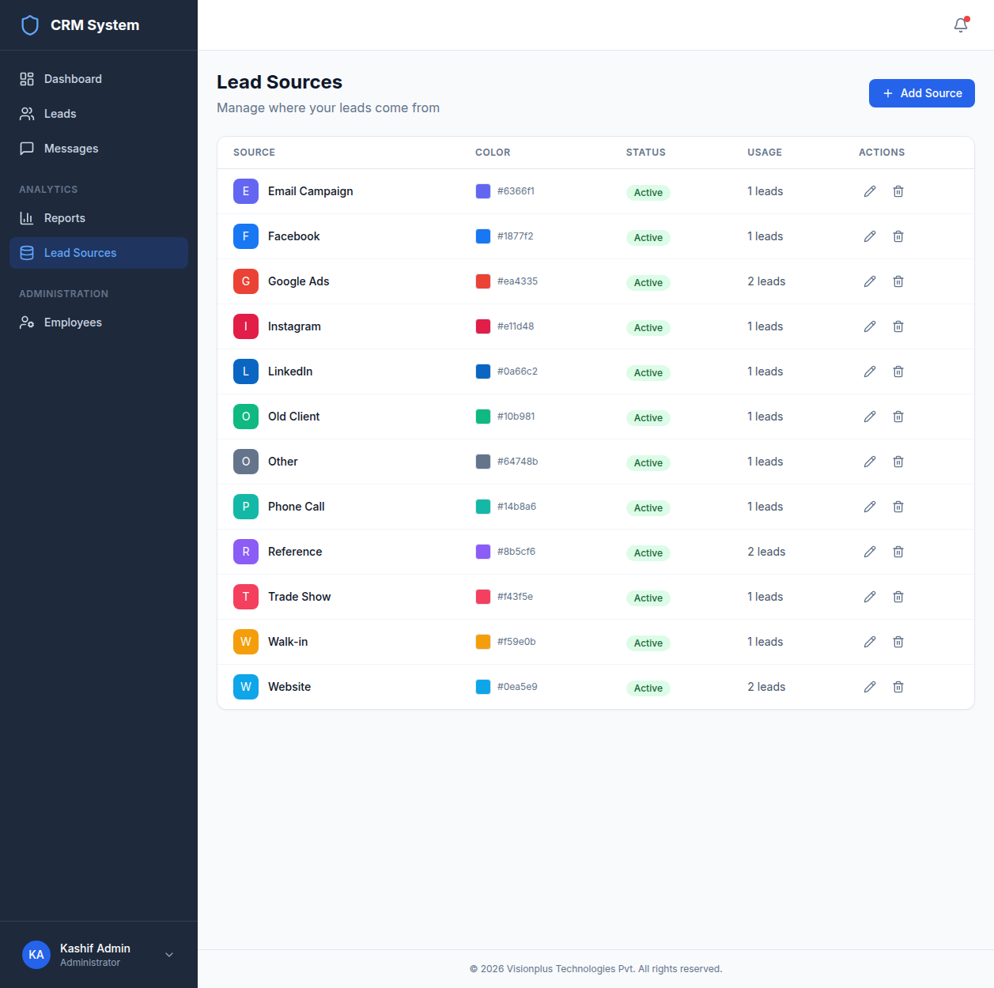
Figure 8: Lead Sources management page with CRUD operations

CRUD:
• Add: Name + Icon + Color → Save
• Edit: Modify fields → toggle Active → Save
• Delete: 0 leads = hard delete, 1+ leads = soft delete (IsActive=false)
• Inline Add: + button on Lead forms

9. Status Reasons (Close Reasons)
Access: Status Reasons in sidebar (Administrator only). Manages the dropdown reasons shown when closing leads as Won or Lost.

Default Closed Lost: Price too high, Chose competitor, No budget/timing, Product doesn't fit, Decision maker unavailable, Other

Default Closed Won: Good price/value, Best solution fit, Strong relationship, Quick implementation, Good reviews/referral, Other

CRUD: Add, Edit (toggle Active), Delete (only if unused), Reorder with drag handle.

10. Follow-ups & Calendar

Follow-ups
On Lead Edit → Follow-ups tab: Schedule with title, description, date/time. Timeline colors: Blue (future), Amber (today), Red (overdue), Green (completed).

Calendar View
Access: Calendar in sidebar. Month-grid of all follow-ups. Navigate with ◀/▶, today highlighted blue.
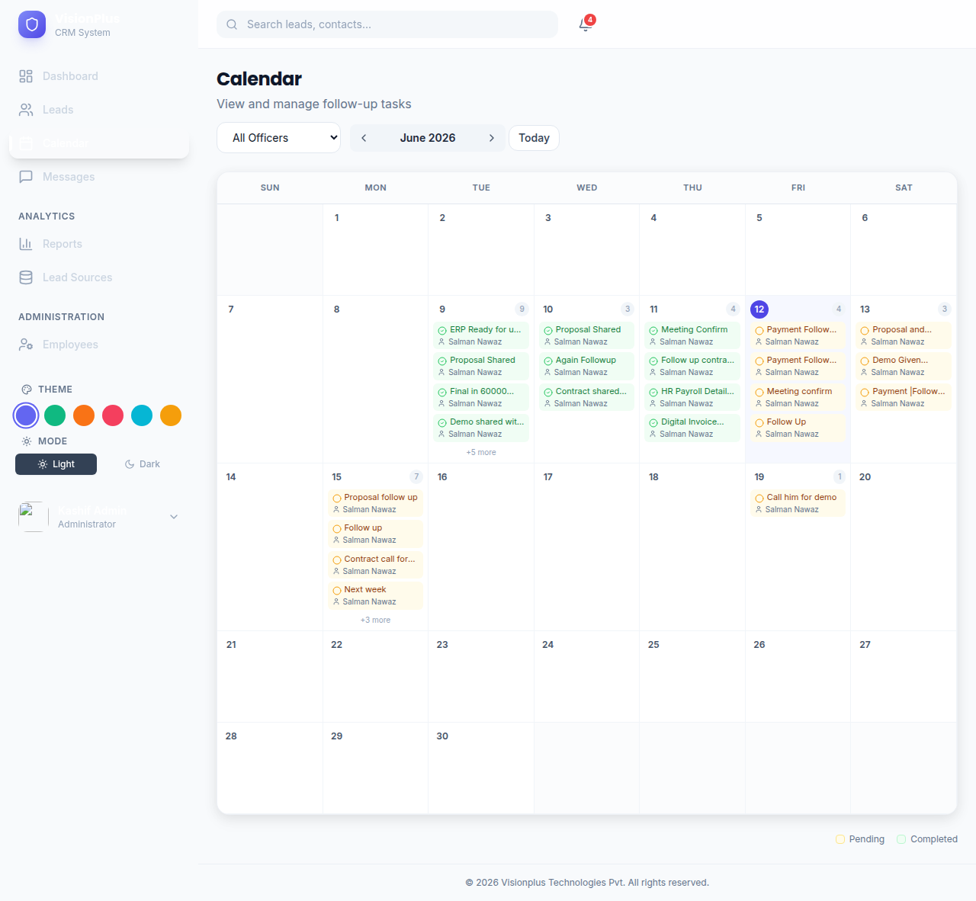
Figure 9: Calendar view showing follow-ups by date

Each day: up to 4 mini cards (amber=pending, green=completed), +N more. Click any card to open lead.
Manager/Admin: Filter by Sales Officer.

11. WhatsApp Messages
Sending: Open lead with phone → Messages tab → type → Send.
History: Shows all sent messages with status (Sent/ Failed), sender, timestamp.

Message Logs:
Central Messages page shows all messages across all leads. Admin/Manager see all. Sales Officer sees own only.

Closed Lead Restriction:
Non-admin users cannot send messages for closed leads.

12. Reports
Access: Reports in sidebar (Manager/Admin only).
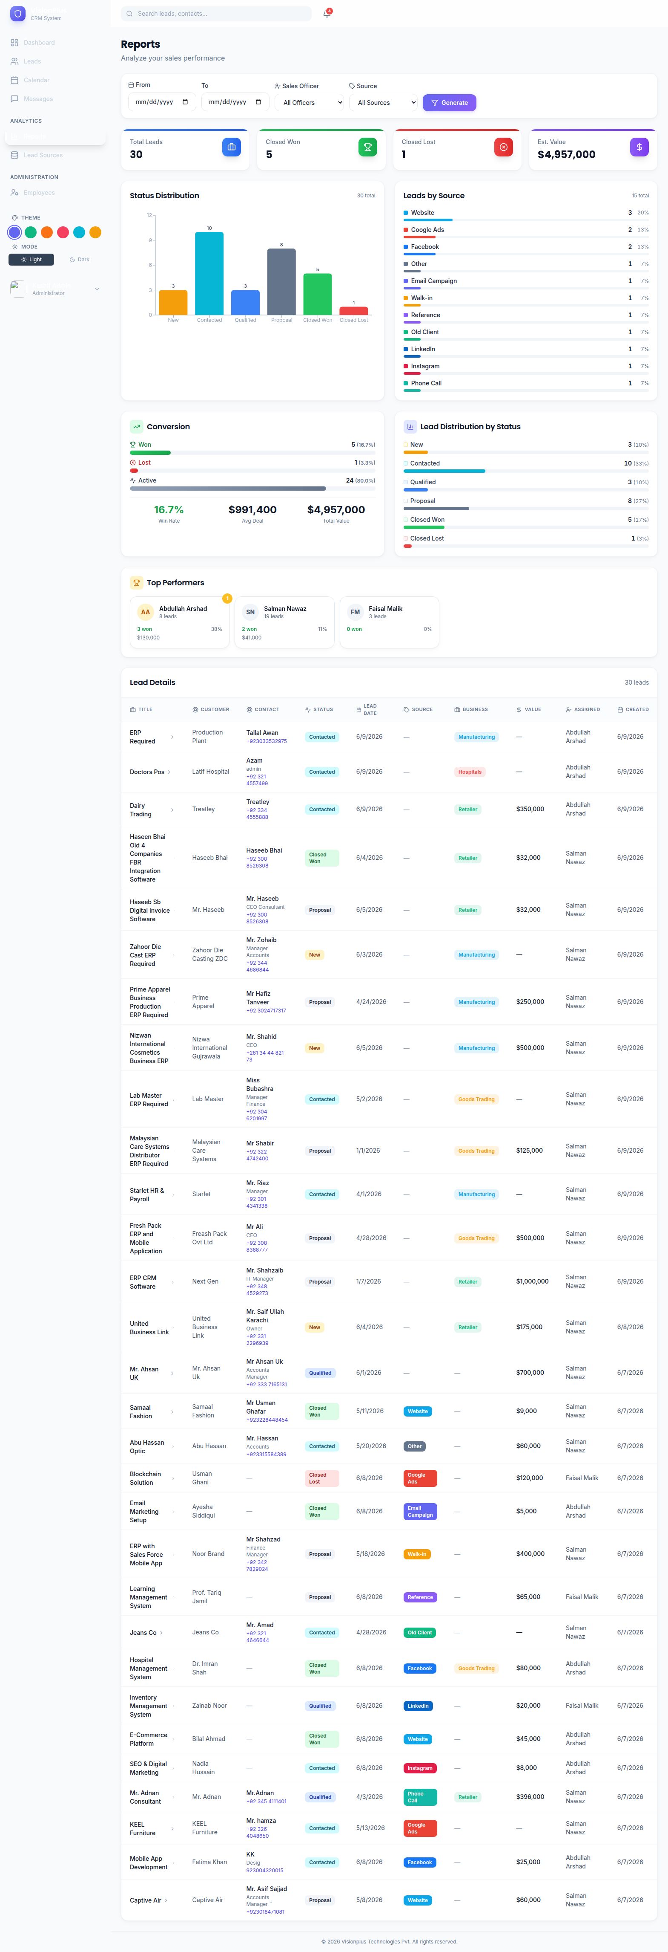
Figure 10: Reports page with filters, KPI cards, and charts

Filters: From/To Date, Sales Officer, Source → Generate.
8 KPI Cards: Total, New, Contacted, Qualified, Proposal, Won, Lost, Est. Value.
Charts: Status Distribution (bar), Conversion Breakdown (win rate), Source Breakdown (doughnut + table).

13. Employee Management
Access: Employees in sidebar (Administrator only).
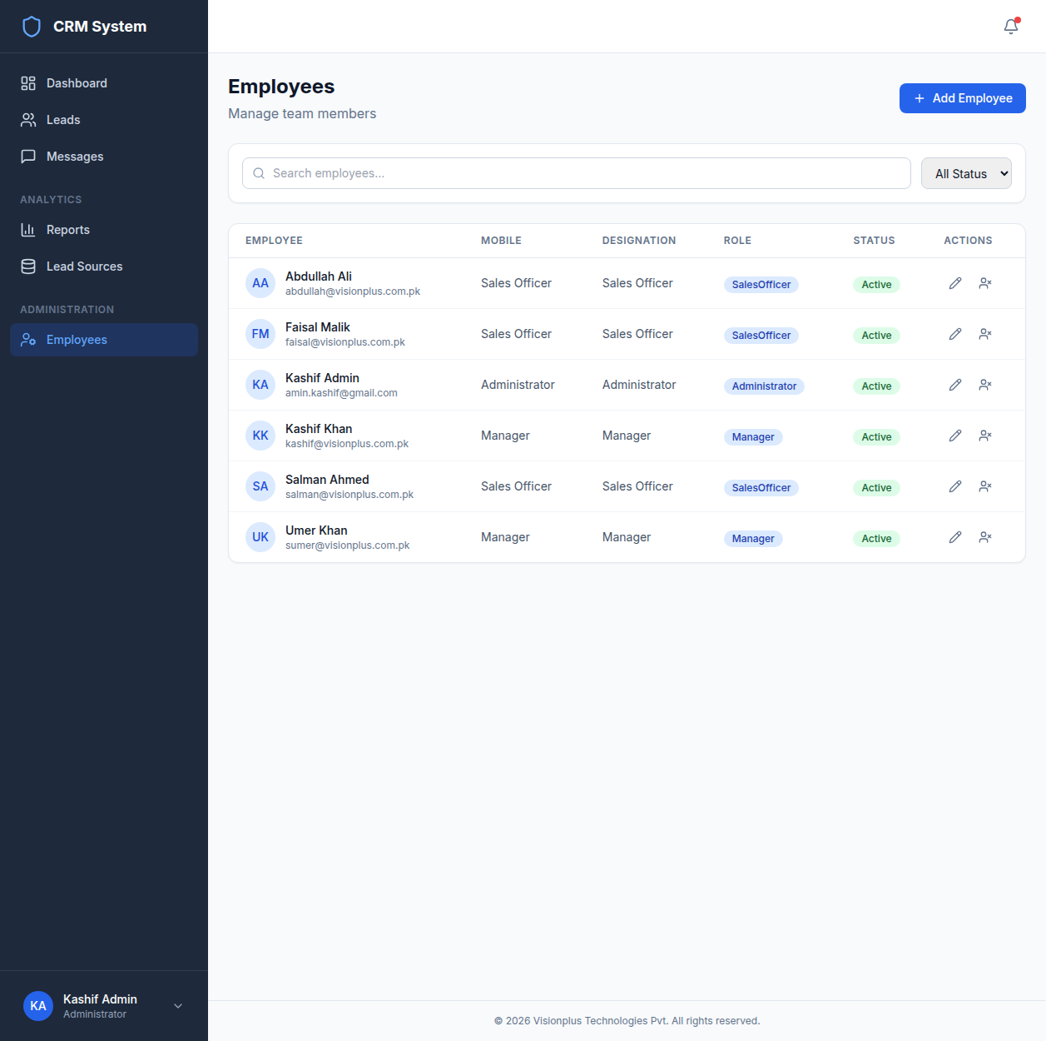
Figure 11: Employee management page with search and filters

Create: Add Employee → fill name/email/mobile → select Designation/ Role → set Password → Save.
Edit: Modify fields. Toggle Active: deactivated users cannot log in, data preserved.

14. User Profile
Access: Click avatar in sidebar footer → Profile.
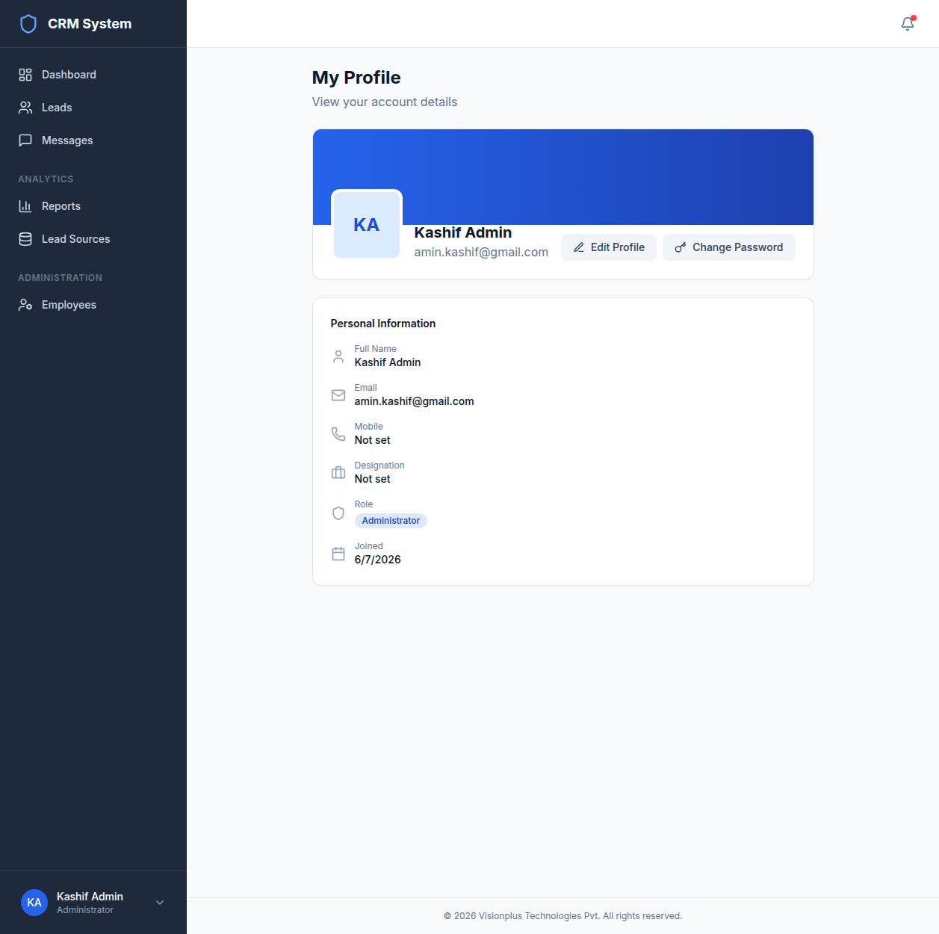
Figure 12: User profile page with personal info and picture management

Profile View: Hero card, personal information, profile picture upload/remove, change password.
Edit: First Name, Last Name, Email, Mobile → Save.
Password: Minimum 6 chars, at least 1 digit.
Picture: JPG/PNG/WebP, max 5 MB.

15. System Flow Diagrams

Lead Lifecycle Flow
New → Contacted → Qualified → Proposal → Closed Won / Closed Lost → LOCKED (Admin only)

Lead Close Flow
1. User changes status to Closed Won/Lost
2. If lead already closed and user not Admin → Block with error
3. Status Change Modal appears → select reason + enter remark (min 10 chars)
4. Confirm → API validates → Status updated + Activity logged

Closed Lead Restriction Flow
1. User attempts to modify a closed lead (status 4 or 5)
2. Is user Administrator? YES → Allow modification. NO → Block all actions.
3. Frontend disables all UI controls for non-admin users
4. Backend returns 400: 'Only System Administrator can modify a closed lead'

16. Troubleshooting
Problem | Solution
Invalid credentials | Check email/password. Case-sensitive.
Account inactive | Contact System Administrator to reactivate.
Page not loading | Clear browser cache (Ctrl+F5).
Cannot change status | Closed leads: Admin only.
Cannot edit lead | Closed leads locked for non-admin.
Remark too short | Enter at least 10 characters.
Kanban drag not working | Closed cards cannot be dragged by non-admin.
Cannot add follow-up | Closed leads: Admin only.
WhatsApp disabled | Lead needs phone. Closed leads: Admin only.
Message Failed | Check WhatsApp connection.
Calendar empty | Sales Officers see own only. Try changing month.

Browser Support: Chrome, Firefox, Edge, Safari (latest 2 versions).

17. Appendix A: Default Users
Name | Email | Password | Role
System Admin | amin.kashif@gmail.com | Admin@123 | Administrator
Kashif | kashif@visionplus.com.pk | Manager@123 | Manager
Umer | sumer@visionplus.com.pk | Manager@123 | Manager
Salman | salman@visionplus.com.pk | Sales@123 | Sales Officer
Abdullah | abdullah@visionplus.com.pk | Sales@123 | Sales Officer
Faisal | faisal@visionplus.com.pk | Sales@123 | Sales Officer

18. Appendix B: Lead Status Reference
Value | Name | Color | Description
0 | New | Amber | Lead entered
1 | Contacted | Cyan | Initial contact
2 | Qualified | Blue | Meets criteria
3 | Proposal | Slate | Proposal sent
4 | Closed Won | Green | Deal closed
5 | Closed Lost | Red | Lost — reason documented

