

**COMSATS University Islamabad (CUI) Attock Campus**

Compiler Construction Lab  
(Semester Project)

MiniCompiler

***By***

**Kashif Hussain CIIT/FA20-BCS-019/ATK**

***Submitted To:*Mr. Syed Bilal Haider**

Semester Project Report :

MiniCompiler

Q2:

*2 functionalities along with screenshorts ( function code +output)*

**Functionality 1: Basic Arithmetic Expression Parsing**

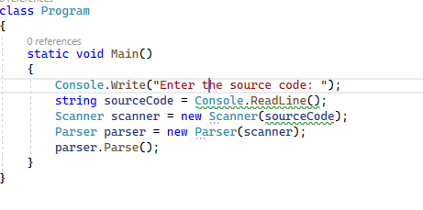

**Functionality 2: Error Handling for Unexpected Characters:**

