

**COMSATS University Islamabad (CUI) Attock Campus**

Compiler Construction Lab  
(Semester Project)

MiniCompiler

***By***

**Kashif Hussain CIIT/FA20-BCS-019/ATK**

***Submitted To:*Mr. Syed Bilal Haider**

Semester Project Report :

MiniCompiler

Q3:

**INPUT:**

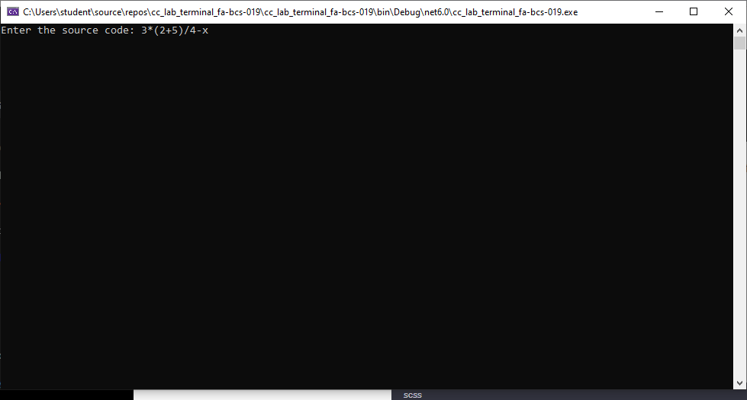

**OUTPUT:**

