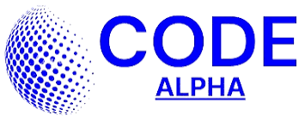

CODEALPHA_PROJECT REPORT
Language Translation Tool
A Python Desktop Application using Tkinter and Google Translate
Submitted as part of the CodeAlpha Internship Program
Domain: (AI)
Prepared by: Kashif Hafeez
Date: July 19, 2026

1. Introduction
Communication across languages is one of the most common challenges in a globally connected world. Manually looking up translations is slow and often loses context, which is why automated translation tools have become an essential part of everyday software. This project, the Language Translation Tool, is a desktop application built in Python that allows a user to type or paste text in one language and instantly receive an accurate translation in another.
The application is built using Python's built-in Tkinter library for the graphical interface and the deep-translator package to access Google Translate's translation engine. It was developed as part of the CodeAlpha internship program under the Python Programming domain, with the goal of demonstrating practical skills in GUI development, API integration, multithreading, and user-experience design.

2. Objective
The main objectives of this project are:
- To design a simple, user-friendly desktop interface for translating text between multiple languages.
- To integrate a reliable third-party translation engine (Google Translate, via the deep-translator library) into a Python application.
- To ensure the interface remains responsive during translation by performing network requests on a background thread.
- To add supporting features such as automatic language detection, language swapping, clipboard copying, and text-to-speech playback.
- To handle errors gracefully (e.g. no internet connection) and provide clear feedback to the user.

3. Tools / Technologies Used
The project relies on the following tools, languages, and libraries:
- Python 3 — core programming language.
- Tkinter / ttk — Python's standard GUI toolkit, used to build the window, widgets, and styling (themed with the 'clam' theme).
- deep-translator (GoogleTranslator) — third-party library used to send text to Google Translate and retrieve the translated result.
- threading — used to run translation requests in the background so the GUI does not freeze while waiting for a network response.
- pyperclip (optional) — enables one-click copying of input or translated text to the system clipboard.
- pyttsx3 (optional) — enables offline text-to-speech playback of the input or translated text.
- messagebox — standard Tkinter dialog module, used for warnings, errors, and information pop-ups.

4. Features of the Project
- Translate text between 26 languages, including English, Urdu, Arabic, French, Spanish, Chinese, Hindi, and more.
- Auto-detect the source language, or select it manually from a dropdown list.
- One-click 'Swap' button to reverse the source and target languages (disabled for Auto Detect, since it cannot be a target).
- Responsive, non-blocking UI — translation runs in a separate thread so the window never freezes.
- Copy-to-clipboard for both the input and the translated text.
- Text-to-speech playback for both the input and the translated text, using a freshly created speech engine per call for reliability.
- Clear button to reset both text boxes instantly.
- Graceful error handling — friendly pop-up messages if translation fails or optional libraries are missing.
- Graceful feature degradation — Copy and Speak buttons automatically disable themselves if pyperclip or pyttsx3 are not installed, instead of crashing the app.

5. Screenshots / Output
The illustration below is a representative mock-up of the application window, showing the language selectors, input box, Translate button, and the translated output box. When the actual application is run, this space should be replaced with a real screenshot of the running window. 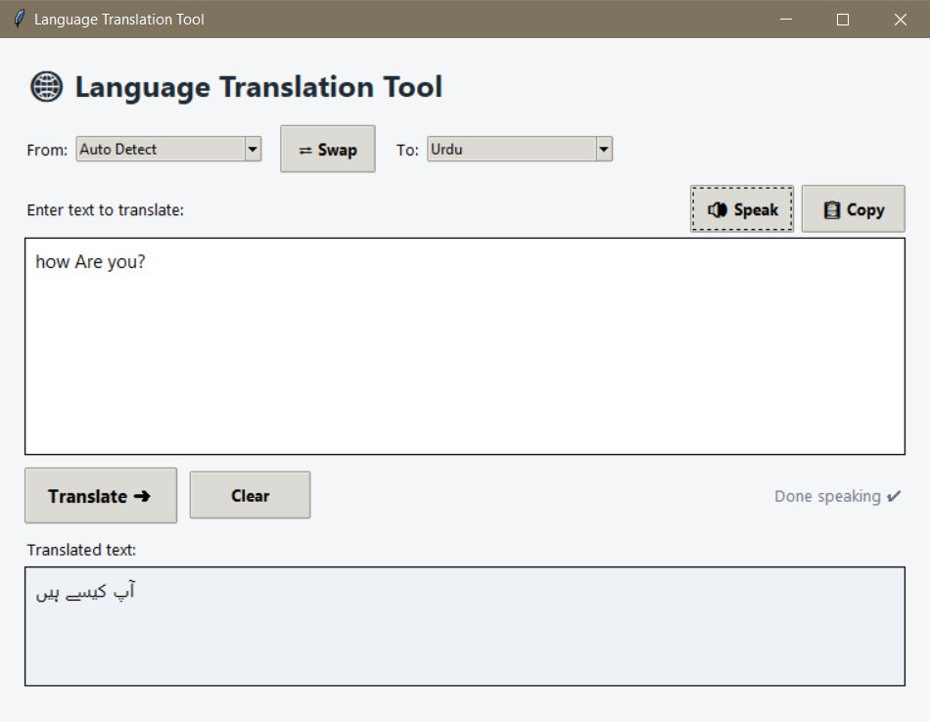

Figure 1: Representative view of the Language Translation Tool interface

6. Algorithm / Flowchart
The step-by-step algorithm followed by the application is:
- Launch the application; the Tkinter window and all widgets are created.
- The user selects a source language (or leaves it as Auto Detect) and a target language.
- The user types or pastes the text to be translated into the input box.
- The user clicks the 'Translate' button, which calls start_translation().
- The input is validated (rejecting empty text), the Translate button is disabled, and the status label shows 'Translating…'.
- A background thread is started to run _translate_worker(), keeping the interface responsive.
- Inside the thread, a GoogleTranslator object is created with the chosen source and target language codes, and translator.translate(text) sends the request.
- If the request succeeds, the result is passed back to the main thread via self.after(), which displays it in the output box and re-enables the Translate button.
- If the request fails (e.g. no internet connection), an error message box is shown instead, and the button is re-enabled.
- The user may optionally copy the input/output text to the clipboard or have it read aloud using text-to-speech.
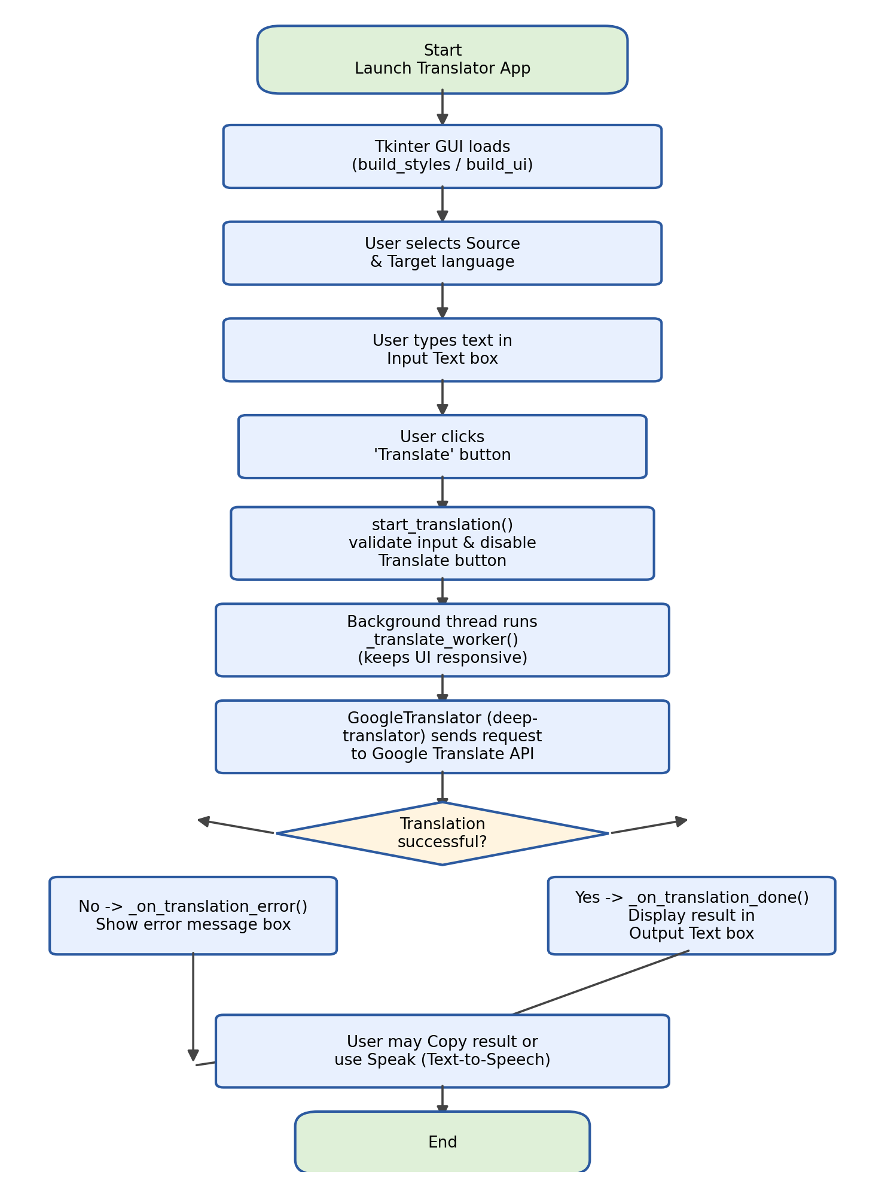
Figure 2: Flowchart of the translation process

7. Code Explanation

7.1 Imports and optional dependencies
The script imports threading and Tkinter for the interface, and GoogleTranslator from deep_translator for translation. pyperclip and pyttsx3 are imported inside try/except blocks, setting CLIPBOARD_AVAILABLE and TTS_AVAILABLE flags — this allows the application to still run even if these optional packages are not installed, simply disabling the related buttons.
try:
import pyperclip
CLIPBOARD_AVAILABLE = True
except ImportError:
CLIPBOARD_AVAILABLE = False

7.2 Language dictionary
LANGUAGES maps human-readable names (e.g. 'French') to Google Translate language codes (e.g. 'fr'). TARGET_LANGUAGES is derived from LANGUAGES by removing the 'auto' entry, since 'auto' is only valid as a source language, never as a translation target.

7.3 The TranslatorApp class
TranslatorApp extends tk.Tk and represents the whole application window. Its constructor sets the title, size, and background colour, then calls _build_styles() to configure ttk widget styling and _build_ui() to lay out every widget: the header, the From/To language dropdowns with a Swap button, the input Text widget, the action row (Translate/Clear/status label), and the output Text widget with its own Copy/Speak buttons.

7.4 Starting a translation
start_translation() reads the text from the input box, checks that it is not empty, disables the Translate button, updates the status label, and then launches _translate_worker() on a new daemon thread. Running the network call on a separate thread is essential — Tkinter's main loop must stay free to keep the window responsive while the request is in progress.
thread = threading.Thread(
target=self._translate_worker, args=(text,), daemon=True
)
thread.start()

7.5 The worker thread and thread-safe UI updates
_translate_worker() performs the actual translation using GoogleTranslator(source=..., target=...).translate(text). Because Tkinter widgets must only be updated from the main thread, the result (or any exception) is not applied directly — instead, self.after(0, callback, ...) is used to schedule _on_translation_done() or _on_translation_error() to run safely back on the main thread.

7.6 Copy and Speak helpers
_copy_text() and _speak_text() are shared helper methods used by both the input and output panels. _speak_text() creates a brand-new pyttsx3 engine for every call rather than reusing one instance — the code comments explain that reusing a single engine across multiple calls is unreliable on Windows and macOS and can cause later speech calls to go silent. Speech also runs on its own background thread so it does not block the interface.

7.7 Error handling
Every risky operation (translation, clipboard access, speech playback) is wrapped in a try/except block. Failures are surfaced through messagebox dialogs with a clear description of the problem and, where relevant, a suggested fix (for example, installing xclip/xsel on Linux for clipboard support, or espeak for text-to-speech).

8. Challenges Faced
- Keeping the UI responsive: translation requires a network call, which can take a noticeable amount of time; performing it on the main thread would freeze the window. This was solved using a background thread combined with self.after() to safely update widgets afterward.
- Optional dependencies: pyperclip and pyttsx3 are not part of the Python standard library and may not be installed on every machine. The application was designed to detect their absence at start-up and disable the related buttons instead of crashing.
- Cross-platform text-to-speech reliability: pyttsx3 engines can behave inconsistently across Windows, macOS, and Linux, particularly when reused for multiple calls. Creating a fresh engine per speech request resolved silent/hanging playback issues.
- Clipboard access on Linux: pyperclip requires a system clipboard backend (xclip or xsel) that is not always pre-installed, which can cause copy operations to fail; this is now handled with a clear, actionable error message.
- Language-target validation: 'Auto Detect' is meaningful only as a source language, so it had to be excluded from the target language list and from the Swap operation to avoid invalid translation requests.

9. Conclusion
The Language Translation Tool successfully demonstrates how a simple, functional desktop application can be built in Python by combining a native GUI toolkit (Tkinter) with a third-party translation API (deep-translator/Google Translate). The project reinforced practical concepts including event-driven GUI programming, multithreading for responsive applications, safe cross-thread UI updates, optional dependency handling, and user-friendly error reporting. The result is a lightweight, easy-to-use translator that supports 26 languages along with convenient copy and text-to-speech features, fulfilling the objectives set out for this CodeAlpha internship task.
Future improvements could include saving translation history, supporting file/document translation, adding more languages, and packaging the application as a standalone executable for easier distribution.

10. References
- Python Software Foundation — Tkinter documentation: https://docs.python.org/3/library/tkinter.html
- deep-translator library documentation: https://pypi.org/project/deep-translator/
- pyperclip documentation: https://pypi.org/project/pyperclip/
- pyttsx3 documentation: https://pypi.org/project/pyttsx3/
- Google Translate: https://translate.google.com/
- CodeAlpha Internship Program: https://www.codealpha.tech/

