**What is Git?**

* Git is VCS (Version Control System) that helps to manage different version of your code.
* It keep all changes that is done by you and your team members to the code.
* If you will make mistake we can easily go back in the prev version of code.
* Git is different from GitHub as GitHub is a website where we can store the Git projects.

Version Control System is a software that helps software developers to work together and maintain a complete History of their work.

CVCS ( Centrialized Version Control System) and DVCS(Distributed / Decentrialized Version Control System) are 2 types of VCS.

Centralized version control system (CVCS) uses a central server to store all files and enables team collaboration. But the major drawback of CVCS is its single point of failure, i.e., failure of the central server. Unfortunately, if the central server goes down for an hour, then during that hour, no one can collaborate at all. And even in a worst case, if the disk of the central server gets corrupted and proper backup has not been taken, then you will lose the entire history of the project. Here, distributed version control system (DVCS) comes into picture.

DVCS clients not only check out the latest snapshot of the directory but they also fully mirror the repository. If the server goes down, then the repository from any client can be copied back to the server to restore it. Every checkout is a full backup of the repository. Git does not rely on the central server and that is why you can perform many operations when you are offline. You can commit changes, create branches, view logs, and perform other operations when you are offline. You require network connection only to publish your changes and take the latest changes.

Git is a **Distributed Version Control System (DVCS).**

**Lets see the basic work flow of Git.**

* 1st we modify file from working directory
* In 2nd step we add these changes to staging area
* In 3rd step we perform commit operation that moves files from staging area and after push operation it stores the changes permanently in Git repository and this will be remote directory .

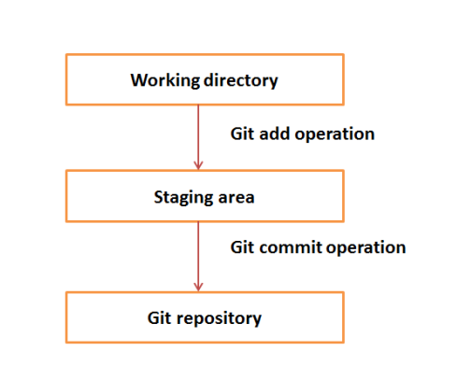

Git add ,

Push

How many branch are there it can be see by GIT BRANCH

Creating branch GIT BRANCH –C “branch-name”

How to switch branch answer is GIT CHECKOUT branch name

Merge command in Git used to see brances in a particular repo.

done