**Testing multiple chains with different starting points within the parameter space**

Chain length = 10,000;

Free seedling;

Consider just one set of parameters for testing the multi-chain response (so no parameter variation over time)

**Chain starting point** = Option 1: Start at the middle point within the Parameter spaces

**Without burn-in:**

Parameter (k, Y, …) values from all iterations:

| **k** | **Y** | **af** | **as** | **sf** | **volume** |
| --- | --- | --- | --- | --- | --- |
| 0.3147048 | 0.3151364 | 0.5849276 | 0.1227222 | 0.03495572 | 1000 |

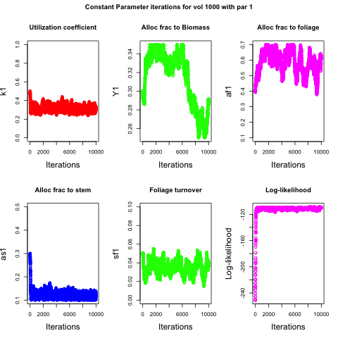

**With 10% Burn-in:**

Chain starting point = Option 1: Start at the mean values within the Parameter spaces

Parameter (k, Y, …) values from all iterations:

| **k** | **Y** | **af** | **as** | **sf** | **volume** |
| --- | --- | --- | --- | --- | --- |
| 0.3137331 | 0.3149086 | 0.5905167 | 0.1214439 | 0.03518621 | 1000 |

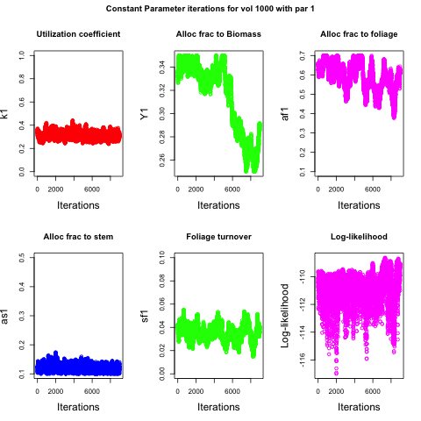

**Chain starting point** = Option 2: Start at the lower range within the Parameter spaces

**Without burn-in:**

Constant parameter (k1, Y1, …) values from all iterations:

| **k** | **Y** | **af** | **as** | **sf** | **volume** |
| --- | --- | --- | --- | --- | --- |
| 0.3109766 | 0.3061146 | 0.5632079 | 0.120689 | 0.03325509 | 1000 |

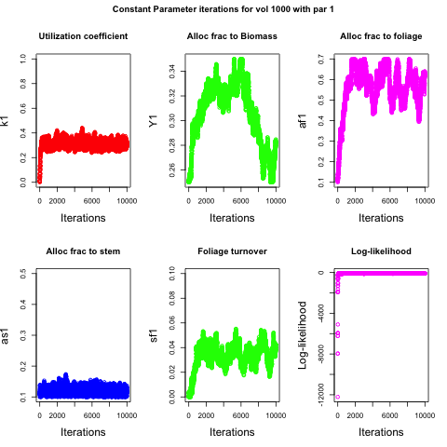

**Chain starting point** = Option 2: Start at the lower range within the Parameter spaces

**With burn-in:**

Constant parameter (k1, Y1, …) values from all iterations:

| **k** | **Y** | **af** | **as** | **sf** | **volume** |
| --- | --- | --- | --- | --- | --- |
| 0.3134388 | 0.3091412 | 0.5856668 | 0.1208248 | 0.03521176 | 1000 |

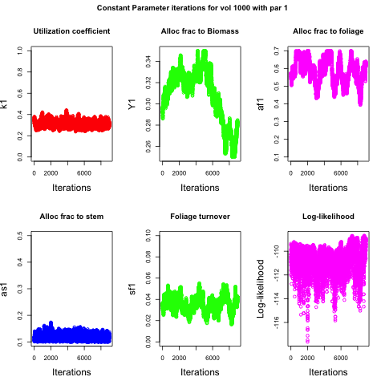

**Chain starting point** = Option 3: Start at the upper range within the Parameter spaces

**Without burn-in:**

Constant parameter (k1, Y1, …) values from all iterations:

| **k** | **Y** | **af** | **as** | **sf** | **volume** |
| --- | --- | --- | --- | --- | --- |
| 0.3364431 | 0.3186342 | 0.5988899 | 0.1264247 | 0.03701302 | 1000 |

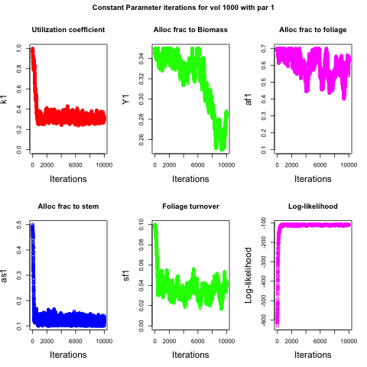

**Chain starting point** = Option 3: Start at the upper range within the Parameter spaces

**With burn-in:**

Constant parameter (k1, Y1, …) values from all iterations:

| **k** | **Y** | **af** | **as** | **sf** | **volume** |
| --- | --- | --- | --- | --- | --- |
| 0.3144499 | 0.3162266 | 0.5907345 | 0.1217738 | 0.03501049 | 1000 |

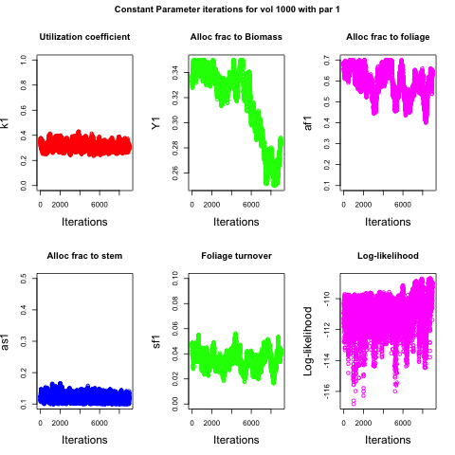

**Summary table:**

Chain length = 10,000;

Free seedling;

Consider just one set of parameters for testing the multi-chain response (so no parameter variation over time)

**Testing multiple chains with different starting points within the parameter space:**

|  |  |  |  |  |  |  |  |
| --- | --- | --- | --- | --- | --- | --- | --- |
| **Chain Starting point** | **Burn-in (10%)** | **Utilization coefficient**  **(k)** | **Growth respiration**  **(Y)** | **Foliage allocation fraction (af)** | **Stem allocation fraction (as)** | **Leaf turnover**  **(sf)** | **Treatment** |
| Middle | No | 0.3147048 | 0.3151364 | 0.584927 | 0.122722 | 0.0349557 | Free |
| Middle | Yes | 0.3137331 | 0.3149086 | 0.590516 | 0.121443 | 0.0351862 | Free |
| Bottom | No | 0.3109766 | 0.3061146 | 0.563207 | 0.120689 | 0.0332550 | Free |
| Bottom | Yes | 0.3134388 | 0.3091412 | 0.585666 | 0.120824 | 0.0352117 | Free |
| Top | No | 0.3364431 | 0.3186342 | 0.598889 | 0.126424 | 0.0370130 | Free |
| Top | Yes | 0.3144499 | 0.3162266 | 0.590734 | 0.121773 | 0.0350104 | Free |