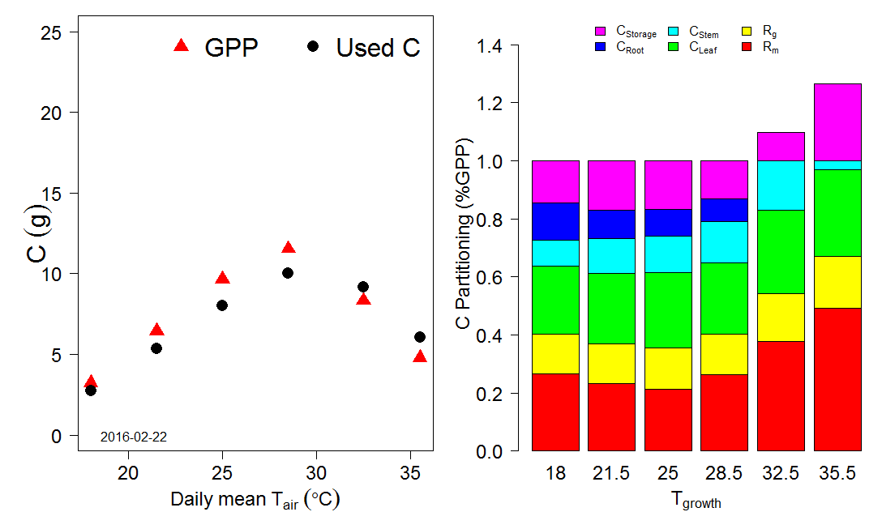

Figure 1: Source of leaf area and biomass: Harvest data

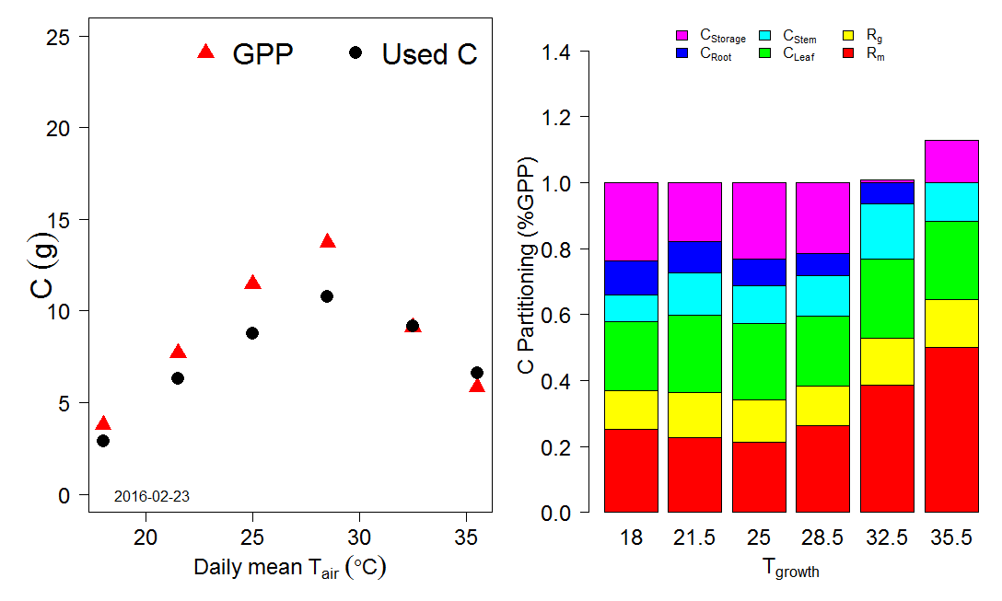

Figure 2: Source of leaf area and biomass: Allometric models (dates from 2016-01-08 to 2016-02-23)

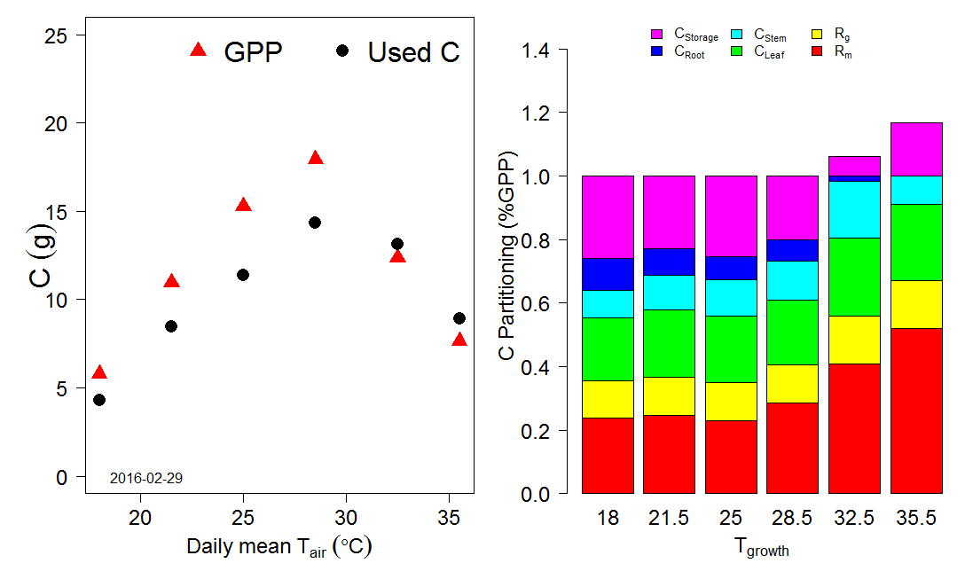

Figure 2: Source of leaf area and biomass: Allometric models (dates from 2016-01-08 to 2016-02-29)