**Daily Carbon gain estimations for GREAT experiment**

Met data: 15 min VPD, Tair and PPFD measured in each glasshouse room

Physiological parameters:

1. Vcmax and Jmax at 25C: Estimated for room 1, 4 and 6 using ACi data. For other rooms, calculated by fitting a smooth line
2. Ea, deltaS for Vcmax and Jmax: : Estimated for room 1, 4 and 6 using ACi data. As no clear relationship with Tgrowth, values were assumed as follows

For room 2 (21.5C): assume room 1 (18C)

For room 3 (25C): assume room 4 (28.5C)

For room 5(32.5C): assume room 6 (36.5C)

1. g1: estimated from short term Asat measurements
2. alpha: estimated by inverting Farquhar model
3. Other parameters: default in Photosyn

Parameter values used

|  |  |  |  |  |  |  |  |  |  |
| --- | --- | --- | --- | --- | --- | --- | --- | --- | --- |
| **Room** | **Tgrowth** | **g1** | **alpha** | **Vcmax25** | **EaV** | **delsV** | **Jmax25** | **EaJ** | **delsJ** |
| **1** | 18 | 1.58 | 0.18 | 115.03 | 58.87 | 0.629 | 210.65 | 42.75 | 0.631 |
| **2** | 22.5 | 7.70 | 0.20 | 92.36 | 58.87 | 0.629 | 150.60 | 42.75 | 0.631 |
| **3** | 25 | 6.34 | 0.19 | 81.69 | 57.71 | 0.629 | 124.81 | 32.67 | 0.625 |
| **4** | 28.5 | 8.78 | 0.19 | 69.06 | 57.71 | 0.629 | 97.80 | 32.67 | 0.625 |
| **5** | 32.5 | 16.45 | 0.16 | 57.93 | 82.55 | 0.633 | 79.92 | 51.00 | 0.631 |
| **6** | 35.5 | 15.43 | 0.14 | 51.90 | 82.55 | 0.633 | 75.60 | 51.00 | 0.631 |

Assumptions:

1. Provenance differences was not considered in any parameter estimation.
2. Temperature response of day respiration was assumed to be similar as dark respiration

Basal rates and Q10 values were averaged across provenances.

1. Temperature response of root and stem respiration (only Q10) was assumed similar to dark respiration. But basal rates were measured values at 25C

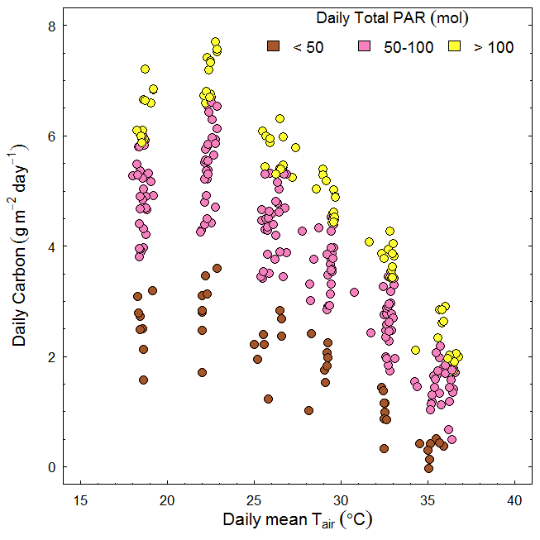

Figure1. temperature response of daily carbon gains.

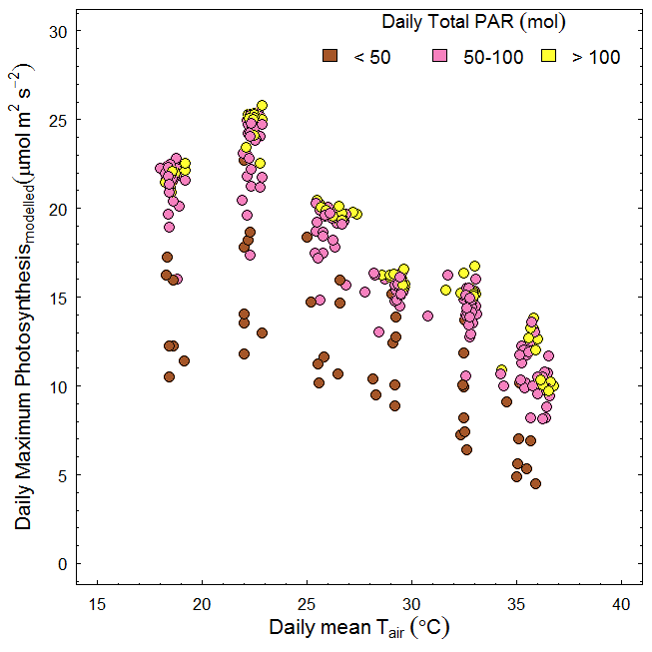

Figure2. temperature response of daily maximum net photosynthetic rate.

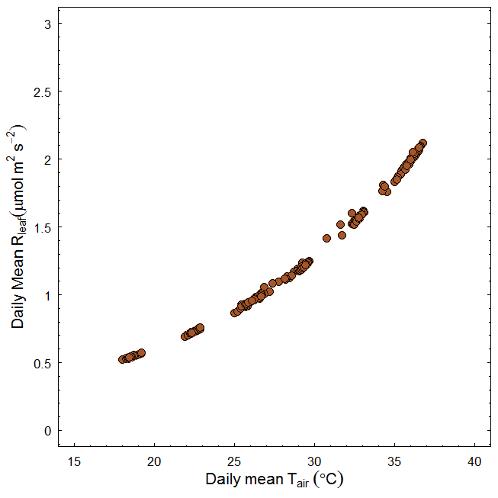

Figure3. temperature response of daily mean leaf respiration rate.

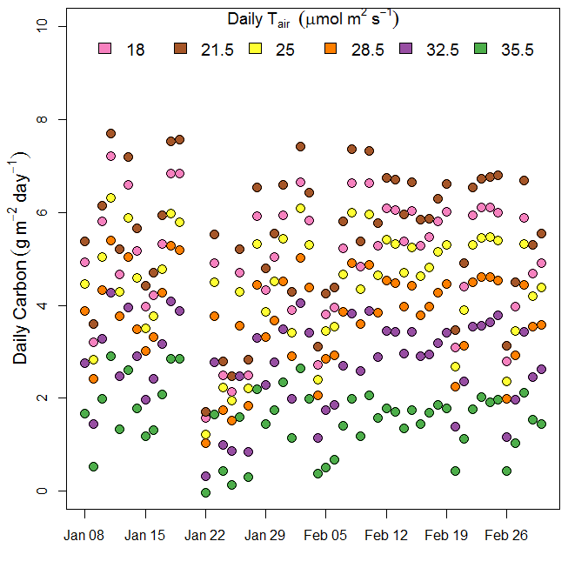

Figure4. Daily carbon gains over the experimental period (52 days from 7th Jan 2016 to 1st March 2016)

**from Drake et al 2017 GCB**

**Fig. S1** Environmental data observed inside six glasshouse bays at Western Sydney University in 2016. Mean daily values of air temperature (Tair; a), relative humidity (RH; b), and vapor pressure deficit (VPD; c) are shown along with hourly averages of incident photosynthetic photon flux density (PPFD; d). Six colors are shown; cool colors reflect low temperature bays while hot colors reflect high temperature bays. PPFD did not differ across bays, so we present the mean PPFD for clarity. Note that there was substantial diurnal variation in T­air­, RH, and VPD that is not evident in these plots of 24-hour averages.